**Attribute Selection**

|  |  |
| --- | --- |
| **Attribute** | **Rationale for Selection** |
| totalAdClicks | Total of ad-clicks per user, this is correlated to the profit of the company |
| revenue | Total money spent on in-app purchase items |

**Training Data Set Creation**

Training data set used for the analysis  
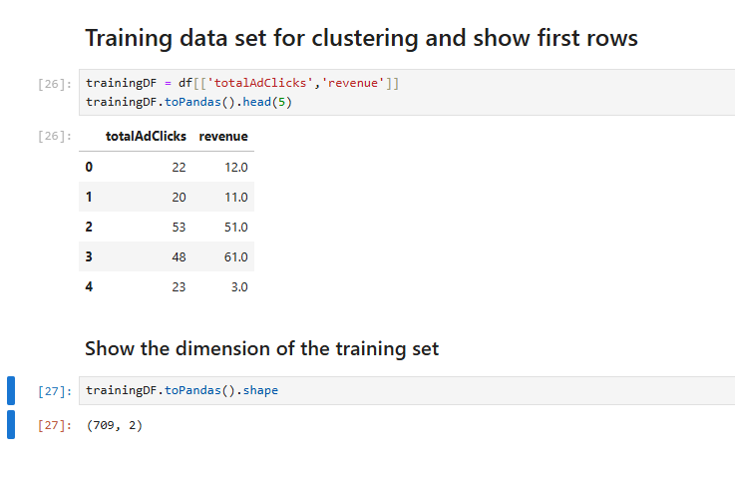

Dimensions of the training data set is 709 rows and 2 columns

It has 2 clusters created

**Cluster Centers**

|  |  |
| --- | --- |
| **Cluster** | **Cluster Center** |
| 1 | [53.0,51.0] |
| 2 | [22.0,12.0] |
| 3 | [20.0,11.0] |

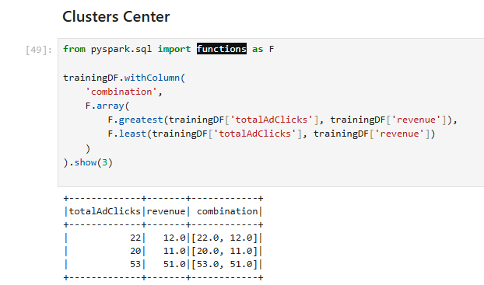

These clusters can be differentiated from each other:

1. Is different because players in the cluster have the highest **‘totalAdClicks’** and **‘revenue’**.
2. Is different because players in the cluster have the second highest **‘totalAdClicks’** and **‘revenue’**.
3. Is different because players in the cluster have the second lowest **‘totalAdClicks’** and **‘revenue’**.

**Recommended Actions**

|  |  |
| --- | --- |
| **Action Recommended** | **Rationale for the action** |
| Increase the different possible combination of click in order to get more revenue | Players into the first cluster are frequent ad-clickers and increase revenue |
| Add extra steps for clicking for avoiding shortage of revenue | Players in the third cluster only could click where there were not possibilities of click |