A Lagrangian Model of the Internucleon Magnetic Interaction: Toward a Field-Theoretic Account of the Nuclear Force Michael Vio Version 2, October 2026 (version 1: 12 January 2025)

Abstract
The residual strong interaction between nucleons is conventionally described by meson exchange at the nucleon level and by quark–gluon dynamics at the sub-nucleon level [E]. This paper develops, as a working hypothesis [H], an alternative nucleon-level picture in which the short-range attraction between nucleons is attributed to the interaction between nucleon spin magnetic moments, mediated by a hypothetical exchange quantum, the magnetron, with gravitation as an additional channel. The magnetron is introduced through a proposed $τ$-neutrino-induced proton–neutron conversion process, which is postulated [P] and stated as a hypothesis [H]. The variational (least-action) formalism is used only formally: no Lagrangian density for the magnetron field is known, and the model is neither a quantum field theory nor QED. Reference forces for $​_{2}^{4}He$ are computed from CODATA 2022 constants. The author’s estimates [N] of the magnetron-mediated force are reproduced; as printed, they do not yield a force in newtons, because they are dimensionally inconsistent or depend on an undetermined scale, and the scale parameters are postulated [P]. A conjectural alpha-module shell scheme [H] and a Bohr-model bound $Z<1/α$ for a point nucleus [M, E] are also discussed. Statements are labelled by epistemic status (Section 1). Corrections relative to version 1 (January 2025) are listed in Appendix A.
Keywords: nuclear force, magnetic dipole interaction, nucleon spin, principle of least action, nuclear shell model, magic numbers, Bohr model, fine-structure constant

1. Introduction and Status of Claims
The work originates in an attempt to account for the short-range attraction between nucleons without descending to the quark–gluon level. The proton and the neutron are treated as point-like sources of four concurrent interactions — electrostatic, gravitational, Lorentz (velocity-dependent magnetic) and spin-magnetic — and the question asked is whether a least-action treatment of these channels, together with one additional exchange process, can account for qualitative or order-of-magnitude features of the nuclear force. The numerical estimates of version 1 are recomputed in Section 4 and Appendix A; the remaining content is a set of postulates and hypotheses, listed explicitly below, together with a few standard results.
What this paper is not. (i) It is not quantum electrodynamics: there is no quantized field, no Lagrangian density and no renormalization. The magnetron plays, for the magnetic channel, a role analogous to that of the virtual photon in QED; this is an analogy, not a derivation. (ii) It does not derive nuclear binding energies. (iii) It does not predict the nuclear magic numbers (Section 5).
Each claim carries one of the following labels. A statement without a label is a definition, a description of the author’s model, or narrative.
Label | Meaning
[E] | Established: standard physics, experimentally supported or textbook
[M] | Mathematical identity or explicit arithmetic from the stated inputs (the calculation is shown)
[P] | Postulate: assumed by the author, not derived
[H] | Hypothesis: proposed, without supporting evidence in this paper; testable in principle
[N] | Numerical estimate by the author, taken from the author’s worksheets; reproduced or not as indicated

1.1 Constants and conventions
Unless stated otherwise, numerical values below are computed with CODATA 2022 constants [11]: $k=1/(4πε_{0})=8.98755×{10}^{9} N m^{2} C^{-2}$, $e=1.602177×{10}^{-19} C$, $G=6.6743×{10}^{-11} m^{3} kg^{-1} s^{-2}$, $m_{p}=1.67262×{10}^{-27} kg$, $h=6.62607×{10}^{-34} J s$, $ℏ=1.05457×{10}^{-34} J s$, $c=2.99792×{10}^{8} m/s$. Two products are used repeatedly: $ke^{2}=2.30708×{10}^{-28} J m$ and $Gm_{p}^{2}=1.867×{10}^{-64} N m^{2}$ [M]. The measured proton root-mean-square charge radius, $≈0.84$ fm [E], is distinct from the radius $r_{p}=1.2$ fm assumed by the author’s worksheets [N].

1.2 The hypothesised conversion channel
The model postulates [P] that a proton struck by an incoming $τ$-neutrino flux converts transiently into a neutron while emitting a bound $π^{+}π^{-}$ pair — the magnetron — and a $μ$-neutrino. The reaction for a proton is written (the first arrow denotes the transformation, the second the decay)
$$\begin{aligned}p+\check{τ}&→n+\hat{ν}+π^{+}+\hat{μ} \\ &→\left(p+e+\hat{ν}\right)+\hat{μ}+{\check{π}}^{-}+π^{+} \\ &=p+\left(e+π^{+}\right)=p+μ+ΔE,\end{aligned} (1)$$
and the complementary channel for a neutron is
$$n+\check{τ}→p+{\hat{π}}^{-}+\hat{μ}+\hat{ν}=\left(p+{\check{e}}_{opto}+\hat{ν}\right)=n+\hat{ν}+\hat{μ}=n. (2)$$
Notation. A caron over a symbol marks an incoming (converging) flux quantum and a circumflex an outgoing (diverging) one; $μ$ denotes the muon, not the magnetron. The symbol ${\check{e}}_{opto}$ is a term of the author’s framework that is not defined here.
Status [H]. These reactions are stated as a hypothesis. Checked line by line (Appendix B), they are not closed under the standard conservation laws as written: in (1) the combination $e+π^{+}$ is electrically neutral, whereas a muon carries charge $±1$ and lepton flavour, so the last equality does not conserve charge or lepton flavour; the flavours of $\hat{ν}$ and $\hat{μ}$ are unspecified, so lepton-flavour conservation in the first step cannot be verified. Version 1 labelled reaction (2) “$β^{+}$ decay”, but the conversion $n→p$ is $β^{-}$ decay ($n→p+e^{-}+{\overset{‾}{ν}}_{e}$); $β^{+}$ is $p→n+e^{+}+ν_{e}$ [E]. The model additionally assumes that at least two nucleons are present within a characteristic interaction time of $∼{10}^{-6}$ s so that proton–neutron pairs can exchange states [P, H], and that the electrostatic channel “pulsates” with a period of $∼6×{10}^{-11}$ s [P, H]; the paper contains no derivation or calculation of either figure.

1.3 Gravitational channel
The nucleon–nucleon gravitational force is the Newtonian one [E],
$$F_{g}=\frac{Gm_{p}^{2}}{r^{2}}, Gm_{p}^{2}=1.867×{10}^{-64} N m^{2}. (3)$$
Version 1 gave the numerator as $1.85×{10}^{-64}$ to $4.09×{10}^{-64}$; the upper value has no justification and the value used here is $1.867×{10}^{-64}$ (Appendix A). The statement that gravitons are not exchanged between nucleus and atomic electrons is a postulate [P] without consequence for this paper.

2. Variational Framework
The model uses the classical least-action formulation of mechanics and of electrostatics, as presented in Feynman’s lectures [1] (Vol. II, Ch. 19). The following is a summary in our own notation, not a quotation.
Particle in a potential [E, M]. For a particle of mass $m$ in a potential $V(x)$ the action is
$$S[x]=\int_{t_{1}}^{t_{2}}{\left[1/2m{\dot{x}}^{2}-V(x)\right]}dt. (4)$$
Replacing $x(t)→x(t)+η(t)$ with $η(t_{1})=η(t_{2})=0$ and keeping first-order terms in $η$, one integration by parts gives
$$δS=\int_{t_{1}}^{t_{2}}{\left[m\dot{x} \dot{η}-V^{'}(x) η\right]}dt=-\int_{t_{1}}^{t_{2}}{\left[m\ddot{x}+V^{'}(x)\right]}η(t) dt, (5)$$
so stationarity for arbitrary $η$ requires
$$m\ddot{x}=-V^{'}(x), (6)$$
that is, Newton’s second law with force $F=-V^{'}(x)$. (Version 1 wrote $F=-V^{'}(x)/m$; the corrected form is given here, Appendix A.)
Electrostatics [E]. If the charge density $ρ$ is known, the potential $Φ$ that solves Poisson’s equation $∇^{2}Φ=-ρ/ε_{0}$ is the one that makes the functional
$$U^{*}[Φ]=\frac{ε_{0}}{2}∫(∇Φ)^{2} dV-∫ρ Φ dV (7)$$
stationary over all space [1]. This is an established equivalence between a variational statement and a field equation.
Formal use in this paper [P]. The magnetic channel between nucleons has no known Lagrangian. The paper applies the structure of (4)–(7) formally: it postulates that a magnetic field-like quantity $H(r,t)$ obeys a wave-type equation (Section 4.1) subject to the boundary conditions $H(2R,t)=0$ and $∂_{r}H(1/R,t)=R$, where $R$ is a large scale parameter taken from the author’s cosmological work and is not a nuclear length (see Section 4.1). The cutoff $r=2R$ is introduced by analogy with the gravitational potential, taken to vanish there [P]. This procedure fixes a functional form and boundary conditions; it does not constitute a derivation of any force, and the equivalence (7) cannot be invoked to justify it, since (7) presupposes a known source and field equation.

3. Reference Forces for the Helium-4 Nucleus
The author takes the internucleon separation of $​^{56}Fe$, $r≈4.2$ fm, as a representative nucleon–nucleon distance and applies it to $​_{2}^{4}He$ [P]; for the two protons of $​_{2}^{4}He$ a centre-to-centre separation $2r_{p}=2.4$ fm (with the assumed $r_{p}=1.2$ fm) is also used [P]. The following reference values are computed with the constants of Section 1.1.
Quantity | Value | Status | Calculation
Coulomb force between two protons, $r=4.2$ fm | $13.1$ N | [M] | $$ke^{2}/r^{2}=2.30708×{10}^{-28}/(1.764×{10}^{-29})$$
Coulomb force between two protons, $r=2.4$ fm | $40.1$ N | [M] | $$2.30708×{10}^{-28}/(5.76×{10}^{-30})=40.05$$
Coulomb energy at $2.4$ fm | $0.600$ MeV | [M] | $2.30708×{10}^{-28}/2.4×{10}^{-15}=9.61×{10}^{-14}$ J $=0.600$ MeV
Gravitational force between two protons, $r=4.2$ fm | $1.06×{10}^{-35}$ N | [M] | $$1.867×{10}^{-64}/1.764×{10}^{-29}$$
Ratio Coulomb : gravitation (any $r$) | $$1.24×{10}^{36}$$ | [M] | $$ke^{2}/(Gm_{p}^{2})=2.30708×{10}^{-28}/1.867×{10}^{-64}$$
Proton–electron attraction at $a_{0}=5.29×{10}^{-11}$ m (hydrogen) | $8.24×{10}^{-8}$ N | [M] | $$2.30708×{10}^{-28}/(5.29×{10}^{-11})^{2}$$
Same, nuclear charge $Z=2$, one electron at $a_{0}$ | $1.65×{10}^{-7}$ N | [M] | $$2×8.24×{10}^{-8}$$
Table 1. Reference forces, computed from CODATA constants.
The electron–proton entries are given only for scale: they bear on the atom, not on the internucleon balance. Version 1 gave $2.3×{10}^{-35}$ N for the gravitational force at 4.2 fm; this corresponds to the numerator $4.09×{10}^{-64}$ ($4.09×{10}^{-64}/1.764×{10}^{-29}=2.32×{10}^{-35}$), and is replaced by the value in Table 1 (Appendix A). Version 1 also gave a “sum over four nucleons”, $2.28×{10}^{-34}$ N; forces add vectorially, so a scalar sum is not a net force. For illustration only, the scalar sum over the six pairs of four hypothetical equidistant nucleons is $6×1.06×{10}^{-35}=6.4×{10}^{-35}$ N [M].
Lorentz force. For a proton of kinetic energy $E_{c}$ moving perpendicular to a field $B_{1}$,
$$v=\sqrt{\frac{2E_{c}}{m_{p}}}, F_{L}=e v B_{1}. (8)$$
Version 1 gave $E_{c}=500$ eV $=1.024×{10}^{-13}$ J. These are not equal: $500 eV=500×1.602177×{10}^{-19}=8.01×{10}^{-17}$ J [M], while $1.024×{10}^{-13}$ J corresponds to $6.39×{10}^{5}$ eV $=639$ keV. The speeds and forces for both energies, with the author’s $B_{1}=3.81$ T [N] (the worksheet itself uses $B_{1}=3.91$ T; the origin of neither value is documented), are:
Kinetic energy | $$v$$ | $$F_{L}=evB_{1}$$ | Calculation
$500$ eV ($8.01×{10}^{-17}$ J) | $3.1×{10}^{5}$ m/s | $1.9×{10}^{-13}$ N | $v=\sqrt{1.602×{10}^{-16}/1.67262×{10}^{-27}}=3.095×{10}^{5}$; $F_{L}=1.602177×{10}^{-19}×3.095×{10}^{5}×3.81$
$639$ keV ($1.024×{10}^{-13}$ J) | $1.1×{10}^{7}$ m/s | $6.8×{10}^{-12}$ N | $v=\sqrt{2.048×{10}^{-13}/1.67262×{10}^{-27}}=1.107×{10}^{7}$; $F_{L}=1.602177×{10}^{-19}×1.107×{10}^{7}×3.81$
Table 2. Proton speed and Lorentz force for the two energies (non-relativistic; $T/m_{p}c^{2}<{10}^{-3}$ in both cases).
Version 1 paired $v=1.1×{10}^{7}$ m/s with $F_{L}∼2×{10}^{-13}$ N; the printed force corresponds to 500 eV and the printed speed to 639 keV (Appendix A). In either case the Lorentz force is small compared with the Coulomb force of $13$–$40$ N [M].
Spin energy [N]. The spin-magnetic channel is characterised by
$$E_{s}=h_{m}f=hν=3.59 eV=q ω r^{2}, (9)$$
which gives $ν=3.59×1.602177×{10}^{-19}/6.62607×{10}^{-34}=8.68×{10}^{14}$ Hz [M]. The last equality is dimensionally inconsistent: $q ω r^{2}$ has the dimension of a magnetic moment (A m$​^{2}$), not of an energy; an energy would require a field, as in $μB$. The identification $h_{m}f=hν$ is likewise not explained, since $h_{m}≠h$ in the model (Section 4.3). Equation (9) is the author’s estimate [N] and is not used below.

4. The Spin-Magnetic Estimate of the Model
This section reports the author’s construction [P, N], following the supplementary documents [3, 4, 5] (author-hosted), together with recomputation checks.

4.1 The postulated field problem [P]
The author’s worksheet [12] works with a two-variable function $H(r,t)$ and the factor $Φ_{A}(t)=1+Ae^{-ct}$, and writes
$$\frac{∂^{2}}{∂t^{2}}​\left[H Φ_{A}\right]-c \frac{∂^{2}}{∂r^{2}}​\left[H Φ_{A}\right]=0, H(2R,t)=0, ∂_{r}H(1/R,t)=R. (10)$$
Two remarks are in order. First, the equation is the one-dimensional wave equation in $r$ (no spherical term), and the symbol $c$ here is a free parameter ($c=30$ in the worksheet), not the speed of light. Second, version 1 stated the inner condition as $H(1/R)=R$, whereas the worksheet imposes it on the $r$-derivative; the derivative form is adopted here. The general solution is of d’Alembert type with two arbitrary functions; the symbolic solver used for the worksheet does not return the solution satisfying both boundary conditions, and the closed-form expression used by the author for the force,
$$F_{mag}(r)=\frac{H(r)}{4πr^{2}}, (11)$$
was obtained by ansatz. Whether that closed form satisfies (10) has not been verified here [N]. The plot of Figure 1 is the original plot of version 1, over $r∈[0.01,1]$ in arbitrary units, whose caption stated the parameter $R=49$; a re-evaluation of the worksheet with its dimensionless parameters ($R=35.67$, $c=30$, $A=1$, $t=0$) gives the same qualitative shape (Appendix A). The same symbol $R$ is used for the cosmological scale $R≈3.6×{10}^{22}$ in the force estimates below, a collision of notation. The curve of Figure 1 is a dimensionless function with a steep fall-off near the origin; it carries no scale in newtons or in metres.
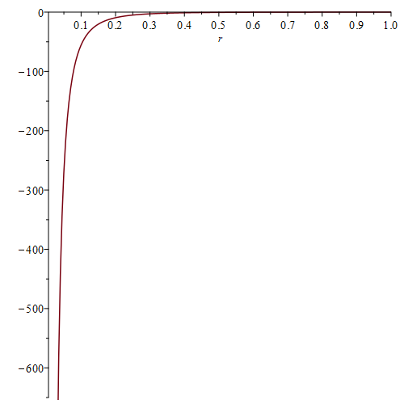
Figure 1. Radial dependence of the model magnetic force $F_{mag}(r)=H(r)/4πr^{2}$ at $t=0$ for $r∈[0.01,1]$ (dimensionless units), as plotted in version 1 (parameter $R=49$ as stated there). A re-evaluation of the worksheet with $R=35.67$, $c=30$ gives the same qualitative shape.

4.2 The flux-quantum construction [N]
The author estimates an internal field of a spinning charge by distributing a magnetic flux quantum of the electron over a sphere of radius $r_{e}=2.818×{10}^{-15}$ m. Version 1 names the input “the electron’s magnetic monopole moment $h/2ec=3.291×{10}^{-16}$ Wb”. Three corrections apply. (a) The expression $h/2ec$ equals $6.9×{10}^{-24}$ in SI units (no weber). (b) The numerical value $3.291×{10}^{-16}$ Wb equals the reduced flux quantum $ℏ/2e=1.05457×{10}^{-34}/(2×1.602177×{10}^{-19})$ [M]. The superconducting flux quantum is $Φ_{0}=h/2e=2.068×{10}^{-15}$ Wb [E]; the quantity is a flux quantum, not a monopole moment, and magnetic monopoles are not established [E]. (c) Dividing by the sphere surface gives, [M],
$$B_{e}=\frac{ℏ/2e}{4πr_{e}^{2}}=\frac{3.291×{10}^{-16}}{4π (2.818×{10}^{-15})^{2}}=\frac{3.291×{10}^{-16}}{9.98×{10}^{-29}}=3.30×{10}^{12} T, (12)$$
a factor $2$ below the $6.596×{10}^{12}$ T printed in version 1 and used in the worksheet. For orientation, the QED critical field is $B_{S}=m_{e}^{2}c^{2}/(eℏ)=4.41×{10}^{9}$ T [E], so (12) is $≈7.5×{10}^{2} B_{S}$. The sphere construction is a postulate [P]: a spinning charge has a dipolar field with zero net flux through any closed surface, so spreading a flux quantum over a sphere has no field-theoretic meaning. Applied to the proton with $r_{p}=1.2$ fm the same construction would give $3.291×{10}^{-16}/(4π (1.2×{10}^{-15})^{2})=1.82×{10}^{13}$ T [M]; the worksheet instead reuses the electron value for the proton. The internal field $B_{2}=3.81×{10}^{14}$ T quoted in version 1 (attributed to [2], not verified here) is a third, unrelated value, distinct from $B_{e}$; no result of this paper depends on it.

4.3 The spin angular velocity [P, N]
Treating the proton as a uniform sphere with moment of inertia $J_{s}=2/5mr^{2}$ and rotational energy $E=1/2J_{s}ω^{2}$, the model takes $E=\frac{B e h_{m}}{m}, (13)$
with $B=B_{e}$, the internal field of Section 4.2 (value as printed in the worksheet, $6.596×{10}^{12}$ T, or the corrected $3.30×{10}^{12}$ T), where $h_{m}$ is a “magnetic minimum-action constant” larger than the Planck constant, and postulates [P] that the particle spins at the rate that satisfies it. The dimension of (13) is that of energy [M] (T C J s kg$​^{-1}$ = J). The value of $h_{m}$ is documented inconsistently: version 1 gives $h_{m}≈(2.27\text{–}2.37)×{10}^{-8}$ eV s $×{10}^{6}$, i.e. $0.0227$ eV s $=3.64×{10}^{-21}$ J s $=5.5×{10}^{12} h$ [M]; the worksheet uses $h_{m}=4.79×{10}^{6} h=3.18×{10}^{-27}$ J s $=1.98×{10}^{-8}$ eV s, without the factor ${10}^{6}$. In all cases $h_{m}$ is a free parameter of the model [P], and the worksheet value is used below.
The angular velocity of version 1 is $ω=2π\sqrt{\frac{5 B e h_{m}}{m r^{2}}}. (14)$
This is not dimensionally consistent: $Beh_{m}$ has dimension kg$​^{2}$ m$​^{2}$ s$​^{-2}$, so the quantity under the root has dimension kg s$​^{-2}$, not s$​^{-2}$ [M]. With $B=6.596×{10}^{12}$ T, $h_{m}=3.18×{10}^{-27}$ J s and $r=r_{p}=1.2×{10}^{-15}$ m, (14) evaluated as printed gives
$$ω_{p}=2π\sqrt{\frac{1.679×{10}^{-32}}{1.67262×{10}^{-27}×(1.2×{10}^{-15})^{2}}}=2π×2.64×{10}^{12}=1.66×{10}^{13} rad/s$$
[M], an equatorial speed $ω_{p}r_{p}=2.0×{10}^{-2}$ m/s. Version 1 gave $1.47×{10}^{14}$ rot/s, which is not obtained from these inputs (Appendix A).
Reading (13) as the rotational energy, $E=1/5mr^{2}ω^{2}$ gives, [M, conditional on this reading], the dimensionally consistent form
$$ω=\sqrt{\frac{5E}{mr^{2}}}=\frac{1}{m r}\sqrt{5 B e h_{m}}, (15)$$
in which the factor $2π$ also disappears. With the printed $B=6.596×{10}^{12}$ T,
$$5Beh_{m}=5×(6.596×{10}^{12})(1.602177×{10}^{-19})(3.177×{10}^{-27})=1.679×{10}^{-32}, ω=\frac{\sqrt{1.679×{10}^{-32}}}{1.67262×{10}^{-27}×1.2×{10}^{-15}}=6.5×{10}^{25} rad/s,$$
and with the corrected $B=3.30×{10}^{12}$ T of (12),
$$5Beh_{m}=8.40×{10}^{-33}, ω=\frac{\sqrt{8.40×{10}^{-33}}}{1.67262×{10}^{-27}×1.2×{10}^{-15}}=4.6×{10}^{25} rad/s.$$
The equatorial speeds are $ωr_{p}=7.7×{10}^{10}$ m/s $≈2.6×{10}^{2} c$ and $5.5×{10}^{10}$ m/s $≈1.8×{10}^{2} c$, respectively, and the rotational energies $E=Beh_{m}/m_{p}$ are $2.0×{10}^{-6}$ J $≈1.3×{10}^{4} m_{p}c^{2}$ and $1.0×{10}^{-6}$ J $≈6.7×{10}^{3} m_{p}c^{2}$ ($m_{p}c^{2}=1.503×{10}^{-10}$ J) [M]. With these inputs the postulate [P] cannot be realised by a rigid classical rotor of radius $r_{p}$; the model requires a different physical interpretation of $ω$.

4.4 The “contact-range” value of “122 N” [N]
Version 1 differentiates a “gravitational-type” function $g(r)=2×{10}^{-64}/r^{3}$ along the trajectory swept by the spinning proton and reports $dg/dt∼122$ N at $r=25/R=7×{10}^{-22}$ m, which the author describes as the edge-to-edge contact separation of two nucleons [P]. The following can be established.
- Dimensions. The coefficient $2×{10}^{-64}≈Gm_{p}^{2}$ has units N m$​^{2}$. If $g=2×{10}^{-64}/r^{3}$, $g$ has units N m$​^{-1}$ and $dg/dt=g^{'}\dot{r}$ has units N m$​^{-1}$ s$​^{-1}$; neither is a force [M].
- Arithmetic. The worksheet computes $F_{21}=2πω_{p}r_{p}⋅2×{10}^{-64}(R/4.2)^{3}=15.3$ ($R=3.567×{10}^{22}$, $2πω_{p}r_{p}=0.125$); the value “$∼122$ N” is the author’s annotation and equals $2×{10}^{-64}(R/4.2)^{3}=122.5$ [M], i.e. $1/r^{3}$ evaluated at $r=4.2/R=1.18×{10}^{-22}$ m, not at $25/R=7.0×{10}^{-22}$ m (where the same expression gives $0.58$). With $R=4.2355×{10}^{22}$ the same expression gives 205 .
- Boundary condition. Version 1 states that $25/R$ is the point where $g^{'}(25/R)=R$. The root of $-4×{10}^{-64}/r^{3}=-R$ is $r=2.24×{10}^{-29}$ m, not $25/R$; and $|-4×{10}^{-64}/(25/R)^{3}|=1.2$, not $R$ [M]. The origin of the value $25$ is not stated. Moreover $25/R=7.0×{10}^{-22}$ m holds for $R=3.567×{10}^{22}$; for $R=4.2355×{10}^{22}$ one gets $5.9×{10}^{-22}$ m.
- Length scale. The length $7×{10}^{-22}$ m is $≈8×{10}^{-7}$ of the proton radius $0.84$ fm ($7.0×{10}^{-22}/8.41×{10}^{-16}=8.3×{10}^{-7}$) [M]; two touching nucleons would be separated by about twice the proton radius. In the model this length is a postulated scale [P] set by $R$, which is a cosmological parameter of the author and not a nuclear length.
- The “${10}^{-18}$ N” values. Version 1 quotes a Lorentz force $∼{10}^{-18}$ N between protons and a residual magnetic attraction $∼{10}^{-18}$ N at $4.2$ fm. The nearest worksheet number is $2×{10}^{-64}/r_{p}^{3}=1.16×{10}^{-19}$ (units N m$​^{-1}$); the printed figures are not reproduced.
Summary [M]. The expressions above are listed with their units and inputs. A force in newtons for the magnetron-mediated interaction is not obtained from any calculation in this paper.

5. A Conjectural Shell-Filling Picture
The empirical nuclear magic numbers are $2,8,20,28,50,82,126$ [E], and are standardly explained by the shell model with a spin–orbit term [6, 7]. The following picture is a hypothesis [H] and is not derived from Section 4. Nucleons are grouped into proton–neutron pairs; two pairs form an “alpha module” ($2p+2n$) held together by the spin-magnetic interaction (Figure 2); further pairs fill concentric, magnetically coupled shells, like the layers of an onion.
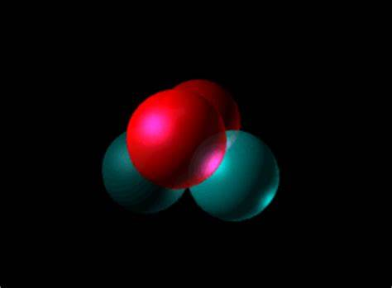
Figure 2. First shell in the author’s picture: an “alpha module” of two proton–neutron pairs bound by the spin-magnetic interaction. Schematic [H].
The author’s counting of pairs per shell gives:
Shell | Pairs added | Nucleons added | Cumulative nucleons | Standard magic number?
1 | 2 (one alpha module) | 4 | 4 | no (the standard values are 2, 8)
2 | 4 | 8 | 12 | no
3 | 8 | 16 | 28 | yes
4 | 11 | 22 | 50 | yes
5 | 16 | 32 | 82 | yes
6 | 22 | 44 | 126 | yes
Table 3. Shell filling in the alpha-module picture. Cumulative values are $4,12,28,50,82,126$ [M].
In this picture the third shell consists of eight proton–neutron pairs coupled around a common ring (Figure 3) [H].
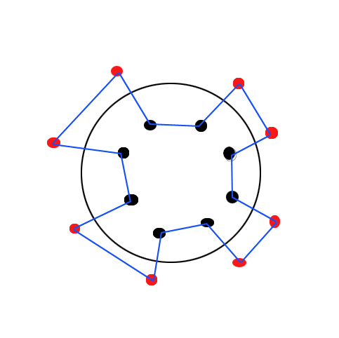
Figure 3. Schematic arrangement of the third shell: eight proton–neutron pairs coupled around a common ring. Schematic [H].
Two observations follow from Table 3 [M]. First, the sequence does not contain $2,8,20$; it coincides with the standard list for $28,50,82,126$ only (version 1 stated that it reproduces the standard magic numbers; Appendix A). Second, the increments $16,22,32,44$ equal the differences $28-12$, $50-28$, $82-50$, $126-82$; the agreement from $28$ upward is therefore built into the choice of the shell sizes, with the initial values $4$ and $12$ free. The pair counts $2,4,8,11,16,22$ are postulated [P]; no calculation in this paper determines them.
Beyond $126$ version 1 lists “near-magic numbers $184,236,…$”. The value $184$ is [H] (predicted by extrapolations of the standard shell model; not confirmed experimentally). The value $236$ is not among the values commonly quoted from such extrapolations and is labelled [H]. Version 1 also speaks of “a sixth and seventh shell beyond 126” after closing the sixth shell at 126; the shells beyond $126$ would be the seventh and later ones. Repulsion between shells is assumed [P]; no calculation in this paper yields it.
The orientation dependence of the interaction between pairs is compared with the tensor force of the deuteron [E, 6]: it is attractive in the collinear (“cigar-shaped”) configuration and repulsive in the side-by-side (“disk-shaped”) configuration, in analogy with two bar magnets. The analogy to a chain $P-N-P-N$ is a hypothesis [H]; the separation at which it would apply is not fixed by any calculation in this paper (Section 4.4).
Figures 4 and 5 reproduce standard shell-model material [6, 7] for comparison: the shells of Table 3 have not been related to the one-particle levels shown.
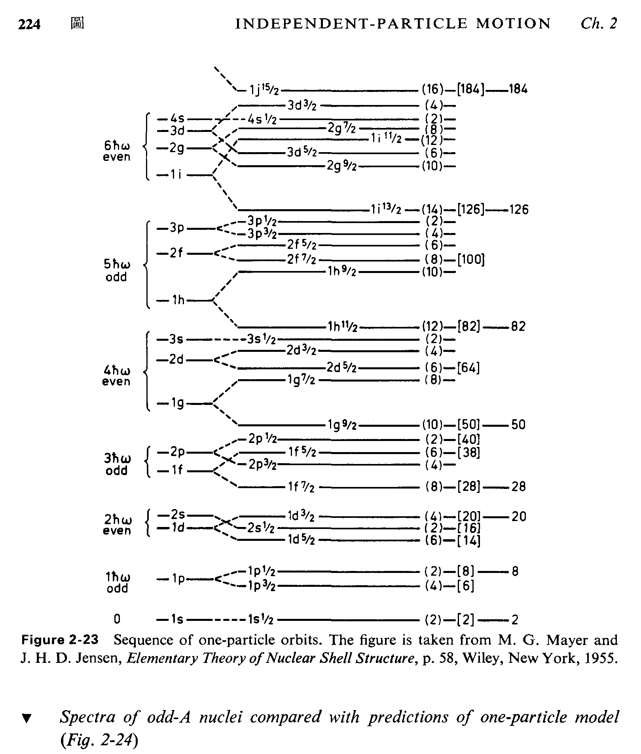
Figure 4. After M. G. Mayer and J. H. D. Jensen [7], p. 58, as reproduced in A. de-Shalit and H. Feshbach [6], Fig. 2-23.
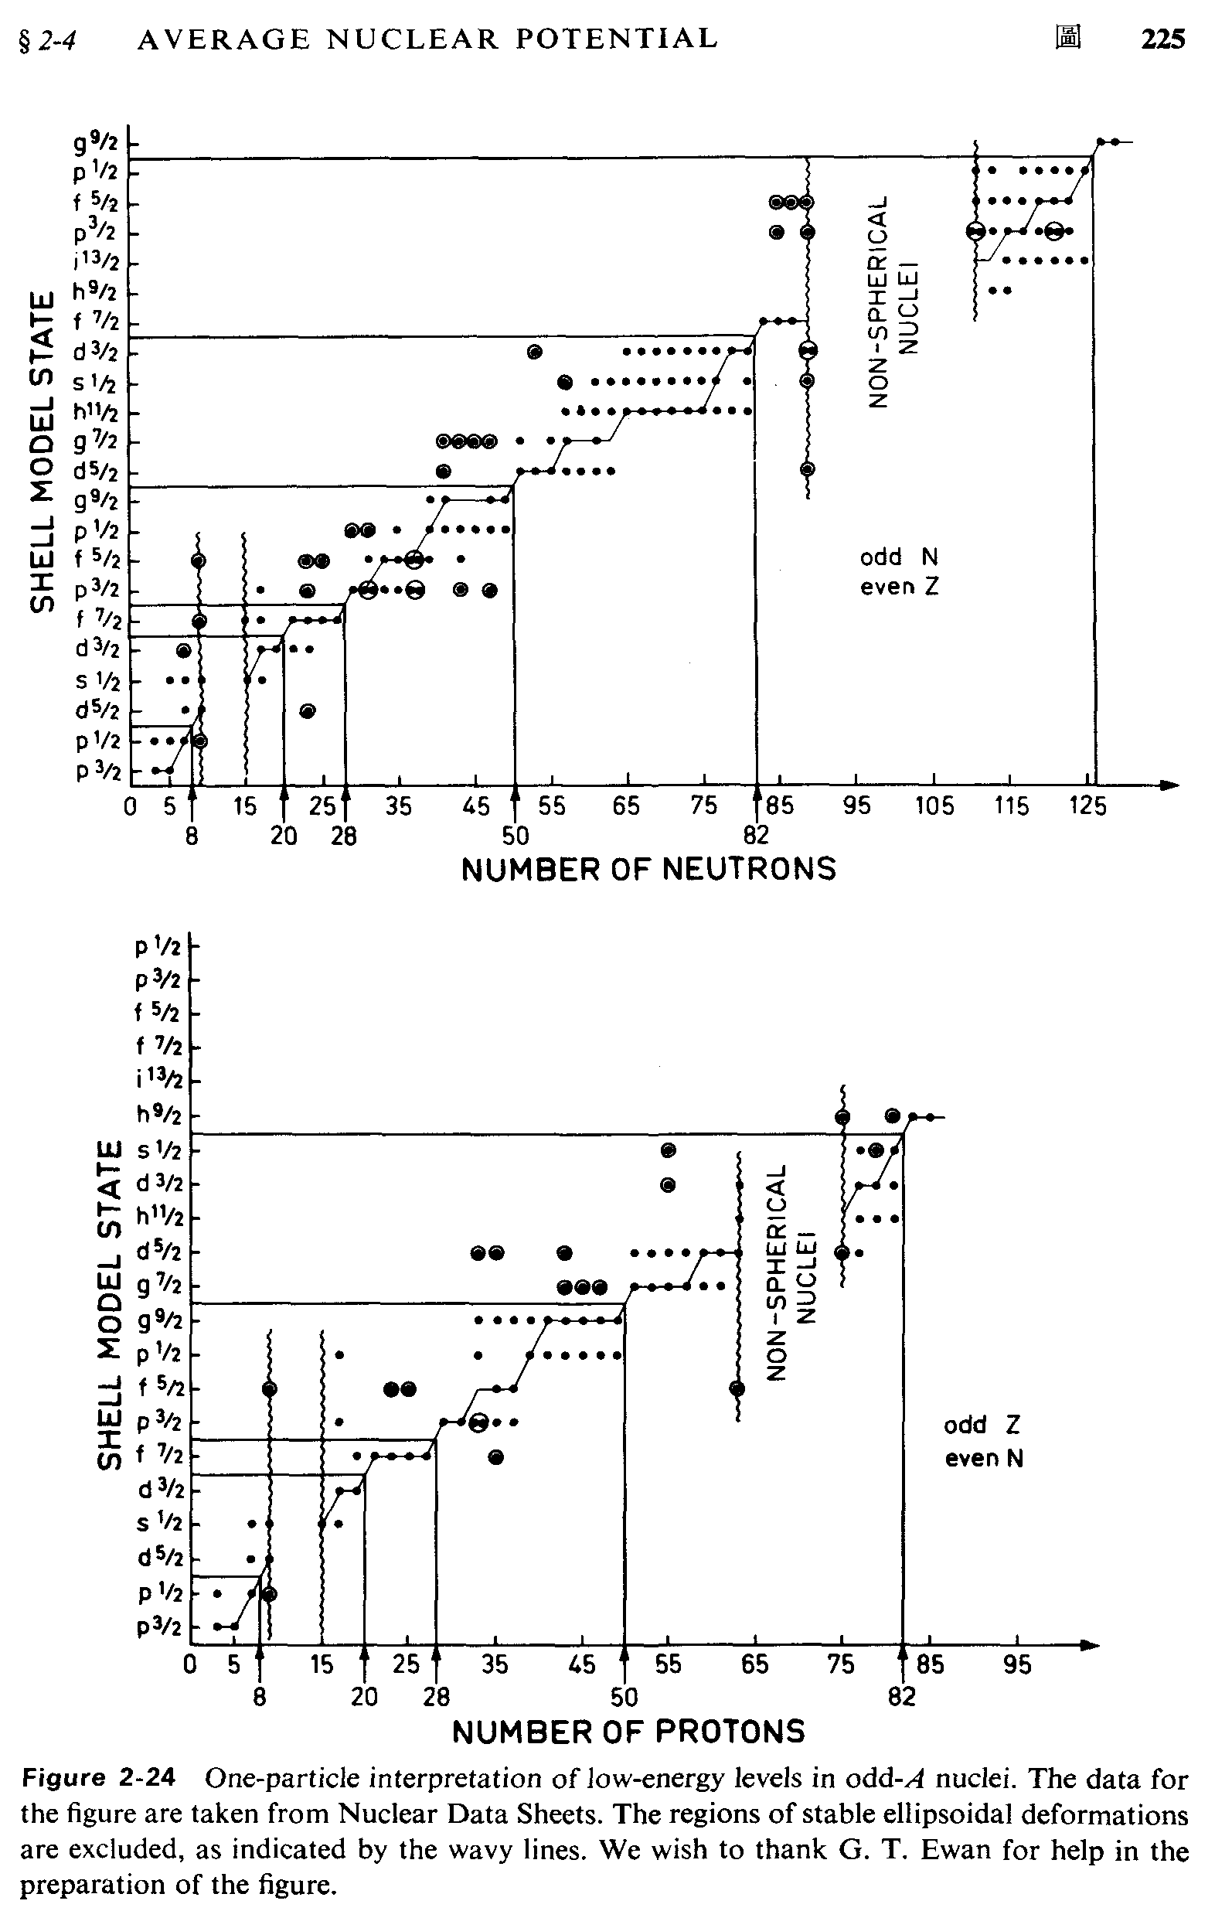
Figure 5. From A. de-Shalit and H. Feshbach [6], Fig. 2-24, after Nuclear Data Sheets.

6. A Relativistic Bound on the Nuclear Charge
This section is independent of the rest of the model. It concerns a point nucleus of charge $Ze$ with one electron in the first Bohr orbit [8], under the Bohr quantization condition (angular momentum $mvr=nℏ$, $n=1$) and the Coulomb force law. It is the first-order version of a standard result [E].
Non-relativistic case [M]. Newton’s second law with the Coulomb force gives $mv^{2}/r=kZe^{2}/r^{2}$, i.e. $v^{2}=kZe^{2}/(mr)$, and Bohr quantization gives $r=ℏ/(mv)$. Eliminating $r$,
$$v=\frac{kZe^{2}}{ℏ}=Zαc, α=\frac{ke^{2}}{ℏc}=\frac{1}{137.036}. (16)$$
The condition $v<c$ gives $Z<1/α=137.036$, where $ℏc/(ke^{2})=3.16152×{10}^{-26}/2.30708×{10}^{-28}=137.04$ [M].
With relativistic mass increase [M]. For uniform circular motion the Coulomb force equals $γmv^{2}/r$, and the quantization condition becomes $γmvr=ℏ$, with $γ=(1-v^{2}/c^{2})^{-1/2}$. Then $γmv^{2}r=kZe^{2}$ and $γmvr=ℏ$ give again $v=\frac{kZe^{2}}{ℏ}, (17)$
independent of $γ$. The condition $v<c$ again yields $Zα<1$.
Relation to version 1. Version 1 used the de Broglie condition $2πr=h/(m_{0}vγ)$ but wrote $r=h/(vγm_{0})$, dropping the factor $2π$, and obtained $Z_{max}=hc/(ke^{2})$ with the value $1/α≈137.036$. With $h$ the quantity is $hc/(ke^{2})=1.98645×{10}^{-25}/2.30708×{10}^{-28}=861.0=2π×137.04$ [M]; the value $137.036$ is obtained with $ℏ$, so $Z_{max}=ℏc/(ke^{2})=1/α$ (Appendix A).
Scope of the result [M, E]. The bound $Zα<1$ is the limit of the Bohr model and of the Dirac equation for a point-like nucleus (the Dirac $1s$ energy $mc^{2}\sqrt{1-(Zα)^{2}}$ ceases to be real at $Z=1/α$) [9]. For a nucleus of finite size the $1s$ level does not become complex at $Z=137$; it reaches the negative-energy continuum at a critical charge $Z_{cr}≈170$–$173$ [10]. The statement “the number of chemical elements is bounded by $Z<137$” therefore holds only within the point-nucleus Bohr model and is not a hard upper limit on the existence of elements; other limits (nuclear stability, fission) are not addressed here.

7. Discussion and Limitations

7.1 Discussion
For comparison with the model’s postulated coupling, the classical magnetic dipole–dipole energy of two protons with magnetic moment $μ_{p}=2.793 μ_{N}$ [E], $μ_{N}=eℏ/2m_{p}=5.0507×{10}^{-27}$ J/T, at $r=2.4$ fm, is $(μ_{0}/4π)μ_{p}^{2}/r^{3}={10}^{-7}×(1.4107×{10}^{-26})^{2}/(2.4×{10}^{-15})^{3}=1.44×{10}^{-15}$ J $=9.0$ keV, and at most twice that ($≈18$ keV) for a collinear aligned configuration [M]. This is about $1.5\%$ of the Coulomb energy at the same distance ($0.600$ MeV, Table 1). The model postulates [P] a coupling much stronger than the ordinary dipole–dipole interaction of the measured moments, mediated by the magnetron; no calculation of that coupling is given.

7.2 Limitations
- No field theory. The magnetron Lagrangian density is unknown; the variational formalism is invoked formally (Section 2). The model has no quantized fields, no gauge structure and no calculable amplitude.
- No quantitative force obtained. The numerical estimates of the spin-magnetic force in version 1 are dimensionally inconsistent or rest on an undefined scale (Section 4, Appendix A); the open issues are the units, the undetermined constant $h_{m}$ and the scale $R$.
- Postulated parameters. The scales $R$, $h_{m}$, $B_{1}$, $B_{2}$ and $r_{p}=1.2$ fm are postulated [P, N]; the interaction time ${10}^{-6}$ s and the period $6×{10}^{-11}$ s are assumptions of the author [P, H] without independent derivation.
- Reaction channel. The conversion process (1)–(2) is not closed under standard conservation laws as written (Section 1.2, Appendix B).
- Shell picture. The agreement with the magic numbers from $28$ upward is built in by construction; the picture does not reproduce $2,8,20$ nor the spin–orbit splitting that accounts for the observed numbers [E].

8. Conclusions
- The Newtonian, Coulomb and Lorentz reference forces for $​_{2}^{4}He$ have been computed [M]: Coulomb $13.1$ N at $4.2$ fm and $40.1$ N at $2.4$ fm; gravitation $1.06×{10}^{-35}$ N at $4.2$ fm (a ratio of $1.24×{10}^{36}$ to the Coulomb force); Lorentz force $1.9×{10}^{-13}$ N at 500 eV and $B_{1}=3.81$ T. Gravitation and the Lorentz force are small compared with the Coulomb repulsion.
- The magnetron, the $τ$-neutrino conversion channel and the spin-magnetic attraction are hypotheses [H, P]. The conversion reactions are not closed under conservation laws as written. The model is not QED, the title’s reference to a “Lagrangian” refers to the formal use of the least-action structure, and “field-theoretic” in the title denotes an aim, not a result.
- The balance between Coulomb repulsion and magnetic attraction is the author’s conjecture [H]; no calculation in this paper supports or excludes it quantitatively.
- The alpha-module shell sequence $4,12,28,50,82,126$ matches the standard magic numbers only from $28$ upward and by construction [M, H].
- For a point nucleus in the Bohr model, $v=Zαc$ and $Z<1/α=137.036$ [M, E]; for finite nuclei the standard critical charge is $Z_{cr}≈170$–$173$ [E].
- Further work on the model would require: a consistent definition of units and of the scale $R$; a Lagrangian density (or a clear statement that none is sought); a conserved set of reactions for the conversion channel; and a comparison with the dipole–dipole benchmark (Section 7.1).

Appendix A. Corrections relative to version 1 (January 2025)
Values were recomputed with the constants of Section 1.1. “Version 1” refers to the January 2025 text; “Disposition” states what the present version does.
Item | Version 1 | Recomputed | Disposition
Coulomb, $4.2$ fm | $∼13$ N | $13.1$ N | Confirmed
Coulomb, $2.4$ fm | $∼40$ N | $40.1$ N | Confirmed
Gravitation $p$–$p$, $4.2$ fm | $2.3×{10}^{-35}$ N | $1.06×{10}^{-35}$ N | Corrected (version 1 used the numerator $4.09×{10}^{-64}$)
Eq. (3) numerator | $1.85$–$4.09×{10}^{-64}$ | $Gm_{p}^{2}=1.867×{10}^{-64}$ N m$​^{2}$ | Upper limit removed
“Sum over four nucleons” | $2.28×{10}^{-34}$ N | not a defined net force (six-pair scalar sum $6.4×{10}^{-35}$ N) | Removed
$p$–$e$ attraction at $a_{0}$ | $8.1×{10}^{-8}$ N | $8.24×{10}^{-8}$ N; $1.65×{10}^{-7}$ N per electron for $Z=2$ | Corrected
$500$ eV in joules | $1.024×{10}^{-13}$ J | $8.01×{10}^{-17}$ J ($1.024×{10}^{-13}$ J $=639$ keV) | Corrected
Proton speed | $1.1×{10}^{7}$ m/s | $3.1×{10}^{5}$ m/s at 500 eV | Corrected
$F_{L}=evB$, $B=3.81$ T | $∼2×{10}^{-13}$ N with $v=1.1×{10}^{7}$ | $1.9×{10}^{-13}$ N at $3.1×{10}^{5}$ m/s; $6.8×{10}^{-12}$ N at $1.1×{10}^{7}$ m/s | Force and speed of version 1 refer to different energies; both given
$$B_{1}$$ | $3.81$ T | worksheet uses $3.91$ T | Origin of both values undocumented [N]
$$B_{2}$$ | $3.81×{10}^{14}$ T (Section 3) | not verified; distinct from $B_{e}$ (Section 4.2) | Not relied upon
$$E_{s}=qωr^{2}$$ | energy | dimension of a magnetic moment | Marked inconsistent; $ν=8.68×{10}^{14}$ Hz for $3.59$ eV
“Magnetic monopole moment $h/2ec$” | $3.291×{10}^{-16}$ Wb | number equals $ℏ/2e$; $Φ_{0}=h/2e=2.068×{10}^{-15}$ Wb; $h/2ec=6.9×{10}^{-24}$ (no weber) | Terminology corrected: flux quantum, not monopole moment
$B_{e}$ from the flux construction | $6.596×{10}^{12}$ T | $3.30×{10}^{12}$ T | Corrected (factor 2); both values used in Section 4.3
$$h_{m}$$ | $0.0227$ eV s ($=5.5×{10}^{12} h$) in text; $4.79×{10}^{6} h$ in worksheet | inconsistent | Free parameter [P]
Eq. (24) (here (14)) | $$ω=2π\sqrt{5Beh_{m}/(mr^{2})}$$ | dimensionally inconsistent; form (15) gives $6.5×{10}^{25}$ rad/s ($B=6.596×{10}^{12}$ T) or $4.6×{10}^{25}$ rad/s ($B=3.30×{10}^{12}$ T); $ωr_{p}≈2.6×{10}^{2}c$ or $1.8×{10}^{2}c$ | Corrected [M, conditional on the reading of (13)]
$$ω_{p}$$ | $1.47×{10}^{14}$ rot/s | printed formula with worksheet inputs: $1.66×{10}^{13}$ rad/s (Section 4.3) | Not reproduced
Eq. (25): “122 N” | $122$ N | worksheet $F_{21}=15.3$; “122 N” is $2×{10}^{-64}(R/4.2)^{3}=122.5$, i.e. $1/r^{3}$ at $r=4.2/R=1.18×{10}^{-22}$ m, not at $25/R=7.0×{10}^{-22}$ m (value $0.58$); $205 with$ $R=4.2355×{10}^{22}$; units not N | Not a force in newtons (Section 4.4)
$r=25/R$, “$g^{'}(25/R)=R$” | $7×{10}^{-22}$ m, “edge-to-edge contact” | root of $g^{'}=-R$ is $2.24×{10}^{-29}$ m; $25/R=5.9×{10}^{-22}$ m for $R=4.2355×{10}^{22}$; length $≈8×{10}^{-7}$ of the proton radius | Not used as a contact distance
“$∼{10}^{-18}$ N” Lorentz / residual magnetic force | $∼{10}^{-18}$ N | nearest value $1.16×{10}^{-19}$ N/m ($2×{10}^{-64}/r_{p}^{3}$) | Not reproduced
Fig. 1 parameters | $R=49$ (original plot) | re-evaluation of the worksheet with $R=35.67$, $c=30$, $A=1$ gives the same qualitative shape; dimensionless units | Figure kept as in version 1; caption states $R=49$ as in version 1 and the re-evaluation separately; curve not a force in newtons
Symbol $R$ | $49$, $35.67$ (plot); $3.567×{10}^{22}$ and $4.2355×{10}^{22}$ (forces) | notation collision | Noted in Section 4.1
Symbol $c$ | speed of light and wave parameter $c=30$ | notation collision | Noted in Section 4.1
Shell sequence | “reproducing the standard magic numbers” | $4,12,28,50,82,126$; matches from $28$ upward only, by construction | Statement corrected
“$184,236,…$ near-magic” |  | $184$ [H]; $236$ not among commonly quoted values | Labelled [H]
“Sixth and seventh shell beyond 126” |  | inconsistent with the sixth shell closing at $126$ | Corrected
Reaction (2) label “$β^{+}$ decay” |  | $n→p$ is $β^{-}$ | Terminology corrected
Reactions (1), (2) |  | not closed under conservation laws as written (Appendix B) | Stated as hypothesis [H]
Derivation of Eq. (6) | $$F=-V^{'}(x)/m$$ | $$F=-V^{'}(x)$$ | Corrected
Passage attributed to Feynman | presented in quotation marks | paraphrase with additions, including the sentence that the force “reduces to the familiar Lorentz form” | Replaced by an attributed summary (Section 2)
$$Z_{max}=hc/(ke^{2})=137.036$$ |  | $hc/(ke^{2})=861.0$; $ℏc/(ke^{2})=137.036$ | Corrected ($ℏ$, factor $2π$)
$Z<137$ as limit on elements |  | limit of the point-nucleus Bohr/Dirac model; finite nucleus $Z_{cr}≈170$–$173$ | Qualified [M, E]
Electrostatic “pulsation” $6×{10}^{-11}$ s; interaction time ${10}^{-6}$ s |  | no derivation | Labelled [P, H]
Conclusion: Lorentz-type attraction comparable to Coulomb at ${10}^{-15}$ m |  | Lorentz force $∼{10}^{-13}$ N against Coulomb $13$–$40$ N (Section 3) | Not retained
Closing formula “Quod erat demonstrandum” |  |  | Removed
Reference “Bohr model”, Wikipedia |  | secondary source | Replaced by [8]
Tensor-force illustration (version 1 Fig. 4) | image of unidentified source |  | Image removed; description kept in Section 5 with reference [6]; later figures renumbered

Appendix B. Line-by-line check of the conversion reactions
Reaction (1), first step. $p+\check{τ}→n+\hat{ν}+π^{+}+\hat{μ}$. Charge: $+1+0→0+0+1+0=+1$ (conserved). Baryon number: $1→1$ (conserved). Lepton flavour: the initial state has $L_{τ}=+1$; the final state contains two neutrino-type quanta whose flavours are not specified; conservation of each lepton flavour cannot be verified without assigning them (if $\hat{ν}$ is taken as $ν_{τ}$, then $\hat{μ}$ would create $L_{μ}≠0$ from nothing).
Reaction (1), final equalities. $p+(e+π^{+})=p+μ+ΔE$. With $e$ read as $e^{-}$, the quantity $e^{-}+π^{+}$ has charge $0$, while a muon has charge $±1$; moreover $e$ carries $L_{e}=+1$ and a muon $L_{μ}=±1$ with $L_{e}=0$. The step does not conserve charge or lepton flavour as written.
Reaction (2). $n+\check{τ}→p+{\hat{π}}^{-}+\hat{μ}+\hat{ν}$: charge $0→+1-1=0$ (conserved); flavours unspecified as above. The label “$β^{+}$ decay” is incorrect ($n→p$ is $β^{-}$). The symbol ${\check{e}}_{opto}$ in the intermediate expression is undefined.
These checks are limited to the information given in the paper; completing the reactions with explicit particle species is outside its scope.

Acknowledgement
AI tools were used to recompute numerical values and to edit the text; the author reviewed all content and is responsible for it.

References
- Feynman, R. P., Leighton, R. B., Sands, M. The Feynman Lectures on Physics, Vol. II, Ch. 19: “The Principle of Least Action.” Addison-Wesley, 1964.
- Internal magnetic-field estimates for nucleons, ScienceDirect: https://www.sciencedirect.com/science/article/pii/S2211379718316176 (cited in version 1 for $B_{2}$; content not verified).
- Vio, M. Flux.pdf (supplementary document on the internucleon magnetic field). https://michaelvio.github.io/
- Vio, M. spin.pdf (supplementary document on the spin-magnetic force). https://michaelvio.github.io/Spin.pdf
- Vio, M. lagrangian.pdf. https://michaelvio.github.io/lagrangian.pdf
- de-Shalit, A., Feshbach, H. Theoretical Nuclear Physics, Vol. I: Nuclear Structure. Wiley, New York, 1974.
- Mayer, M. G., Jensen, J. H. D. Elementary Theory of Nuclear Shell Structure. Wiley, New York, 1955.
- Bohr, N. (1913). On the constitution of atoms and molecules. Philosophical Magazine, 26, 1–25.
- Dirac, P. A. M. (1928). The quantum theory of the electron. Proceedings of the Royal Society A, 117(778), 610–624.
- Greiner, W., Müller, B., Rafelski, J. (1985). Quantum Electrodynamics of Strong Fields. Springer, Berlin.
- Mohr, P. J., Newell, D. B., Taylor, B. N., & Tiesinga, E. (2025). CODATA recommended values of the fundamental physical constants: 2022. Reviews of Modern Physics, 97, 025002.
- Vio, M. (2025). lagrangian.mw (Maple worksheet). Unpublished.

