Mapping SAS Formats to R, Part 2

A Comprehensive Guide for the SAS Programmer

Michael Walshe

# Picking Up From Last Time

Last time, we introduced the SAS format and looked at methods for replicating two aspects of it’s functionality in R, specifically performing a lookup and grouping data. Today, we’ll investigate how to:

* Apply a ‘mask’ to data. This means that you can change the way that data is displayed, without changing the underlying data (e.g. a value of -0.6534 could print as (65.3%))
* Read formatted data as a different type, for example to read a value of "£1,000.00" in a CSV as 1000.

# Masks

Using a format as a “mask” for data is the most common use-case in SAS, keeping the underlying data the same but applying formatting when it is displayed. There are a number of methods we can use to replicate this in R.

## Method 1: Base R

Using Base R, there are several different functions that can format data.

The first we’ll use is the format() function, which can format any R object for printing, but is typically used for numeric vectors and has a large set of options:

numbers <- runif(10, -1000000, 1000000)  
  
format(numbers, justify="right", width="10", big.mark=",") |> print()

#> [1] "-424,844.96" " 576,610.27" "-182,046.16" " 766,034.81" " 880,934.57"  
#> [6] "-908,887.00" " 56,210.98" " 784,838.09" " 102,870.03" " -86,770.53"

format(numbers, digits=3, scientific=TRUE) |> print()

#> [1] "-4.25e+05" " 5.77e+05" "-1.82e+05" " 7.66e+05" " 8.81e+05" "-9.09e+05"  
#> [7] " 5.62e+04" " 7.85e+05" " 1.03e+05" "-8.68e+04"

Alternatively, the sprintf function provides a familiar interface to those used to C style formatting, for more detail run ?sprintf.

sprintf("$%.2f", numbers)

#> [1] "$-424844.96" "$576610.27" "$-182046.16" "$766034.81" "$880934.57"   
#> [6] "$-908887.00" "$56210.98" "$784838.09" "$102870.03" "$-86770.53"

## Method 2: [{scales}](https://scales.r-lib.org/)

The {scales} package is used by {ggplot2} to scale data for graphs, but it also includes some useful formatting functions that can help with common formats. For example:

scales::label_dollar(prefix="£", style_negative="parens")(numbers)

#> [1] "(£424,845)" "£576,610" "(£182,046)" "£766,035" "£880,935"   
#> [6] "(£908,887)" "£56,211" "£784,838" "£102,870" "(£86,771)"

Note that all the scale::label_... functions return another function, and we’ve passed the numbers vector into this. There are label functions for currency, percents, dates, time, mathematics, SI units, p-values, and more! If a particular label is used frequently in your code, it may be helpful to assign it to a helper function

percent <- scales::label_percent(  
 accuracy=0.1,  
 suffix=" %",  
 decimal.mark=",",  
 style_negative="parens"  
)  
  
percent(runif(5, -1, 1))

#> [1] "91,4 %" "(9,3 %)" "35,5 %" "14,5 %" "(79,4 %)"

## Method 3: [{formatttable}](https://renkun-ken.github.io/formattable/)

All the examples covered so far have 1 key difference to SAS formats, they return the data converted to a new format, rather than the original data with a mask that applies when printing. For this, we can use {formattable}. This lets us apply formats to a vector or data.frame, and then continue to work with them as if they were standard R vectors. Only when it comes time to print does the format get applied.

For example:

values <- runif(5, -1, 1)  
  
percs <- formattable::percent(values)  
  
print(percs)

#> [1] 79.96% -50.78% -91.59% -34.42% 90.90%

print(percs ** 2)

#> [1] 63.94% 25.79% 83.88% 11.84% 82.63%

This is not limited to standard numeric formats, for which {formattable} includes methods for: digits, commas, percents, accounting, currency, and scientific notation. There are also advanced methods for styling the output table, for example conditional formatting similar to Excel:

my_data <- data.frame(  
 region_code = c("SA", "SA", "E", "AS", "AN", "NA"),  
 measure = runif(6)  
)  
  
formattable::formattable(  
 my_data,  
 list(measure=formattable::color_tile("white", "pink"))  
)

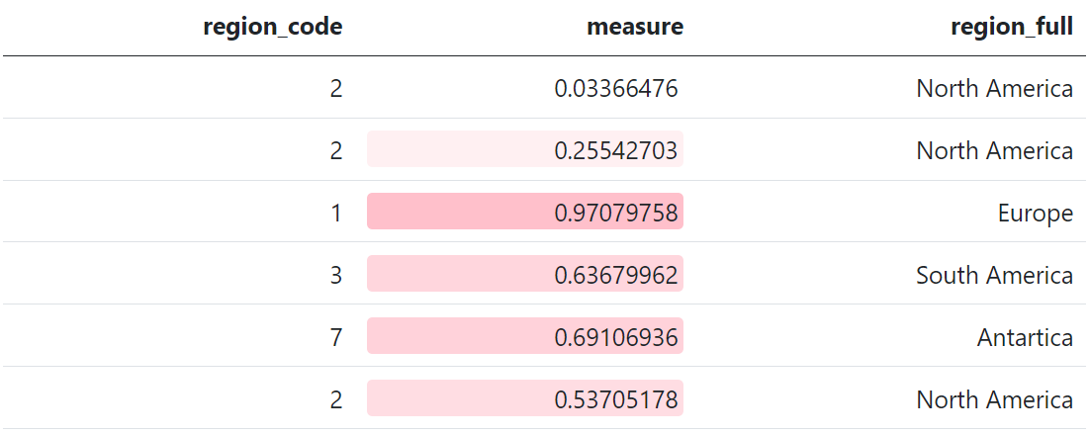

Note however that {formattable} formats will not be persisted unless the data is saved in an Rdata or RDS format.

# Reading in Data

The final use of a SAS (in)format that we’d like to replicate is reading in character data as numeric. The simplest way to do this is using parse_number from [{readr}](https://readr.tidyverse.org/), which provides a method to ignore non-numeric data in a column and attempt to parse it as a number:

readr::parse_number(c("£1,000.00"))

#> [1] 1000

And for date formats, {readr} also provides readr::parse_date or readr::parse_datetime. Each of these functions should generally not be used explicitly, instead use the col_types argument of readr::read_csv and similar to specify that a column is datetime, date, numeric, etc.

However, when it comes to more complex formats (e.g. “(82.5%)”) this will not take into account that it is a percentage and negative, and so more custom methods must be used:

values <- c("(82.5%)", "2%", "28.55%")  
  
my_format <- function(x){  
 x |>   
 stringr::str_replace_all(c("\\(" = "-", "\\)" = "")) |>   
 readr::parse_number() / 100  
}  
  
my_format(values)

#> [1] -0.8250 0.0200 0.2855

# Honourable Mentions

* An incredibly useful package for formatting tables for output is [{gt}](https://gt.rstudio.com/index.html). This also includes a large number of formatting functions; however these can only be used at the point of printing the data and you cannot extract the formatted data, therefore this was not featured here. But if you need to produce tables, this and [{gtsummary}](https://www.danieldsjoberg.com/gtsummary/) are great options
* An excellent package that provides a very large number of built-in formats is [{numform}](https://cran.r-project.org/web/packages/numform/index.html). This had the most included formats of all packages considered, however due to its relatively low usage (~1.2K downloads per month) the {scales} package was featured instead.
* The {formattable} package has unreleased functions for parsing different formats from text, for example parse_accounting. On release, these may be a good method to read in formatted data.