The Four Musketeers: Shine May Hung, Yan Wang, Manuel Duarte, Michael Weinberg

Group Project: First Iteration Deliverables

Screen shots that show user stories that were created:

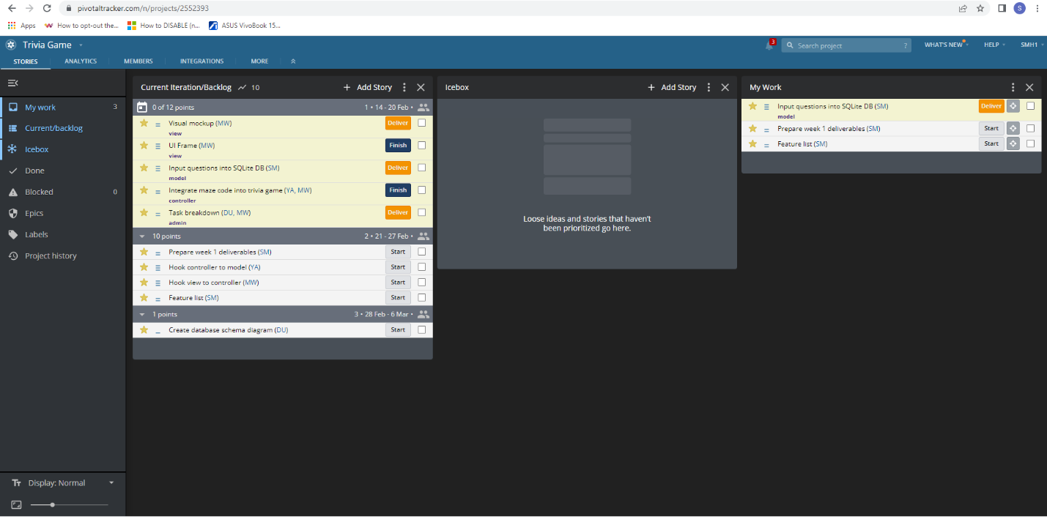

Screen shots of stories in first iteration:

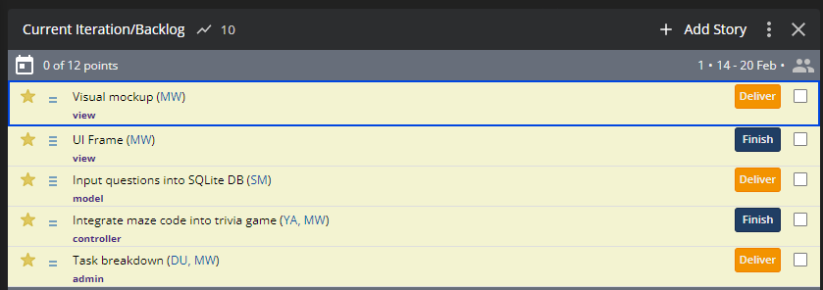

Screen shots of completed stories:

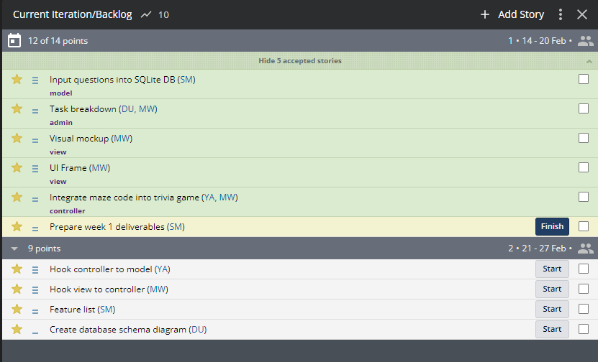

Screen shots from GitHub that show all files in repo and history of commits:

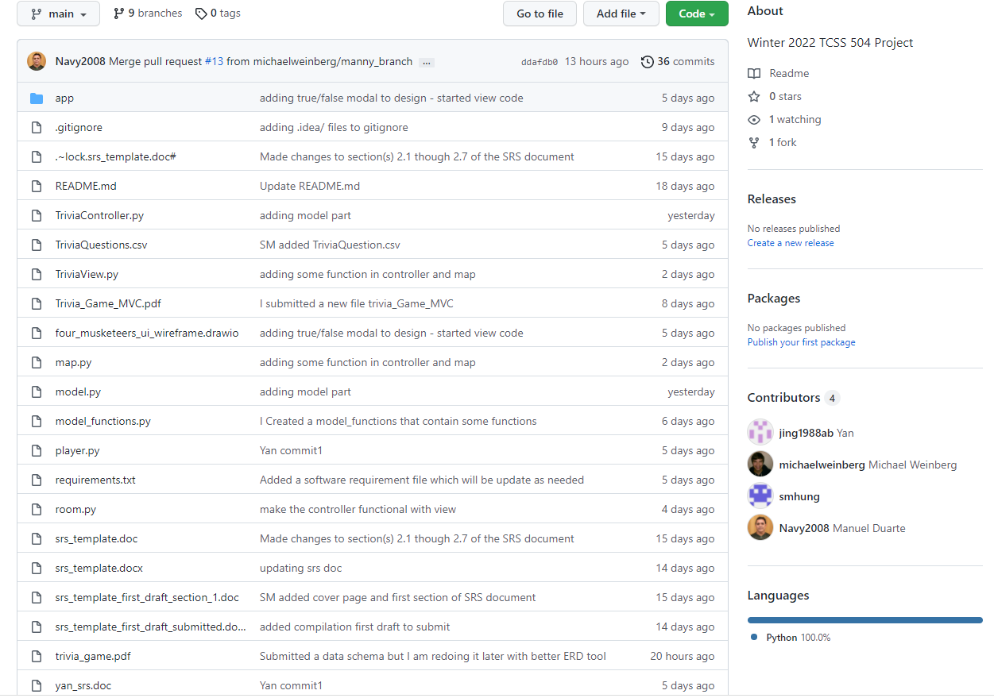

Report from Toggl showing hours for team with breakdown of the total hours for each team member and what that team member did:

