Kinematic Hand Synergies Differ Between Reach-and-Grasp and Functional Object Manipulation

A. Michael West Jr.1 and Neville Hogan2,3

1Department of Mechanical Engineering, Johns Hopkins University

2Department of Mechanical Engineering, Massachusetts Institute of Technology

3Department of Brain and Cognitive Sciences, Massachusetts Institute of Technology

**SUPPLEMENTARY MATERIAL**

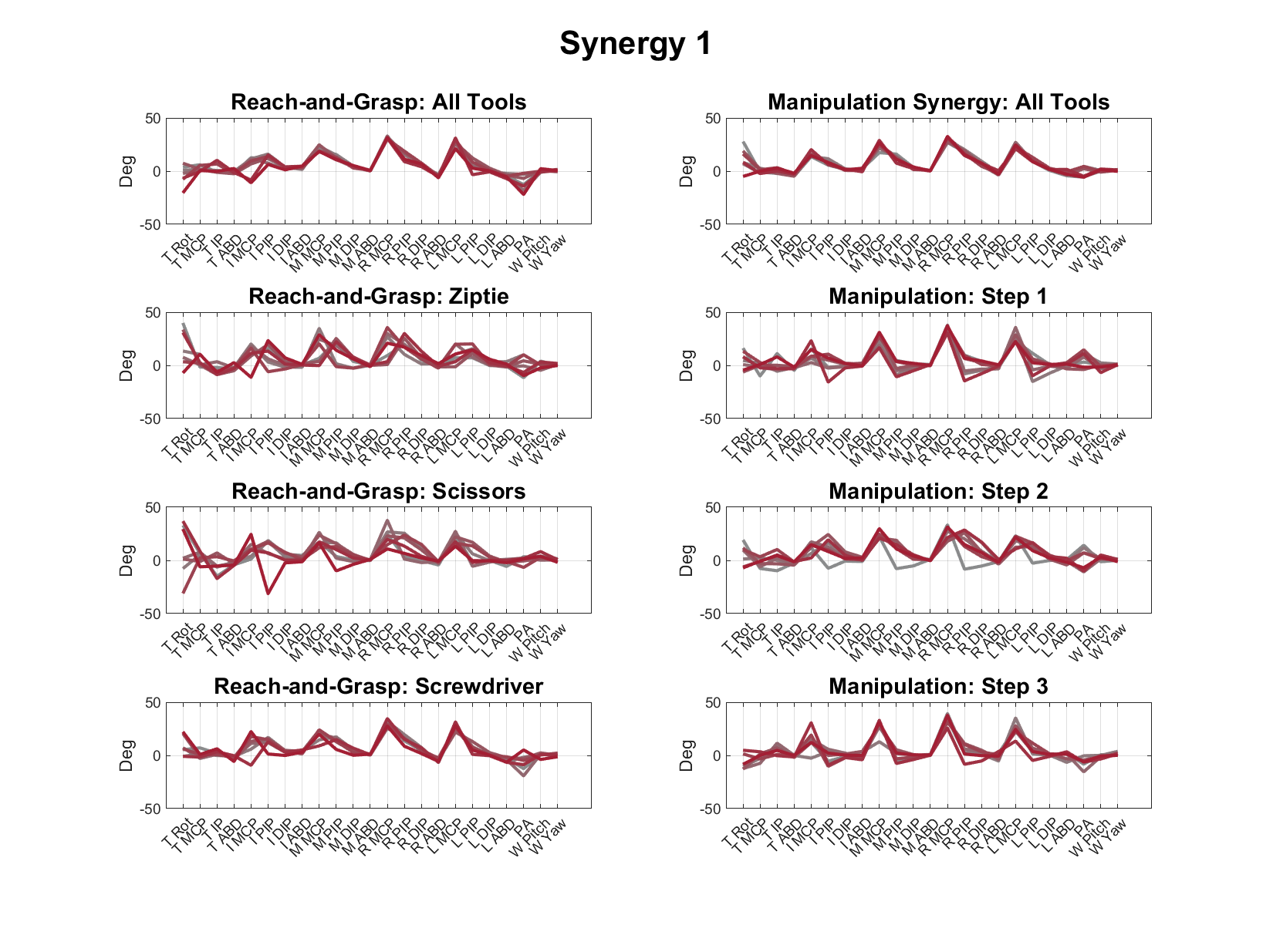

***Figure S1:*** *The first synergy. Each line denotes a different subject. Each row denotes synergies computed across a different data set (i.e. j in while each column denotes synergies computed across either reach-and-grasp, , or manipulation, .* *Note, the abbreviations T, I, M, R, and L refer to the thumb, index, middle, ring, and little fingers, respectively, while W refers to the wrist.*

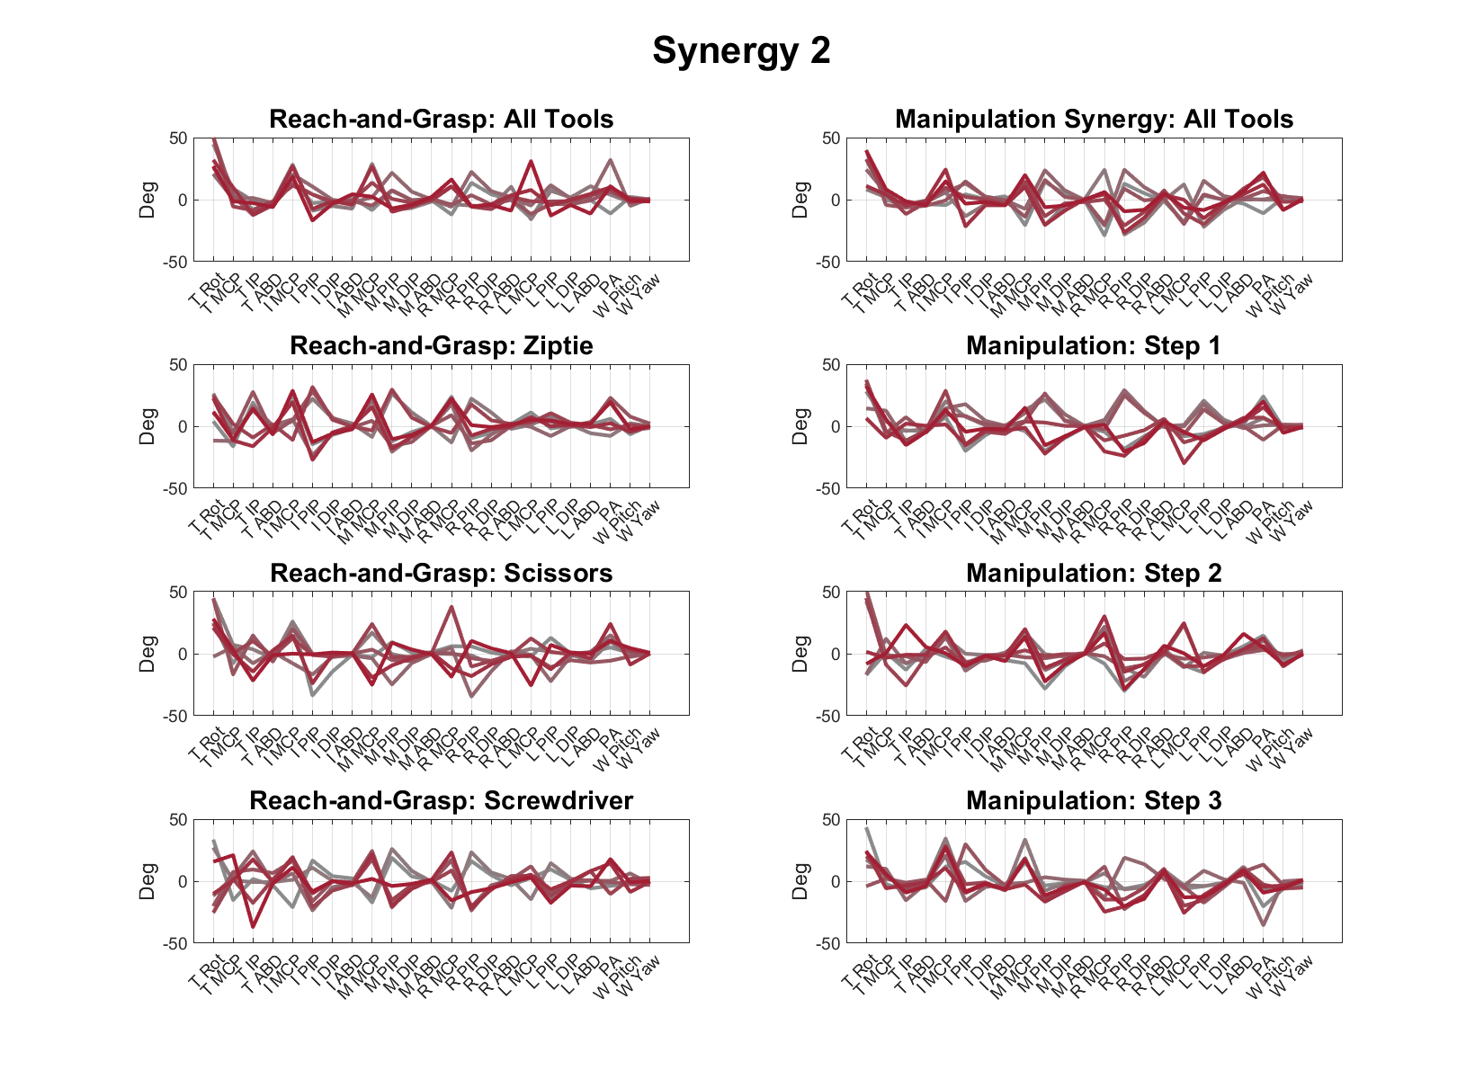

***Figure S2:*** *The second synergy. Each line denotes a different subject. Each row denotes synergies computed across a different data set (i.e. j in while each column denotes synergies computed across either reach-and-grasp, , or manipulation, . Note, the abbreviations T, I, M, R, and L refer to the thumb, index, middle, ring, and little fingers, respectively, while W refers to the wrist.*

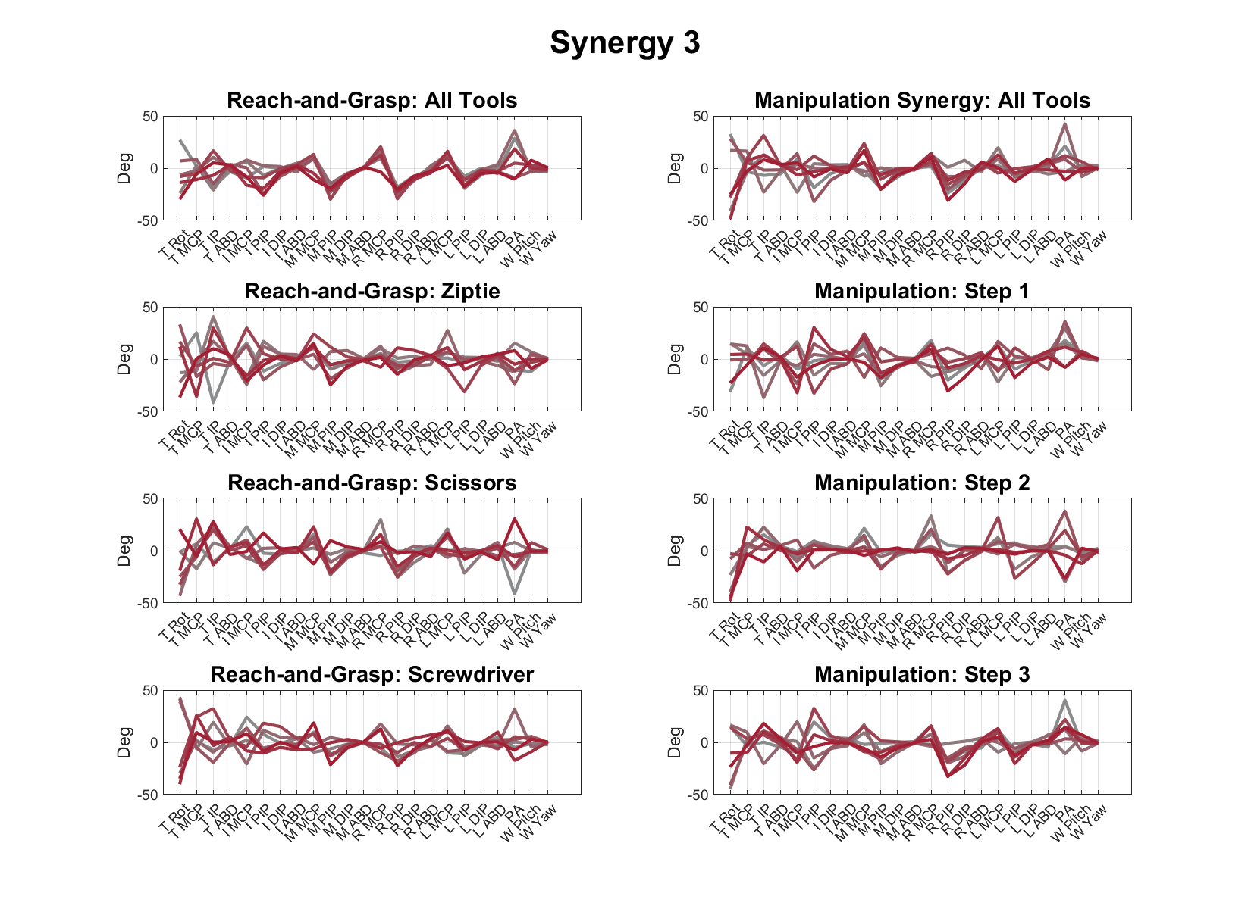

***Figure S3:*** *The third synergy. Each line denotes a different subject. Each row denotes synergies computed across a different data set (i.e. j in while each column denotes synergies computed across either reach-and-grasp, , or manipulation, . Note, the abbreviations T, I, M, R, and L refer to the thumb, index, middle, ring, and little fingers, respectively, while W refers to the wrist.*

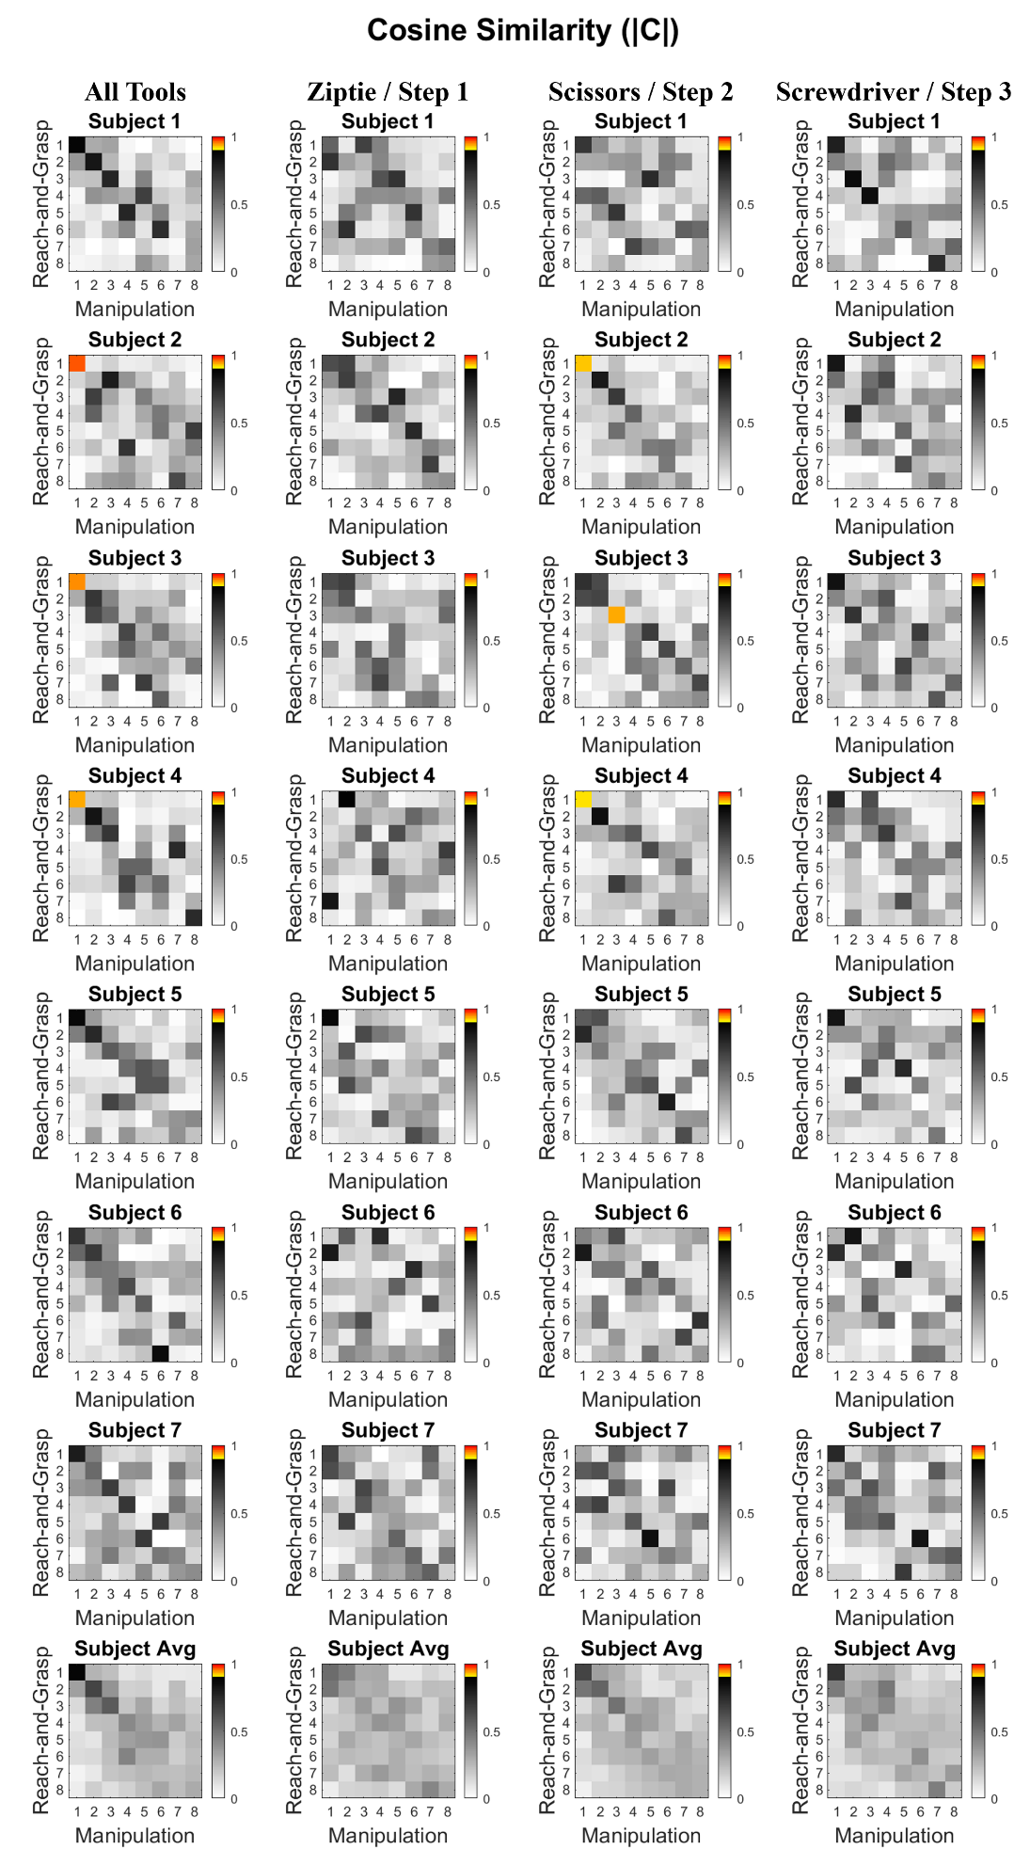

**Figure S4:** Cosine similarities between the first 8 synergies for the reach-and-grasp and manipulation tasks for all subjects. Cosine similarities greater than 0.9 are highlighted in color. Each row denotes a different subject; the last row shows the average across all subjects. Each column denotes comparison across a different subset of tools.

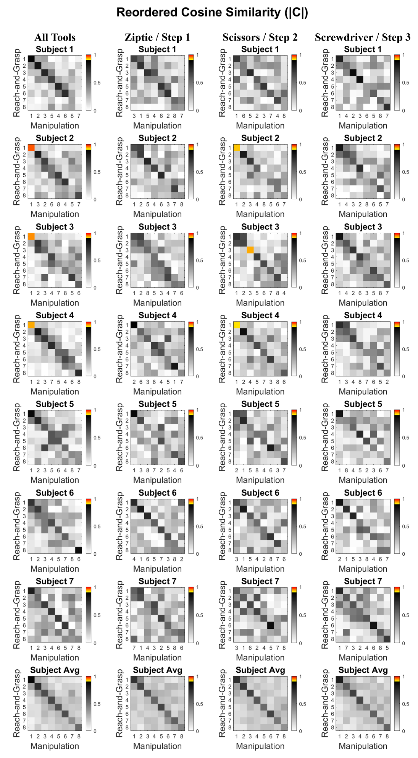

**Figure S5:** All subjects’ first 8 synergy cosine similarities between the reach-and-grasp and manipulation synergies upon reordering the columns of the manipulation synergy matrix to maximize similitude. Note, the label of the x-axis refers to the original synergy rank based on the variance-accounted-for in the manipulation data. Cosine similarities greater than 0.9 are highlighted in color. Each row denotes a different subject; the last row shows the average across all subjects. Each column denotes comparison across a different subset of tools.