**IT Project Management**

**Band.id**



Team Kapten

Akmal Ramadhan Arifin 1606837423

Michael Wijaya 1606883543

Senna Faris Wibowo 1606

Faculty of Engineering

Universitas Indonesia

2019

# 

# Preface

It is a great opportunity for all of us to do this project. This project itself is a project that will be assessed as a final project of the Project Management class we took this semester. We will give our best and maximum effort in doing the project despite all of the odds that happens along the way.

This project itself, “Band.id” is a web-based platform to meet band performers and event organizers. Band organizers will be able to apply to gigs which are made by event organizers, and event organizers themselves can easily create gig vacancies and just need to wait for applications to come along. This concept came from a friend who has a band but never found such platform that meets specifically bands and event organizers.

May this project give us a whole new experience in running an IT project and a new skillset, technical as well as interpersonal skill. This project will be a new thing for us to run because we are using completely new development tools and languages which will be a challenge in developing this website.

**Table of Contents**

Preface i

Chapter 1: Introduction 1

1.1. General Purpose 1

1.2. Function 1

1.3. Tools 1

1.3.1. Specification 1

1.3.2. Development 2

1.3.3. Validation 3

1.3.4. Evolution 3

1.4. Hardware 3

1.5. Risk Analysis 3

Chapter 2: Project Management 4

2.1. Project Integration Management 4

2.1.1. Project Plan Development 4

2.1.2. Project Plan Execution 4

2.1.3. Overall Change Control 4

2.2. Project Scope Management 4

2.2.1. Scope Planning 4

2.2.2. Scope Verification 4

2.3. Project Time Management 4

2.4. Project Cost Management 4

2.4.1. Cost Estimation 4

2.4.2. Resource Planning 4

2.5. Project Quality Management 4

2.6. Project Human Resources Management 4

2.7. Project Communication Management 4

2.7.1. Communication Planning 4

2.7.2. Information Distribution 4

2.7.3. Performance Reporting 4

2.8. Project Risk Management 4

2.8.1. Risk Identification 4

2.8.2. Risk Response Control 4

Chapter 3: Design Diagram 5

3.1. Use Case Diagram 5

3.2. Activity Diagram 5

Chapter 4: Implementation 6

Chapter 5: Testing 7

5.1. Compatibility Testing 7

5.2. Functional Testing 7

5.3. Performance Testing 7

Chapter 6: User Manual 8

6.1. User Manual 8

6.1.1. General Information 8

6.1.2. Project References 8

6.2. Getting Started 8

# Chapter 1: Introduction

This chapter will describe the general purpose and goals of the project, the functions expected from the project, the tools needed and the risk analysis of the project working.

## General Purpose

Isi

## Function

There are some functions on Band.id:

1. User registration and set up band profile
2. Registration for employers and event organizers
3. Event organizers can publish event vacancies
4. Band performers can send application to events

## Tools

### Specification

**JavaScript Framework**

JavaScript is one of the most popular programming languages for web development. We use it for both back and front-end. Using JavaScript for server and client side has some advantages such as makes us easier because use same language, good for applications that require real-time data, and faster than PHP. For this project, we use Node.js on the server side and React.js on the client side.

**Database Management System**

Database Management System (DBMS) is a system software for creating and managing databases. The DBMS provides a systematic way to create, retrieve, update, and manage data. In this project, we use NoSQL for the database because its flexibility, more scalable, high performance and functionality.

**Server Hosting**

A web application needs a server hosting. Server hosting is a service to post a website onto the Internet. Since we are still on the early-stage development, we use a free hosting service to reduce cost and easier to use.

### Development

**Node.js**

Node.js is an open source server environment that uses JavaScript. Node.js can generate dynamic page content. We use Node.js because it runs single-threaded, non-blocking, asynchronous, which is very memory efficient. When handling a file request, Node.js eliminates the waiting, continues with the next request, and when the file system has opened and read the file, the server returns the content to the client.

**React.js**

React.js is an open source JavaScript library to build interactive user interface. Some React.js features:

1. Process of writing components is smoother with JSX
2. Increase efficiency
3. Stable code
4. Flexible
5. Scalability
6. Enhance SEO performance

**MongoDB**

MongoDB is a cross-platform, document-oriented database that provides high performance, high availability, and easy scalability. MongoDB works on concept of collection and document. In this project, we use MongoDB Atlas, a cloud version of the database. With MongoDB Atlas, the data are stored on a cluster, so it’s easier to use rather than using local server.

**Heroku**

Heroku is a cloud platform as a service (PaaS) that enables application development and deployment. Heroku supports various programming language such as Java, Node.js, Scala, Python, PHP, Clojure, and Go. With Heroku, we can deploy our application and access it using Internet.

### Validation

To validate the market needs, in the future we will make a survey about our project. Our target are band and event organizers. The survey will be an online form where the responders have to answer each question.

### Evolution

Our idea is not completely original. There are some similar projects we found on the Internet. To improve our product and gain more users, we will add more features in the future. The features to be added are news feed, chat between users, event organizer admin page, and many more. In addition, we plan to use open API such as Google Maps to enhance user experience.

## Hardware

Our hardware is a laptop/PC with the latest version of web browser.

## Risk Analysis

1. Fail to load the data from database to the application
2. We can’t explore more features because limited time to develop the system

# Chapter 2: Project Management

## Project Integration Management

Our Project Integration Management aims to coordinate all knowledge of this project management. We will see through the project processes including all activities needed for this project completion. We also want to ensure everything specifically, so the project could be completed successfully on time.

### Project Plan Development

In this project, we separate our code in two parts, back and front-end. We use JavaScript for both. First, we create a REST API using Node.js and Express.js to connect the application with the database. Second, we create the main site using React.js to fetch data from API. The API and the main site run on different server.

When user opens band.id website for the first time, it will land on the landing page. On that page user will see photos and information about the project. There also will be a navigation bar that consist of events, log in, and sign up tabs.

On the event page, users can find events that suit them. Users don’t have to sign up or log in to access that page. But, if they want to send an application to events, they have to log in first, if they don’t have an account, they will be redirected to registration page.

On the registration page, user have to fill some information about name, email, password, etc. If the registration is succeeded, they will be redirected to set up their band profile. Again, user has to fill some information about their band such as name, genre, past events, etc.

### Project Plan Execution

### Overall Change Control

## Project Scope Management

### Scope Planning

### Scope Verification

## Project Time Management

## Project Cost Management

### Cost Estimation

### Resource Planning

## Project Quality Management

## Project Human Resources Management

## Project Communication Management

### Communication Planning

### Information Distribution

### Performance Reporting

## Project Risk Management

### Risk Identification

### Risk Response Control

# Chapter 3: Design Diagram



## Use Case Diagram

## Activity Diagram

# Chapter 4: Implementation

We are using Visual Studio for making our codes and implementing it using node.js which is the backend side of this project. It is responsible to handle requests from the client and send response based on the request made from the client, also to start the server. For the front-end side, we use React.js for the interface development. Using React.js enables us to create a great UI as React is used to make numerous of popular websites such as AirBnB, Facebook, Netflix, and Dropbox. What we have made is an API made in Node.js (with Express) which is used by the React.js getting the data from the API and render it to the front-end.

Models

Apply.js

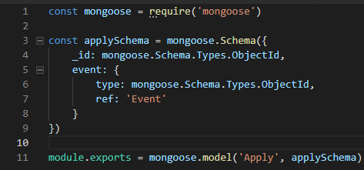

Event.js

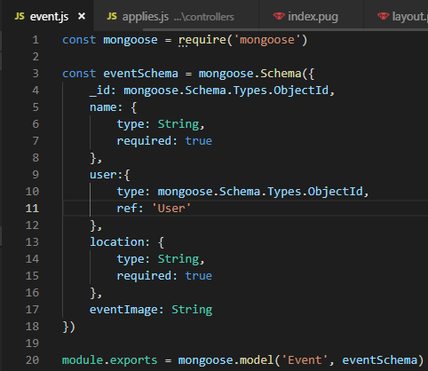

databaseUser.js

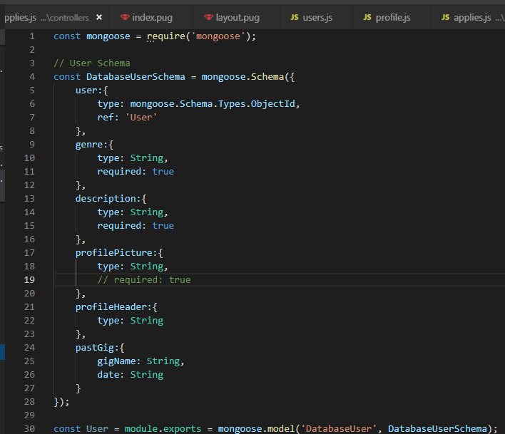

User.js

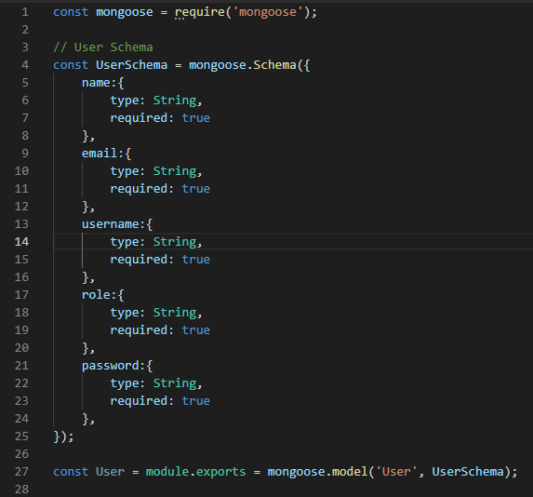

Middleware

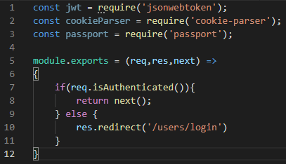

Routes

Applies.js

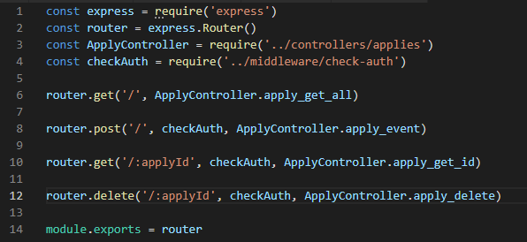

Events.js

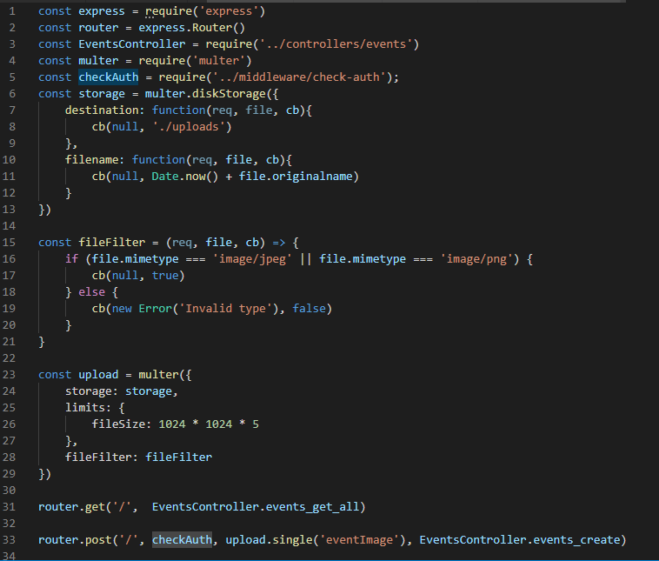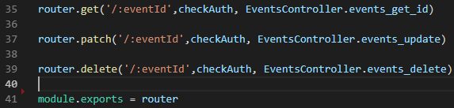

Profile.js

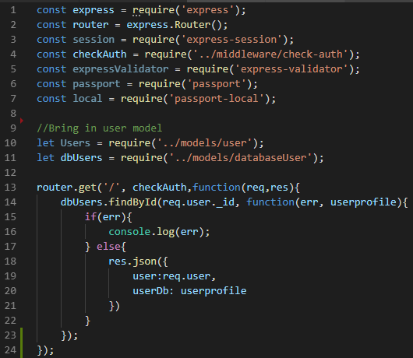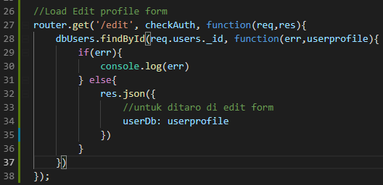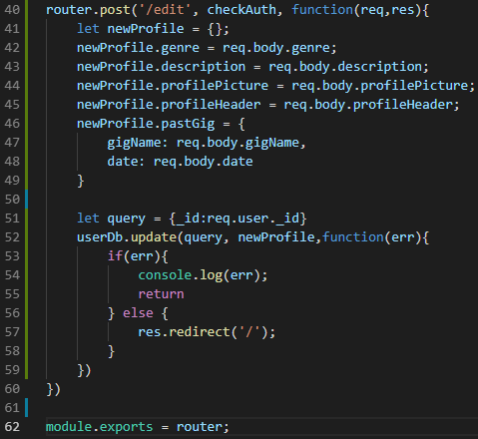

Users.js

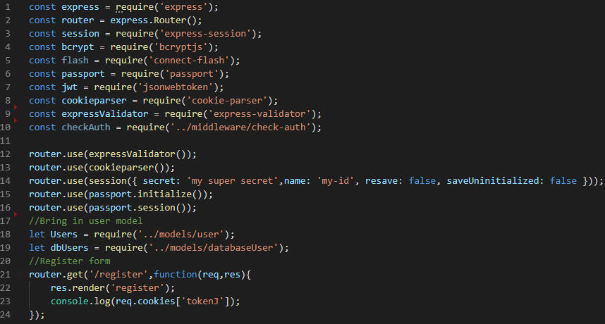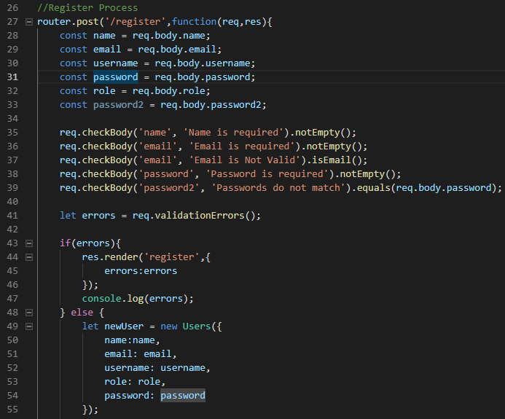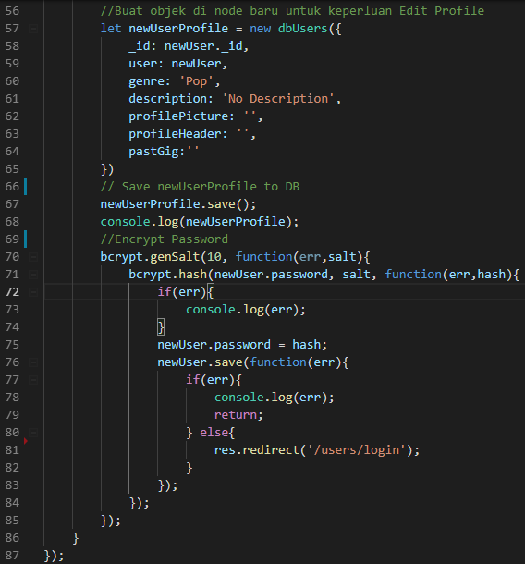

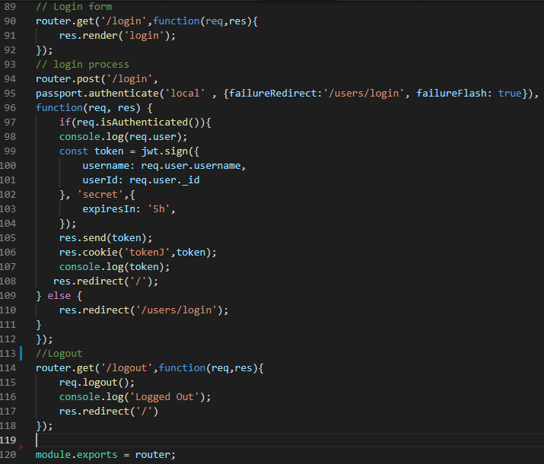

Controllers

Applies.js

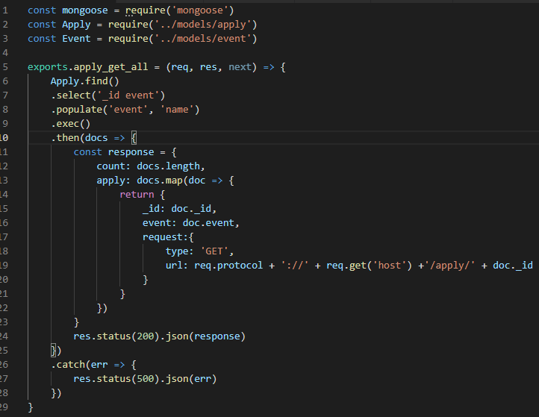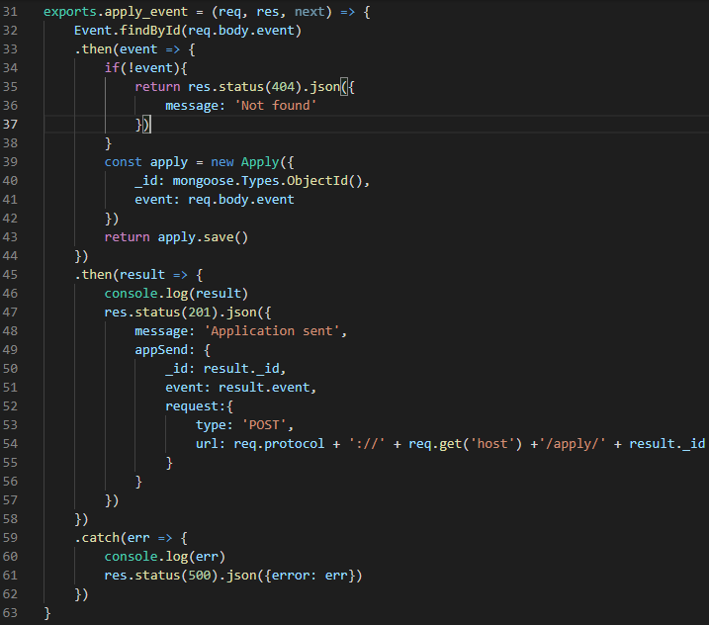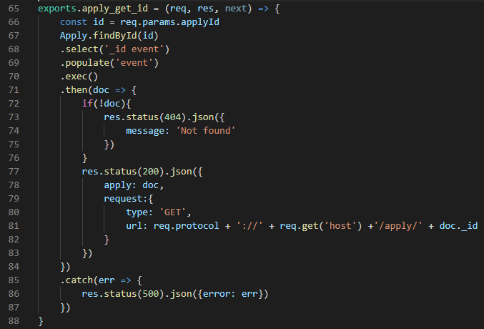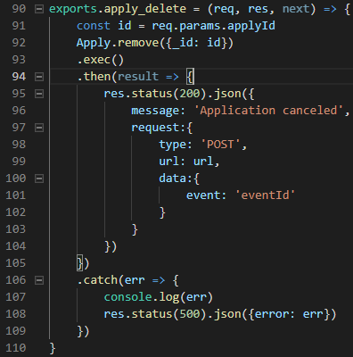

Events.js

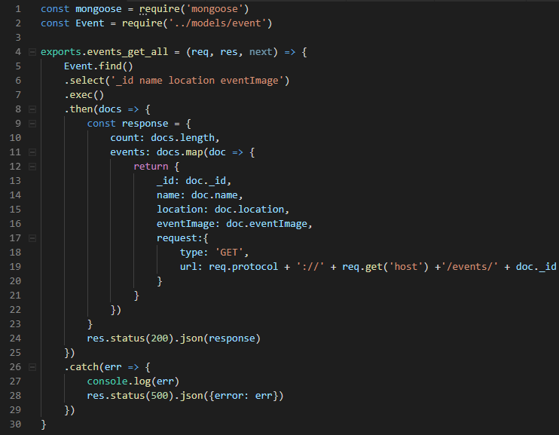

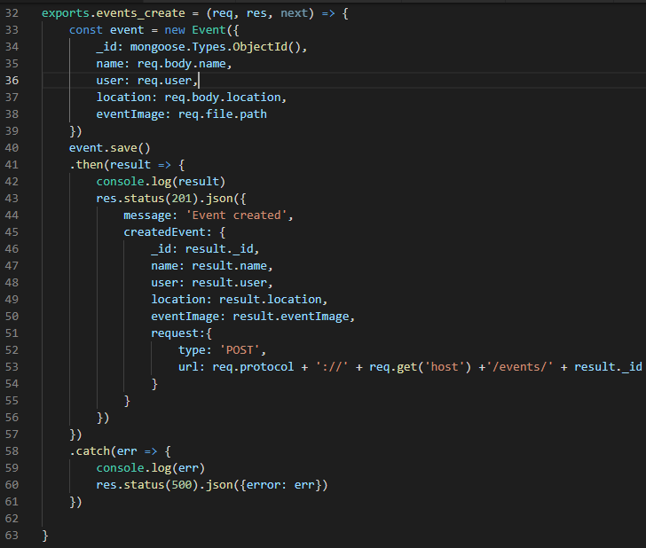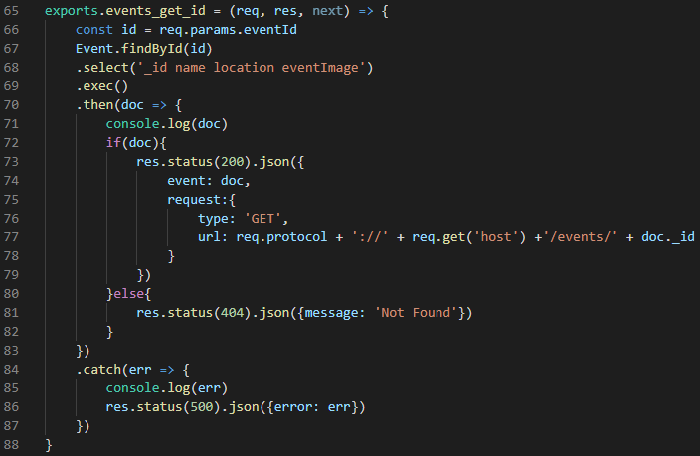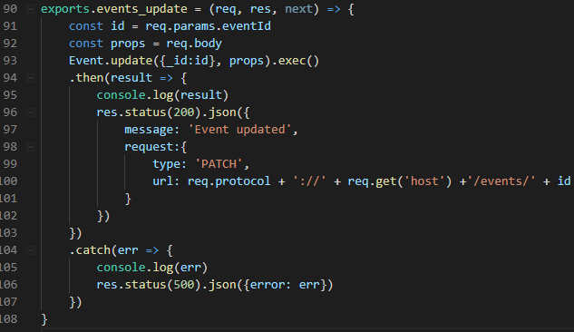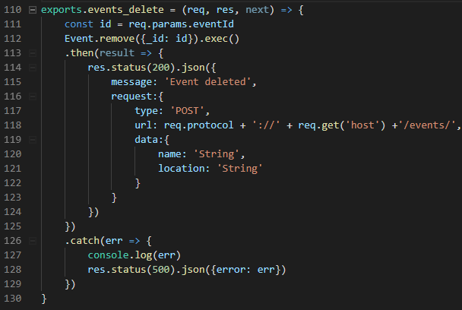

Config

Passport.js

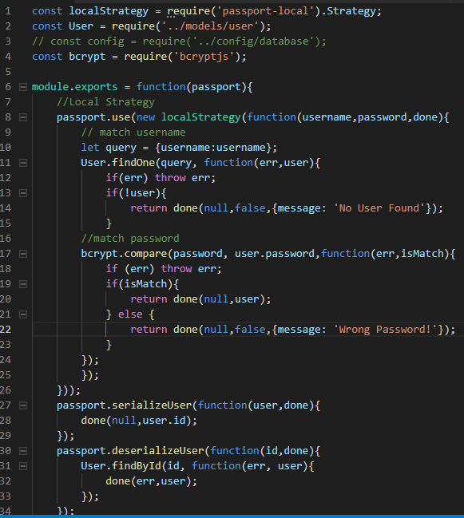

# Chapter 5: Testing

This chapter documents and tracks the necessary information required to effectively define the testing of the project’s product. The test plan document is created during the planning phase of the project. Unit testing are done by team member who does not act as the unit code author. System testing will be done by customer using standard Software Usability Scale questionnaire and will be done after all the unit testing have been determined as passed.



## Compatibility Testing

### 5.1.1 Test Risk / Issue

Band.id is a website running on Node.JS and Express based server rendered on React.js. This website will be running on web browsers. In this test plan, Band.id is tested with various web Browsers.

### 5.1.2 Items to be Tested

|  |  |  |  |
| --- | --- | --- | --- |
| Item to Test | Test Description | Test Date | Responsibility |
| Application | Run the application with various Web Browsers | May 03, 2019 | Senna Faris Wibowo |

### 5.1.3 Test Approach

The goal of this test is to find if there are any Web Browsers that are not compatible with the website. If there are one or more web browsers that are not compatible, we will make adjustment regarding the problems.

### 5.1.4 Test Regulatory / Mandate Criteria

To do the testing, the pre-condition needed is that the web browsers have to be the latest version. No multiple device is needed as we can install multiple web browsers in one device.

### 5.1.5 Test Pass/ Fail Criteria

Compatibility test is determined a success / passed if the website works well on different web browsers. This includes the graphical interface and functions of the website are working accordingly. It is determined as failed if there are any of those aspects that does not work correctly.

### 5.1.6 Test Entry / Exit Criteria

The test will be conducted if the devices are installed with multiple web browsers. The test will be stopped if all features of the website run well on multiple web browsers.

### 5.1.7 Test Deliverables

The result of this test is shown on the table below.

|  |  |  |
| --- | --- | --- |
| Tester Number | Browser | Status |
| 1 | Google Chrome | Success |
| 2 | Firefox | Success |
| 3 | Safari | Success |
| 4 | Microsoft Edge | Success |

### 5.1.8 Test Suspension Condition

The test will be suspended if there are any obstacles, such as the availability of the devices that supports the test, readiness of the features which will be tested, and the team member’s availability. The test will be resumed if all the requirements needed is fulfilled.

### 5.1.9 Test Environmental

The environment of this test is the browsers that runs on the device used in the test. There is no specific skill required to do this test, but the tester must know the features of the website completely.

## Functional Testing

### 5.2.1 Test Risk / Issue

There may be some algorithms that do not flow according to our plan. It may occur due to human error in writing the code, some mistakes in the implementation, or some plugins that are missing.

### 5.2.2 Items to be Tested

|  |  |  |  |
| --- | --- | --- | --- |
| Items to Test | Test Description | Test Date | Test Responsibility |
| Graphics | Check if the UI and images used shows correctly on the web browser. | May 05, 2019 | Senna Faris Wibowo |
| API | Check if the API functions work accordingly | Akmal Ramadhan, Michael Wijaya |
| Database | Check if the data input by user successfully stored on the database. | Akmal Ramadhan |
| User Access Control | Check if the access control of the user is successfully implemented | Michael Wijaya |

### 5.2.3 Test Approach

This test’s goal is to check whether the system we implement on the application does meet the requirements written on the plan before. Our focus is to check the connection within the website and the database.

### 5.2.4 Test Regulatory / Mandate Criteria

The minimum criteria for running this test is that the website have passed the compatibility test.

### 5.2.5 Test Pass/ Fail Criteria

The test succeeded if all aspects that are being tested does meet the design stated on the plan.

### 5.2.6 Test Entry / Exit Criteria

The test begins by starting the web server and open the website on the tester’s device using any web browser we have tested in the compatibility test. This test stops when all test conditions has passed or there is a function that does not work correctly.

### 5.2.7 Test Deliverables

|  |  |  |  |  |
| --- | --- | --- | --- | --- |
| Test Numbers | Number of Trials | Problems Encountered | Solution | Status |
| 1 | 7 | Cannot create event | Correct the connection to the database | Success |
| 2 | 9 | User is not passed between sessions | Use JWT as stateless user authentication | Success |

### 5.2.8 Test Suspension Condition

The website functionality testing will be suspended if the are any errors or bugs in the web page that needs to be fixed before resuming test.

### 5.2.9 Test Environmental

The requirement for the tester is knowledge of the website’s purposes, usage of each button, and expected results of each test conditions.

## Performance Testing

### 5.3.1 Test Risk / Issue

Website might have performance issues like slow database connection which might affect the functionality of the website.

### 5.3.2 Items to be Tested

|  |  |  |  |
| --- | --- | --- | --- |
| Item to Test | Test Description | Test Date | Responsibility |
| Loading speed | Determining the time needed of doing the activities of the website. | May 05, 2019 | Senna Faris Wibowo |
| Bug | Determining if there are any bugs in the website | Michael Wijaya, Akmal Ramadhan |

### 5.3.3 Test Approach

The tested application will be measured by the amount of time needed to load page and storing data to database. The time will be compared with another web browser in the same test.

### 5.3.4 Test Regulatory / Mandate Criteria

The requirement is that the website has already passed the compatibility test.

### 5.3.5 Test Pass/ Fail Criteria

The test is determined passed if the website and each feature loads in maximum of two seconds and the refresh rate is not longer than 5 seconds periodically. This numbers can be changed depends on what type of browser and the connection that is used for testing.

### 5.3.6 Test Entry / Exit Criteria

The test started when the criteria is fulfilled and stopped when the website passed or failed the test after three trials.

### 5.3.7 Test Deliverables

|  |  |  |  |
| --- | --- | --- | --- |
| Test Browser | Average of Loading Time (Second) | Bug Found | Status |
| Google Chrome | 2 | - | Success |
| Mozilla Firefox | 1 | - | Success |
| Safari | 1 | 1 | Suspended |

### 5.3.8 Test Suspension Condition

The test stopped when all devices has passed the second trial in loading time or if a bug is found.

### 5.3.9 Test Environmental

The environment of this test is the browsers that runs on the device used in the test. There is no specific skill required to do this test, but the tester must know the features of the website completely.

# Chapter 6: User Manual



## User Manual

### General Information

### Project References

## Getting Started