Assignment 2 – Knowledge Representation and Reasoning with Bayesian Networks
(Michael Wang, 33899835)
  - Question 1
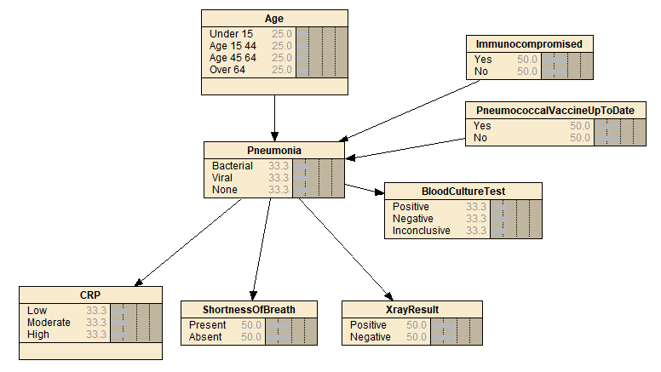
  - Question 2
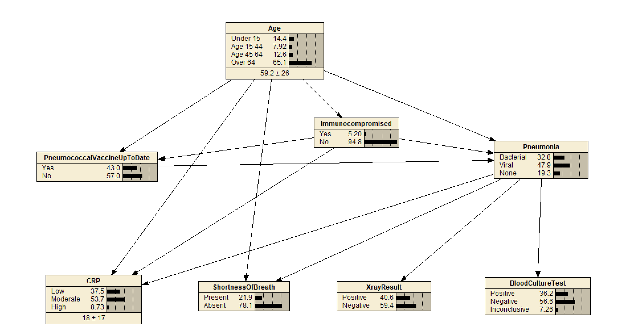

Variable Dictionary:
ID | Description | States | Parents | Parameterisation Source
Age | Patient's age in years. | Under 15 [0, 15),  Age 15-44 [15, 45),  Age 45-64 [45, 65),  Over 64 [65, Infinity). | None | Data files: riskfactors, symptom, medtest
Immunocompromised | Whether the patient has a condition causing weakened immunity. | Yes, No. | Age | ME (weight 20), Data files: riskfactors, symptom
PneumococcalVaccineUpToDate | Whether the patient is up to date with pneumococcal vaccination. | Yes, No. | Age, Immunocompromised | ME (weight 20)
Pneumonia | The patient's true pneumonia status and type. | Bacterial, Viral, None | Age, Immunocompromised, PneumococcalVaccineUpToDate | ME (weight 20), Data files: riskfactors, symptom, medtest
CRP | C-reactive protein, a sign of bacterial pneumonia. | Low [0, 5), Moderate [5, 40), High [40, Infinity). | Pneumonia, Age, Immunocompromised | Data file: symptom
ShortnessOfBreath | Whether the patient presents with shortness of breath. | Present, Absent | Pneumonia, Age | Data file: symptom
XrayResult | Result of a chest X-ray, giving an indication of pneumonia. | Positive, Negative | Pneumonia | LIT (weight 60), Data file: medtest
BloodCultureTest | Result of a blood culture test, identifying causative bacteria in the blood. | Positive, Negative, Inconclusive | Pneumonia | LIT (weight 60), Data file: medtest

  - Question 3
- Given the age is under 15, the probability of the boy having bacterial pneumonia, viral pneumonia and no pneumonia are 0.19, 0.555 and 0.255 respectively. 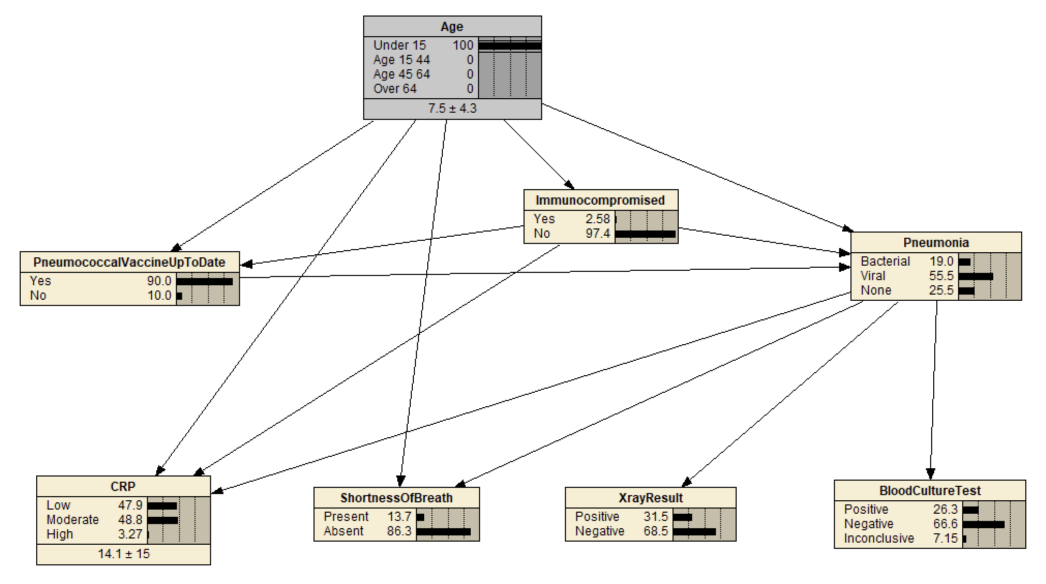
Given the age is over 64, the probability of the woman having bacterial pneumonia is 0.428.
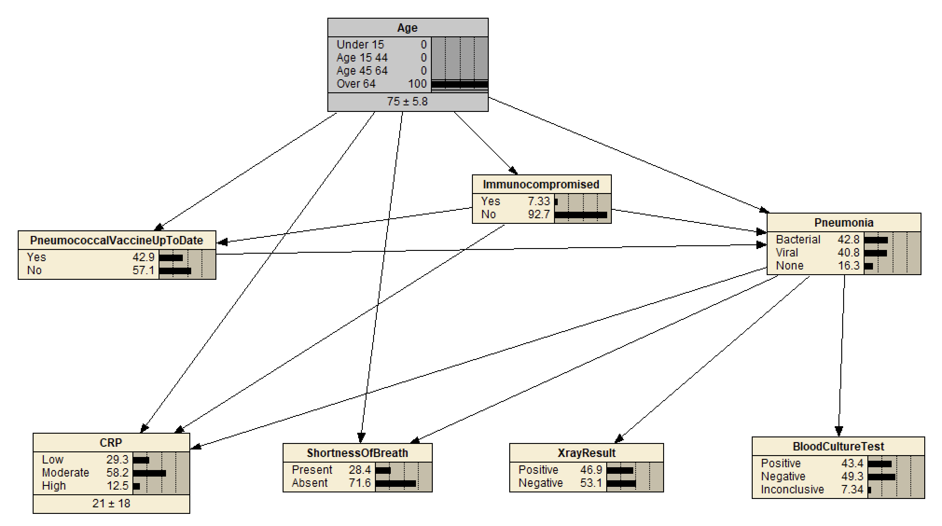

Hence, the 72-year-old woman is more likely to have bacterial pneumonia, by 0.238. The chance of the boy having any type of pneumonia is 0.745.

- a) The woman’s predicted CRP level has a mean of 23.9 and a standard deviation of 19.
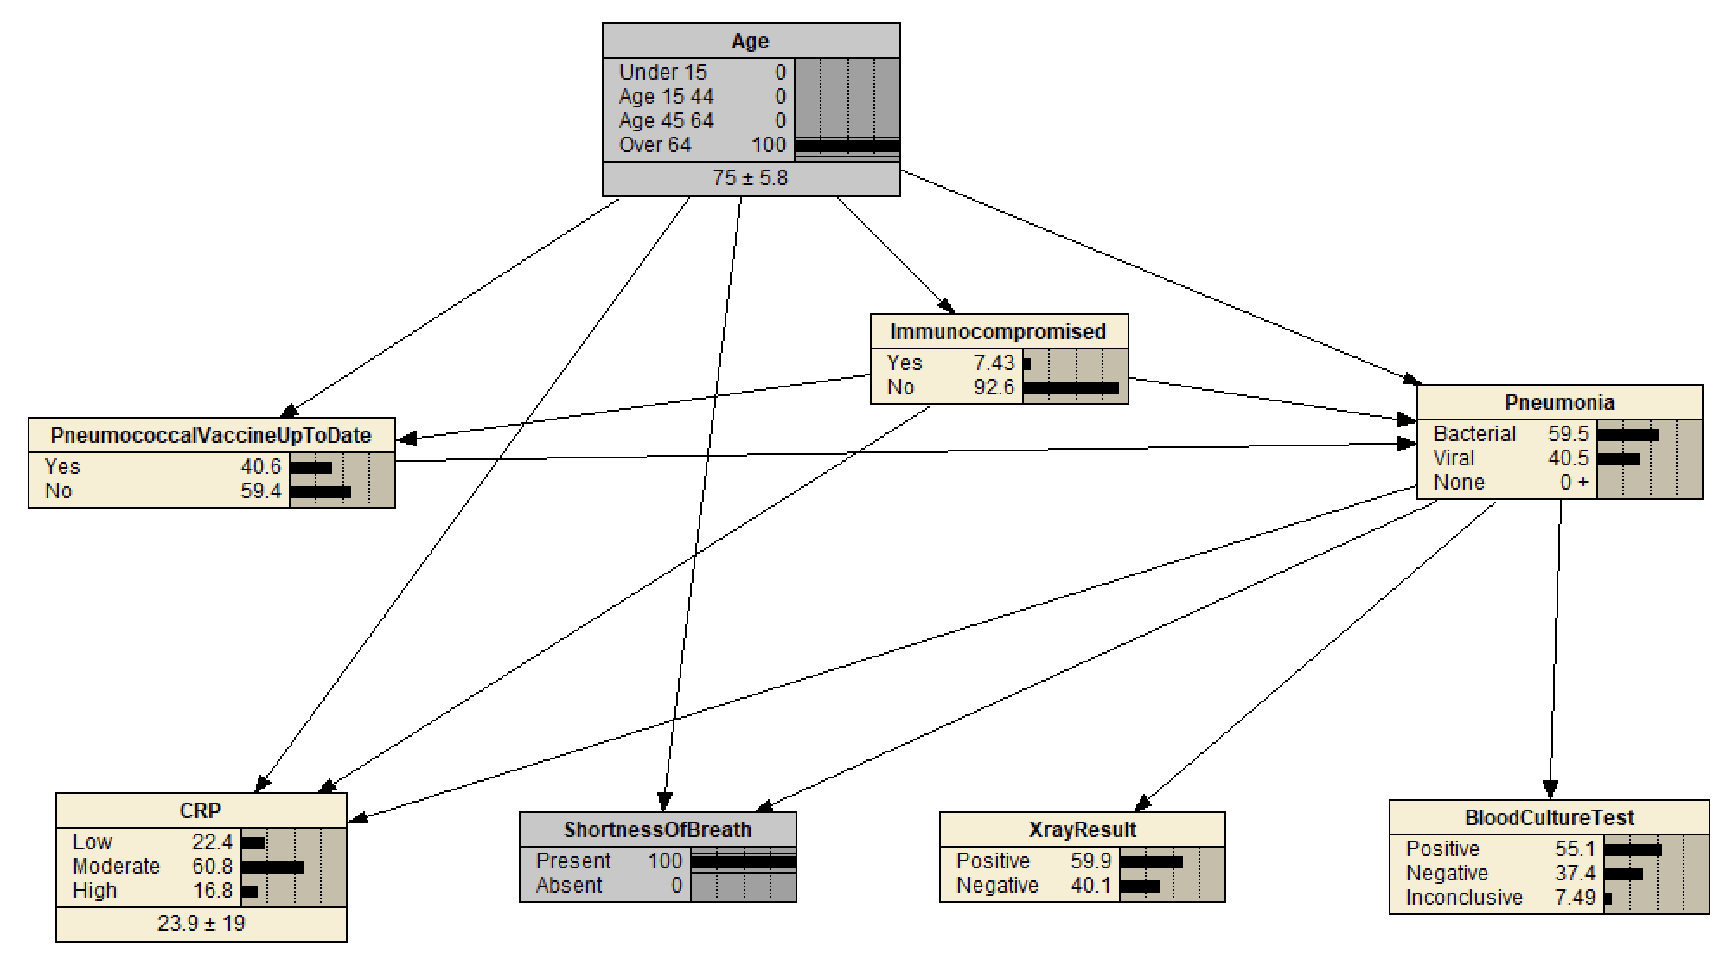

b) Given all the information, the probability of bacterial pneumonia for the boy is 0.625 and for the woman is 0.595.
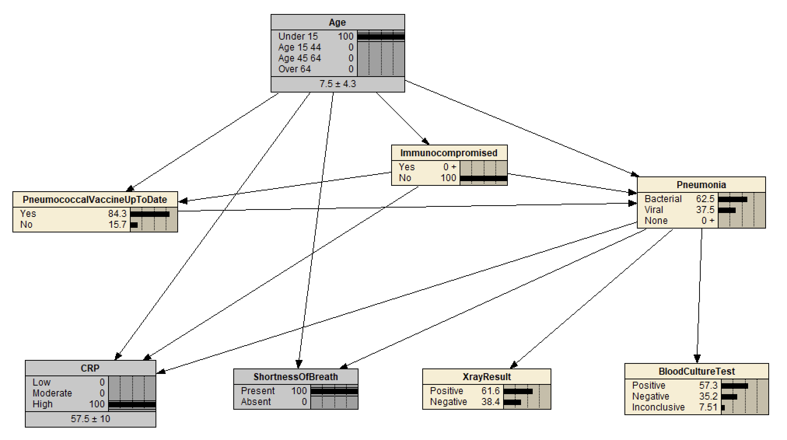
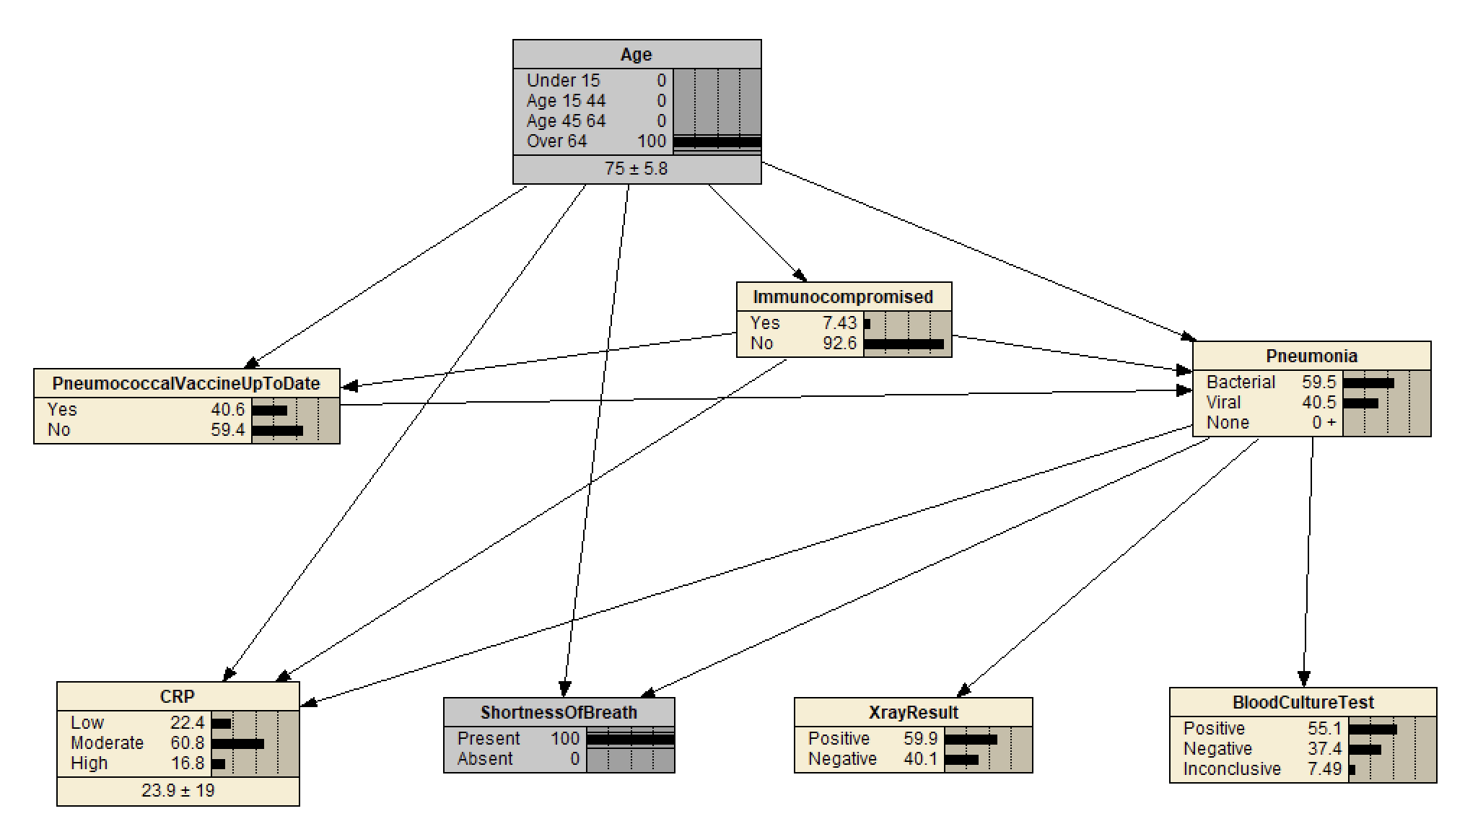
c) Before observing CRP, the probability that the boy is immunocompromised is 0.0299.
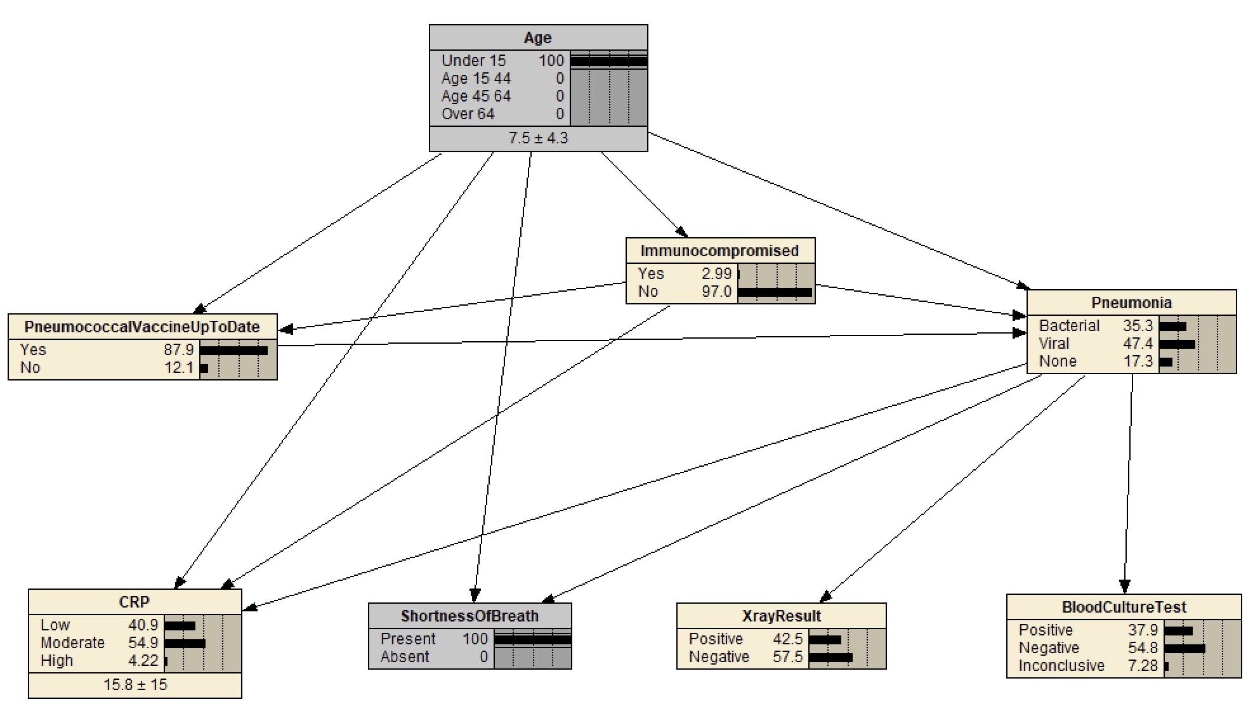

After observing CRP, the probability that the boy is immunocompromised is approximately 0 (0+).
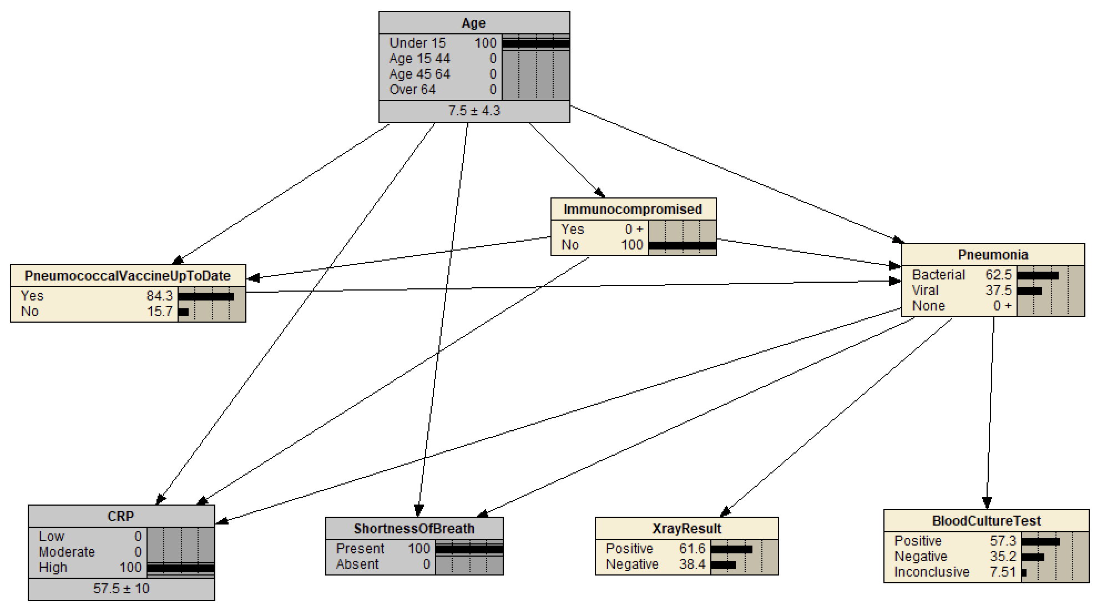

The reason for this is that in the trained CPT for CRP, the under 15/immunocompromised = Yes rows assign almost no probability to High CRP, the evidence then propagates back along the arc and decreases the probability of immunocompromised = Yes.

- Given the X-ray result is negative, the probability of the boy having bacterial pneumonia and viral pneumonia is 0.289 and 0.711 respectively.
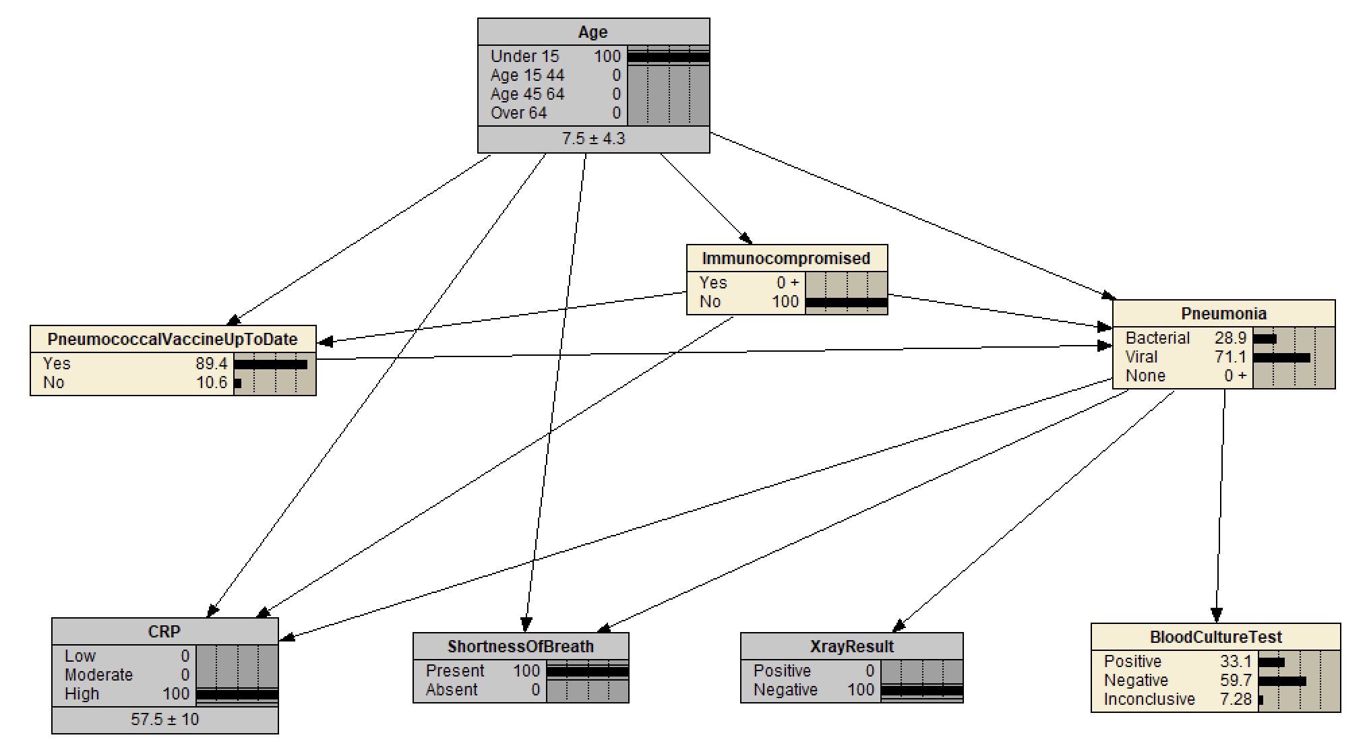

Given the X-ray result is positive, the probability of the woman having bacterial pneumonia and viral pneumonia is 0.816 and 0.184 respectively.
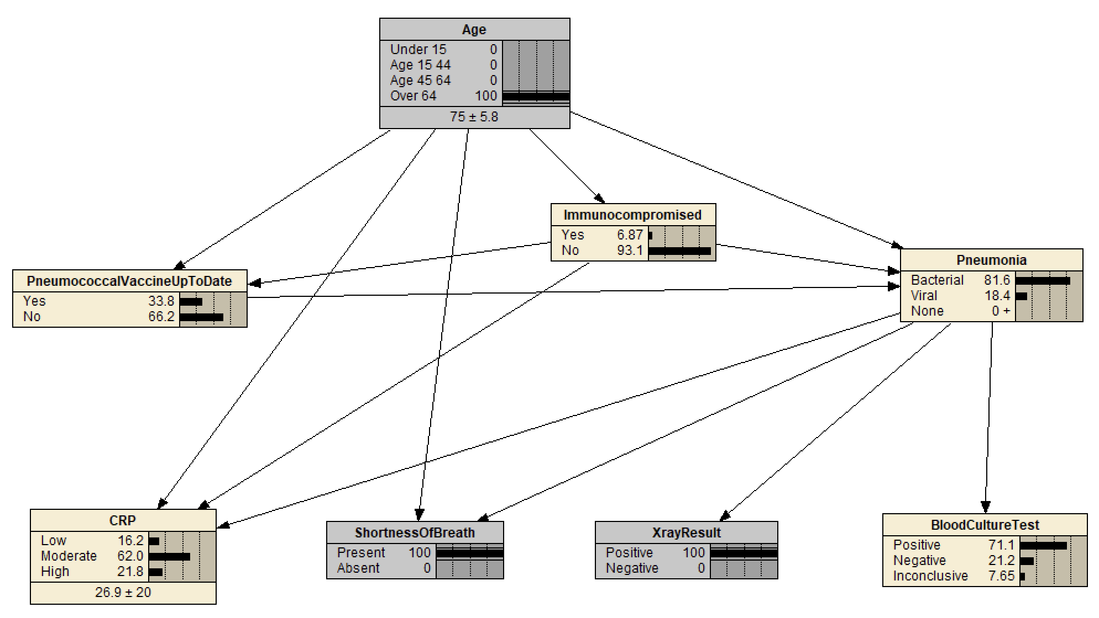

Hence, the woman is more likely to have bacterial pneumonia.

  - Question 4
- a) The entropy of the pneumonia node when there is no evidence is 1.494.
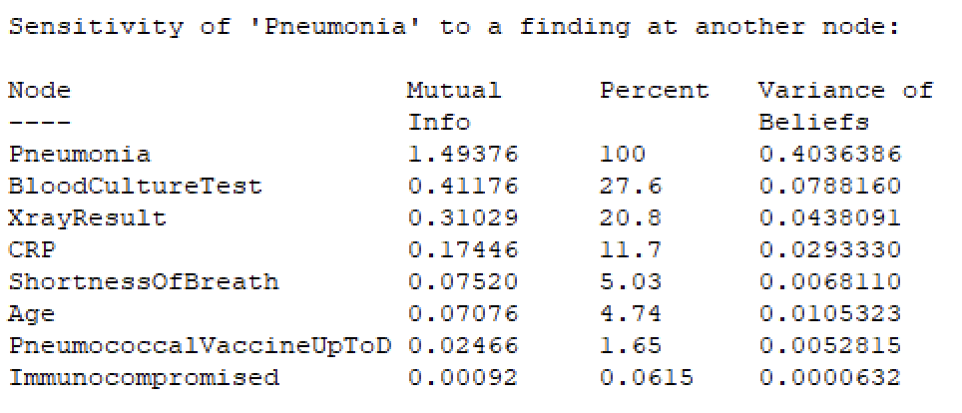

b) BloodCultureTest would provide the most information about pneumonia on its own.
i) The mutual information of this variable with pneumonia is 0.412 bits, which is 27.6% of the pneumonia node’s entropy.
ii) 0.412 bits, same as the expected reduction in entropy in part i).

c) Immunocompromised provides the least information about pneumonia. Its mutual information with pneumonia is 0.00092 bits.
The reason is because about 95% of the patients are not immunocompromised, so if we are told that the patient is not immunocompromised, knowing it doesn’t tell me much as this was what I expected.
On the other hand, if I was told the patient is immunocompromised, the probability of bacterial pneumonia, viral pneumonia and no pneumonia is (130/385 = 0.338), (190/385 = 0.493) and (65/385 = 0.169) respectively, which is very close to if we have not observed it (0.328, 0.479, 0.193), meaning we wouldn’t have learned much anyways.
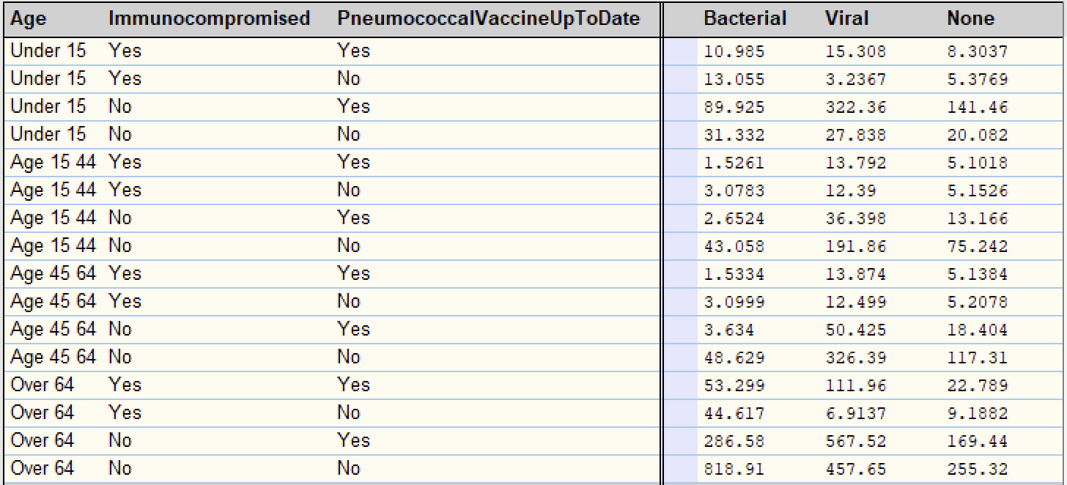
- CRP, PneumococcalVaccineUpToDate and ShortnessOfBreath now provide more information than before. Age and BloodCultureTest now provide less information than before. Some variables now have less mutual information with pneumonia because:
- The evidence already provides enough information about these variables, knowing these would not give us much new information. For example, age would not tell us much because immunocompromised patients are concentrated in the elderly.
- The variable is bad at separating the remaining types of pneumonia. Knowing a negative X-ray result largely rules out the chance of a bacterial pneumonia and BloodCultureTest is bad at separating viral and no pneumonia as their rows are nearly identical.
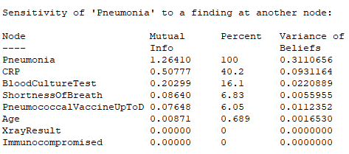

- a) The error rate on the test data is 29.82%
b) The confusion matrix is shown below. It performs worst on None, only 2 of 22 healthy patients are correctly identified.
c) The log score is 0.5571.
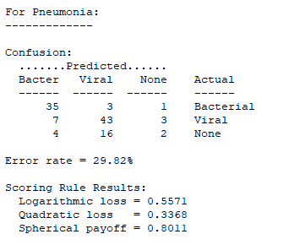

- Model 1:
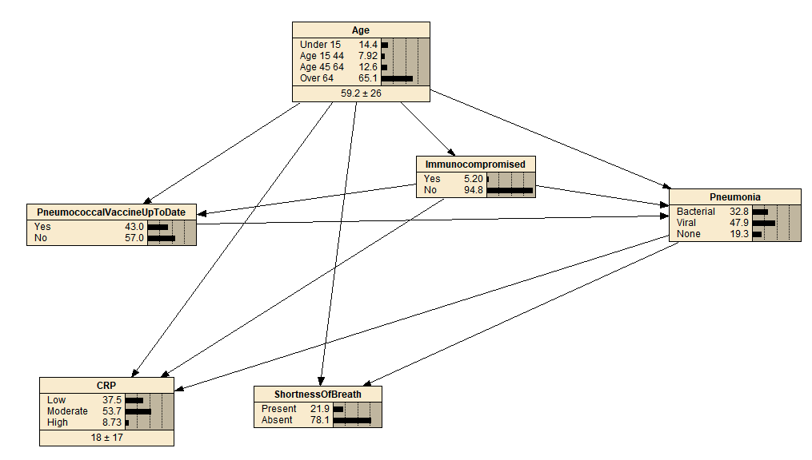

Model 2:
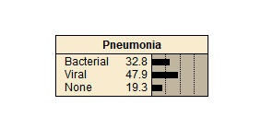

- Model 1 error rate: 39.47%
Confusion matrix: see below.
Log score: 0.8084
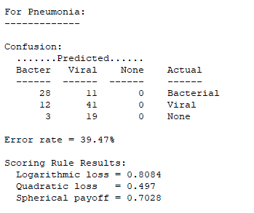

Model 2 error rate: 53.51%
Confusion matrix: see below.
Log score: 1.041
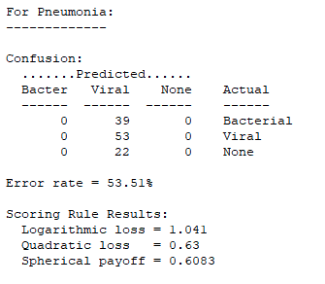
Compared to iii), both reduced models perform worse than the full model. The error rate rises from 29.82% to 39.47% when the two test nodes are removed, and to 53.51% for the one-node model, while logarithmic loss rises from 0.5571 to 0.8084 to 1.041. The confusion matrices show that removing the X-ray and blood culture wipes out the ‘None’ class entirely, with Model 1 never predicting that state at all against the full model's 2 of 22. Model 2 predicted Viral for all 114 cases and therefore misclassifying every bacterial and no-pneumonia patient.

- The full model tells us more information than a model that simply guesses the most common answer, evident in the 29.82% error rate compared to the 53.51% error rate. The log score improves in the same way from 1.041 down to 0.5571, meaning the confidence it places on the correct diagnosis rises from roughly 35% to 57%.

Most of the improvement comes from the two test nodes. Taking away the two test nodes cost more than taking away all five of the other nodes together.

A downside of the model is that it is only good at telling bacterial pneumonia from viral pneumonia, but bad at separating a healthy patient from one with pneumonia. This is evident in the model only able to find 2 out of 22 who had no pneumonia, and without the two tests it finds none. Hence, this is useful for working out which kind of pneumonia someone has but not for deciding whether they have pneumonia.

  - Question 5
- Modified Network:
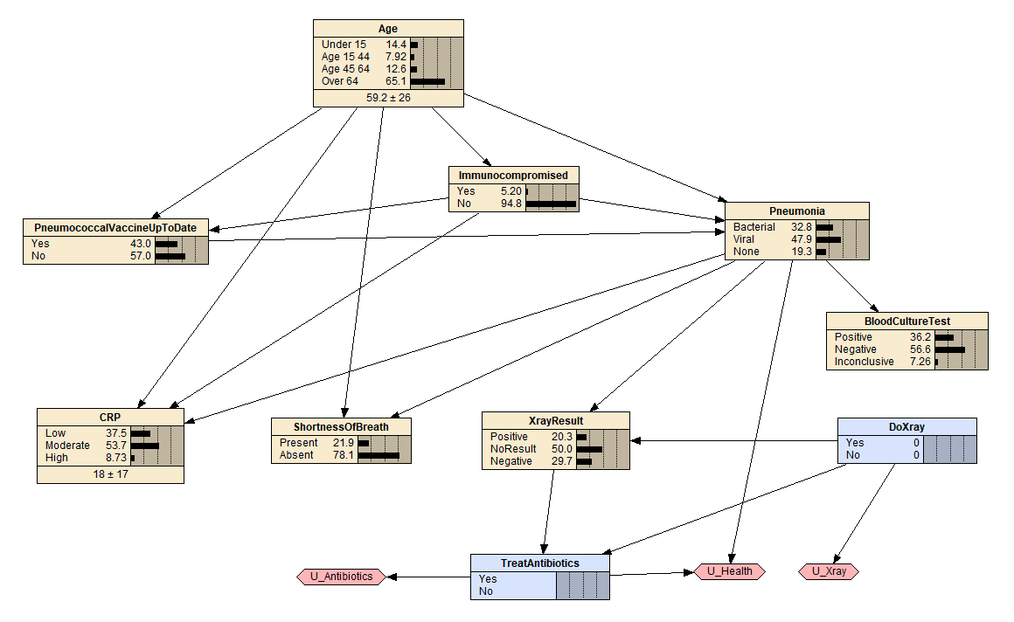

- Let:
b = P(Bacterial | Negative) if negative result, P(Bacterial | Positive) otherwise
v = P(Viral | Negative) if negative result, P(Viral | Positive) otherwise
n = P(None | Negative) if negative result, P(None | Positive) otherwise
X = cost and harm of the X-ray
A = cost and harm of the antibiotics
B = harm of bacterial pneumonia left untreated
V = harm of viral pneumonia
U_Health: (Bacterial, treat) = 0, (Bacterial, no treat) = −B, (Viral, either) = −V, (None, either) = 0.
$$EU(treat) = -X - A + [b * 0 + v*-V + n*0] = -X - A - v*V$$
$$EU(no treat) = -X + [b*-B + v*-V + n*0] = -X - b*B - v*V$$
$$EU(treat) - EU(no treat) = b*B - A$$
- Treat when b > A/B
After a positive X-ray result, treat when A/B < b = 0.253.
After a negative X-ray result, not treat when A/B > b = 0.0151
We want to choose A, B such that 0.0151 < A/B < 0.253.
Choose A = 20, B = 200.
Choose V = 20 to show that untreated bacterial is worse than viral.
For X-ray utility, let P be the chance the X-ray reads positive give the patient took it.
$$EU(no x-ray) = -b_{n}*B - v*V$$
$$EU(x-ray) = -X + P(-A - v*V) + (1-P)(-b*B - v*V)$$
$$EU(x-ray) - EU(no x-ray) = P(b*B - A) - X$$
Hence, we should x-ray when X < P(b*B – A) = 0.216 * (0.253 * 200 – 20) = 6.61
Choose X = 3.
Overall utility table:
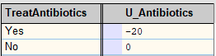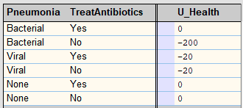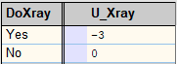

  - Question 6
- The expected utility for doing the X-ray test is -20.702, and for not doing the X-ray test is -24.317.
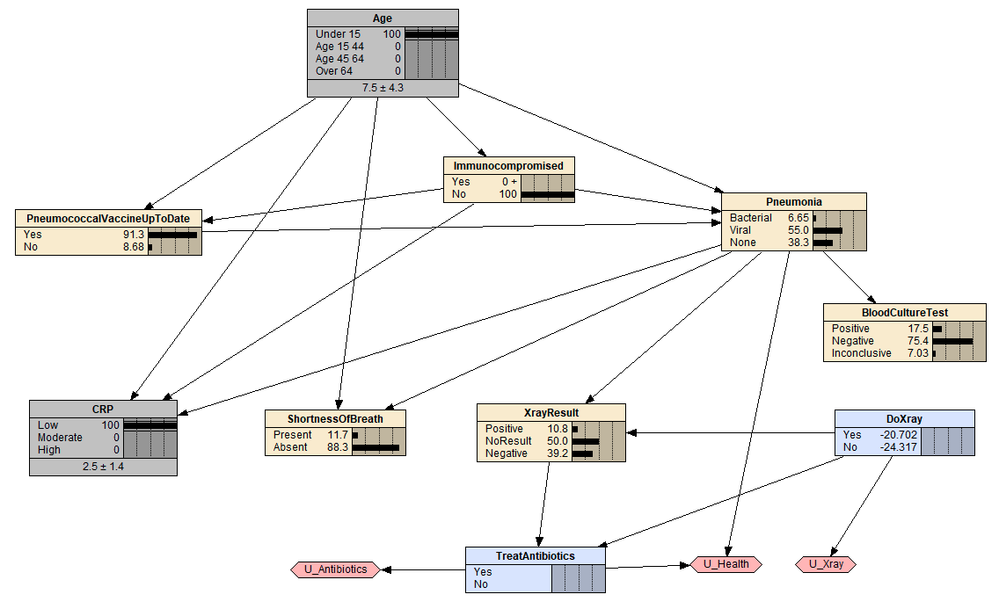

Given the patient did X-ray, the expected utility for taking antibiotics is -34.009 and for not taking the antibiotics is -27.317.
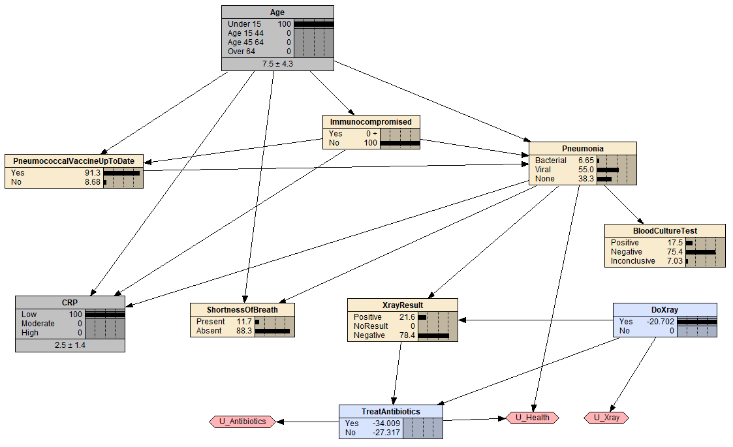
Given the patient did not do X-ray, the expected utility for taking antibiotics is -31.009 and for not taking the antibiotics is -24.317.
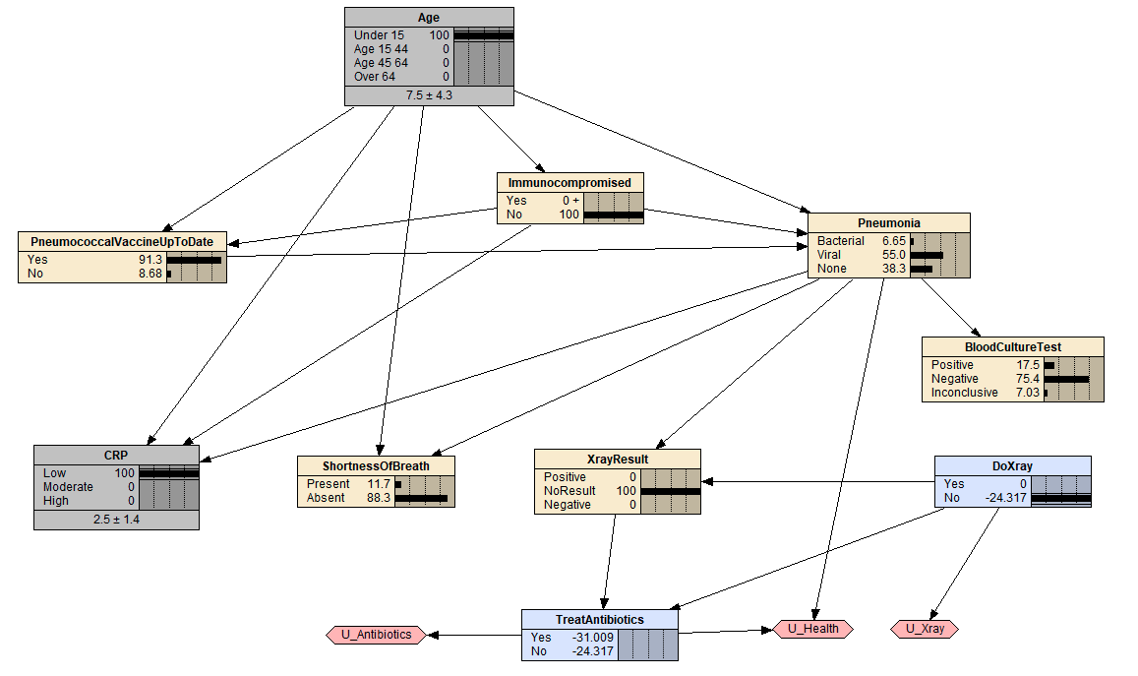

- The results are as follows:
Evidence | P(Bacterial) | EU(X-ray) | EU(no X-ray) | Gap | Decision
CRP low | 6.65% | -20.702 | -24.317 | +3.62 | Take X-ray
CRP low +  Shortness of breath | 14.1% | -24.721 | -31.005 | +6.28 | Take X-ray
CRP moderate +  Shortness of breath | 48.7% | -31.486 | -28.486 | -3.00 | No X-ray

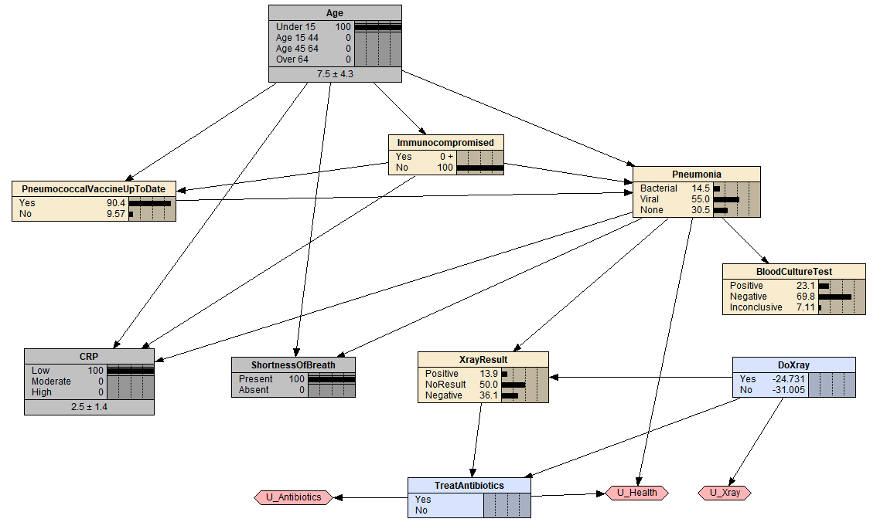
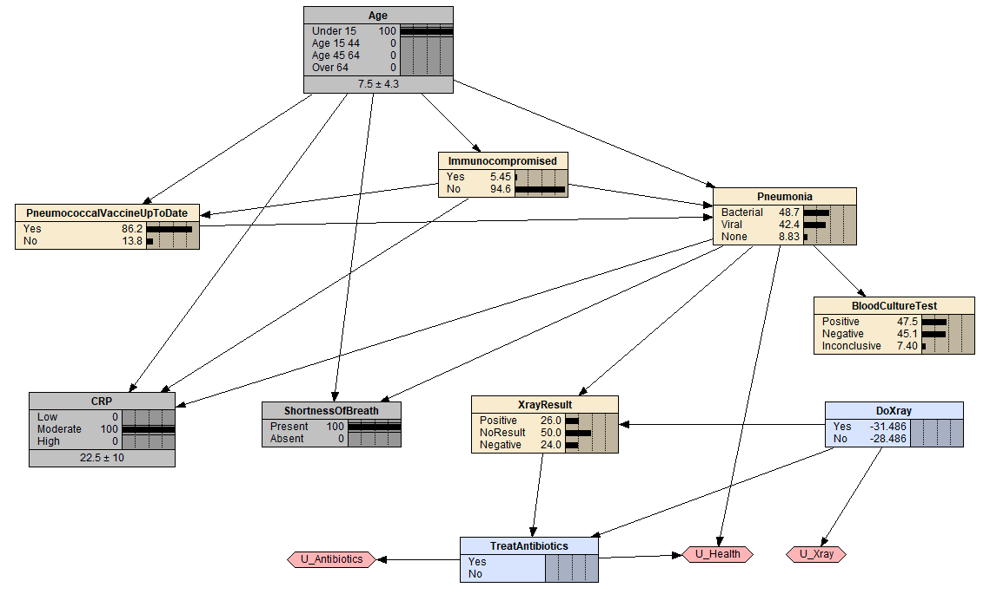
The utility I assigned in the previous question says the patient should only take treatment if b > A/B = 10%. This means a patient should be prescribed when the chance of bacterial pneumonia is above 10%.
If we take the X-ray and the result is positive, chance will rise to 77.2%, we prescribe. If we take the X-ray and the result is negative, chance will fall to 18%, we still prescribe.
Since there is no result that would make the patient do anything different, doing an X-ray in this case would not be worth it.
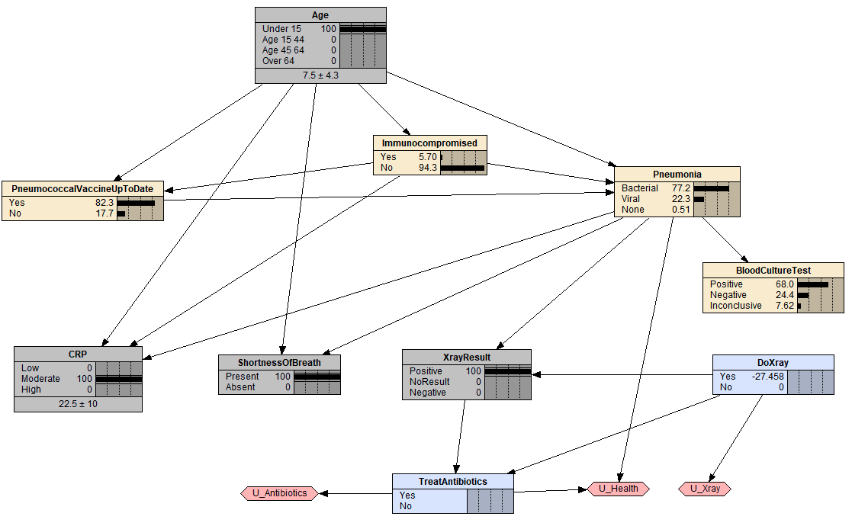
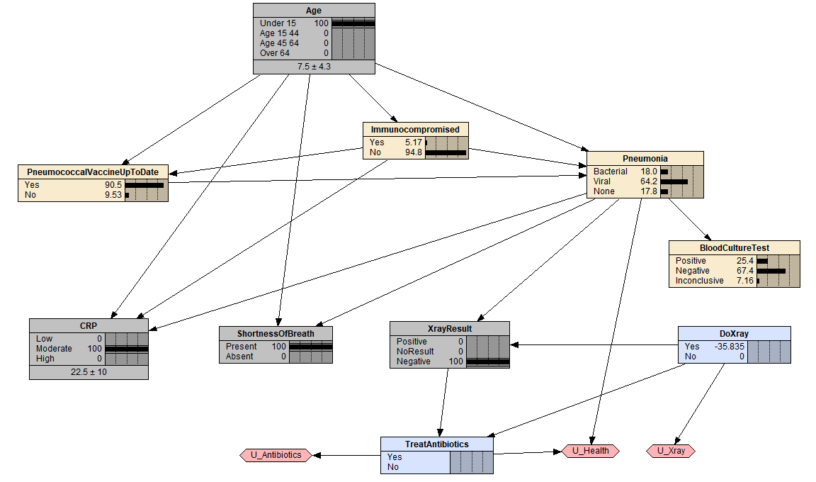

Without the X-ray result, we should treat the patient with antibiotics. With shortness of breath and moderate CRP, the patient’s probability of bacterial pneumonia is 48.7%, which is far above the 10% threshold. In addition, regardless of the X-ray result, we always have to prescribe as a negative result only drags the bacterial probability down to 18%, which is still above the 10% threshold.

