**PARTITIONS**

**PARTITIONS** : A MECHANISM TO DIVIDE THE TABLE DATA INTO MULTIPLE PARTS.

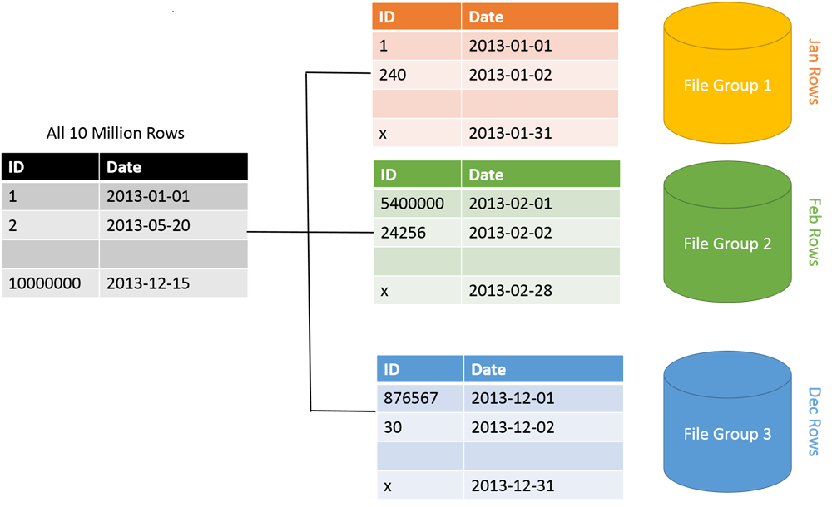

**STEPS TO IMEPLEMENT PARTITIONS:**

STEP 1: DEFINE PARTITION **FUNCTION** - TO SPECIFY THE CONDITION FOR DATA SPLIT

STEP 2: DEFINE PARTITION **SCHEME** - TO SPECIFY THE LOCATIONS FOR DATA SPLIT

STEP 3: IMPLEMENT PARTITIONING ON THE TABLE USING FUNCTION & SCHEME.

STEP 4: APPLY COMPRESSIONS ON OLD (COLD) INACTIVE PART(S) OF THE TABLE [DWH]

Lab: Step 1: Launch SSMS > Connect to your SQL Server > Run the given .SQL File

This installs the source database

Step 2: Right Click Database > New Query > Verify number of partitions for Sales_Data

SELECT * FROM SYS.PARTITIONS WHERE OBJECT_ID = OBJECT_ID('sales_data')

Step 3: To define new partitions on Sales_Data table:

FROM SSMS > CONNECT TO SERVER > DATABASE > EXPAND TABLES > RIGHT CLICK SALES_DATA TABLE > STORAGE > CREATE PARTITION > SELECT PARTITION COLUMN (SalesAmount) > PARTITION FUNCTION, PARTITION SCHEME > SPECIFY FILEGROUP, RANGE (BOUNDARY : LEFT) :

RANGE 1 <=50

RANGE 2 <=500

RANGE 3 REMAINING DATA

ESTIMATE STORAGE > NEXT > RUN IMMEDIATELY.

Step 4: Right Click Database > New Query > Verify number of partitions for Sales_Data

SELECT * FROM SYS.PARTITIONS WHERE OBJECT_ID = OBJECT_ID('sales_data')

**COMPRESSION**

**COMPRESSION** : A MECHANISM TO IDENTIFY UNIQUE VALUES OF A COLUMN AND STORE THEM ONLY ONCE. EX: IF MULTPLE CUSTOMERS HAVE SAME GENDER VALUE THEN STORE THE GENDER VALUE ONLY ONCE AND USE IT AS A REFERENCE FOR ALL REQUIRED CUSTOMERS. THIS SAVES SPACE.

ADVANTAGE OF COMPRESSION : LESS STORAGE SPACE. HENCE FASTER SCANS & SEEKS (SEARCH)

DISADVANTAGE OF COMPRESSION: ANY UPDATES TO TABLE NEED RE-COMPRESS THE DATA.

-- IN REAL-TIME, WE USE COMPRESSION FOR DWH DATABASES (REASON: THEY STORE COLD DATA).

TYPES OF COMPRESSION:

** 1. **ROW COMPRESSION** : APPLICABLE FOR MULTIPLE COLUMNS WITH SIMILAR DATA

EXAMPLE : GENDER & MARITAL STATUS COLUMNS HAVE SAME VALUE "M". UNIQUE COLUMN VALUES ARE STORED

2. **PAGE COMPRESSION** : APPLICABLE FOR MULTIPLE ROWS WITH SIMILAR DATA

EX: SAME PRODUCT SOLD TO SAME CUSTOMER

HOW TO IMPLEMENT COMPRESSIONS?

ALTER TABLE SALES_DATA REBUILD PARTITION = 1 WITH ( DATA_COMPRESSION = ROW)

ALTER TABLE SALES_DATA REBUILD PARTITION = 1 WITH ( DATA_COMPRESSION = PAGE)

ALTER TABLE SALES_DATA REBUILD PARTITION = 1 WITH ( DATA_COMPRESSION = NONE)

-- TO COMPRESS THE ENTIRE TABLE :

ALTER TABLE SALES_DATA REBUILD WITH ( DATA_COMPRESSION = ROW)

-- REAL-WORLD CONSIDERATIONS FOR PARTITIONS, COMPRESSIONS:

USE PARTITIONS BASED ON THE COLUMN(S) USED MOST FREQUENTLY IN QUERIES

USE COMPRESSED PARTITIONS ON COLD (INACTIVE) DATA.