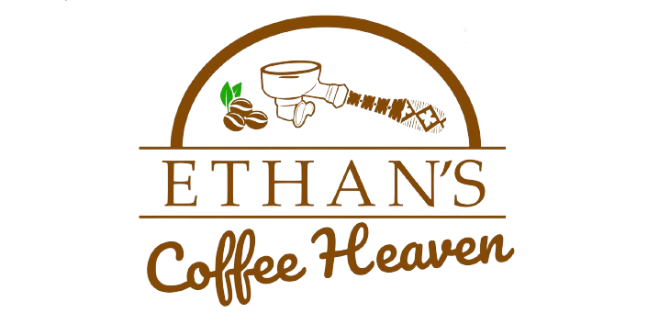
BREAKFAST MENU

Eggs Benedict $15.00
Pouched eggs, bun, bacon, lettuce & sauce.

Eggs Any Style $10.95
2 eggs Poached/ Boiled/ Fried/ Sunny side up with side of wholemeal or white toast.

Ethan’s Pancake $17.00
Banana or chocolate chip pancake, ice-cream, icing and maple syrup.

French Toast $10.95
Maple syrup with icing sugar.

Omelette $12.50
Chicken/ Veggie/ Ham/ cheese and Bacon.

Waffles $12.50
Maple syrup, Honey, Chocolate

Boatsman Breakfast $18.00
2 eggs of your choice, homemade hash brown, grilled tomato, mushroom, baked beans and toast.

Fruit Platter $12.00
Seasonal fruits.

Extras
Egg $2.00
Toast $1.50
Bacon $4.50
Pancake $5.00
Maple $1.50
Honey $1.50
Ice cream $3.50
Hash brown $2.00
Sausage $2.00
Mushroom $3.50
Ketchup $1.00

