First meeting: Alignment

Strategic Initiatives

* Company brand name
* Slogan
* Logo
* Vision and mission statement
* Situational Analysis (SWOT + PESTEL)

Strategy Planning

* Create a strategy based on the goal ~~and research data (e.g., customer)~~
* Markets can be volatile so be able to pivot and change (be flexible)
* Effects of Marketing, R&D, logistics ~~and finance~~
* Branding, Advertising, Public Relations (PR) campaigns

Round 1 (1 operational year) 10/3/2023

* Company Profile
* Logo
* Slogan
* Vision/Mission
* Chairmans
* Business Plan (stick to 5P’s strategy)
* Analysis:
* Competitive
* Product Leadership
* **Elaborate on Decision:**
* At Sneaky, we are dedicated to providing our customers with the best possible products that lead the industry in terms of innovation, performance, and style. Our commitment to product leadership means that we constantly strive to develop new and innovative designs that push the boundaries of what's possible.
* We invest heavily in research and development to ensure that our products are at the forefront of the industry, and we are constantly seeking feedback from our customers to ensure that their needs and preferences are reflected in our designs. Our team of experienced designers, engineers, and marketers work tirelessly to deliver the highest quality products that exceed our customers' expectations.
* We believe that our focus on product leadership sets us apart from the competition, and we are committed to maintaining our position as a leader in the industry. Our customers can trust that when they choose Sneaky, they are choosing products that are innovative, reliable, and stylish.
* Market (Entry Strategy)
* Man (quality + customer intimacy)
* Woman (quality + customer intimacy)
* **SWOT**
* Opportunities
* Growing market for high-quality sneakers due to increasing focus on health and wellness
* Growing trend towards sustainable and eco-friendly products
* Expansion into new markets through strategic partnerships and acquisitions
* Focus on digital marketing and social media to reach younger consumers
* Threats
* Intense competition from established players in the market
* Fluctuating raw material prices and supply chain disruptions
* Economic downturns and consumer spending changes
* Potential shifts in consumer preferences and fashion trends
* Government regulations and trade restrictions that impact the import/export of products.
* Strengths
* High-quality products that are durable and comfortable
* Strong brand image and reputation in the market
* High level of customer intimacy and focus on customer needs
* Innovative product designs that appeal to customers
* Strong distribution network and partnerships with retailers
* Experienced and knowledgeable management team
* Employee learning and growth: HR Care places a strong emphasis on the professional development of its employees. This is evident in the company's training programs, mentorship opportunities, and career advancement paths.
* Employee satisfaction: By prioritizing employee learning and growth, HR Care is able to create a positive work environment that promotes job satisfaction and employee retention. This can result in higher productivity, better customer service, and a stronger company culture.
* Weakness
* High pricing may limit market penetration
* Dependence on a few key suppliers for raw materials
* Counterfeiting: The sneaker industry is plagued by counterfeiting, which can dilute the brand image and result in lost revenue.
* Seasonality: The demand for sneakers can fluctuate with the seasons, with sales typically peaking in the summer and around holidays.
* Dependence on fashion trends: The sneaker industry is heavily influenced by fashion trends, and a misstep in design or style can result in excess inventory and lost sales.
* **Elaborate on Decision:**
* Based on the SWOT analysis, there are several opportunities for a high-quality sneakers shoes company with a focus on customer intimacy, including expanding the product range, offering customization, emphasizing social responsibility, expanding e-commerce capabilities, and partnering with fashion designers or other brands. However, it is important to carefully evaluate the potential impact on costs, production efficiency, and brand image when considering these options.
* Identity
* Targets
* Customer/market
* Highest Quality (2nd as a target) (KPI) - 1st achieved
* Market Leader in quality segments (2nd as a target) - 1st achieved
* Percentage of having decline a sale (2%) - 18.34% achieved – stock issue
* Learn & Growth
* Education level of staff (75% as a target) - 71.66% achieved
* Motivation staff (75% as a target) - 64.76% achieved
* Sustainability policy
* Gender equality
* Responsible consumption and production
* Climate Action
* **Elaborate on decision:**
* By emphasizing responsible consumption and production practices, our company aims to reduce waste and environmental impact while promoting circularity in the sneaker industry. This statement reflects the company's commitment to sustainability by taking a proactive approach towards responsible consumption and production. To achieve this, the company may adopt practices such as using sustainable materials, reducing waste in production processes, and implementing recycling programs for end-of-life sneakers. By doing so, the company can reduce its carbon footprint and promote a circular economy, where resources are reused, recycled, and repurposed. Additionally, the company can promote sustainability by educating customers on the importance of responsible consumption and encouraging them to choose products that are environmentally friendly and durable.
* Perspective
* Growth (ANSOFF)
* Product development
* You are developing new products for existing markets. How can your existing customer be better serviced and how will your products become better than those of your competitors?
* **Elaborate decision:**
* By developing new products for our existing markets, we aim to better serve our customers by offering them innovative and high-quality sneakers that meet their evolving needs and preferences, while also differentiating ourselves from our competitors. This statement highlights the company's focus on product development to better serve existing customers and gain a competitive advantage. To achieve this, the company may invest in research and development to identify new materials, designs, and features that enhance the performance, comfort, and style of their sneakers. Additionally, the company may seek feedback from customers to understand their preferences and tailor their product development efforts accordingly. By doing so, the company can improve customer satisfaction and loyalty, while also differentiating themselves from competitors by offering unique and innovative products.
* Decisions
* Management:
* 2 Employees
* Customer Manager (low wages)
* Marketing Manager (low wages)
* Activities focused on
* Large Clients
* Important customers, measured by turnover, receive extra attention from you. This personal approach will make them feel more valued and increases their loyalty. Furthermore, it will increase the chance for sales in this target group.
* Market Analysis
* Focusing on data quality will allow you to better analyze a market or your competition. The names of your competitors will be visible so you know which competitors are active in the different segments.
* Risk Management
* Managing risk ensures a company's safety. Additionally, it will create trust for providers of capital and may result in lower interest rates for new loans.
* Purchasing
* Increase warehouse size 3000 -> 6000?
* Mens/Woman Sneakers
* Distributor
* Fast delivery
* Order limits
* 500-3000
* Order months
* 12 (Dec)
* Marketing
* Product
* Agreements
* Research & Development
* Research & Development
* Research & Development: 2 (people)
* Budget R&D: 100%
* ~~Machine~~
* R&D research projects
* ~~Decrease purchasing costs~~
* Reliability: 40%
* Quality research to unlock stars: 40%
* Innovation research: 20%
* Price
* Mens/Women: 125 euros
* Place
* Selective distributor
* Using selective distribution, you only use stores and outlets that fit your product. It will have a positive impact on your position within the quality market, as well as improve your customer-relationship, but will have a slight negative effect on your position in the price-market.
* Promotion
* Online Marketing
* Website SEO
* Extended
* ~~Advertise on search engine results (adwords)~~
* Advertise using a large online social network
* Monthly Budget: 5000 euros
* Advertise on online Linked business network
* Monthly Budget: 200
* Billboard
* Staff
* Recruitment
* Recruitment Program: Basic
* On Boarding
* Current Workforce
* Maximum workload per employee 100%
* Current amount of FTEs (Full Time Employees) 0 (9 employees)
* ~~Purchase HCM~~
* Reward
* Renumeration (increase wages): 1%
* Bonuses on Above Target: 2%
* Profit sharing: 0%
* Education
* Development high potential program
* Education budget: 1000 euros
* Time per employee allocated for training purposes: 0.05FTE
* Coaching and mentors programme
* ~~Mandatory internal courses~~
* ~~Financial (loan)~~

RESULTS

Internal Results

*Inventory*

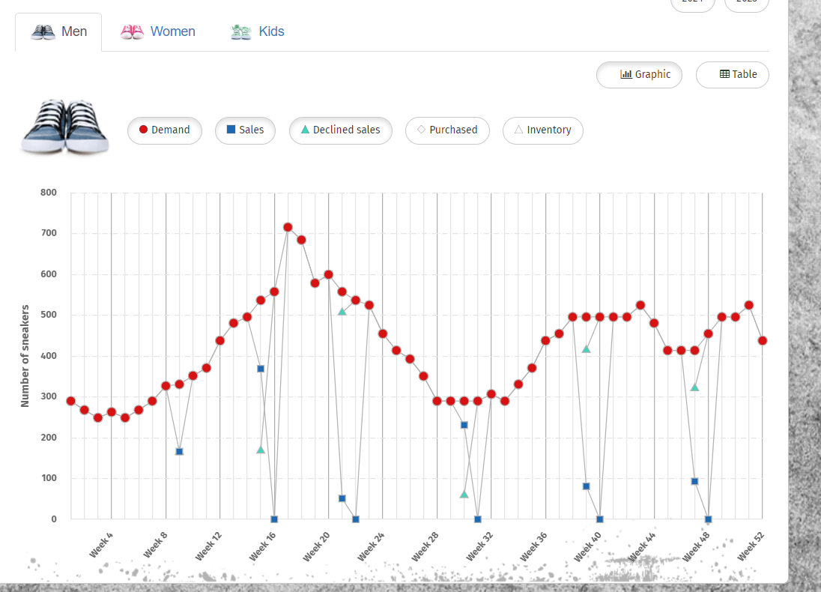

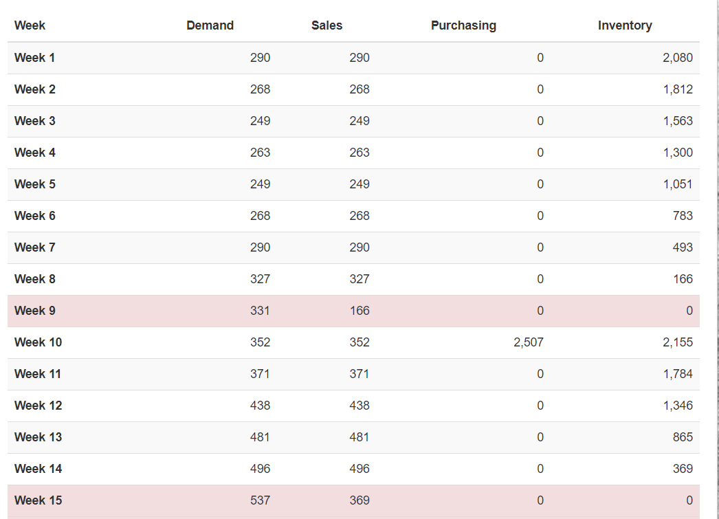

*Staff*

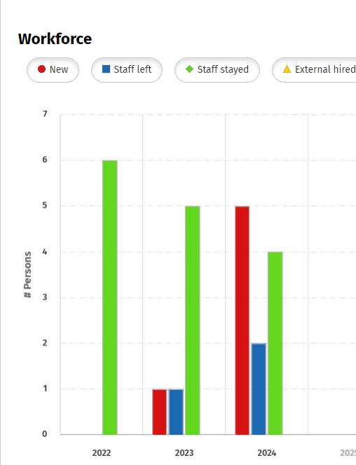

Financial Results

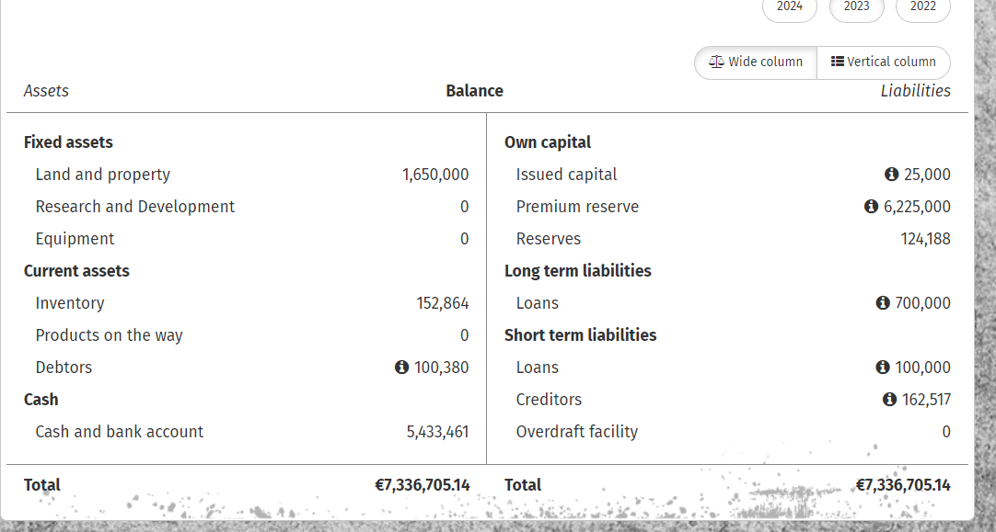

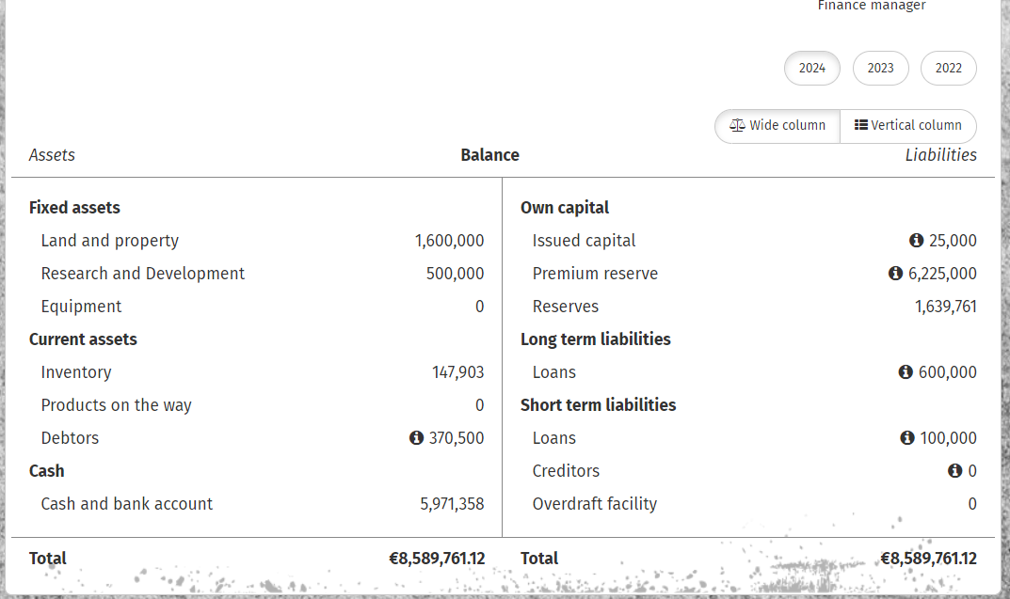

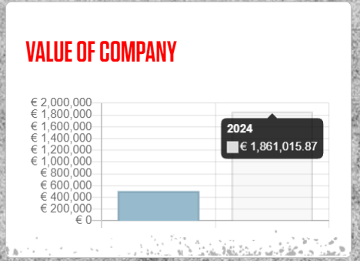

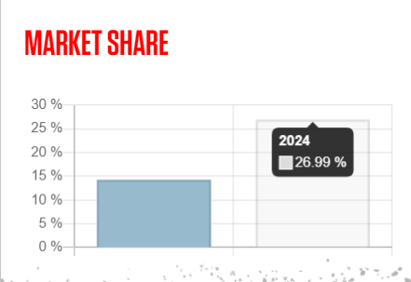

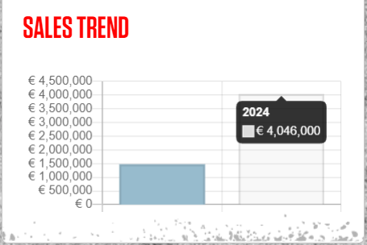

Round Feedback thoughts summary

Positives

* Keep minimum staff & R&D (as a startup build foundation)
* Give bonuses to on above target
* Focus Market
* Marketing campaigns (SEO)
* Product development with highest quality

Negatives

* Low investment
* Low Risk (stronger competitors could have won)
* Low Inventory
* Low R&D

Second Meeting for 17/03/2023

Round 2 (x operational year’s )17/03/2023