1) 11 человек из германии - SELECT \* FROM Customers WHERE Country LIKE 'Germany';

2) Имена 4 клиентов оканчиваются на на 'e';

3) INSERT INTO Customers (CustomerID, CustomerName, ContactName, Address, City, PostalCode, Country) VALUES ('92', 'Student', 'Viktor Volkov', 'Lineynaya 47', 'Novosibirsk', '630105', 'Russia');

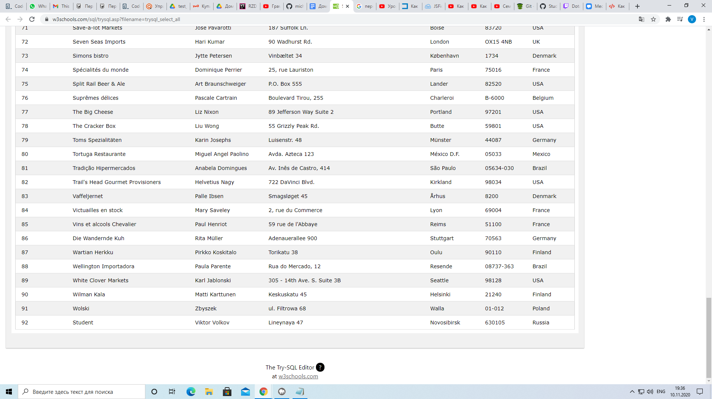

4) UPDATE Customers

SET ContactName = 'Petya Petrov'

WHERE CustomerID = 92;

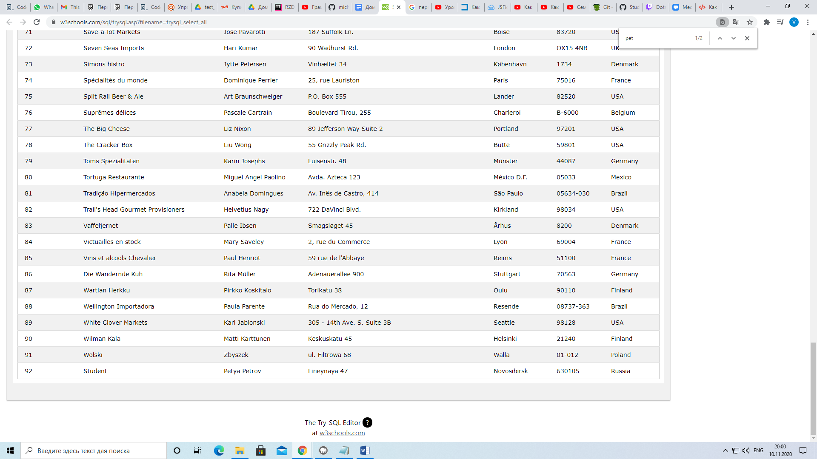

5) Delete From Customers WHERE city = 'Nantes';

Result: You have made changes to the database. Rows affected: 2

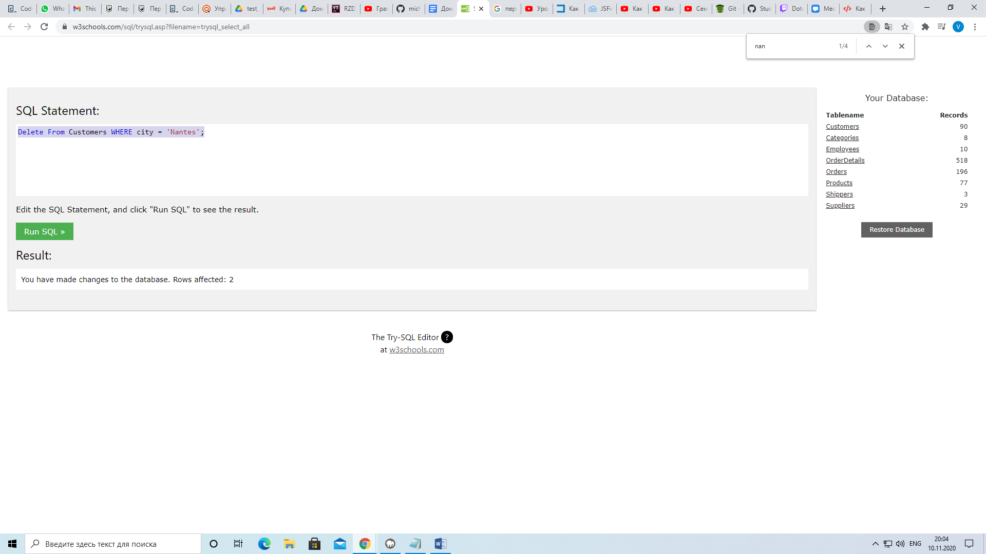

6) 10248 10254 10269 10297 10320 10333 10358 10359 10372 10378 10397