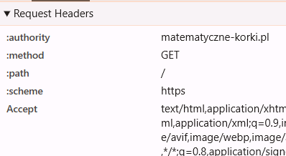
Z1
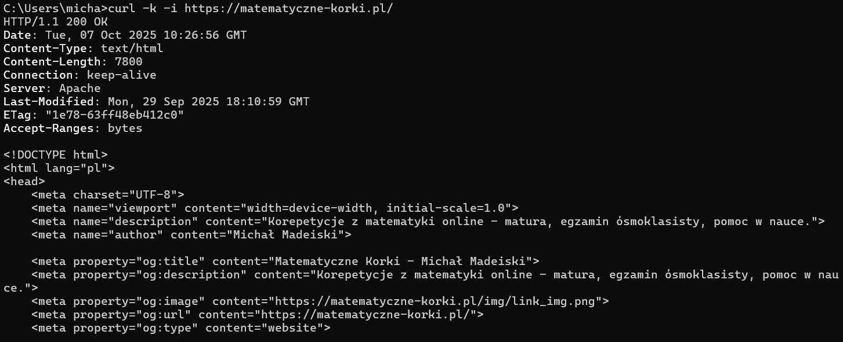
Z2
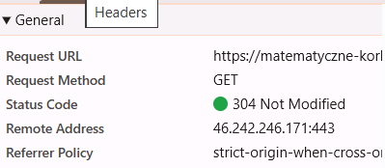
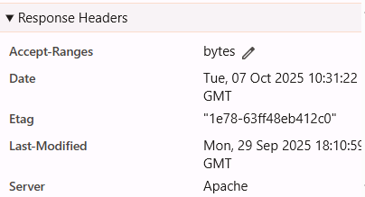

Z3
https://www.google.com/search?q=pogoda+wroclaw&rlz=1C1CHBD_plPL973PL973&oq=pogoda+wroclaw&gs_lcrp=EgZjaHJvbWUyBggAEEUYOTIMCAEQABhGGIACGIAEMgcIAhAAGIAEMgcIAxAAGIAEMgcIBBAAGIAEMgcIBRAAGIAEMgcIBhAAGIAEMgcIBxAAGIAEMgcICBAAGIAEMgcICRAAGIAE0gEIMjUxN2owajeoAgCwAgA&sourceid=chrome&ie=UTF-8
https://www.google.com/search?q=pogoda+warszawa&rlz=1C1CHBD_plPL973PL973&oq=pogoda+warszawa&gs_lcrp=EgZjaHJvbWUyBggAEEUYOTIMCAEQABhGGIACGIAEMgcIAhAAGIAEMgcIAxAAGIAEMgcIBBAAGIAEMgcIBRAAGIAEMgcIBhAAGIAEMgcIBxAAGIAEMgcICBAAGIAEMgcICRAAGIAE0gEIMjUxN2owajeoAgCwAgA&sourceid=chrome&ie=UTF-8
Z4
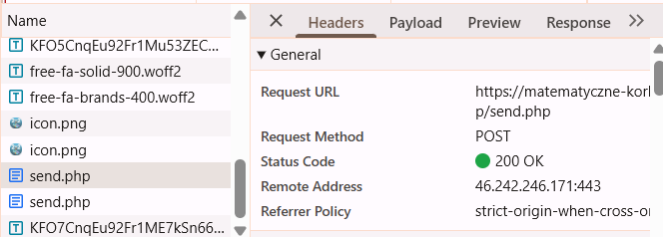
Z6
