Intro:

Consider n-bit integer (for arbitrary natural n). There is a way to encode factorization problem for such an integer as a boolean formula in CNF form, which is satisfiable iff original integer is composite. Moreover such satisfying assignment reveals information about factors.

Consider following multiplication: N = P*Q (1). To reduce Integer Factorization to SAT-CNF it suffices to encode multiplication (1) as a boolean formula in CNF form. N, P, Q can be represented as a n-bit vectors of boolean variables. The only vector which has to be fixed is N. It can be enforced by a set of unit clauses enforcing the value of N.
For instance consider N = 5
In binary bin(N) = 101
We can use 3 boolean variables to describe N=<x0, x1, x2>
We see that: x0=1, x1=0, x2=1. We can enforce N=5 by adding following constraint (set of clauses):
x0 ^ ~x1 ^ x2
It is possible to show that this is the only dependence on a particular (fixed) value of N. The multiplication (1) itself can be encoded the same way regardless of the value of N (for all n-bit N's).

It is reasonable then to consider only the part of the boolean formula which encodes n-bit multiplication alone (which is the same for all n-bit numbers).

 | Average number of positive literals in a solution | Percentage of positive literals in a solution (at average)
4 | 11 | 0.25
8 | 19 | 0.25(3)
16 | 24.88 | 0.2182
32 | 35.0784 | 0.2179
64 | 44.7432 | 0.2071
128 | 57.8591 | 0.2074
256 | 70.6718 | 0.2019
512 | 86.8677 | 0.2025
1024 | 102.9083 | 0.1994
2048 | 122.3466 | 0.2002
4096 | 141.5085 | 0.1982
8192 | 164.1273 | 0.1989

Percentage of positive literals in a solution (at average) is close to 1/5 but slightly varies depending on number of bits

Graphs for N=1024
Number of satisfying assignments having exactly n-variables set to TRUE.
Y axis - number of satisfying assignments
X axis – number of variables set to TRUE in a satisfying assignment
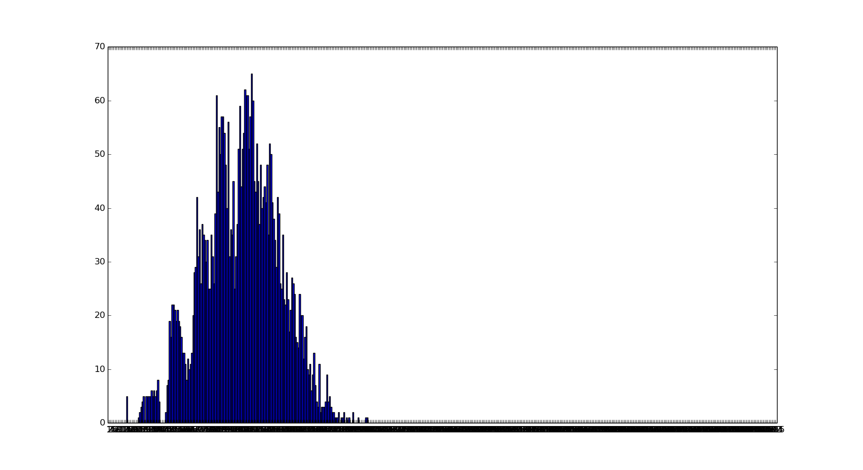
Y axis – number of satisfying assignments in which X appears to be set to TRUE
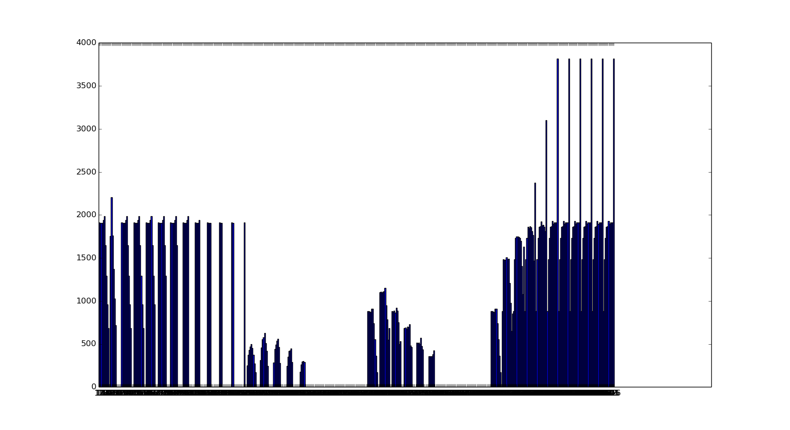

Graphs for N=8192
Number of satisfying assignments having exactly n-variables set to TRUE.
Y axis - number of satisfying assignments
X axis – number of variables set to TRUE in a satisfying assignment

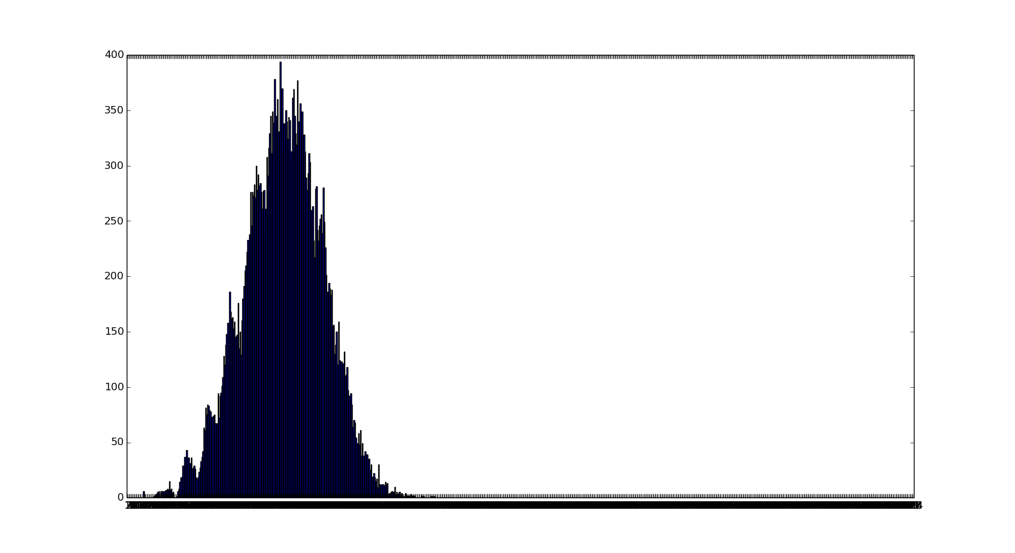
Y axis – number of satisfying assignments in which X appears to be set to TRUE
