Michal Lizler
6/9/2025
DSC 333: Intro to Big Data

Final Project Report

  - Introduction:
In the age of data-driven decision making, many industries focus on trying to predict what will sell the most. This project will explore the relationship between popularity and various other attributes within songs. Using regression model, we are seeking to predict songs popularity based on numerical attributes like tempo, energy, danceability, positiveness, and other audio characteristics provided in the dataset. The objective of this project is to include data processing and exploration using spark, using Athena to query my data, Orchestration of my data pipeline/scaling improvements, and lastly results and model evaluation.

Dataset:
For this project I decided to use the “500K+ Spotify Songs with Lyrics,Emotions & More” for my analysis, because of the large amount data which was around 500k songs and 39 columns. These columns were very broad and included categories like Speechiness and Liveness which I thought would be interesting in the analysis. Last reason for picking this dataset was because of its organization and how well it was structured therefore it was easier to work with. The size of the dataset was over 1GB.

Data Processing/Transformation:
I firstly removed all non-numerical fields and length since my project focuses on different aspects of the dataset. Then I removed all the duplicates and converted explicit column from yes/no to Booleans. I then made sure all my fields were converted to an int or a float and then dropped all the rows with any field classified as null. This got rid of around 15k rows which left us with around 490k rows of data confirming how well organized and thorough this dataset is. I then treated all continuous numerical fields for skewness since all of them were not properly distributed. Lastly, I checked for multicollinearity and removed “good for yoga” since it had high correlation with another variable called “good for meditation”. This left me with a dataset that was ready for machine learning.

Model Evaluation
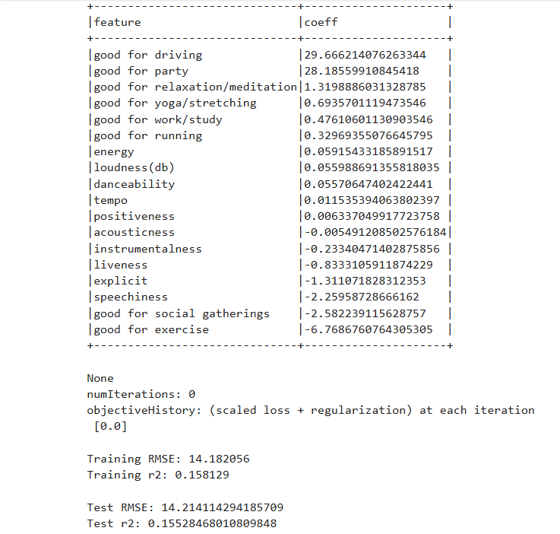
As we can see in the figure above, we can see each of our predicting variables (features) and their impact on our predicted variable (popularity). We can see that the "good for driving" and "good for party" Booleans were most impactful in our model. Then, at the bottom of the picture, we can see our training and testing results. We can see that our RMSE is at 14, and popularity was rated out of 100, which could be better, but I originally anticipated much worse results. Testing and training R² were around the number I anticipated, since these numerical attributes do not tell us much about a song, since many songs can have the same number in each category but sound completely different.
The model could be improved if I removed less impactful features. I decided against removing features, since only two have a meaningful impact, and they were Booleans. Therefore, the results were not as interesting, since "good for party" and "good for driving" are the two most obvious parameters for a song being popular. I could’ve encoded the lyrics and changed the genre to categorical fields. This caused me issues, since many songs were part of multiple genres, and those were separated by commas. This was also an issue in lyrics, which kept breaking my Athena table, which caused many headaches while working on this project.
Lastly thing that could’ve helped the model was having another database with each artist and their popularity, because it could help balance out the data, since a more popular artist has a bigger chance that their song becomes more popular. Lastly, and probably most important, I could’ve chosen a different technique than regression, since this is the simplest (which means least accurate) method for building prediction models.

Current work flow
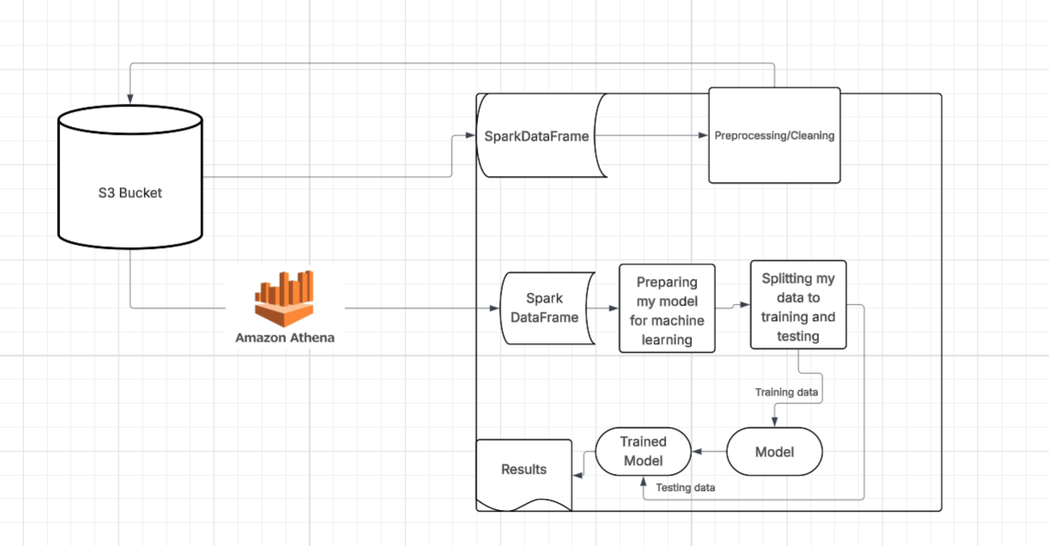

Expanded Design
In the expanded design the Data would be pulled by genre which would then show us which genre is affected most by which column

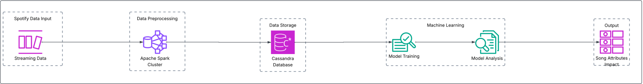

Challenges
Biggest challenges that I faced while working on this project was getting more familiar with Amazon Athena since it is not a database it but an intermediary between me and the data in my bucket, which gave me some headaches when trying to redefine my table and change columns after they were created since there was no way of checking it in the s3 bucket. Another challenge was getting used to working with that large amount of data since Spark was so fast, I sometimes forgot that I cannot just load my entire dataset into Panda data frame since that would crash my cluster. The benefit of distributed computing is the speed since my dataset was quite large and most of the computations took around 1 minute maximum.

Conclusion
In conclusion, I think there is more to explore if I had even more data, but in the end, I think it is hard to predict songs success solely on data that comes with the song since there are many other outside factors that affect songs popularity. In my future work, if I find time and even bigger dataset, which could include even more data including artists popularity at the time of release, if the song became popular on social media and lastly access to Spark and rest of the AWS arsenal, I think I would continue on this project and try to see if I can make the model more accurate.

Sources:
Devdope. 900k Spotify Dataset. Kaggle, May 14th 2025, https://www.kaggle.com/datasets/devdope/900k-spotify.

