CS 361

Michal Bochnak

Netid: mbochn2

Oct 26, 2017

Homework Assignment #3

Simulation of a Memory Paging System Report

Analysis below is as follows:

1. General results for Chevalier_473.nz, as specified in Blackboard instruction #4.
2. Two files group (a and b). Each group contains analysis data of 2 similar images.
3. Final analysis which takes results from above bullet point (2) under the consideration, and compares results from the group #1 with the results from group #2.

**1.**

Results for file: Chevalier_473.nz, number of memory accesses: entire file, frame table size: 256.

# of memory accesses: 1013613

Infinite memory hits: 950938

Infinite memory misses: 62675

FIFO memory hits: 98290

FIFO memory misses: 915323

**2a.**

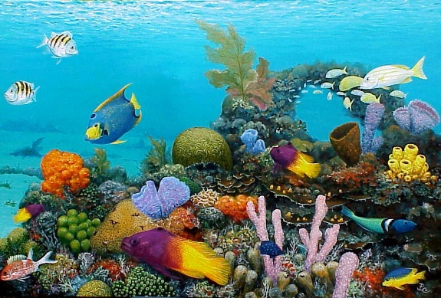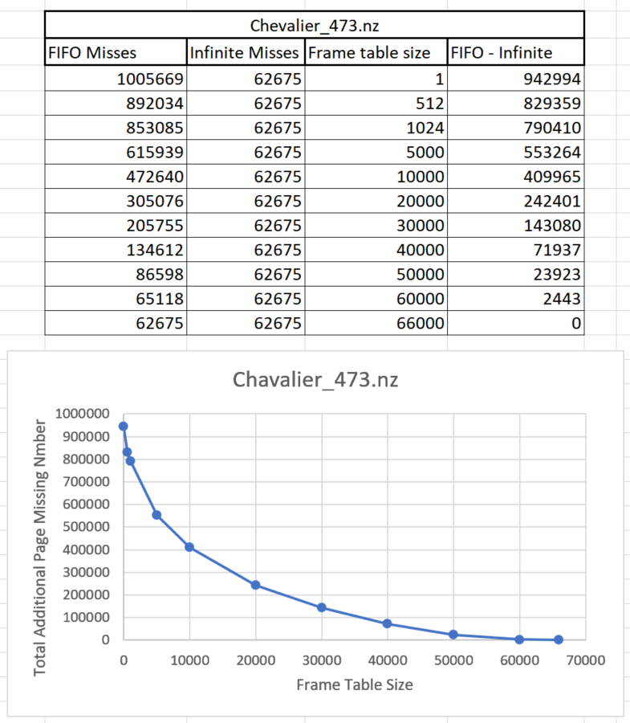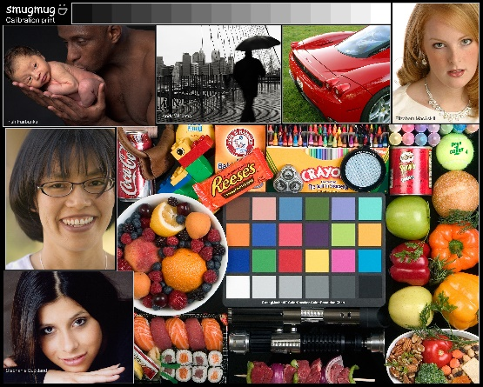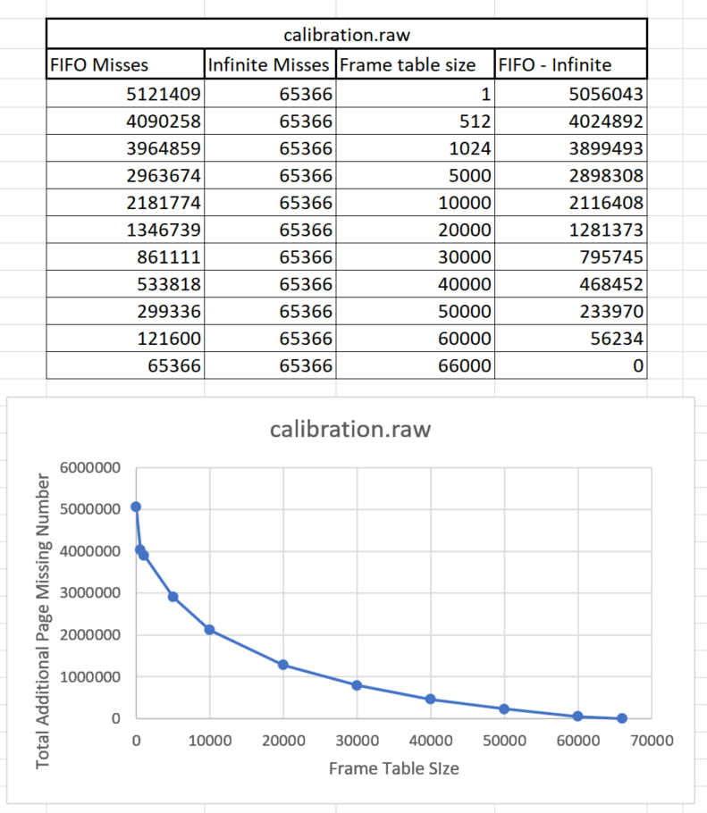

**2b.**

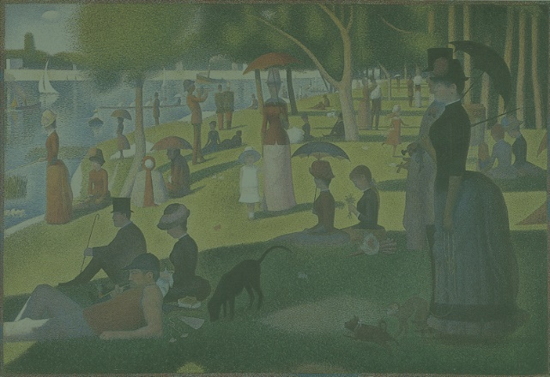

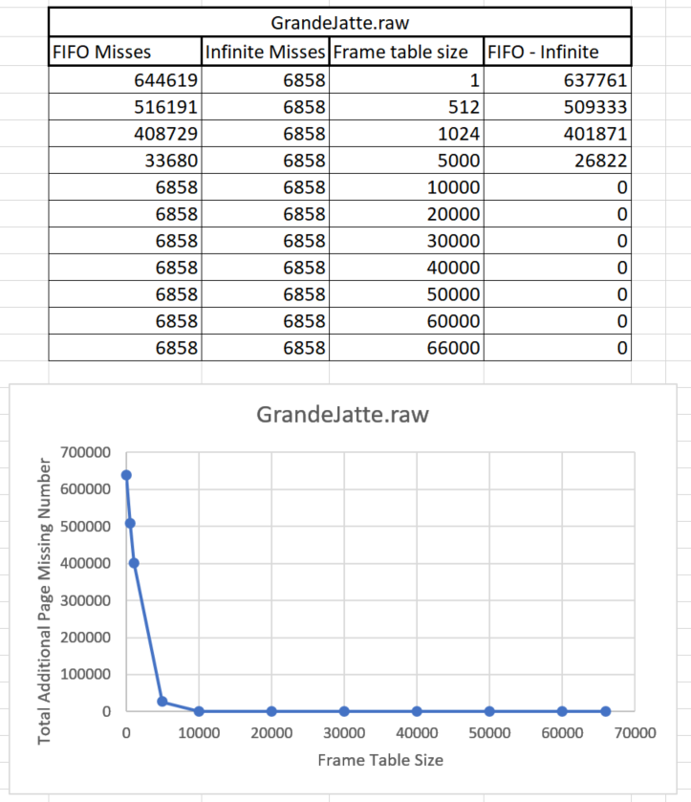

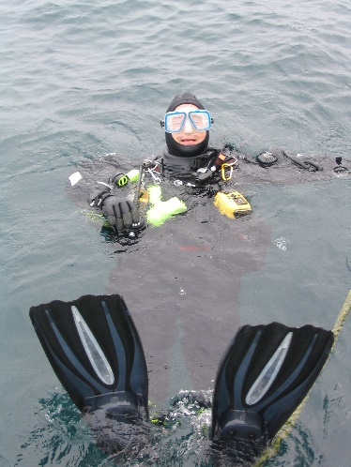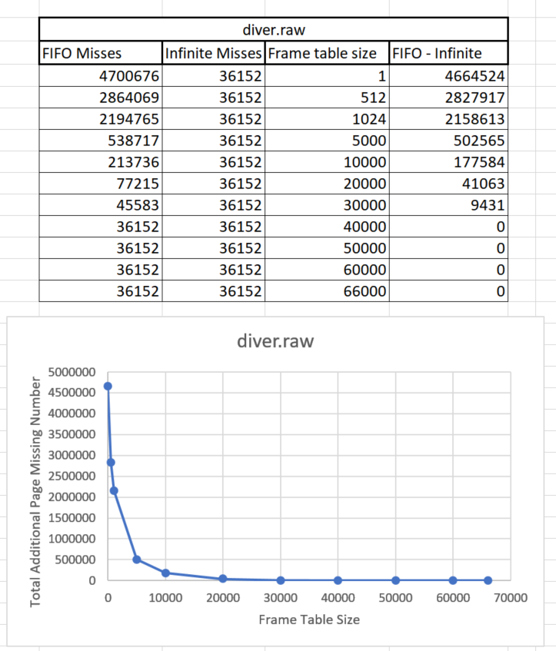

Chevalier_473 and calibration (2a) both have similar graphs. Since pixels are very diverse on both images we need frame table size of around 66000 for FIFO to be able to fit all possible colors and get the same number of misses as for the infinite memory. We can also see that doubling the size of the frame table have relative impact on the improvement in hits. For example, doubling the frame table size for calibration image from 512 to 1024 reduces number of misses by only around 3%, while doubling the frame size from 10,000 to 20,000 reduces misses by around 38%. That indicates that size of frame table at some point will fit all the possible memory accesses and all data needed will be there. That is proven by the graph when table size is reaching 66,000. That seems to be true also for the GrandeJatte and diver images (2b). In that case doubling frame size for diver image from 512 to 1024 reduces misses by about 23%, but doubling from 10,000 to 20,000 reduces misses by 64%. From that we can clearly see that images from group 2b will need smaller frame table size to fit all possible combination of colors. That is because colors range on these images is smaller. More colors are similar. Thus, there is greater probability for the group 2b that color is already in the table than it is for group 2a which have much greater range of colors. Group 2b needs frame table size of little bit above 30,000 (diver) and less than 10,000 (GrandeJatte) to fit all possible combination, while group 2a need frame table size of almost 66,000 for both images. 2b group graph is much steeper at the begging than 2a graph.