Multiscale Statistical Process Control of RR Interval Dynamics for Explainable Pre-Onset Characterization of Paroxysmal Atrial Fibrillation
Michel Alexander Castañeda Alarcón¹ (ORCID 0009-0006-9860-0865), Javier Díaz-Carmona¹ (ORCID 0000-0002-7363-3349), Horacio Rostro González²,³ (ORCID 0000-0001-7530-9027), and Alejandro Espinosa-Calderón⁴ (ORCID 0000-0002-1758-4212)
¹ Tecnológico Nacional de México / Instituto Tecnológico de Celaya, Celaya, Guanajuato, Mexico
² Universidad de Guanajuato, Guanajuato, Mexico
³ IQS School of Engineering, Universitat Ramon Llull, Barcelona, Spain
⁴ Tecnológico Nacional de México / CRODE Celaya, Celaya, Guanajuato, Mexico
Corresponding author: Michel Alexander Castañeda Alarcón, m2003047@itcelaya.edu.mx
Abstract. Paroxysmal atrial fibrillation (PAF) may be preceded by subtle changes in rhythm dynamics that are difficult to characterize using conventional heart-rate variability (HRV) descriptors alone. This study proposes a multiscale statistical process control (SPC) framework for explainable pre-onset characterization of PAF from RR interval dynamics. The analysis used the PhysioNet PAF Prediction Challenge Database learning set, restricted to the main 30-min p-records. For each consecutive odd-even p-record pair, the odd record was labeled as PAF-distant and the even record as pre-onset. Continuation records ending in c and n-records from subjects without documented atrial fibrillation were excluded from the primary paired task. RR intervals were derived from QRS annotations and analyzed using RR-count windows, 5-min windows, and full-record aggregation. Interpretable HRV and SPC features were extracted using Shewhart, CUSUM, EWMA, moving-range, and runs-rule descriptors. Grouped validation by pair identifier and 500 pair-level bootstrap iterations were used to reduce leakage and quantify uncertainty. SPC configurations improved over reduced HRV descriptors, with B_SPC reaching AUC = 0.776 (95% CI: 0.694-0.863) and pairwise concordance = 0.840 (95% CI: 0.733-0.941). Shewhart out-of-control rate and count showed the strongest paired pre-onset increases. These findings support SPC as an interpretable feature-engineering layer for ECG rhythm characterization, requiring external validation before clinical deployment.
Keywords: Electrocardiography · Statistical process control · RR intervals · Paroxysmal atrial fibrillation · CUSUM · Explainable machine learning · PhysioNet
1 Introduction
Paroxysmal atrial fibrillation (PAF) is clinically relevant because its intermittent presentation makes it difficult to observe directly during routine electrocardiographic evaluation. The PhysioNet/Computing in Cardiology Challenge 2001 was designed around this difficulty by asking whether ECG segments recorded before PAF contain enough information to characterize imminent arrhythmia onset [1,2]. In the challenge formulation, the relevant question is not merely whether atrial fibrillation is present, but whether the pre-onset state contains detectable changes in the surface ECG or derived RR interval dynamics.
Most automated approaches to PAF onset analysis have relied on heart-rate variability (HRV), RR irregularity, ectopy-related features, entropy measures, or machine-learning classifiers trained over RR-derived descriptors [4-9]. Such methods can provide useful discrimination, but they often summarize the signal through global statistics or performance-oriented models. In biomedical settings, and particularly in high-stakes settings, this creates two related difficulties [17]: the signal behavior leading to a decision can be hard to explain, and model performance estimated on small retrospective datasets can be overinterpreted as clinical predictiveness.
Statistical process control (SPC) offers a complementary perspective. Instead of treating RR intervals only as aggregate HRV descriptors, SPC models the RR sequence as a temporal process subject to expected variation and special-cause deviations. Shewhart charts, CUSUM, EWMA, moving-range statistics, and runs rules can transform RR dynamics into interpretable process-behavior features: pointwise deviations, cumulative drift, gradual changes, local instability, alarm density, and persistence of abnormal patterns [10,11]. This creates a bridge between biomedical signal processing and explainable machine learning, because each feature family corresponds to a recognizable temporal behavior of the physiological process.
This paper proposes a multiscale SPC feature-engineering framework for explainable pre-onset characterization of PAF using RR intervals from the PhysioNet AFPDB learning set. The study emphasizes characterization rather than clinical deployment. Specifically, it evaluates whether SPC-derived features can distinguish PAF-distant and pre-onset records within matched p-record pairs and whether these features add discriminative and interpretive value beyond reduced HRV descriptors.
The contributions are fourfold: (i) a corrected paired AFPDB design that uses only the main 30-min p-records for the primary far-vs-pre-onset task; (ii) a multiscale RR representation including RR-count windows, 5-min windows, and full-record aggregation; (iii) an interpretable SPC feature set based on Shewhart, CUSUM, EWMA, moving-range, and runs-rule descriptors; and (iv) a leakage-aware evaluation strategy based on pair-level grouping, fold-local collinearity control, 500 pair-level bootstrap iterations, and pairwise concordance.
2 Related Work
2.1 PAF Pre-Onset Analysis and AFPDB
The PAF Prediction Challenge Database was introduced to support the study of imminent PAF from ECG excerpts [1,2]. Its learning set contains records beginning with p and n. The p-records come from subjects with PAF [3]. In each p odd-even pair, the even-numbered 30-min record immediately precedes a PAF episode, which can be verified in the like-numbered continuation record ending in c. The odd-numbered record is distant from PAF. Records beginning with n come from subjects without documented atrial fibrillation [3]. This structure is essential: mixing n-records or continuation c-records into the primary paired pre-onset task changes the scientific question.
Early work on PAF prediction explored whether pre-onset rhythm behavior contains information sufficient to distinguish imminent PAF from more distant segments [2-5]. Subsequent studies used HRV, wavelet, entropy, ectopy, and machine-learning features to improve discrimination [6,7]. These studies motivate the present work, but our emphasis differs: the goal is not to claim clinical prediction readiness, but to build an interpretable multiscale representation of the pre-onset state.
2.2 HRV, Interpretability, and Statistical Process Control
HRV analysis provides established descriptors of autonomic and rhythm variability, including RMSSD, standard deviation of RR intervals, coefficient of variation, and Poincare-derived SD1 and SD2 [10,11]. These features are interpretable and useful, but they may not explicitly describe how deviations evolve over time. A pre-onset state may involve not only increased variability but also changes in alarm frequency, cumulative drift, or sequential persistence.
SPC methods were developed for process monitoring and have been extended to healthcare surveillance, quality monitoring, and clinical performance evaluation [8,9]. In ECG-derived RR analysis, the analogy is natural: a patient's rhythm can be treated as a temporal process, and departures from its baseline behavior can be summarized through process-control descriptors. This study uses that analogy to generate features that remain computationally simple and interpretable.
3 Materials and Methods
3.1 Dataset and Corrected Paired Design
The analysis used the learning set of the PhysioNet AFPDB. Only the 50 main p-records were used for the primary task. Odd p-records (p01, p03, ..., p49) were labeled as PAF-distant segments (y = 0), and even p-records (p02, p04, ..., p50) were labeled as pre-onset segments (y = 1). Each odd-even pair was assigned a common pair_id, yielding 25 matched pairs.
Continuation records ending in c were excluded from training and evaluation because they verify what occurs after the main 30-min segment; they are not the primary pre-onset samples in the paired learning task. Records beginning with n were excluded from the primary task because they represent subjects without documented AF and address a different question, namely risk-group or screening discrimination rather than within-PAF pre-onset characterization.
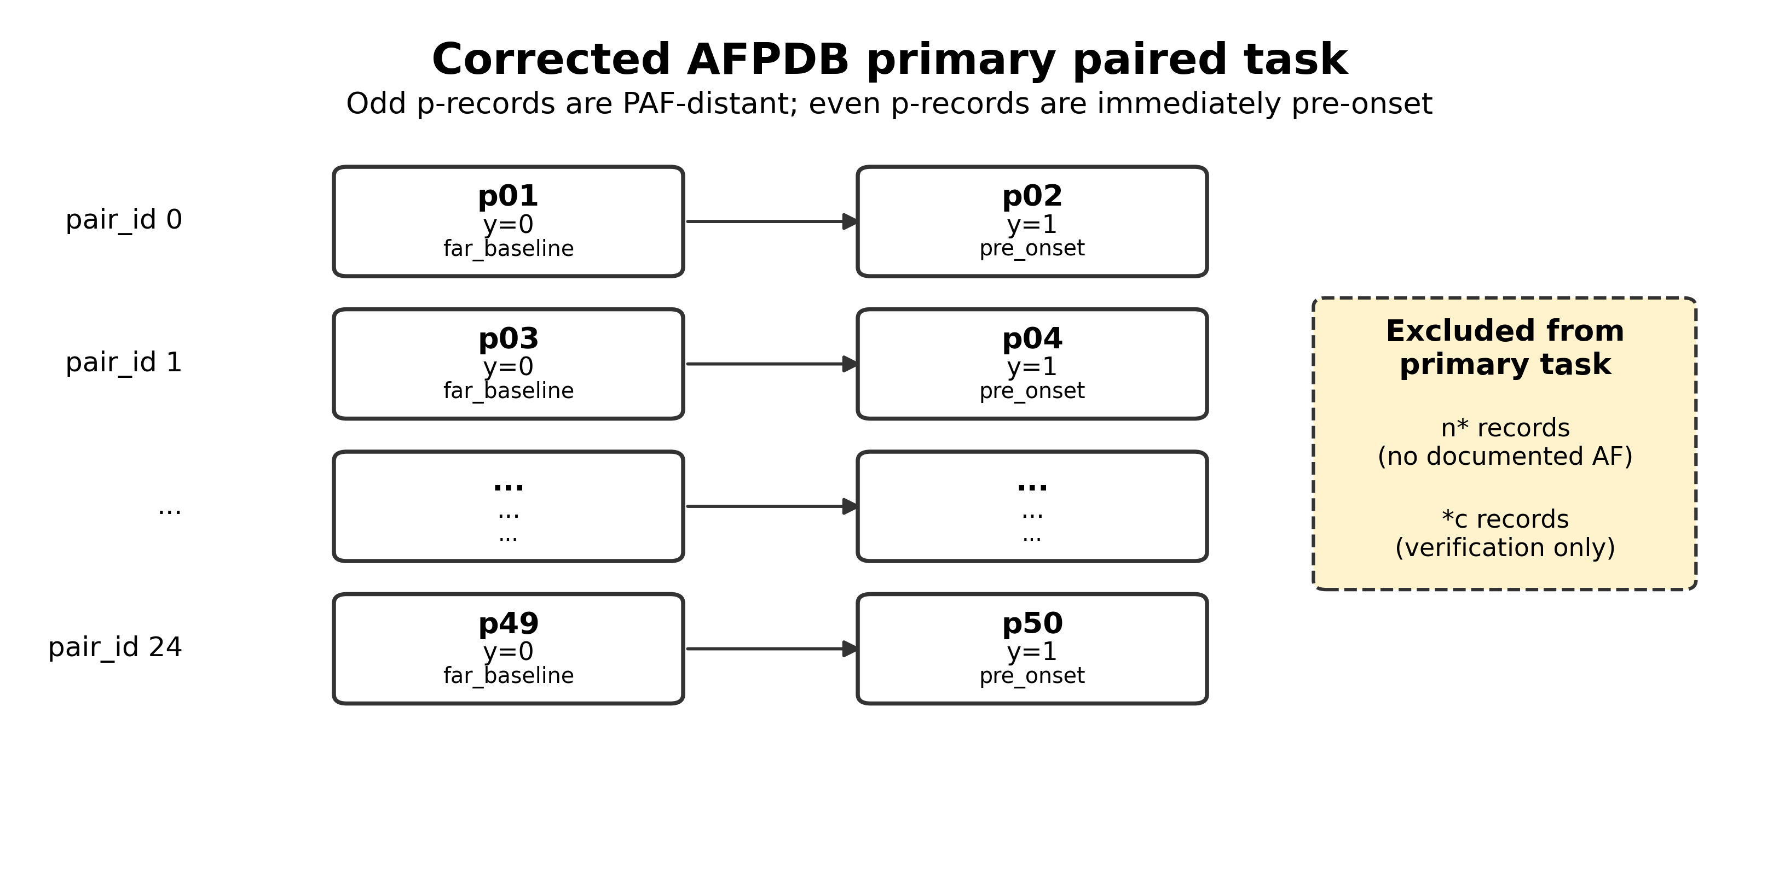
Fig. 1. Corrected AFPDB paired design used in the primary analysis. Odd p-records are PAF-distant segments and even p-records are pre-onset segments. Continuation records ending in c and n-records were excluded from the primary paired task.
Table 1. Primary dataset audit.
Item | Value
Main p-records included | 50
Matched odd-even pairs | 25
PAF-distant records (y=0) | 25
Pre-onset records (y=1) | 25
Continuation records (*c) used in primary task | 0
n-records used in primary task | 0
Temporal representations per record | 6
Aggregated rows | 300
3.2 RR Extraction and Baseline Estimation
RR intervals were derived from QRS annotations using the WFDB ecosystem [12,13]. QRS sample indices were converted into RR intervals in milliseconds according to the sampling frequency obtained from the record metadata. The cumulative RR time was used for both RR-count and time-based windowing.
For SPC feature extraction, a record-level baseline was estimated from the first 200 RR intervals of each record. Standardized deviations were then computed relative to this baseline. Since the available qrs annotations are machine-generated and unaudited in the AFPDB documentation, all results are interpreted as exploratory rhythm-dynamics findings rather than clinically audited beat-level diagnoses [1].
3.3 Multiscale Windowing
To capture temporal behavior at different resolutions, features were computed across six representations: 50 RR, 100 RR, 128 RR, 200 RR, 300 s, and full-record aggregation. RR-count windows emphasize beat-indexed dynamics, whereas the 300-s representation approximates common short-term HRV practice. Full-record aggregation summarizes the entire 30-min segment and is interpreted as retrospective characterization, not real-time early warning.
The complete computational workflow is summarized in Fig. 2. The pipeline starts with the corrected AFPDB p-record manifest, extracts RR intervals, generates multiscale windows, computes HRV and SPC descriptors, and evaluates feature blocks using grouped validation and pair-level resampling.
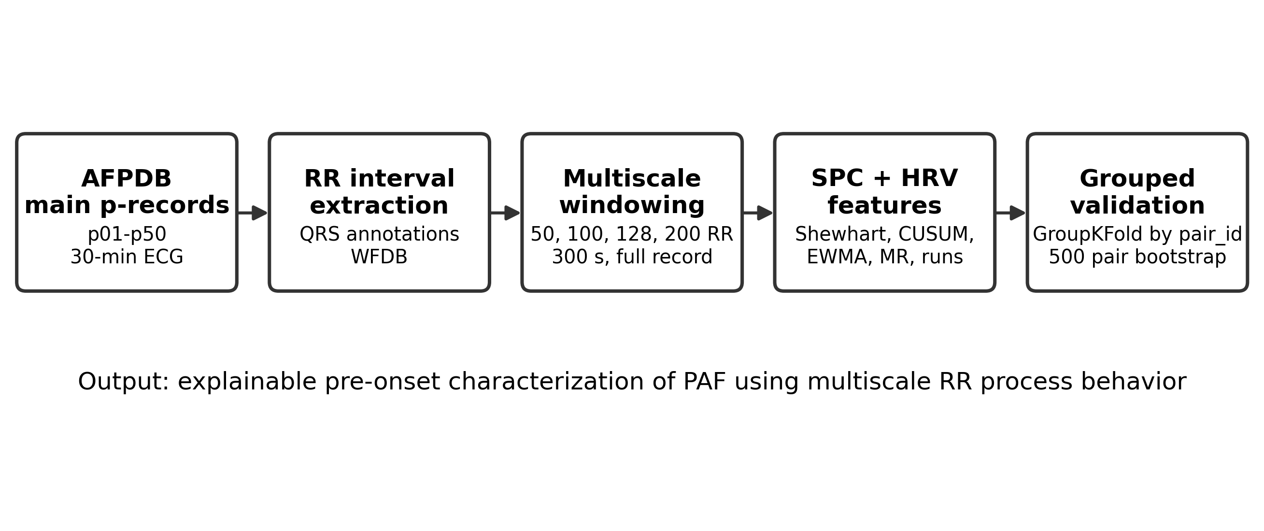
Fig. 2. Methodological workflow of the proposed multiscale SPC framework for RR-based pre-onset characterization of PAF.
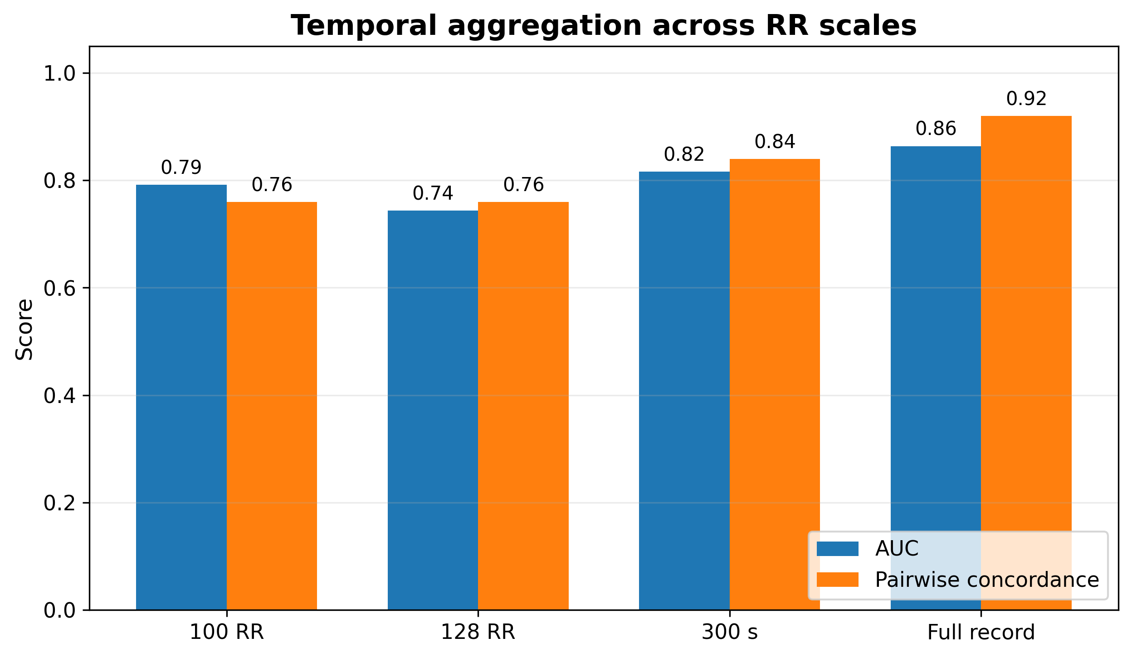
Fig. 3. Temporal aggregation across RR scales. Full-record aggregation provides the strongest retrospective summary, while shorter RR-count windows support operational multiscale characterization.
3.4 SPC Feature Extraction
Feature extraction was organized into HRV and SPC families. HRV features included RMSSD, coefficient of variation of RR intervals, SD1, SD2, and SD1/SD2 ratio [12,13]. SPC features were designed to describe process behavior rather than only global variability.
Shewhart features captured pointwise deviations beyond control limits, which is appropriate when the clinical question concerns abnormal excursions rather than only average rhythm level. CUSUM features captured cumulative positive and negative deviations, making them sensitive to sustained small shifts that may be missed by isolated thresholds. EWMA features summarized gradual drift by weighting recent deviations while retaining historical memory. Moving-range features described local beat-to-beat instability, while runs-rule features captured sequential persistence and trend-like behavior. Ectopy-like features were computed in the pipeline only as exploratory RR-pattern descriptors and were not interpreted as clinically confirmed ectopic beats.
z_t = (RR_t - mu_0) / sigma_0 (1)
C_t^+ = max(0, C_{t-1}^+ + z_t - k), C_t^- = min(0, C_{t-1}^- + z_t + k) (2)
EWMA_t = lambda z_t + (1 - lambda) EWMA_{t-1} (3)
MR_t = |RR_t - RR_{t-1}| (4)
Table 2. Feature families and interpretive role.
Family | Example features | Interpretive role
HRV | rmssd, cv_rr, sd2 | Short- and long-term rhythm variability
Shewhart | shewhart_out_rate, shewhart_out_count | Frequency of pointwise out-of-control behavior
CUSUM | cusum_abs_max, cusum_alarm_density | Accumulated drift and sustained deviations
EWMA | ewma_last, ewma_slope | Gradual changes in standardized RR deviations
Moving range | mr_max, mr_out_count | Local beat-to-beat instability
Runs rules | longest_run_below_median, rule violations | Sequential persistence and trend behavior
Ectopy-like | short-long sequence count | Exploratory RR-pattern irregularity, not clinical ectopy
3.5 Feature Blocks, Validation, and Bootstrap
Feature blocks were defined to quantify the contribution of HRV and SPC descriptors. The reduced HRV block contained RMSSD, CV_RR, and SD2. The B_SPC block contained Shewhart, CUSUM, EWMA, moving-range, and runs-rule features. C_HRV_SPC combined HRV and SPC features, while D_HRV_SPC_Poincare added Poincare descriptors.
Logistic regression was treated as the primary interpretable classifier, and random forest was used as a performance-oriented comparator. Model fitting and cross-validation were implemented using scikit-learn [16]. Group-aware splitting by pair_id was used to prevent paired records from appearing simultaneously in training and validation folds. Collinearity pruning, when applied, was fitted only on training folds and then applied to validation folds. Performance was summarized with ROC-AUC, F1-score, sensitivity, specificity, and pairwise concordance. Pairwise concordance measures whether, within a matched pair, the pre-onset record receives a higher pre-onset score than its PAF-distant counterpart; therefore, it directly evaluates the matched clinical question rather than only global separation.
Confidence intervals were estimated with 500 pair-level bootstrap iterations. Each resample preserved the matched-pair structure, avoiding the unrealistic assumption that all rows are independent.
PC = (1 / N_pairs) sum I(score_pre,i > score_far,i) (5)
4 Results
4.1 Dataset Integrity and Class Summary
The final executed notebook confirmed that the primary analysis contained 50 records, 25 matched pairs, and a balanced distribution of 25 PAF-distant and 25 pre-onset records. All audit checks passed: no continuation records ending in c were included, no n-records were used, all records were p-records, each pair_id contained exactly two records, and each pair contained one y = 0 and one y = 1 record.
At the full-record scale, pre-onset records showed larger median HRV and SPC descriptors than PAF-distant records. For example, median RMSSD increased from 74.136 ms to 138.358 ms, CV_RR increased from 0.076 to 0.106, Shewhart out-of-control rate increased from 0.014 to 0.065, and CUSUM absolute maximum increased from 101.031 to 532.666. These summary values suggest that the pre-onset state is characterized by increased rhythm instability and process deviation.
Table 3. Full-record class summary for selected descriptors.
Class | RMSSD | CV_RR | SD2 | Shewhart out-rate | CUSUM abs max | MR MAD
far_baseline (y=0) | 74.136 | 0.076 | 71.470 | 0.014 | 101.031 | 7.812
pre_onset (y=1) | 138.358 | 0.106 | 96.574 | 0.065 | 532.666 | 7.812
4.2 Paired Delta Characterization
Paired delta analysis compared each pre-onset p-record against its matched PAF-distant p-record. The strongest consistent differences were observed in SPC and variability features. Shewhart out-of-control rate had a median paired increase of 0.0482 in pre-onset records, with 84% of pairs showing a positive delta (Wilcoxon p = 0.0011; rank-biserial r = 0.748). Shewhart out-of-control count had a median increase of 93 events, with 80% positive deltas (p = 0.0013; r = 0.735).
HRV and Poincare descriptors also increased. RMSSD had a median paired increase of 35.58 ms, SD1 increased by 25.16, CV_RR increased by 0.0222, and SD2 increased by 10.55. CUSUM absolute maximum showed a smaller but still positive effect. Overall, pre-onset records were not defined only by a mean heart-rate shift but by higher instability, more out-of-control behavior, and stronger cumulative deviations.
Table 4. Main paired feature differences: pre-onset minus PAF-distant.
Feature | Median delta | Positive pairs | Wilcoxon p | Rank-biserial r
shewhart_out_rate | 0.0482 | 84.0% | 0.0011 | 0.748
shewhart_out_count | 93.0000 | 80.0% | 0.0013 | 0.735
rmssd | 35.5786 | 76.0% | 0.0042 | 0.637
sd1 | 25.1578 | 76.0% | 0.0042 | 0.637
cv_rr | 0.0222 | 72.0% | 0.0061 | 0.612
sd2 | 10.5535 | 68.0% | 0.0125 | 0.563
cusum_abs_max | 173.4909 | 60.0% | 0.0422 | 0.465
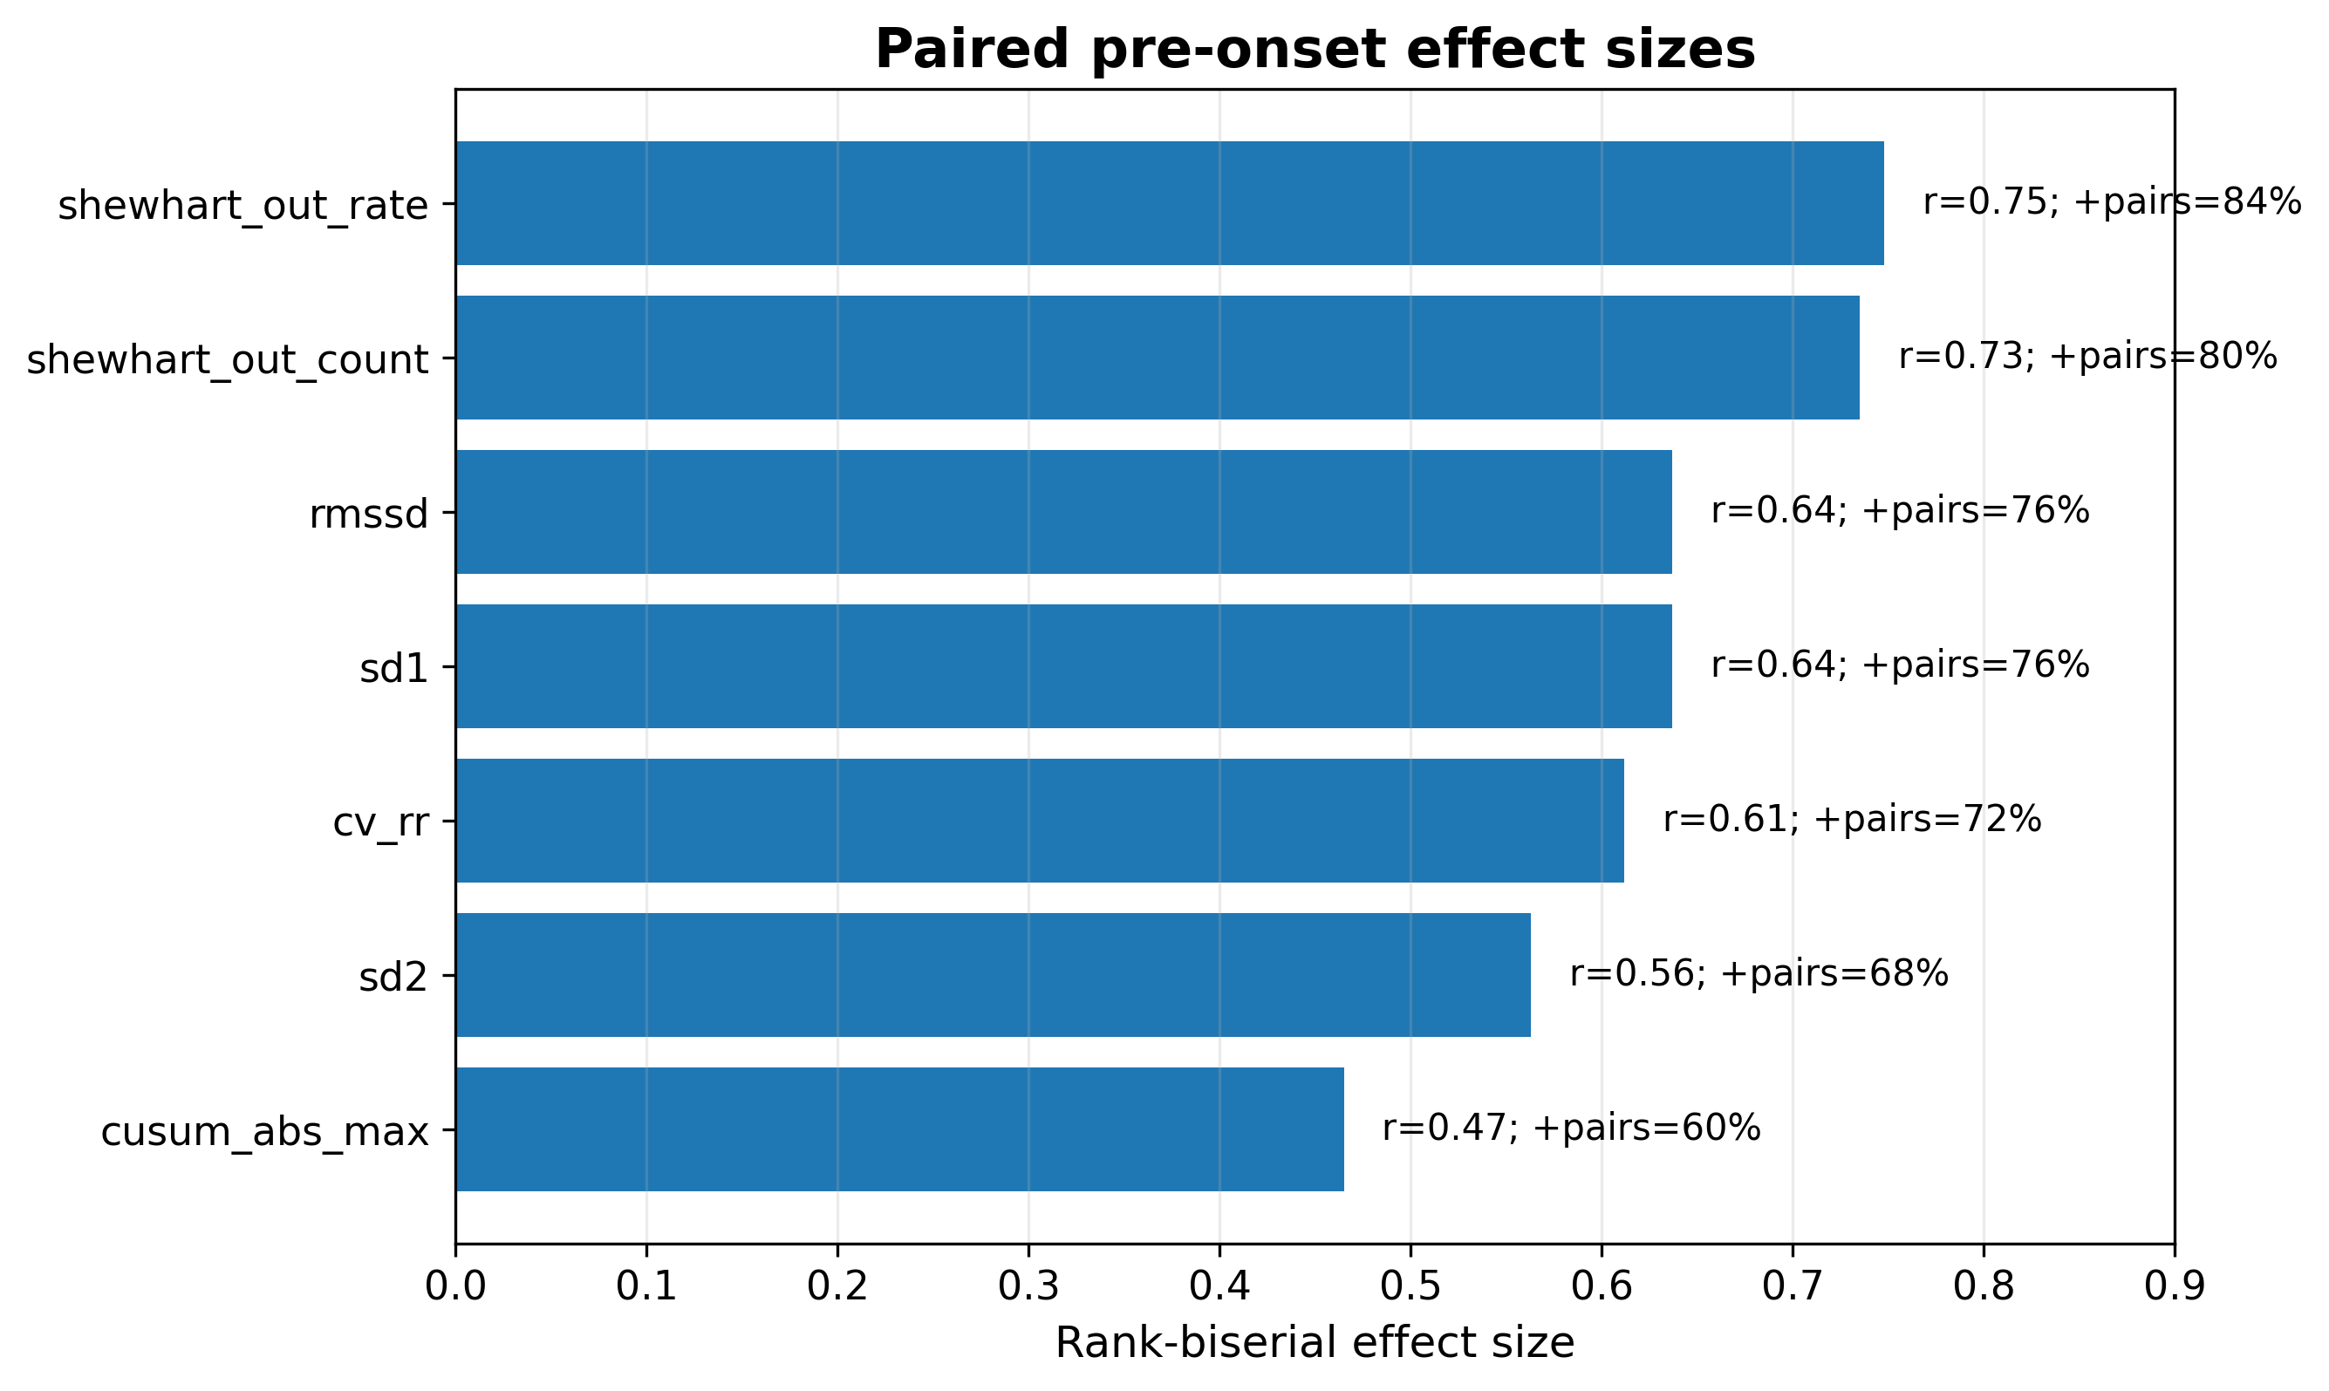
Fig. 4. Paired delta effect sizes for selected features. Shewhart out-of-control descriptors and HRV variability measures showed the strongest consistent pre-onset increases.
4.3 Feature Block Performance
SPC-based configurations improved over the reduced HRV descriptor set. In full-record paired characterization, the reduced HRV block reached AUC = 0.744 and pairwise concordance = 0.72. The B_SPC block reached AUC = 0.800 and pairwise concordance = 0.84, and the D_HRV_SPC_Poincare block also reached AUC = 0.800 and pairwise concordance = 0.84. The pruned B_SPC configuration showed the highest pairwise concordance (0.88), suggesting that a reduced and less collinear SPC representation may improve within-pair ordering stability.
Cross-validation across multiscale windows showed that the 100-RR scale was especially strong for operational discrimination. At this scale, B_SPC with random forest reached AUC = 0.800, F1 = 0.693, sensitivity = 0.68, and specificity = 0.76. The C_HRV_SPC logistic regression model reached AUC = 0.768 and F1 = 0.702, supporting the feasibility of a more interpretable model.
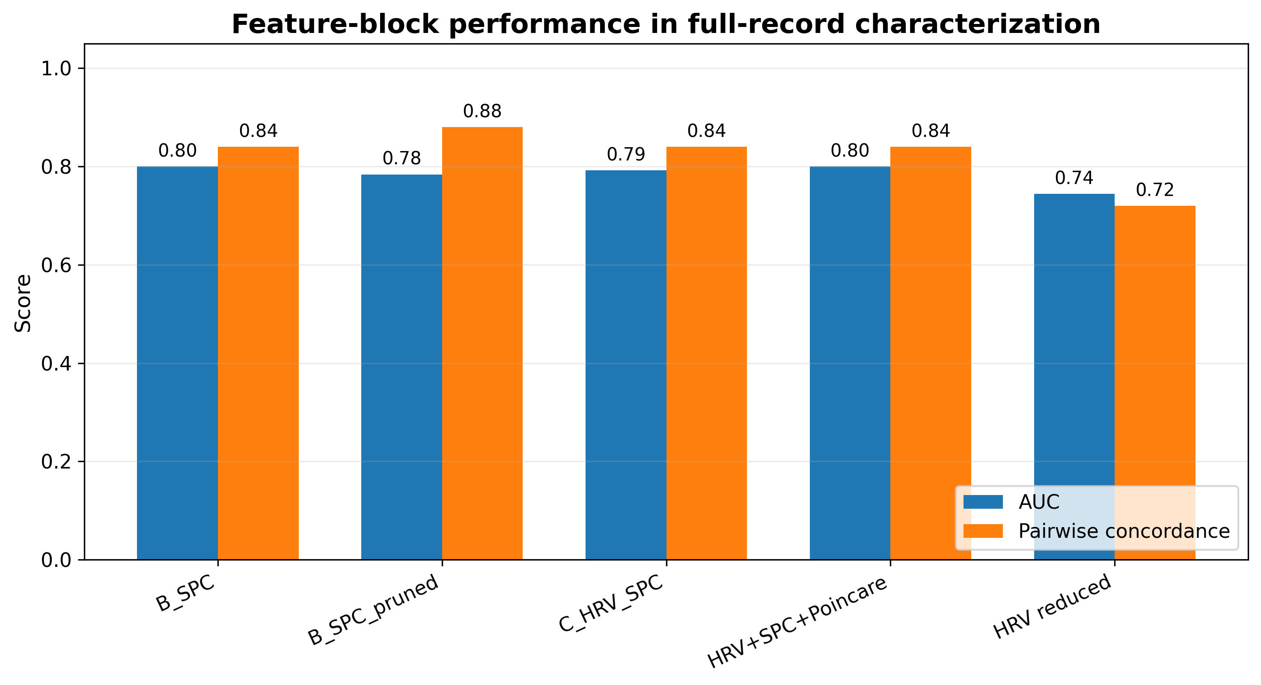
Fig. 5. Feature block performance in full-record paired characterization. SPC-based configurations show higher AUC and pairwise concordance than the reduced HRV descriptor set.
Table 5. Representative multiscale cross-validation results.
Window | Size | Block | Model | AUC | AUC SD | F1 | Sens. | Spec.
rr_count | 100 | B_SPC | RandomForest | 0.800 | 0.166 | 0.693 | 0.68 | 0.76
rr_count | 100 | D_HRV_SPC_Poincare | RandomForest | 0.792 | 0.142 | 0.717 | 0.72 | 0.76
rr_count | 100 | E_HRV_SPC_Poincare_Ectopy | RandomForest | 0.792 | 0.159 | 0.672 | 0.68 | 0.72
rr_count | 100 | C_HRV_SPC | RandomForest | 0.776 | 0.173 | 0.686 | 0.68 | 0.76
rr_count | 128 | C_HRV_SPC | RandomForest | 0.776 | 0.142 | 0.671 | 0.68 | 0.72
rr_count | 128 | B_SPC | RandomForest | 0.768 | 0.190 | 0.680 | 0.64 | 0.80
rr_count | 100 | D_HRV_SPC_Poincare | LogReg | 0.768 | 0.140 | 0.611 | 0.60 | 0.72
rr_count | 100 | C_HRV_SPC | LogReg | 0.768 | 0.153 | 0.702 | 0.72 | 0.68
4.4 Bootstrap Confidence Intervals and Incremental Value
Pair-level bootstrap results further supported the added value of SPC descriptors. For AUC, the reduced HRV block obtained 0.6544 (95% CI: 0.5778-0.7337), whereas B_SPC obtained 0.7760 (95% CI: 0.6937-0.8628). C_HRV_SPC obtained 0.7664 (95% CI: 0.6869-0.8605), and D_HRV_SPC_Poincare obtained 0.7760 (95% CI: 0.6949-0.8677). Pairwise concordance improved from 0.72 in the reduced HRV block to 0.84 in the SPC-based configurations.
Incremental full-record comparisons showed that replacing reduced HRV with B_SPC increased AUC by 0.144 and F1 by 0.1927. Adding HRV to SPC did not improve AUC beyond the pure SPC block in this configuration, suggesting that SPC features already captured much of the discriminative pre-onset structure.
Table 6. Pair-level bootstrap estimates using 500 resampling iterations.
Configuration | AUC | AUC 95% CI | Pairwise concordance | PC 95% CI
hrv_reduced_interpretable | 0.6544 | 0.5820-0.7303 | 0.72 | 0.600-0.867
B_SPC | 0.7760 | 0.7043-0.8619 | 0.84 | 0.733-0.941
B_SPC_pruned | 0.7520 | 0.6798-0.8341 | 0.88 | 0.786-1.000
C_HRV_SPC | 0.7664 | 0.6949-0.8605 | 0.84 | 0.733-0.941
D_HRV_SPC_Poincare | 0.7760 | 0.7022-0.8649 | 0.84 | 0.733-0.941
4.5 Temporal Aggregation
Temporal aggregation demonstrated that scale affected characterization. With 70 features, the 100-RR representation reached AUC = 0.792 and pairwise concordance = 0.76; the 300-s representation reached AUC = 0.816 and pairwise concordance = 0.84; and the full-record representation reached AUC = 0.864 and pairwise concordance = 0.92. This does not imply real-time prediction, because full-record aggregation observes the complete 30-min segment. Rather, it indicates that pre-onset instability is distributed across the record and can be captured retrospectively by multiscale process descriptors.
Table 7. Temporal aggregation results.
Window type | Size | Features | AUC | Pairwise concordance
rr_count | 100 | 70 | 0.792 | 0.76
rr_count | 128 | 70 | 0.744 | 0.76
Time | 300 | 70 | 0.816 | 0.84
full_record | 1800 | 70 | 0.864 | 0.92
4.6 Logistic Regression Interpretability
Stable logistic regression coefficients were examined for SPC and HRV+SPC blocks. In the B_SPC block, moving-range maximum, EWMA slope, Shewhart out-of-control rate, Shewhart out-of-control count, and moving-range out-of-control count showed stable positive coefficients across folds. In C_HRV_SPC and D_HRV_SPC_Poincare, EWMA slope and moving-range maximum remained among the strongest positive contributors, while RMSSD and SD1/SD2 ratio also contributed positively.
These patterns reinforce the paired delta analysis: pre-onset characterization is driven by local instability, progressive drift, and increased out-of-control behavior, not only by global HRV magnitude. The strongest negative stable coefficients, such as EWMA last and longest run below median in some blocks, suggest that directionality and persistence patterns also matter and should be studied in future analyses.
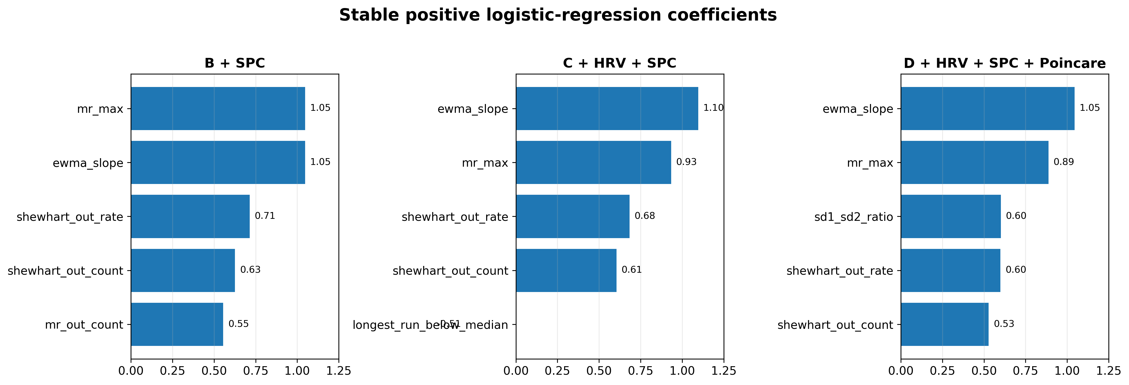
Fig. 6. Stable logistic regression coefficients for the HRV+SPC+Poincare block. Positive coefficients indicate features associated with the pre-onset class.
Table 8. Stable logistic regression coefficients from SPC and HRV+SPC blocks.
Block | Feature | Mean coef. | SD coef. | Direction
B_SPC | mr_max | 1.0482 | 0.0690 | +
B_SPC | ewma_slope | 1.0469 | 0.2935 | +
B_SPC | shewhart_out_rate | 0.7137 | 0.1039 | +
B_SPC | shewhart_out_count | 0.6259 | 0.1151 | +
C_HRV_SPC | ewma_slope | 1.0963 | 0.3227 | +
C_HRV_SPC | mr_max | 0.9337 | 0.0792 | +
C_HRV_SPC | shewhart_out_rate | 0.6837 | 0.0989 | +
C_HRV_SPC | shewhart_out_count | 0.6052 | 0.1111 | +
D_HRV_SPC_Poincare | ewma_slope | 1.0453 | 0.3136 | +
D_HRV_SPC_Poincare | mr_max | 0.8882 | 0.0971 | +
D_HRV_SPC_Poincare | sd1_sd2_ratio | 0.6016 | 0.1142 | +
D_HRV_SPC_Poincare | shewhart_out_rate | 0.5989 | 0.0907 | +
5 Discussion
This study suggests that multiscale SPC features provide an interpretable representation of RR interval dynamics before PAF. The corrected paired AFPDB design shows that pre-onset records exhibit stronger out-of-control behavior, greater RR variability, and larger cumulative deviations than PAF-distant records from the same p-record sets. The most consistent individual findings were Shewhart out-of-control rate and Shewhart out-of-control count, indicating that the pre-onset state may involve more frequent departures from baseline rhythm stability.
The improvement of SPC-based blocks over reduced HRV descriptors supports the central premise of this work: control-chart features add process-behavior information beyond conventional variability descriptors. HRV features such as RMSSD, CV_RR, SD1, and SD2 captured increased variability, but SPC translated this variability into alarm frequency, cumulative deviation, gradual drift, and moving-range instability. These descriptors are easier to audit than opaque feature embeddings because their physiological interpretation is tied to specific time-dependent behaviors.
The multiscale design also matters. The 100-RR window performed strongly in cross-validation, suggesting that short-to-intermediate RR windows may capture operational pre-onset changes. The 300-s and full-record representations showed stronger retrospective aggregation performance, especially in pairwise concordance. However, full-record aggregation must not be interpreted as real-time early prediction because it summarizes the entire 30-min segment. A future prospective analysis should evaluate progressively truncated windows to estimate when discriminative SPC markers first emerge before onset.
The distinction between characterization and prediction is essential. The present study uses a small public challenge dataset, machine-generated QRS annotations, retrospective paired segments, and no external validation. Therefore, the results should not be presented as clinical readiness. Instead, they establish a reproducible methodological basis for studying whether SPC descriptors provide explainable markers of rhythm instability before PAF.
The corrected task design is also methodologically important. Using n-records in the primary pre-onset task would answer a different question: discrimination between subjects with and without documented AF. Using continuation c-records as positive samples would also alter the intended paired task. By restricting the main analysis to odd-even p-records, the study preserves the original pre-onset characterization question in at-risk subjects.
From an engineering perspective, SPC can be interpreted as a feature-engineering layer rather than a competing black-box model. The goal is not to replace advanced ECG models but to provide transparent descriptors that can complement machine learning. These descriptors could later be tested in longer monitoring records, raw ECG morphology pipelines, or clinician-in-the-loop validation settings.
5.1 Limitations
Several limitations must be emphasized. First, the primary paired task includes only 25 matched pairs, limiting statistical power and increasing uncertainty around model estimates. Second, QRS annotations are machine-generated and unaudited, so beat-level errors may affect RR-derived features. Third, the study uses RR intervals only and does not evaluate raw ECG morphology, atrial activity, P-wave descriptors, or expert-confirmed ectopic beats. Fourth, ectopy-like variables were derived from RR patterns and should not be interpreted as clinically confirmed premature atrial contractions. Fifth, no external validation dataset was used. Finally, full-record aggregation provides retrospective characterization and should not be confused with real-time early warning.
Table 9. Main limitations and mitigation strategies.
Limitation | Impact | Mitigation/Future work
Small paired sample (25 pairs) | Uncertain model estimates | Pair-level bootstrap; external validation
Machine-generated QRS annotations | Potential RR errors | Audited annotations or detector comparison
RR-only analysis | No morphology/P-wave information | Add raw ECG and atrial features
Ectopy-like features not clinically confirmed | Risk of overinterpretation | Treat as exploratory RR-pattern descriptors
No external validation | Limited generalizability | Test on independent ECG cohorts
Full-record aggregation | Retrospective, not real-time | Progressively truncated pre-onset windows
6 Conclusion
This full-paper study presents a multiscale SPC framework for explainable pre-onset characterization of PAF using RR interval dynamics. In the corrected AFPDB paired design, SPC features captured increased out-of-control behavior, local instability, and progressive drift before PAF onset. Compared with reduced HRV descriptors, SPC-based configurations improved AUC and pairwise concordance while preserving interpretability through process-behavior features. These findings support SPC as a transparent feature-engineering layer for ECG rhythm analysis. External validation, progressively truncated windows, clinically audited annotations, and raw ECG morphology integration are required before the method can be interpreted as a deployable prediction system.
Declarations
Conflict of Interest. All authors declare that they have no conflicts of interest.
Data Availability. The study uses the publicly available PhysioNet PAF Prediction Challenge Database. Code and analysis workflows will be made available upon acceptance or through an author-maintained repository.
Acknowledgements. The authors acknowledge PhysioNet and the Computing in Cardiology Challenge organizers for providing open access to AFPDB. The corresponding author acknowledges the academic support of Tecnológico Nacional de México / Instituto Tecnológico de Celaya.
References
1. Goldberger, A.L., Amaral, L.A.N., Glass, L., Hausdorff, J.M., Ivanov, P.C., Mark, R.G., Mietus, J.E., Moody, G.B., Peng, C.K., Stanley, H.E.: PhysioBank, PhysioToolkit, and PhysioNet: Components of a new research resource for complex physiologic signals. Circulation 101(23), e215-e220 (2000). https://doi.org/10.1161/01.CIR.101.23.e215
2. Moody, G.B., Goldberger, A.L., McClennen, S., Swiryn, S.P.: Predicting the onset of paroxysmal atrial fibrillation: The Computers in Cardiology Challenge 2001. Computers in Cardiology 28, 113-116 (2001). https://doi.org/10.1109/CIC.2001.977604
3. Moody, G.B.: PAF Prediction Challenge Database. PhysioNet (2001). https://physionet.org/content/afpdb/1.0.0/
4. Hnatkova, K., Waktare, J.E.P., Murgatroyd, F.D., Guo, X., Baiyan, X., Camm, A.J., Malik, M.: Analysis of the cardiac rhythm preceding episodes of paroxysmal atrial fibrillation. American Heart Journal 135(6), 1010-1019 (1998). https://doi.org/10.1016/S0002-8703(98)70069-3
5. Zong, W., Mukkamala, R., Mark, R.G.: A methodology for predicting paroxysmal atrial fibrillation based on ECG arrhythmia feature analysis. Computers in Cardiology 28, 125-128 (2001). https://doi.org/10.1109/CIC.2001.977607
6. Maier, C., Bauch, M., Dickhaus, H.: Screening and prediction of paroxysmal atrial fibrillation by analysis of heart rate variability parameters. Computers in Cardiology 28, 129-132 (2001). https://doi.org/10.1109/CIC.2001.977608
7. Thong, T., McNames, J., Aboy, M., Goldstein, B.: Prediction of paroxysmal atrial fibrillation by analysis of atrial premature complexes. IEEE Transactions on Biomedical Engineering 51(4), 561-569 (2004). https://doi.org/10.1109/TBME.2003.821030
8. Narin, A., Isler, Y., Ozer, M.: Early prediction of paroxysmal atrial fibrillation based on short-term heart rate variability. Physica A: Statistical Mechanics and its Applications 509, 56-65 (2018). https://doi.org/10.1016/j.physa.2018.06.022
9. Castro, H., Garcia-Racines, J.D., Bernal-Norena, A.: Methodology for the prediction of paroxysmal atrial fibrillation based on heart rate variability feature analysis. Heliyon 7(10), e08244 (2021). https://doi.org/10.1016/j.heliyon.2021.e08244
10. Montgomery, D.C.: Introduction to Statistical Quality Control. 8th edn. Wiley, Hoboken (2020)
11. Woodall, W.H.: The use of control charts in health-care and public-health surveillance. Journal of Quality Technology 38(2), 89-104 (2006). https://doi.org/10.1080/00224065.2006.11918593
12. Task Force of the European Society of Cardiology and the North American Society of Pacing and Electrophysiology: Heart rate variability: Standards of measurement, physiological interpretation, and clinical use. Circulation 93(5), 1043-1065 (1996). https://doi.org/10.1161/01.CIR.93.5.1043
13. Shaffer, F., Ginsberg, J.P.: An overview of heart rate variability metrics and norms. Frontiers in Public Health 5, 258 (2017). https://doi.org/10.3389/fpubh.2017.00258
14. Moody, G., Pollard, T., Moody, B.: WFDB Software Package (version 10.7.0). PhysioNet (2022). https://doi.org/10.13026/gjvw-1m31
15. WFDB Software for Python: A toolkit for physiological signals. PhysioNet. https://physionet.org/content/wfdb-python/
16. Pedregosa, F., Varoquaux, G., Gramfort, A., Michel, V., Thirion, B., Grisel, O., Blondel, M., Prettenhofer, P., Weiss, R., Dubourg, V., et al.: Scikit-learn: Machine learning in Python. Journal of Machine Learning Research 12, 2825-2830 (2011)
17. Rudin, C.: Stop explaining black box machine learning models for high stakes decisions and use interpretable models instead. Nature Machine Intelligence 1, 206-215 (2019). https://doi.org/10.1038/s42256-019-0048-x

