Next Steps

If you have already requested/received your rights in the system, your learning is complete. You may now close this window.

If you are ready to proceed with requesting access, please follow the below steps.

- Print your certificate of completion for this training. After completing the training, you should proceed to your learning history. Find the eProcurement training you have completed. Click the “Print completion certificate” button at the right hand side.
- Login to IT Central
Enter your login name and password (these credentials are the same that you use everyday to log into your PC). User name is “ent\XXXXXX”
3. Scroll to the middle of the page and click “New Request” button
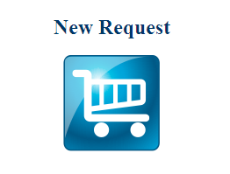
4. On the left hand side of the page, scroll to “PeopleSoft FSA – Business User” (alphabetical) option from the A to Z Catalog
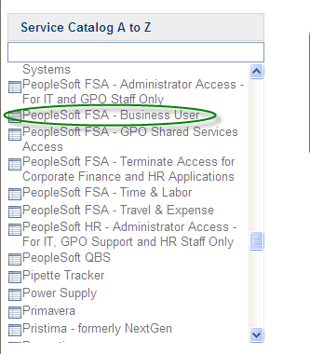

5. Select “New User” from the first drop down menu
6. Select “Add” from the next drop down menu
7. Select “Yes” from the next drop down menu if you need to add more business units to your access than just your own or “No” if you do not. If you need to add business units, provide the business unit numbers in the box below this question.

8. Select “Yes” if you need to remove business units from your access or select “No” if you do not. If “Yes” enter the business unit numbers in the box that follows this question.
Proceed in the same fashion through the next categories depending on the role(s) you need. If you are unsure which roles to select, please contact your SuperUser.

9. If this is the only request you are making then your transaction is complete and you can proceed to click on the Order Now button (upper right hand corner of the order form).
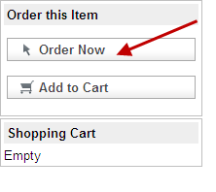
If you have any additional requests then you can click on the Add to Cart Button and continue with your transaction until you have finished.
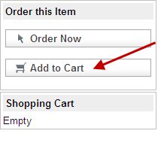
10. Once you have clicked on the Order Now button you are ready to finalize your transaction and will be directed the screen below where you add any additional comments or special instructions. You must attach your certificate of completion from iLearn to this request.
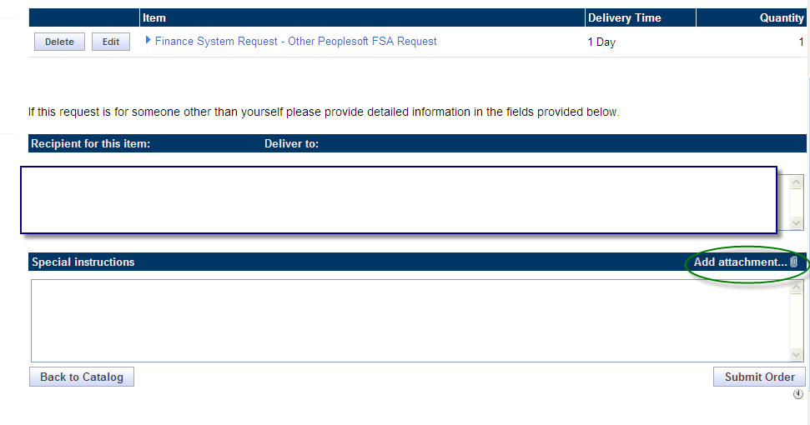

12. Once completed you can then click on the Submit Order button
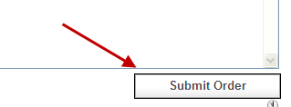
Your line Manager will then receive an email to approve the request.

Once approved your request will then be routed to the appropriate team to grant your access rights based on the role you requested.

You will be notified via email when your request has been completed.

