**FPGA2-PRE**

**PART 1:**

**PS2-Interface module:**

First, we will demonstrate a single keypress on zero button works correctly:

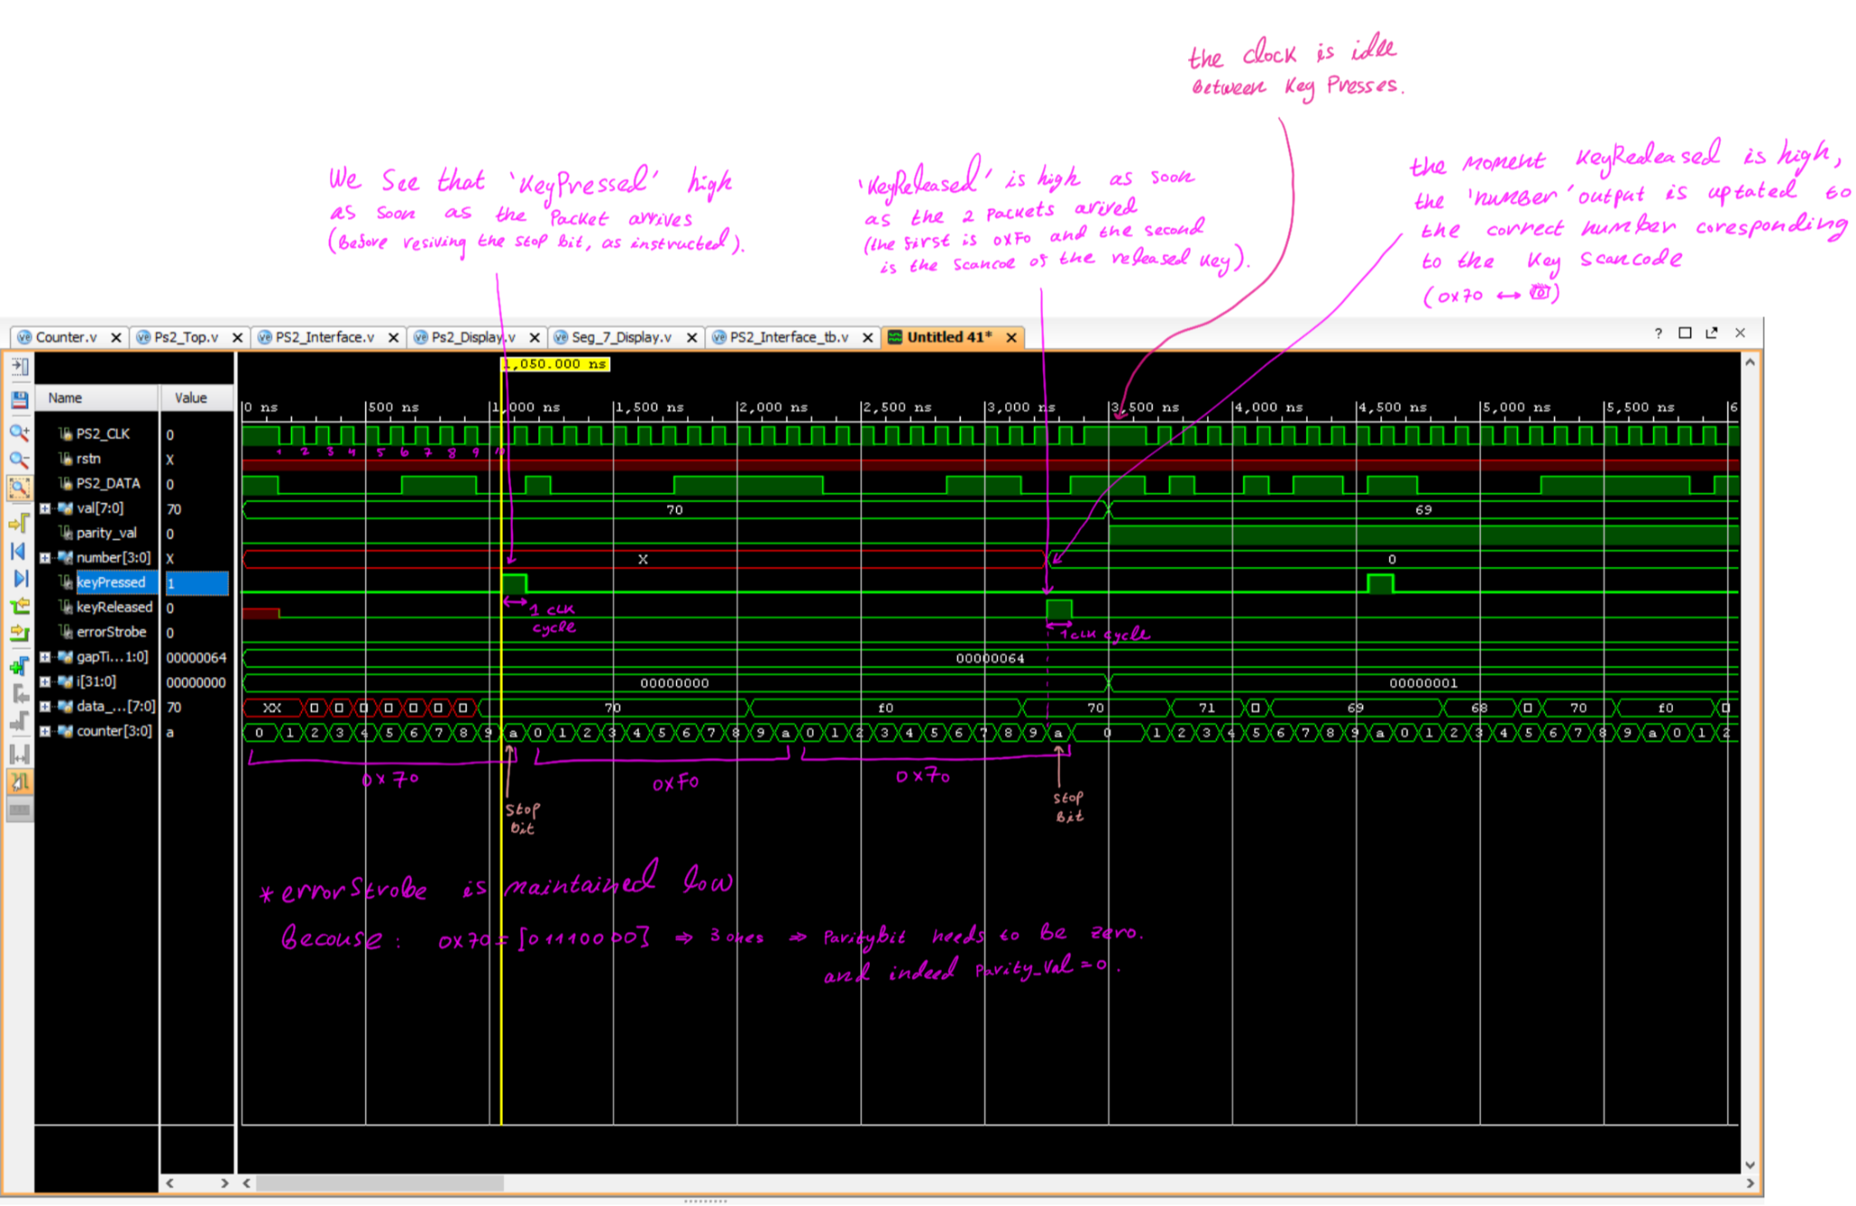

Assuring ‘**errorStrobe**’ works correctly:

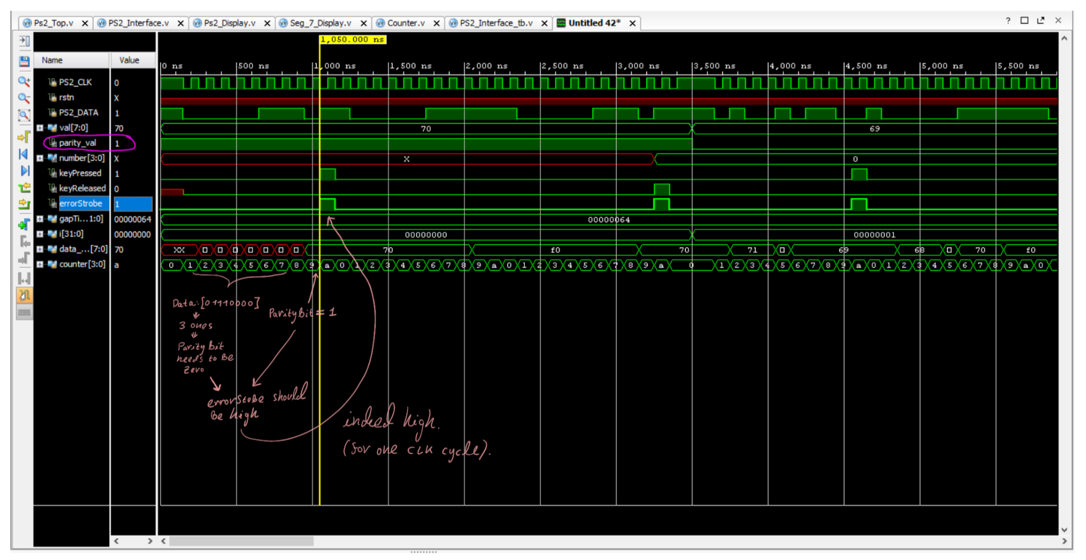

Now, we demonstrate the zero is not special and all the number key presses work as accepted.

We simulate a keypress on all the 0-9 buttons.

The numbers are pressed consecutively with a gap of 200nsec between a release to the next keypress.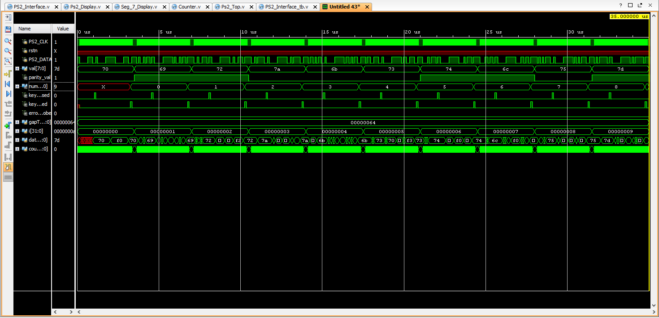

We can see that **‘number’** is updated when ‘**keyRelese**’ is high, and the output as changes from 0 to 9 as expected.

‘**errorStrobe**’ remanded low the whole time because we programed the parity-bit the following way (in the TB file):

assign parity_val = (^val)? 0:1;

Let’s also look at a zoomed-in section of the simulation above:

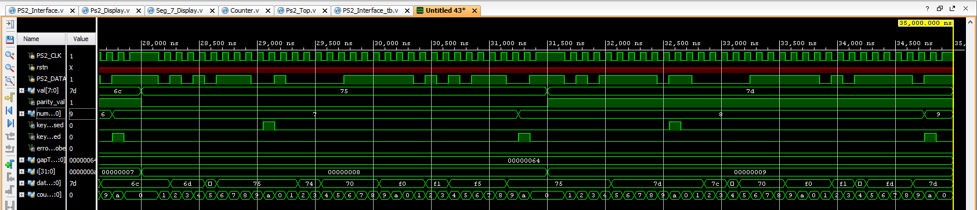

We can see that the behavior we demonstrated in the 0-keypress remains the same, hence all key presses work as expected.

**PS2-Top module:**

PART 2:

This project was designed to print a pixeled image of a piano to the screen. A piano was selected due to straight lines being easier to display in code.

As suggested, the display was divided by 8 to essentially create a 100X75 monitor.

* Modification of the clk from 100MHz to 50MHz ()

* Pixel_state changing colors

* Important marks over x axis of the monitor
  + X =800: entering retrace -> pixel_state =0, colors =0

* + X =856 -> Hsync =0

* + X =976 -> Hsync =1

* + X =0: out of retrace -> pixel_state =1, colors =’f’

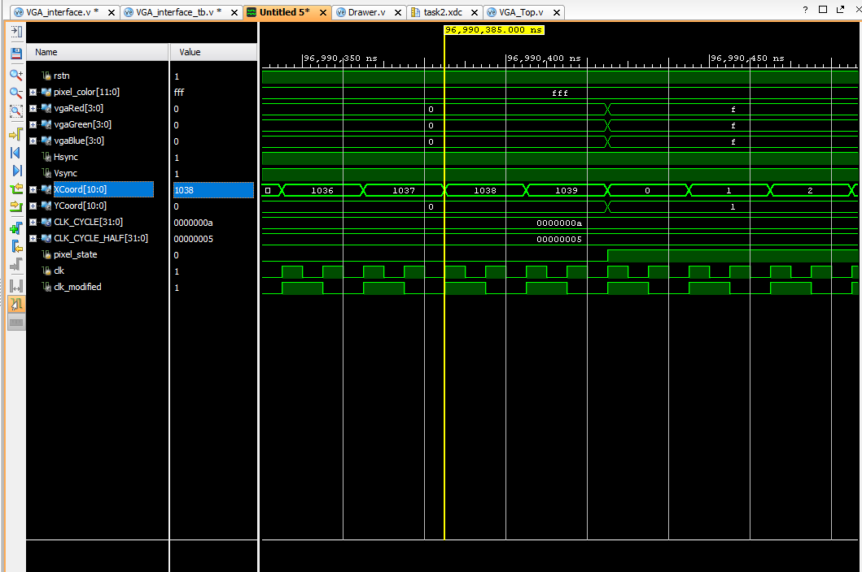

* Important marks over y axis of the monitor
  + Y =600: in retrace -> pixel_state =0 (already down), colors =’0’

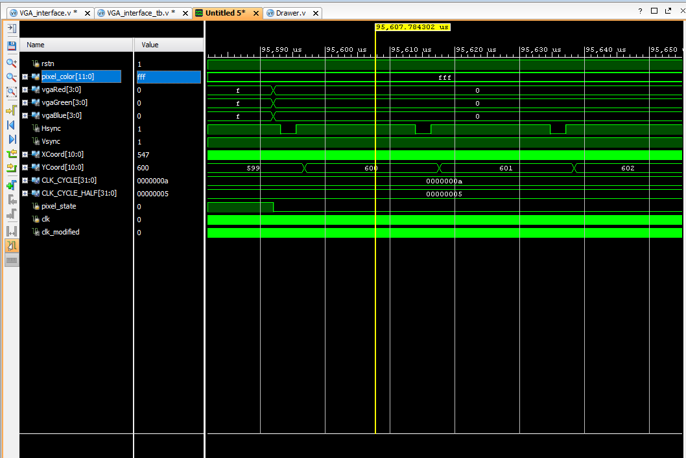

* + Y =637 && X =0 -> Vsync =0

* + Y =643 && X=0 -> Vsync =1

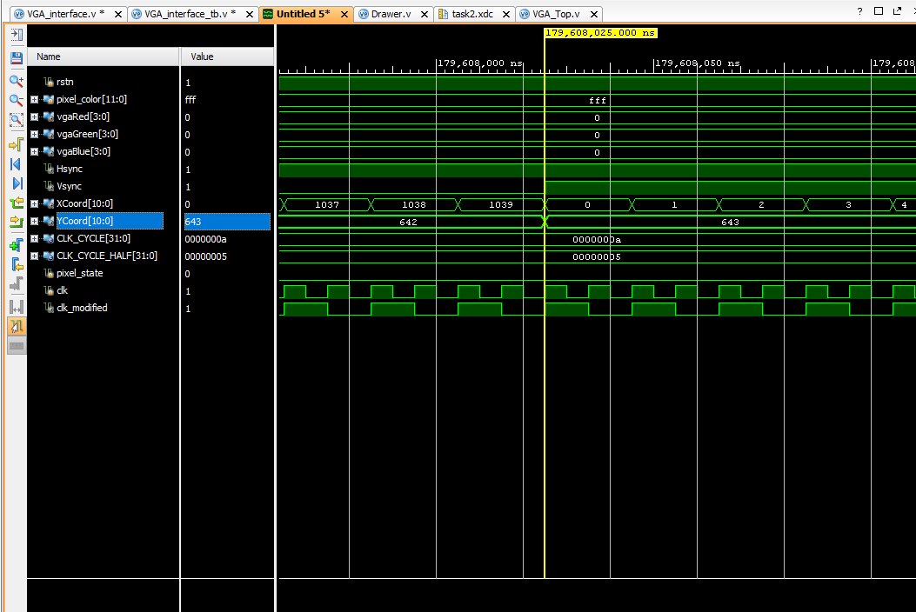

* + Y =665: out of retrace -> pixel_state =1

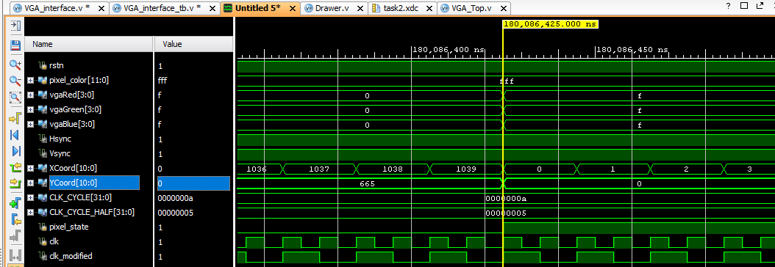

* Vsync zoom-out [637:642]

* Retrace areas zoom-out

