FormEditor – module for setting user forms

Daniel Kupka

<kippo@yo.cz>

2007-07-21

Abstract

This document describes interface for FormEditor module. It contains some simple
examples and screenshots for the users to make using of this module easier.

Introduction

Welcome to FormEditor module. This module helps scenario designer to fill the form dislayed to common user. Almost all texts scripted in edits will be displayed to user. The module serves as instrument for connection with other FerdaWizard boxes.

Parts of user interface

Main dialog window

Main dialog window contains elements necessary to set up an user form. Those are:

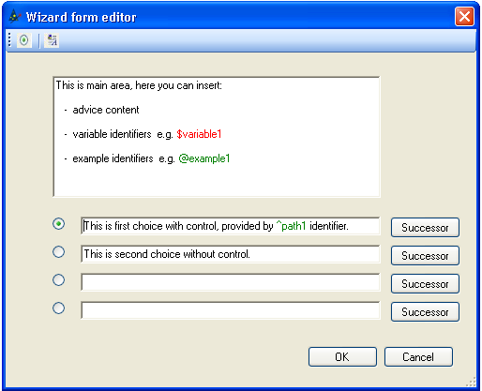
- New choice button - Adds to main dialog radio button, edit and successor button - it means one choice.

- New rich text area button - Adds to main dialog new rich text box for advices or comments.

- Main rich text box area 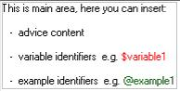 - Advices for Ferda user. Beyond common text could contain also variable and example identifiers. Variable identifier (highlighted with red color) is expanded by the result of FerdaLanguege code. After selecting identifier Editor of WizardLanguage code or Example of practical situation dialog is displayed.

- Choice - Text of choice. Text could contain also path identifier. After selecting path identifier is displayed Path to property dialog.

- Successor button - Button activates Setting successor dialog. If some box has only one successor of type Form – successor dialog needn’t be activated.

Editor of WizardLanguage code

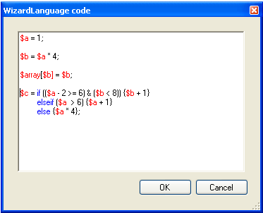

WizardLanguage code must contain assignment with variable identifier on left side. Value of this variable is expanded in the advice. Code could contain user defined variables. Examples of WizardLanguage codes are in the bubble help.

Example of practical situation dialog

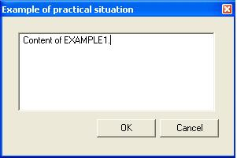

In this dialog could be inserted practical example consisting of simple text.

Path to property dialog

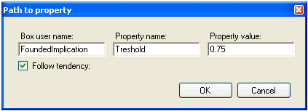

Presently FerdaWizard is working in “hand” work mode – the settings are made by user and system only offers computed settings. But system must control user. To do this FerdaWizard must have information what to control. Path to property dialog serves to set up box name, property name and offered new value of controlled property. Path to property dialog contains:

- Box user name - User name of the box containing controlled property.

- Property name - Name of controlled property.

- Property value - New offered value of the controlled property. The value could be a number or some just used variable identifier.

- Follow tendency - If FerdaWizard have to control tendence respecting between user setting of the property, offered setting and old setting. Useful only for cardinal values.

Setting successor dialog

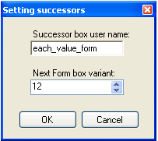

Dialog for setting basic informations about successor box of actual box of type Form. If some form has one or more choices, each choice must have its own successor. Setting successor dialog contains:

- Successor box user name - User name of the successor box of actual box of type Form.

- Next Form box variant - Form variant is decimal number symbolizing order of choices in the form. The order is connected to so-called „basic variant of form“. Basic variant is the order of choices firstly displayed to user. Property may be filled for successor box of type Form. More information about variants is in the bubble help.

