RegEditor – module for setting regular expressions

Daniel Kupka

<kippo@yo.cz>

2007-07-21

Abstract

This document describes interface for Regeditor module. It contains some simple
examples and screenshots for the users to make using of this module easier.

Introduction

Welcome to RegEditor module. This module helps scenario designer to connect regular expression with box of type Form. Regular expression helps user to detect situation when some box of type Form with its variant was often in history. Regular expressions are useful only if oriented cycle is in scenario structure.

Parts of user interface

Main dialog window

Main dialog window contains one important element – expression area for editing regular expressions.

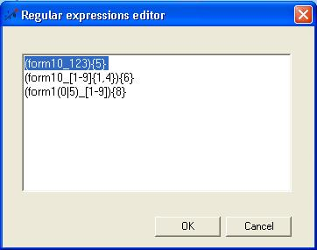

Expression area 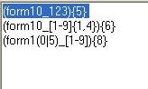 - Contains rows with regular expressions. Each expression must be in one’s own row. To activate Setting successors dialog select row with expression matches situation successor helps to solve.

Setting successor dialog

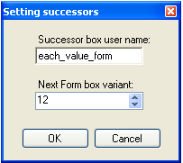

Dialog for setting basic informations about successor box of actual box of type Reaction on generated. Each row in Expression area has its successor box of type Form. Setting successor dialog contains:

- Successor box user name - User name of the successor box of actual box of type Reaction on generated.

- Next Form box variant - Form variant is decimal number symbolizing order of choices in the form. The order is connected to so-called „basic variant of form“. Basic variant is the order of choices firstly displayed to user. Property may be filled for successor box of type Form. More information about variants is in the bubble help.

