**Overview**

We need to build an application that will be a connector between GNL data and Salesforce. Right now, the sales guys are manually entering data into Salesforce from each form submission and phone call and we want to automate that process so they won’t have to do that task anymore. As data is created or updated in GNL, we want to pass that into our Salesforce account.

**Development Details**

Create a new private GitHub repo to hold the codebase for this new application.

Build an application that will listen for a postback from our API server and then execute a series of actions as each postback comes in.

We can host this application on our Media Temple server or on a new server at Rackspace. We will lock this server down to only accept traffic from the IP addresses of the two postback servers.

When a postback comes in from the GNR API, it will contain the lead ID (SNLID) of a Straight North lead. Our application must then make a call back to the API to get all necessary lead data for the specified ID. Lead data will be returned in JSON format. The additional call to get the audio file for phone call leads will not be necessary.

We will need to store the lead ID in a local MySQL database so that we have a running log of which leads have been sent to Salesforce and what their associated Salesforce lead ID is so that we can update records in Salesforce later on.

Once we have the Lead data from our API, it must then be transformed to the correct format to be sent over to Salesforce.

Before we send the lead over to Salesforce, we need to check our database to see if we have sent this lead to Salesforce previously. If not, we will create a new lead in their system. If we have already sent this lead to Salesforce, we don’t want to create a new lead, instead, the existing lead will be updated. When updating a lead, we only want to update the Phone_Call_Notes__c field and the Classificaiton__c fields as that is the only data that will be changing when a lead is updated. We will find the existing lead via the Salesforce lead ID we have saved in the database.

Connect to the Salesforce API and create a new lead or find and update an existing lead. After any new lead is created, we need to obtain the Salesforce lead ID and save that id in our database, associating it with the Straight North lead ID.

No audio files will need to be transferred over to SF, only textual call data will be sent.

**Application Structure Diagram**

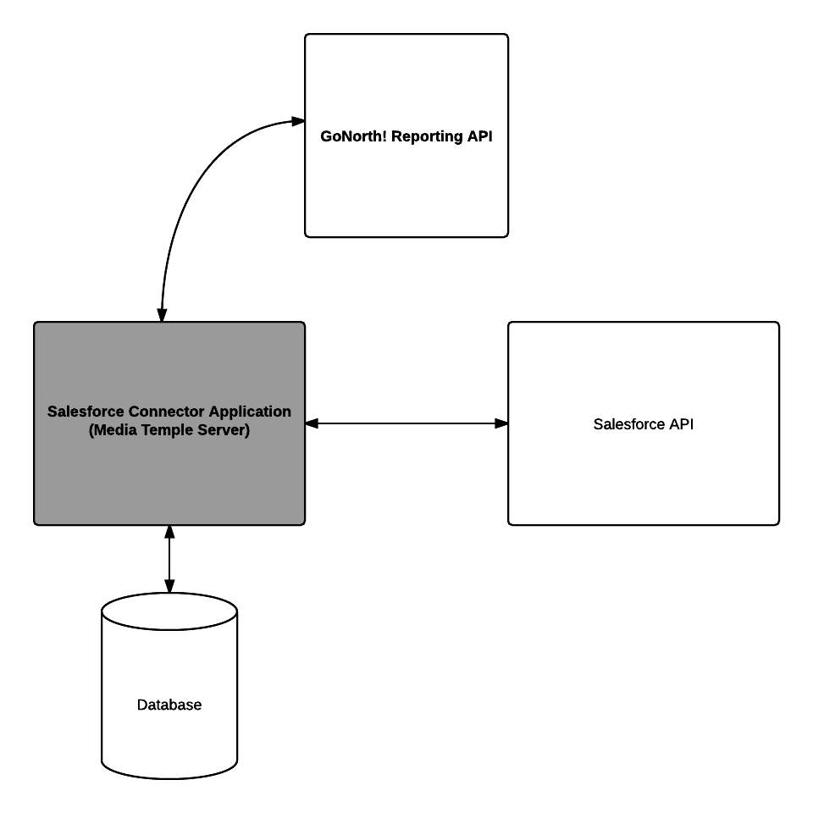

**Other Notes:**

* Field Mapping and other important Salesforce information will be found here: /Volumes/clients-web/GoNorth Leads/Salesforce/salesforce-field-mapping.txt
* Hosting for account setup on mt.straightnorth.com. Domain pointed to account (and name of account) is: <http://sfconnect.gonorthleads.com/>
* Will need to install SSL cert on new host server for application (can leverage a current wildcard cert for this)
* I still need to set Eric up with a GNR account so he can access his API key and documentation – please let MC know as soon as you are ready for this.

**Data fields from GNR API:**

* Items with a strikethrough do not need to be sent to Salesforce

**General Fields**

* id
* date
* classification
* source
* type
* ~~pre_conversion_url~~
* ~~conversion_url~~
* ~~visit~~
  + ~~keyword~~
  + ~~referral_url~~
  + ~~entry_url~~
  + ~~date~~
  + ~~user_agent~~
  + ~~campaign~~
  + ~~ad_group~~
  + ~~match_type~~
* notes

**Form Fields**

* name
* email
* phone
* website_url
* interested_in
* im_budget
* website_budget
* comments
* help
* how_can_we_help
* 0
* 1
* seogroup-form-keyword
* seogroup-form-name
* seogroup-form-email
* first_name

**Phone Fields**

* duration
* status
* trackable_number
* caller_name
* caller_number
* caller_state
* caller_city
* caller_postal_code