Scala vs Java Cheatsheet
- No semicolons
- Types after names
  - x: Int, s: String
- Method marked with def, immutable variable with val, mutable with var
def hello(name: String): String = "Hello" + name
- Lazily evaluated immutable variables marked with lazy val
- Singleton class marked with object, algebraic data type with case class
- Type inference
def double(x: Int) = x * 2
- Everything is an expression
b = if (a > 3) 2 else 1
- Automatic getter/setter generation for public fields
  - Getters named same as field
  - Setters named field_=, used like assignment
- All methods can be used as infix
  - foo process bar same as foo.process(bar)
- == uses equals by default
- Special apply and update methods
  - foo() same as foo.apply()
  - foo() = 3 same as foo.update(3)
- Empty parentheses handling
  - Java methods can be called as foo or foo()
  - Scala method foo can be called as foo or foo()
  - Scala method foo() can be called only as foo() - expected side-effects
- Methods ending with : used as infix are reversed
- Method calls can use curly braces instead of parentheses
  - foo(x) becomes foo { x }
  - curly braces allow multiple lines
- No C-style for loop, instead a for-comprehension
- Primitives are a part of the class hierarchy

Classes
- Interfaces marked with trait
trait Test { def a: Int }
- Regular classes marked with class
class Test { val a = 3 }
  - Extends by default from AnyRef
  - Classes can extend from one other class and multiple traits
class Test2 extends Test1 with Trait1 with Trait2
- Singleton classes marked with object
object Test { val a = 3 }
- static methods defined in a "companion object"
class Test { val a = 3 }
object Test { def construct = new Test }
- Algebraic data types marked with case class
case class Test(a: Int)
  - Useful method implementations (equals, toString, copy)
  - Default companion object (apply, unapply, tupled)
  - Extends from Product
- Every class has one primary constructor
class Test(a: Int, val b: Int, var c: Int)
  - Can declare publicly visible fields
- Classes can declare auxiliary constructors
class Test(a: Int) { def this(s: String) = this(s.toInt) }
  - Must begin with a call to another constructor

Unified type hierarchy
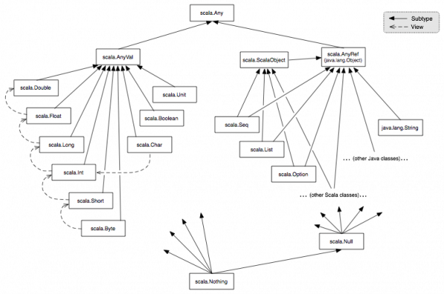
(outdated - ScalaObject not used anymore, collections in scala.collection)
- Primitives are objects too
val x: List[Any] = List("a", 3, 1.0, true)
- Unit is used as an empty return type (void)
- Value classes (AnyVal) define implicit conversions
val x: Long = 3
- Nothing is used to test there is no instance applicable
val emptyOnly: List[Nothing] = List(3) // fails to compile
  - Nothing extends everything
- Null is a class of null
- Reference classes (AnyRef) define reference equality (eq, ne) and monitor synchronization (synchronized, notify, notifyAll) methods

Functional programming
- Function types defined using =>
def foo(bar: Int => String)
- Functions are objects too
val foo = (x: Int) => x.toString // foo(3) == "3"
val list = List(foo) // list(0)(3) == "3"
- Functions can be higher-kinded (functions returning functions)
val foo = (x: Int) => (y: Int) => x + y // foo(2)(3) == 5
- Higher-kinded functions can be simply defined
def foo(x: Int)(y: Int) = x + y
- Underscore (_) as a placeholder for arguments (in order)
foo(_.toString) // for signature def foo(x: Int => String)
bar(_ + _) // for signature def bar(x: (Int, Int) => Int)
- Underscore as partial application of a higher-kinded function
def foo(x: Int)(y: Int) = x + y
val plusTwo = foo(2) _ // plusTwo(3) == 5
- Special syntax for lazily evaluated function parameters
def foo(x: => Int) = x
  - Always evaluates x, just syntactic sugar for
def foo(x: () => Int) = x()
- Multiline anonymous functions can be defined in curly braces
foo { (a, b) => // for signature def foo(x: (Int, Int) => Int)
val c = a + b
a + c
}

