Nightlight Emulator
Initial Design
Author: Michał Jaremko
Date: 2014-11-28
Version: 0.4
Table of Contents
1.Introduction 2
1.1.Motivation 2
2.Design 2

Introduction
This document briefly describe Nightlight Emulator design and its motivation.

Motivation
Nightlight Emulator is desired to acts as a device connected to the cloud. Main motivation to create this component is to facilitate automated test. For this reason it looks that the best solution is to implement it as Ruby module. Ruby was chosen because:
- Already written tests use Ruby and it is convenient to use the same language.
- Ruby fits all known portability and other requirements.
- If there will be such need, the same module can be used to create demo web app.

Design
Central part of Nightlight Emulator is Device class. After initialized it should behave as connected device. Initialize method replace BLE setup from real world. Below class diagram shows base idea of interfaces that will be extended during implementation.
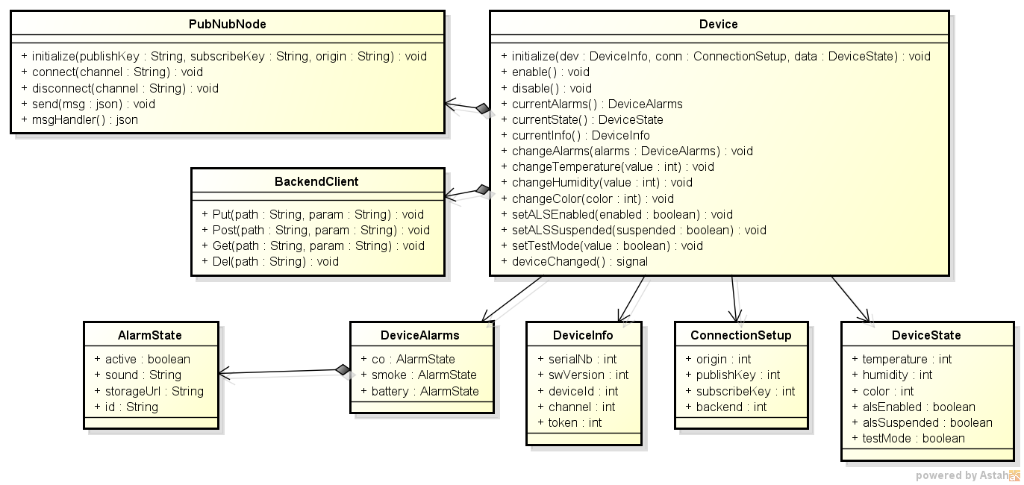
Internally Device will runs separate thread that listen PubNub, Backend messages and respond to them as device would.
There may be multiple Device classes created simultaneously, but they should have different ids, tokens etc. (as real devices).
For more sophisticated tests PubNubNode, BackendClient classes can be used directly.

