Documentation:

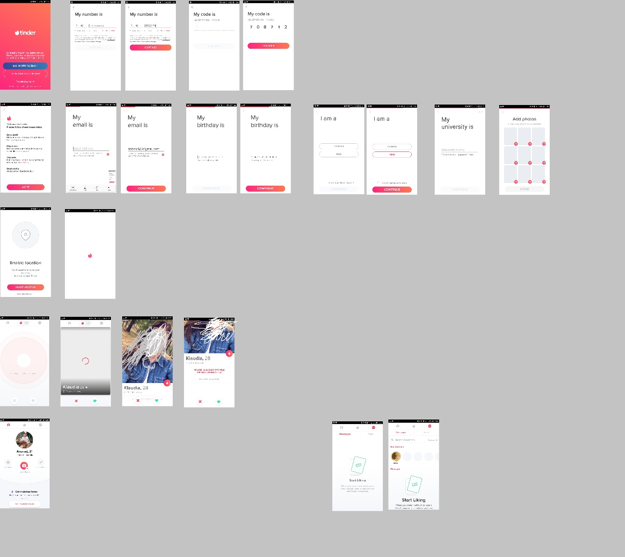

Use Cases:

1. Get List Of Match Suggestions
2. Like given Match Suggestion
3. Dislike given Match suggestion

Models:

User:

{

„id” : Int,  
„name”: String,  
„age”: Int,  
“description”: String,  
“photos”: List<PhotoFile>

}

PhotoFile:

{

„id”: Int,  
„uri”: String

}