DSP_DNS_Book

Michał Lesiowski

Invalid Date

Table of contents

# Preface

This is a Quarto book.

To learn more about Quarto books visit <https://quarto.org/docs/books>.

1 + 1

[1] 2

13 / 3

[1] 4.333333

Test test 123

# Wprowadzenie

## Cel dokumentu

## Zakres systemu

## Definicje, akronimy, skróty

## Dokumenty referencyjne

## Odbiorcy dokumentu

|  |
| --- |
| Uwaga |
| To jest przykładowy callout w sekcji bocznej. |

|  |  |  |
| --- | --- | --- |
| This is a template for a simple Quarto book output to html, PDF or docx format. It includes a GitHub Action that will build the website automatically when you make changes to the files. The NOAA palette and fonts has been added to theme.scss. The webpage will be on the gh-pages branch. Serving the website files from this branch is a common way to keep all the website files from cluttering your main branch | This is a template for a simple Quarto book output to html, PDF or docx format. It includes a GitHub Action that will build the website automatically when you make changes to the files. The NOAA palette and fonts has been added to theme.scss. The webpage will be on the gh-pages branch. Serving the website files from this branch is a common way to keep all the website files from cluttering your main branch | This is a template for a simple Quarto book output to html, PDF or docx format. It includes a GitHub Action that will build the website automatically when you make changes to the files. The NOAA palette and fonts has been added to theme.scss. The webpage will be on the gh-pages branch. Serving the website files from this branch is a common way to keep all the website files from cluttering your main branch |

This is a template for a simple Quarto book output to html, PDF or docx format. It includes a GitHub Action that will build the website automatically when you make changes to the files. The NOAA palette and fonts has been added to theme.scss. The webpage will be on the gh-pages branch. Serving the website files from this branch is a common way to keep all the website files from cluttering your main branch

This is a template for a simple Quarto book output to html, PDF or docx format. It includes a GitHub Action that will build the website automatically when you make changes to the files. The NOAA palette and fonts has been added to theme.scss. The webpage will be on the gh-pages branch. Serving the website files from this branch is a common way to keep all the website files from cluttering your main branch

Fruit prices

| fruit | price |
| --- | --- |
| apple | 2.05 |
| pear | 1.37 |
| orange | 3.09 |

### Grid tables

Bardziej zaawansowany typ np dodatkowe paragrafy, bloki kodu, listy

| Fruit | Price | Advantages |
| --- | --- | --- |
| Bananas | $1.34 | * built-in wrapper * bright color |
| Oranges | $2.10 | * cures scurvy * tasty |

## Link do 2 pages

intro

## Funckje jakie oczekuje od końcowego rozwiązania:

* Output do: PDF, DOCX, HTML
* Github Actions that will build website automatically when I make changes to the files
* Obsługa diagramów
* Konfigruacja pełna layoutu np. wygląd, czcionki poprzez theme.csss
* Templates dla

# 1. Introduction

This is a book created from markdown and executable code.

See Knuth (1984) for additional discussion of literate programming.

1 + 1

[1] 2

## 1.1 Rozdział kolejny

Test

| Col1 | Col2 | Col3 |
| --- | --- | --- |
| 1 | 2 | 3 |
| 1 | 2 | 3 |
| 3 | 3 | 3 |

## 1.2 Rozdział drugi

Drugi rozdział

### 1.2.1 Trzeci podrozdział

Trzeci itd.. You can also do this on a per-format basis (if for example you want to provide a higher resolution image for EPUB and a lower resolution image for HTML to reduce download time). For example:

By “right format”, we mean that the data is tidy, and ready to be summarised and graphed.

Quarto Pub is a free publishing service for content created with Quarto. Quarto Pub is ideal for blogs, course or project websites, books, presentations, and personal hobby sites.

It’s important to note that all documents and sites published to Quarto Pub are publicly visible. You should only publish content you wish to share publicly.

|  |
| --- |
| Caution |
| Tu znajduje się zwijana sekcja w boxie callout typu caution |

|  |
| --- |
| Tip |
| Altair is based on Vega-Lite, a high-level grammar of interactive graphics |

Właściwe linki i tu przykładowy odnośnik do mojej [[books]] książek

|  |
| --- |
| Note |
| A tu znajduje się callout note |

Cytacik lub wcięcie takie coś…

If you haven’t published to Quarto Pub before, the publish command will prompt you to authenticate. After confirming that you want to publish, your content will be rendered and deployed, and then a browser opened to view your site.

A jeśli chcemy umieścić kod to możemy to zrobić przy użyciu takiej dyrektywy jak poniżej. Może być ona też zwijana i rozwijana. To się określa w konigu yaml/

library(tidyverse)  
penguins <- read.csv('https://raw.githubusercontent.com/rfordatascience/tidytuesday/master/data/2020/2020-07-28/penguins.csv')%>%  
 drop_na()  
head(penguins)

species island bill_length_mm bill_depth_mm flipper_length_mm body_mass_g  
1 Adelie Torgersen 39.1 18.7 181 3750  
2 Adelie Torgersen 39.5 17.4 186 3800  
3 Adelie Torgersen 40.3 18.0 195 3250  
4 Adelie Torgersen 36.7 19.3 193 3450  
5 Adelie Torgersen 39.3 20.6 190 3650  
6 Adelie Torgersen 38.9 17.8 181 3625  
 sex year  
1 male 2007  
2 female 2007  
3 female 2007  
4 female 2007  
5 male 2007  
6 female 2007

We’ve removed missing values here, which means that the data has 333 rows now[^1]. Ten indeks górny przypis ^1 coś nie chce zabanglać

If you have an existing Quarto Pub site that you want to publish to, you should manually create a _publish.yml file that looks like the example above, but with the appropriate id and url values for your site.

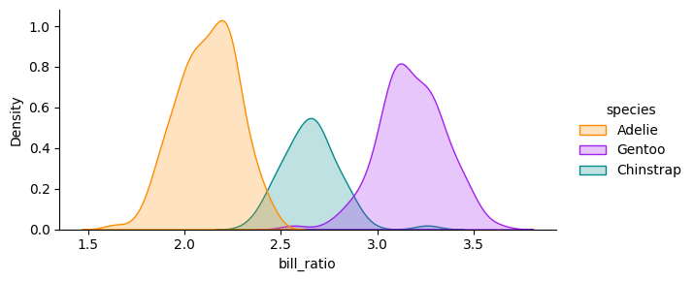

Właściwy opis wykresu

### 1.2.2 Podział na dwie kolumny

Poniżej demo jak podzielić przestrzeń na 2 kolumny

|  |  |  |
| --- | --- | --- |
| |  | | --- | | Figure 1.1: Właściwy opis wykresu | |  |

|  |  |
| --- | --- |
| |  | | --- | | Figure 1.2: Właściwy opis wykresu | |

The average bill length is 43.9927928 mm and the average bill depth is 17.1648649 mm.

The data was collected between 2007 and 2009

### 1.2.3 Zewnętrzne źródło

|  |
| --- |
| Figure 1.3: Elephant |

### 1.2.4 Dyrektywa na całą szerokość

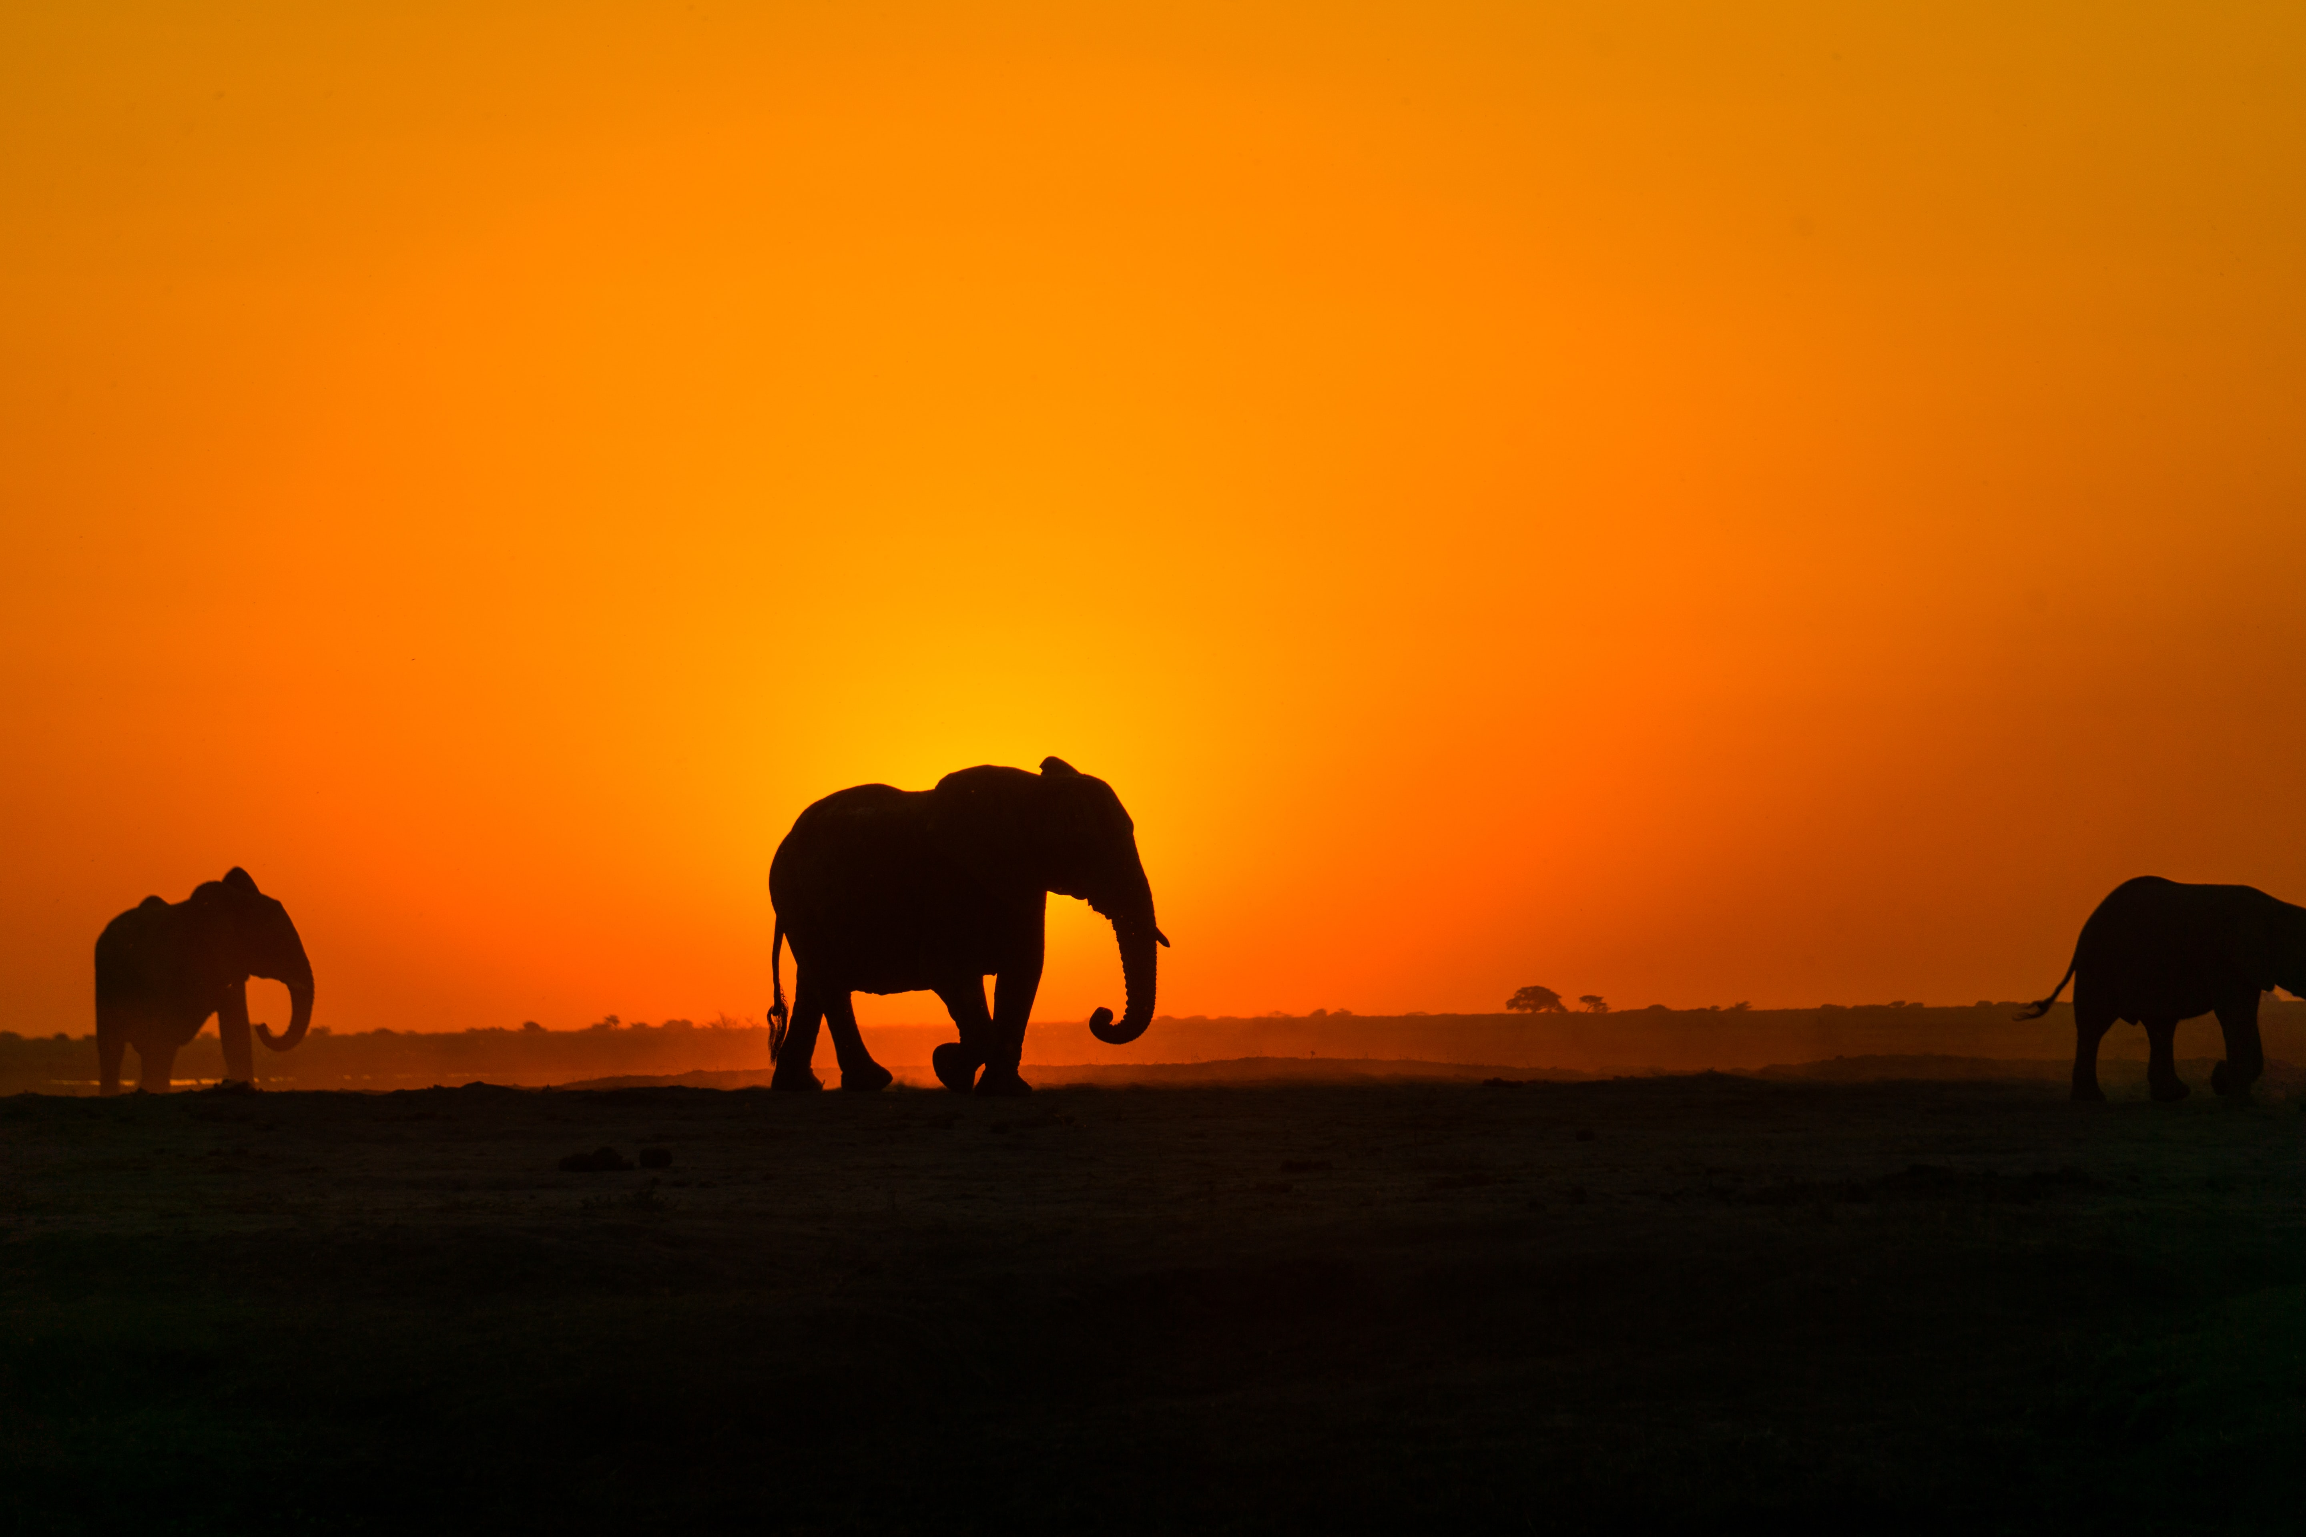

### 1.2.5 Dyrektywa na całe okno



A full screen image

Dodatkowo szerokości

knitr::kable(  
 mtcars[1:6, 1:10]  
)

|  | mpg | cyl | disp | hp | drat | wt | qsec | vs | am | gear |
| --- | --- | --- | --- | --- | --- | --- | --- | --- | --- | --- |
| Mazda RX4 | 21.0 | 6 | 160 | 110 | 3.90 | 2.620 | 16.46 | 0 | 1 | 4 |
| Mazda RX4 Wag | 21.0 | 6 | 160 | 110 | 3.90 | 2.875 | 17.02 | 0 | 1 | 4 |
| Datsun 710 | 22.8 | 4 | 108 | 93 | 3.85 | 2.320 | 18.61 | 1 | 1 | 4 |
| Hornet 4 Drive | 21.4 | 6 | 258 | 110 | 3.08 | 3.215 | 19.44 | 1 | 0 | 3 |
| Hornet Sportabout | 18.7 | 8 | 360 | 175 | 3.15 | 3.440 | 17.02 | 0 | 0 | 3 |
| Valiant | 18.1 | 6 | 225 | 105 | 2.76 | 3.460 | 20.22 | 1 | 0 | 3 |

# 2. Document - Sample 1

Software Requirements Specification

1. Metryka
   1. Tytuł
   2. Logo/ Unikalny numer / Wersja dokumentu (wersja z Github?)
   3. Data utworzenia / Data modyfikacji
   4. Authors (Tabela: Name, Role, Department)
   5. Historia dokumentu (Tabela: Data, Wersja, Revision Description, Revision Author)
   6. Approvals (może na końcu tabela: Approval date, Approved Version, Approver Role, Approver)
2. Introduction
   1. Cel projektu (purpose of project)
   2. Definicje, akronimy, skróty, słownik (Terms, Acronyms and Definitions)
   3. Odnośniki i powiązane dokumenty (Related documents)
   4. Instrukcja obsługi (opcja)
3. Opis systemu
   1. Zakres (Scope)
      1. Funkcjonalności z zakresie (In Scope Functionality)
      2. Poza zakresem (Out of Scope Functionality)
   2. Kontekst systemu - Opis systemu, jak system będzie wpasowany w otoczenie, interakcje z innymi systemami
4. Goals
5. Functional Requirements
6. Non-functional requirements
7. User Stories
8. Wireframes
9. Acceptance Criteria
10. Rules
11. Assumptions and Constraints

RACI? co jeszcze, tabele - User Stories,

Makiety - opis tabelki do tego,

Lightbox

Test GIT i jak katalog tych dokumentów

# 3. Summary

In summary, this book has no content whatsoever.

1 + 1

[1] 2

# References

Knuth, Donald E. 1984. “Literate Programming.” *Comput. J.* 27 (2): 97–111. <https://doi.org/10.1093/comjnl/27.2.97>.