**in 中文

[Page0] Login **登入**

[Page1] Homepage

* 1. Banner: image, search bar for courses **搜尋課程**



* 1. Popular course list **熱門課程** (add “**前往看所有課程**” button) *\* Grid/List view*

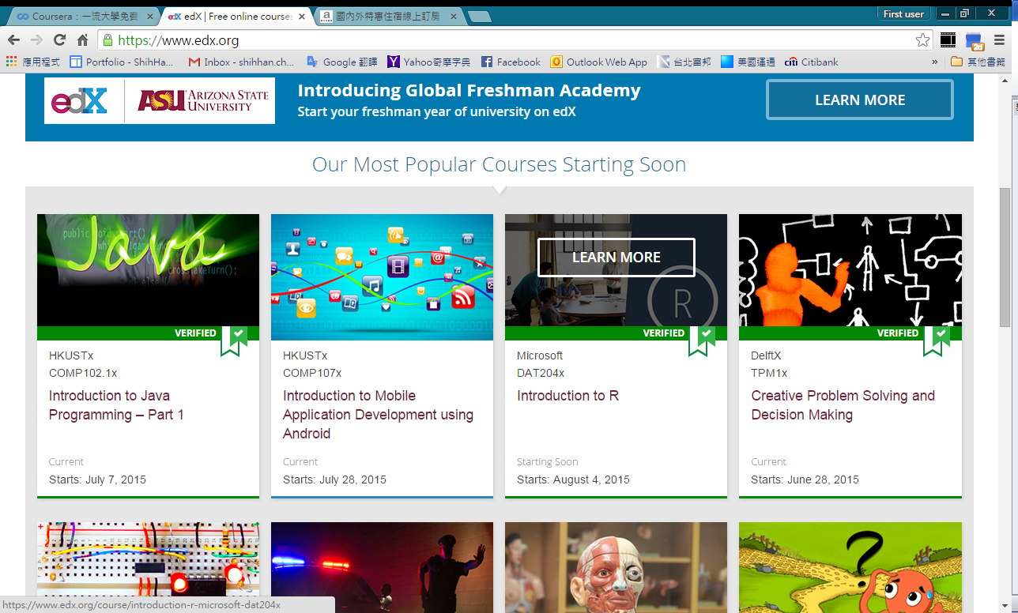 edX

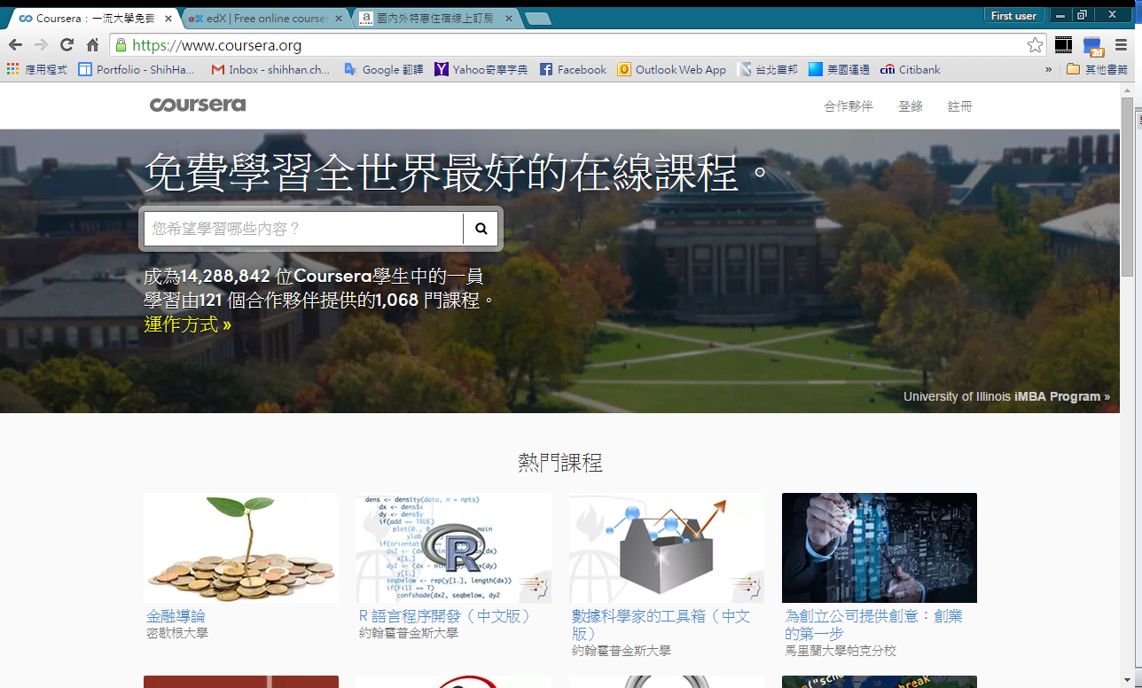 Coursera

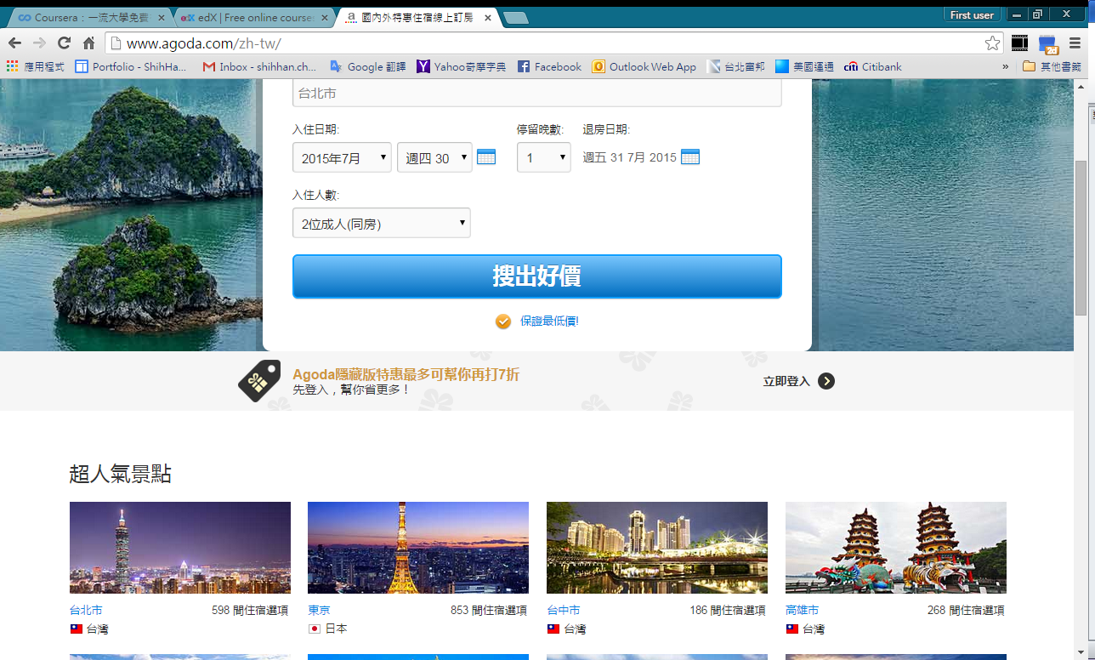 Agoda

[Page2] Course List (all or by search, currently no index) *\* Grid/List view*

**課程**

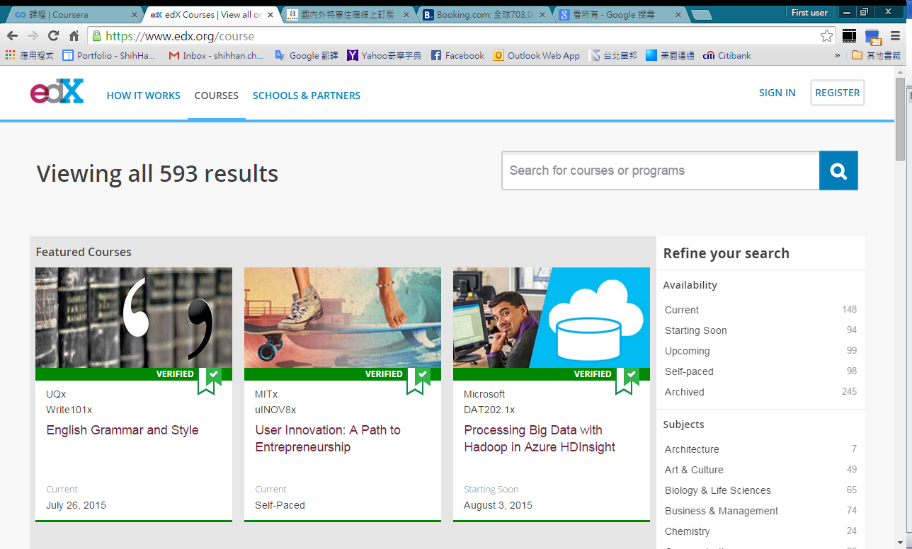 edX

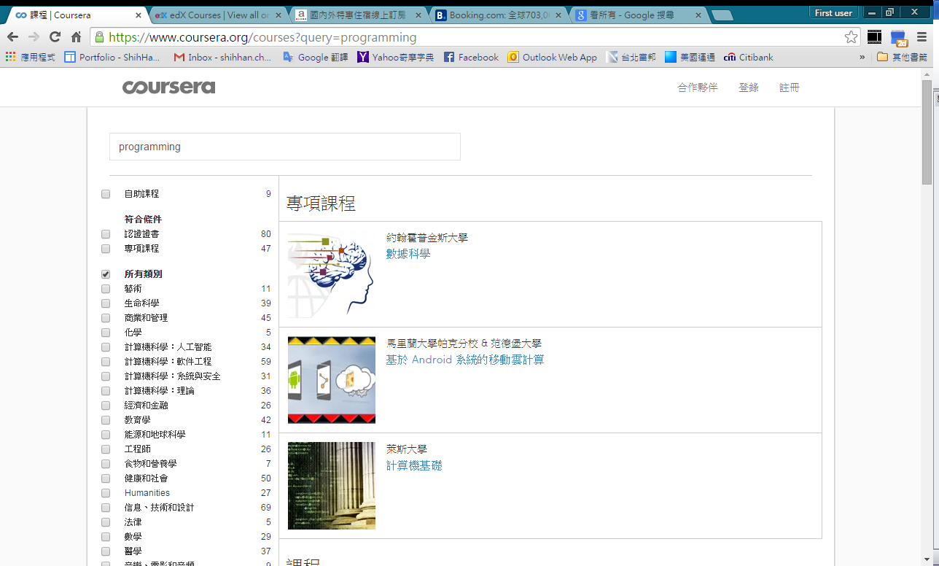 Coursera

[Page3] Course page (for each course)

* Banner: course name, course theme, intro video, enroll button
* About (course description) **課程概述**
* Other attributes on the right (TBD)

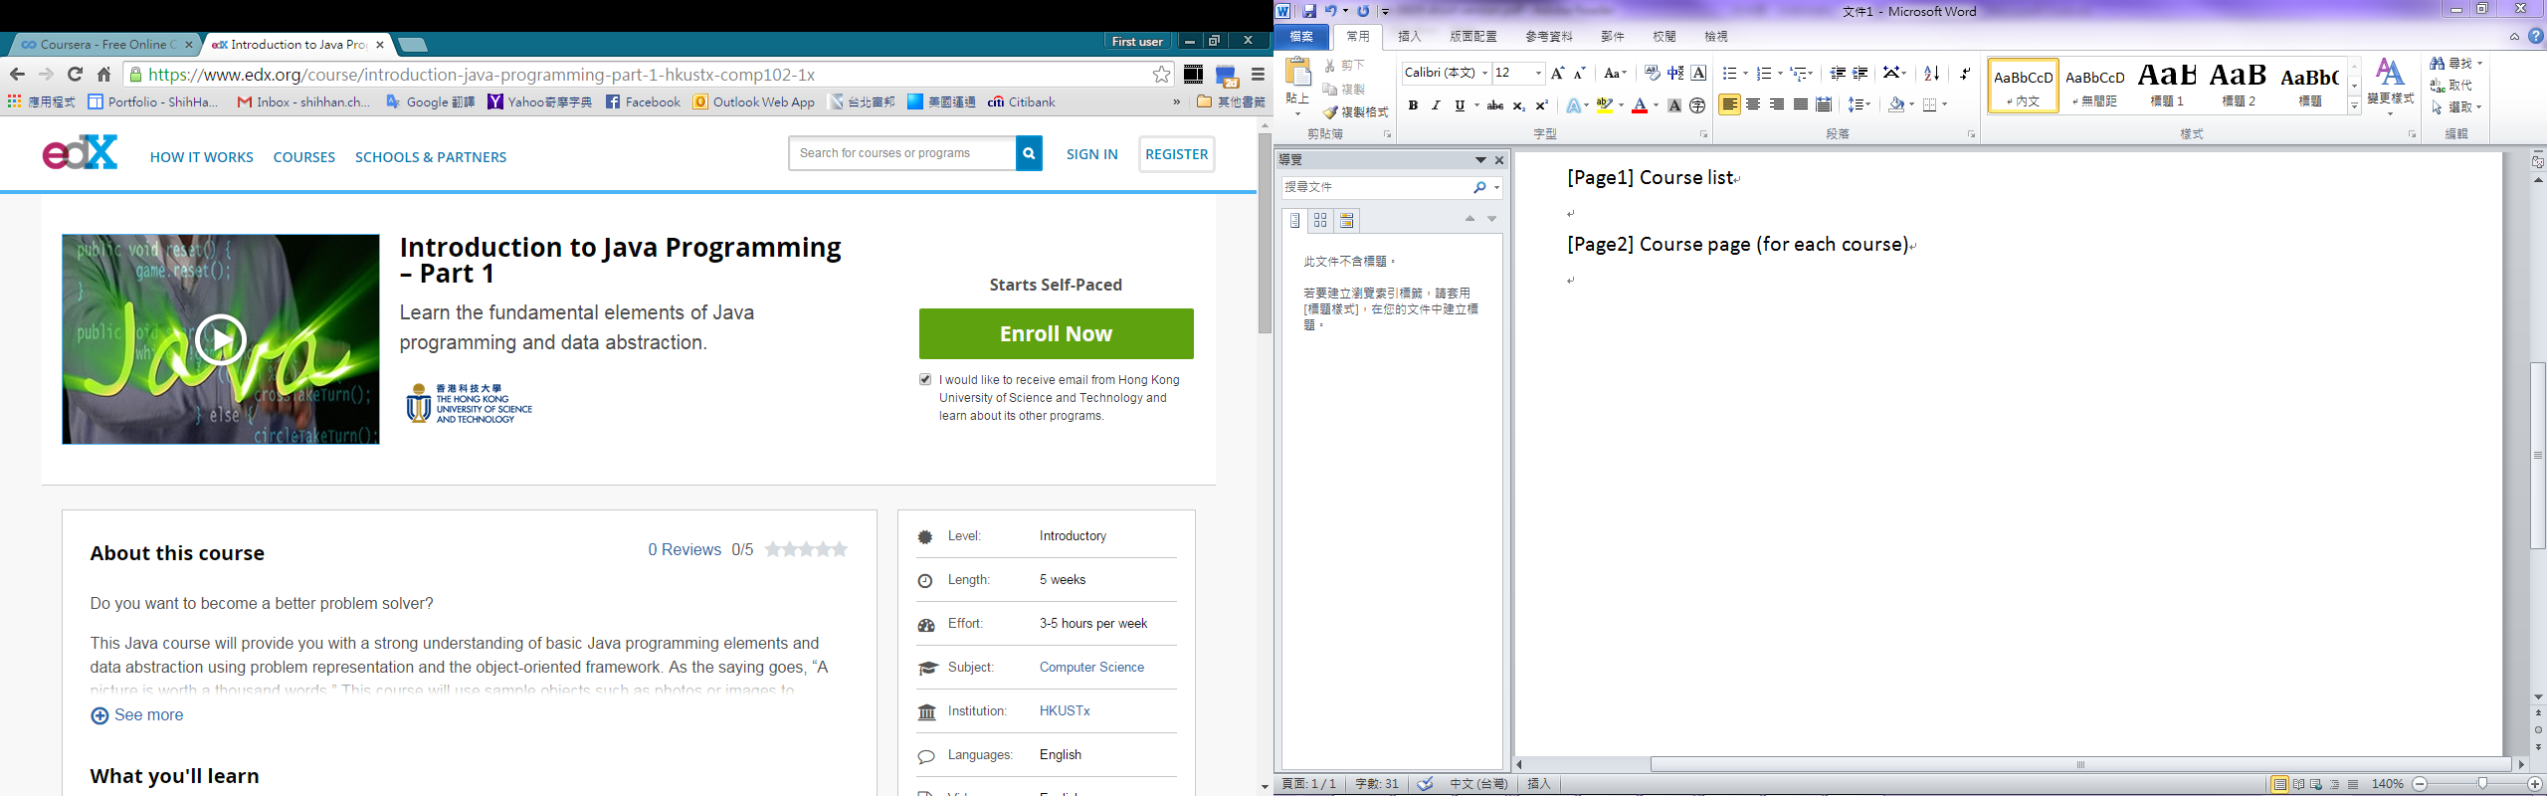 edX

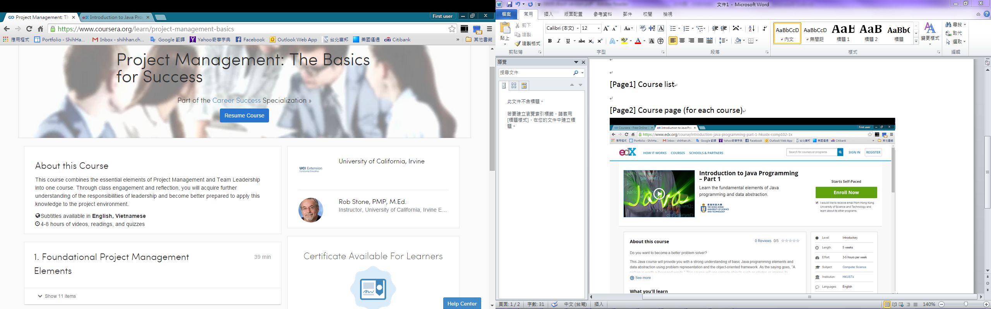 Coursera

[Page4] My courses (Dashboard) 管理**我的課程** / **課程面板**

* Current 正在進行的課程 (當前課程?)
* Archived/Past 已完成的課程
* Watchlist 關注的課程

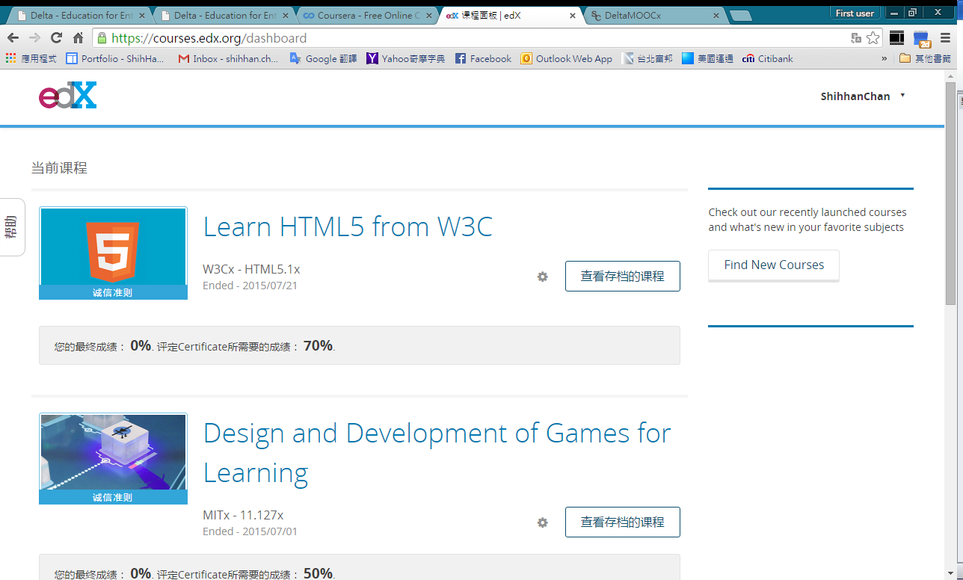 edX

 Coursera

[Panel/icons]

Always

* Login/out
* Home
* Search

In Course

* Map
* Next
* Jump (enable when an object is selected)
* Info (enable when an object is selected)
* Chat
* *Forum*
* *Class mgmt*
* *Class member mgmt*
* *Personal learning mgmt*

[Need to be enabled in Editor first] (Controller either)

*** Questionnaire / Quiz (e.g. Google Form) **問卷** / **測驗**

*Text field, Text area, Radio button, Checkbox, Dropdown menu, …*

*** Course map to be enlarged automatically

* Expand/collapse courseware
* Adjustable courseware

*** Refine Course Attributes (in both English and 中文)

* Picture (required) **圖片**
* Introduction video and text (required) **簡介**

*** Permission (Editor, Resource…)

*** Log in