Kinematic Modeling in 2D
Kinematic model : dato dalla statica // dynamic model: modello cinematico + preciso
frame: inertial frame (east nord up/eart center earth fix (usati nei sistemi GNSS)) /body frame (in G) / sensor frame (centro sensore)
transformazioni tra i frame: translation e rotation (omogenee matrici ) [R|t;01]
nonholonomic data struttura robot essa puo limitare il suo movimento → ne tengo conto (riduce i gdl?)
velocità pari alla tangente delle angolo orientazione theta → tgT=dy/dx (velocita rispetto a y ed x)→ riscrivendo nonholonomic constraint dy*cosT-dx*sinT=0 → dx =v cosT e dy=vsinT
state: sono quelle cose che definiscono al poszione in qualsiasi condizione
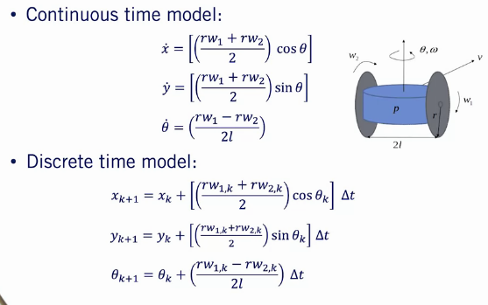
2 model robot uso ICR per determinare velocità robot

The Kinematic Bicycle Model
Reference on vehicle: center on wheel rear /back or gravity
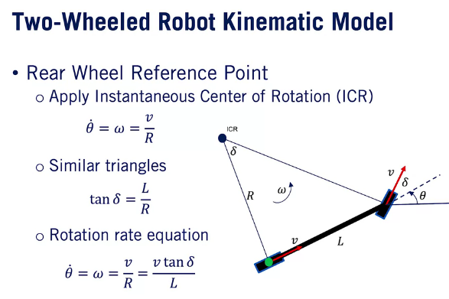
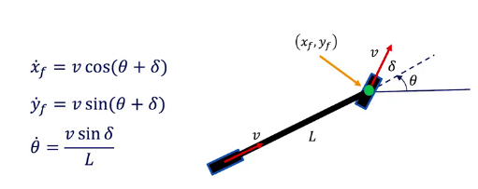

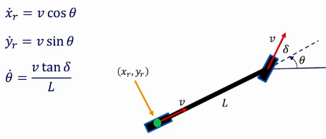

Because of the no slip constraints we enforce on the front and rear wheels, the direction of motion at the cg is slightly different from the forward velocity direction in either wheel and from the heading of the bicycle. This difference is called the slip angle or side slip angle, which we'll refer to as Beta, and is measured as the angular difference between the velocity at the cg and the heading of the bicycle → beta calcolato se no slip
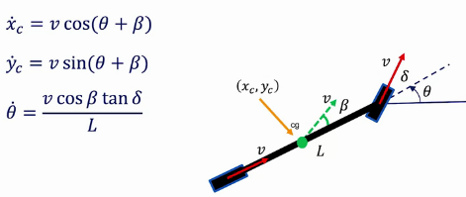
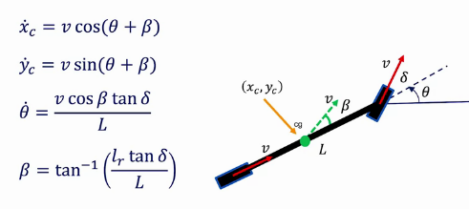

Since Delta is an input that would be selected by a controller, there is no restriction on how quickly it can change which is somewhat unrealistic. Instead, our kinematic models can be formulated with four states: x, y, Theta, and the steering angle Delta. If we assume we can only control the rate of change of the steering angle Phi, we can simply extend our model to include Delta as a state and use the steering rate Phi as our modified input
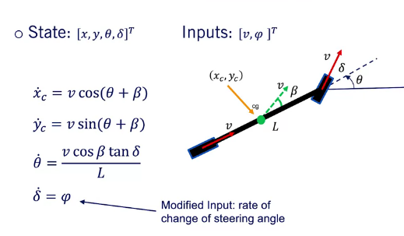

Dynamic Modeling in 2D
Wheel I*d2theta+b*dtheta+k*theta=tau_{drive}-t_{load}
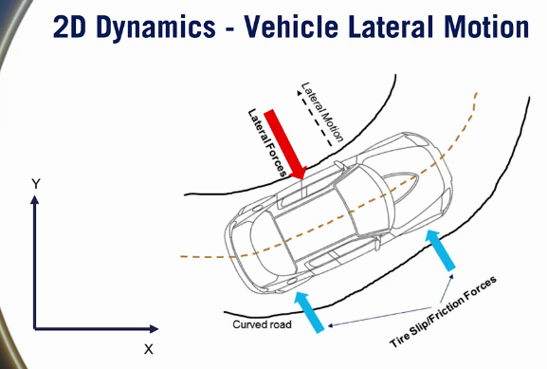
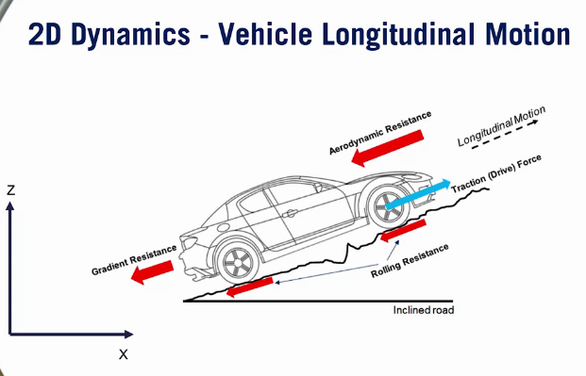

Longitudinal Vehicle Modeling
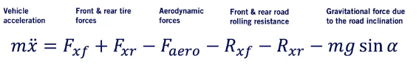
Semplificazione: sinalpha=alpha /somma Fx e Rx
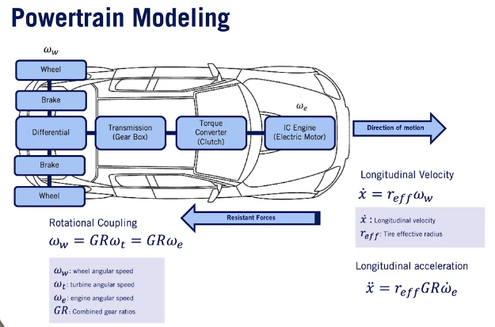
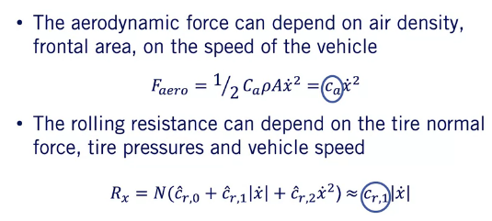
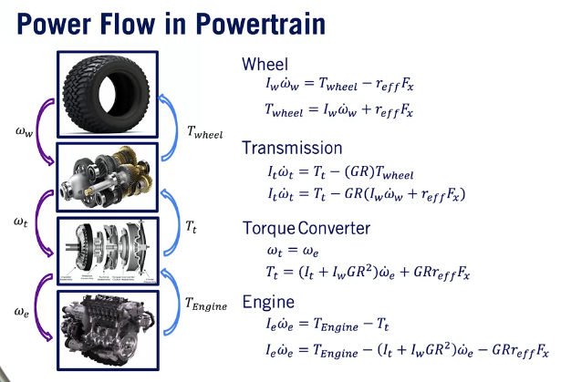
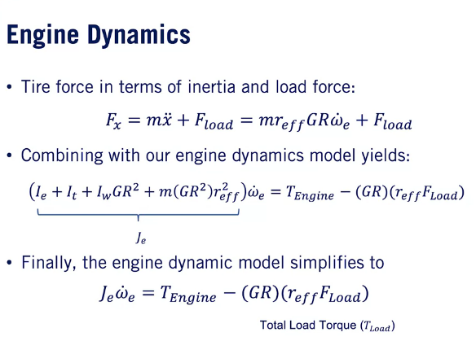

Lateral Dynamics of Bicycle Model
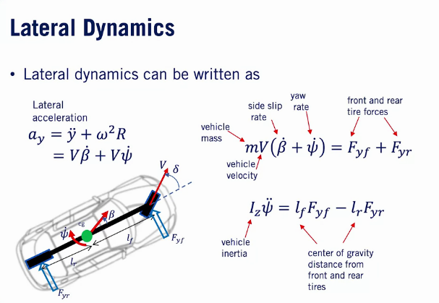
Longitudianl velocity costant / left and right unite / movimento sospensioni, inclinazione strada e aereodinamica non contemplate

beta e tridente sono slip
V =omega*R e dtridente=omega
front and rear slip angle
They are defined in exactly the same way as the vehicle slip angle beta, but are defined relative to the direction of the wheel and the vehicle velocity at the wheel center

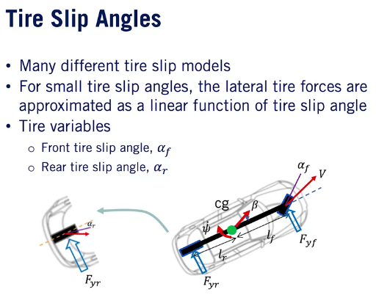
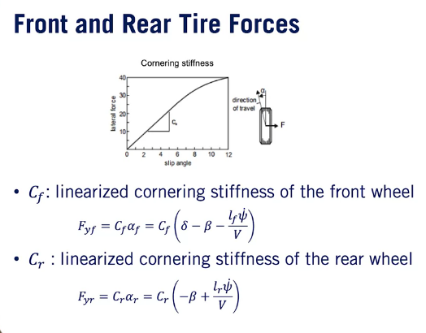
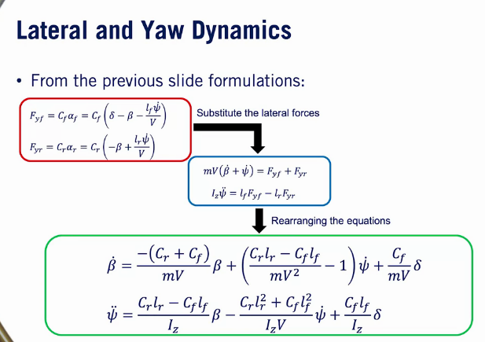
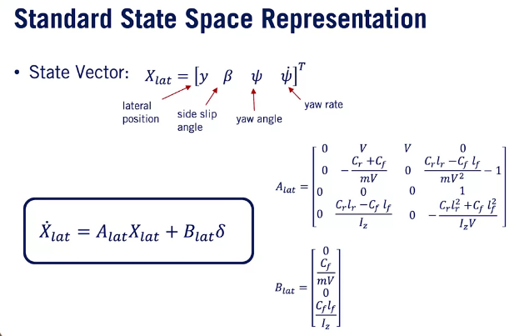

Vehicle Actuation
Input lateral dynamic is steering /throtle and brake only for forward (per semplicità sono divisi)
steering dipende dagli ingranaggi ma ipotizziamo che sia un rapporto costante tra giro volante e giro ruote
torque (motore → torque converter (clutch) → trasmission (gear box) → differential → wheel)
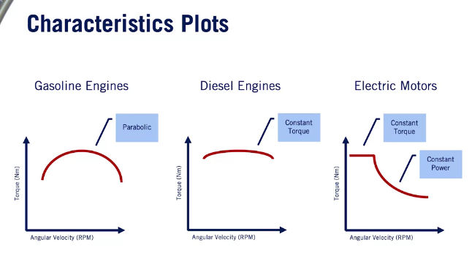
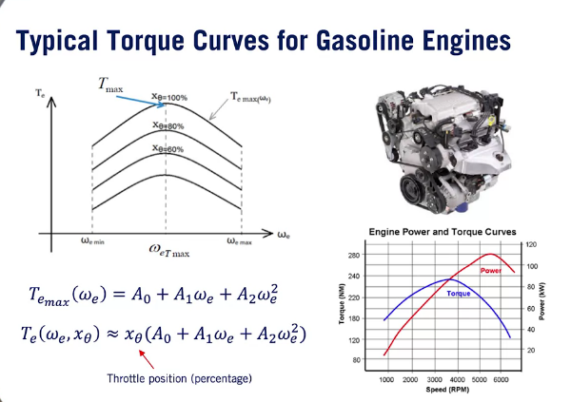

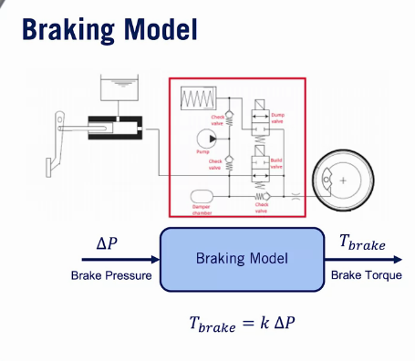
semi-empirical model

Tire Slip and Modeling
