Light Detection and Ranging Sensors
Laser, stop watch count when light laser on, after he travel back and capture by photodetector (round trip time)
r=1/2 c(light velocity)*t (round trip time)
can also measure intensity

3d scanner, a mirror chose hight of laser scanner and rotate

spherical cordinates: range(time travel), elevation and azimuth (anticlock wise respect x) (using encoder position of mirror)
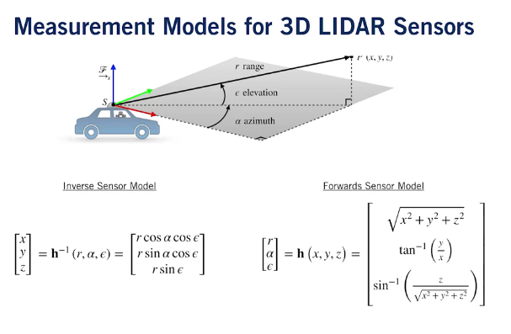

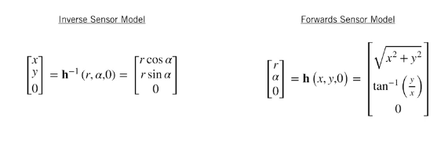

3rror:
-incertezza nella determinazione del vero tempo di arrivo
-incertezza nella misura orientazione specchio
-interaction con il target (assorbe la luce, o altro)
-variation of progation speed (differente in base alla presenza di nebbia che porta a variare la velocità della luce)
-macchina si muove ad una velocità che non risulta influenzare la luce ma la rotazione dello specchio essendo che compie rotazioni attorno 5-20Hz l’uscita può essere distorta con duplicati e altro
→ gaussian
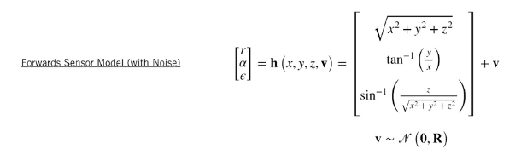

LIDAR Sensor Models and Point Clouds
Data structure P=[p1 p2 p3 p4 … ]=[[x1 y1 z1] ^{T} [x2 y2 z2]^{T} … ] → calcolo veloce con numpy

operazioni con il cloud points → translation , rotation e scaling

traslation: P=P-R (numpy use broadcast semantic)
rotation:cange the base of vector P=CP
scaling: scalling matrice con valori diagonali pari al fattore da scalare r’=[x 0 0; 0 y 0; 0 0 z]r (S)
combinazione: P=SC(P-R)

plane fitting : plane-fitting for self-driving cars is figuring out where the road surface is and redicting where it's going to be as the car continues driving
z=a+bx+cy we want a,b,c → least-squares → e=z(stima)-z(reale)=(a+bx+cy)-z
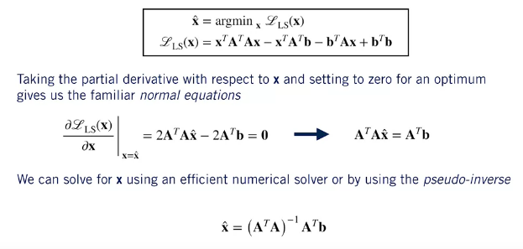
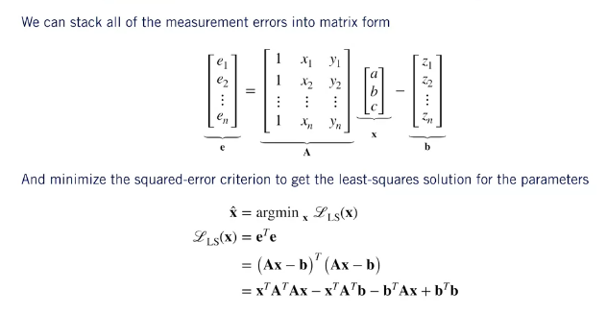

with noise is need a batch

http://pointclouds.org/

Pose Estimation from LIDAR Data
Problema da risolvere: point set registration problem

we dont know quali punti corrispondono agli altri
→ iterative closest point algoritm (ICP)
intuizione: trovato ottimo movimento allora punti vicini sono gli stessi
→ euristico: best candidate is the closest

ICP:
1. guess trasformation (C,R) using IMU
2. associare i punti con quelli a distanza minima
3.risolvere in modo di avere un ottimo(C,R)
4. ripetere da 2. usando quella ottenuta come guess

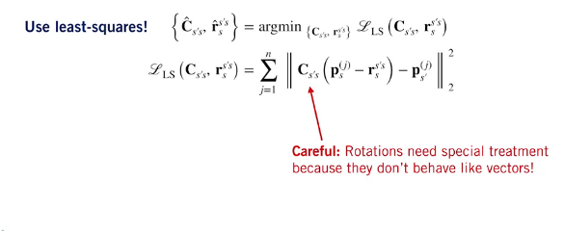
LS

problema con matrici rotazione →

1.compute centroid
2. calcolare lo spread
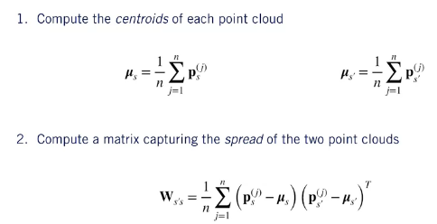

3. find optimal using singular value decomposition: factorizing a matrixThe SVD is a way offactorizing a matrix into the product of two unitary matrices, U and V, and a diagonal matrix S,
whose non-zero entries are called the singular values of the original matrix. There are several ways to interpret the SVD. But for us, it's easiest to think about U and V as rotations and the S matrix as a scaling matrix
4. recover translation
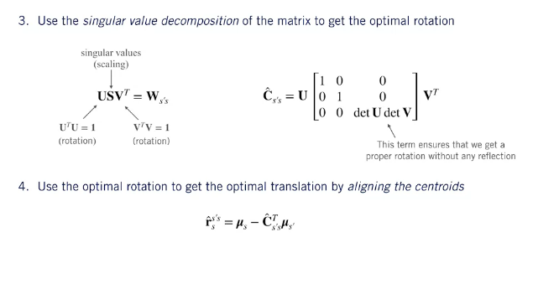

how misure covariance:
This expression tells us how the covariance of the estimated motion parameters is related to the covariance of the measurements in the two point clouds using certain second-order derivatives of the least squares cost function
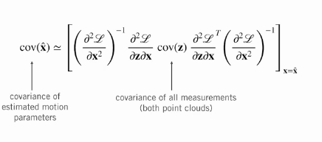

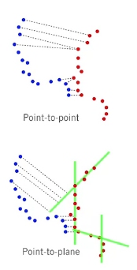

-point to point : minimizza la minima distanza tra ogni punto di con il piu vecino

-poito to plane:minimizza la distanza perpendicolare tra ogni punto della prima misura è il piu vicino piano creato dai punti della seconda misura

se due oggetti si muovono alla stessa velocita i punti sono alla stessa distanza il che porta a ipotizzare che siamo fermi→ nn si puo usare solo ICP→ robust loss fuction

simpler approach for dealing with outliers like these is to choose a different loss function that is less sensitive to large errors induced by outliers than our standard squared error loss. The class of loss functions that have this property are called Robust Loss Functions or robust cost functionsWe can write this out mathematically by generalizing our least squares loss function so that the contribution of each error is not simply the square of its magnitude, but rather, some other function rho The key difference is that the slope of the loss function does not continue to increase as the errors become larger, but rather, it remains constant or it tapers off. Robust loss functions make the ICP problems slightly more difficult because we can no longer derive a nice closed form solution for the point cloud alignment step, and this means we need to add another iterative optimization step inside our main loop
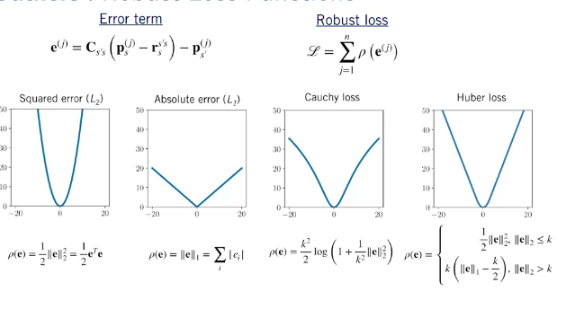

https://en.wikipedia.org/wiki/Point_set_registration
https://en.wikipedia.org/wiki/Iterative_closest_point
https://ieeexplore.ieee.org/document/4209579
https://arxiv.org/abs/1710.07104
https://ieeexplore.ieee.org/document/132043
https://ieeexplore.ieee.org/document/121791

