State Estimation in Practice
Calibration (sensor model, relative pose, time offset (syncronized))

precision

speed requirements (campionamento per la sicurezza) dipende da cpu e precisione voluta

localization failure sensor fail or provide bad data,estimation error(linear) large state uncertainty (basarzi troppo su misura che decade in precisione aumentando errore)

dynamic word: light pedestian car season change the world arous us

Multisensor Fusion for State Estimation

Importante che siano scorrelati:
imu provides smoothing of gnss, fill-in during during outages due to jamming or maneubering
gnss provide absolute position
information to mitigate imu drift
lidar accurate position within know maps(da gnss fornisce la mappa)
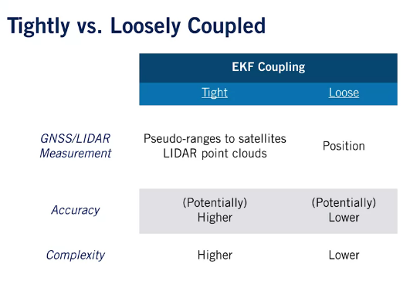
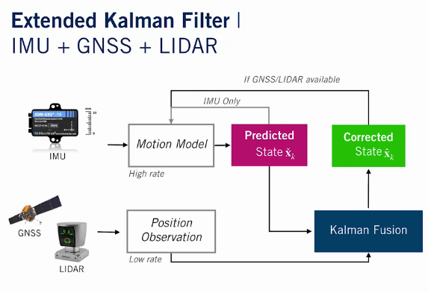

vehicle state : posizione velocità e quternione
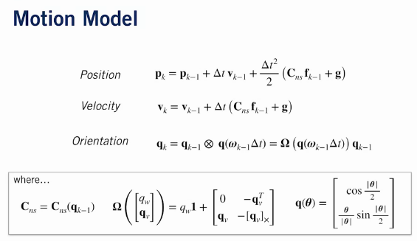

advantages using the error state as rotation 3 based on global navigation frame respect the local frame

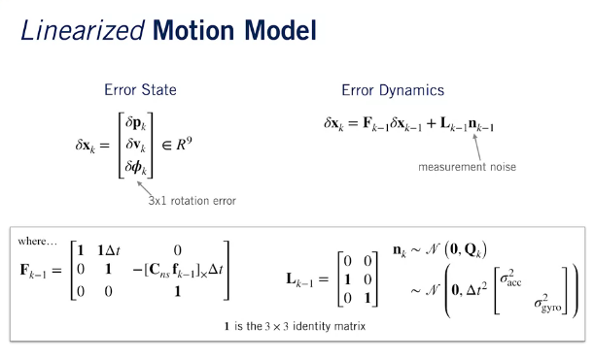
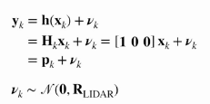

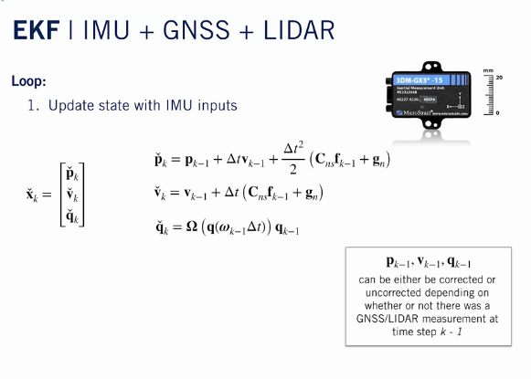
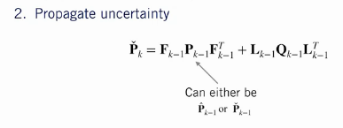

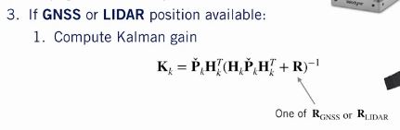

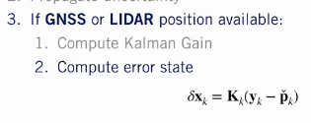
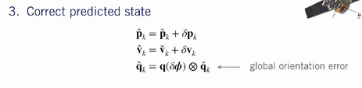

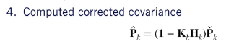

We have chosen to use a global orientation error. This means that the orientation update involves multiplying by the error state quaternion on the left. This is different from the propagation step, where we multiplied by the incremental quaternion defining the orientation change on the right

https://medium.com/@wilburdes/sensor-fusion-algorithms-for-autonomous-driving-part-1-the-kalman-filter-and-extended-kalman-a4eab8a833dd
https://www.technologyreview.com/2017/07/21/150383/this-image-is-why-self-driving-cars-come-loaded-with-many-types-of-sensors/

Sensor Calibration - A Necessary Evil
Intrinsic calibration: depends of the sensor (R for know the velocità tangenziale data pulsazione)
-manufacture specifications (comunque cambia)
-measure by hand
-estimate as part of the state (accuracy hight but increase complexitu)

extrinsic sensor calibration: posizione relativa fra i vari sensori : cad model /measure by hand / estimate

temporla calibration: cercare di determinare due misure sincrone, anche sapendo frequenza puo esserci delay: assumere delay zero / hardware synchronization /estimate (very complicated)

https://www.trescal.us/customer-service-bulletin/all-you-need-to-know-about-sensor-calibration
https://aimotive.com/blog/content/1227
https://apollo.auto/platform/perception.html

Loss of One or More Sensors

importance of sensor redundancy for robust localization

se un sensore nn funzia allora elimino qualsiasi cosa che possa essere legato a quel controllo automatico

