The linear kalman filter
simile recursive leat square-
update state witgh prediction abd correction(fatta da misure) e poi fusione
motion model x(k+1)= Fx+Gu+w(noise Gauss)
measurament model: y=Hx+v(noise Gauss)

1prediction: x(k+1)=Fx+Gu P(k+1)=FPF^{T}+Q
2a optimal gain K=PH^{T}(HPH^{T}+R)⁻¹
2b correzione x=x+K(y-Hx)(innovazione) P=(1-KH)P

https://www.bzarg.com/p/how-a-kalman-filter-works-in-pictures/

Kalman Filter and The Bias BLUEs
Unbiased se bias tende a 0
iniziale condizione state sono unbiased e rumore bianco
consistenza : E[e^2]=E[(pstima-pvero)^2]=P
la covarianza coincide con sqrt var error
dato che dato iniziali è
best linear unbiased estimator (con migliore varianza)

https://en.wikipedia.org/wiki/Bias_of_an_estimator

the extended kalman filter
linearaziong a point of wok-→ find a tangent using Taylor expansion:
f=f(a)+df/dx|x=a (x-a)^2+…
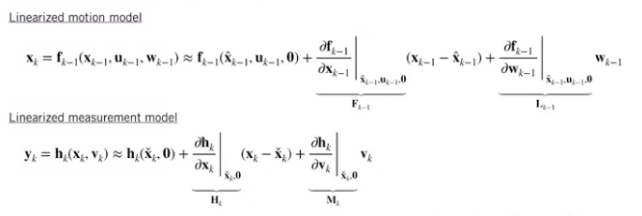
linearized respect the previus state, measured on actual state

jacobian ti dice come varia velocita output in base velocita all’input

First, in the prediction and correction steps, we're still using the non-linear models to propagate the mean of the state estimate and to compute the measurement residual or innovation. That's because we linearized our motion model about the previous state estimate, and we linearize the measurement model about the predicted state. By definition, the linearized model exactly coincides with the non-linear model at the operating point. The second difference is the appearance of the L and M Jacobians related to the process and measurement noise. In many cases, both of these matrices will be identity since noise is often assumed to be additive.
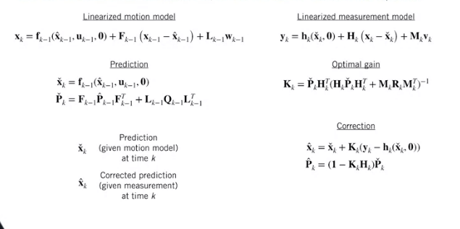

https://www.embedded.com/using-nonlinear-kalman-filtering-to-estimate-signals/

An Improved EKF - The Error State Extended Kalman Filter
Large part nominal state e small part error state
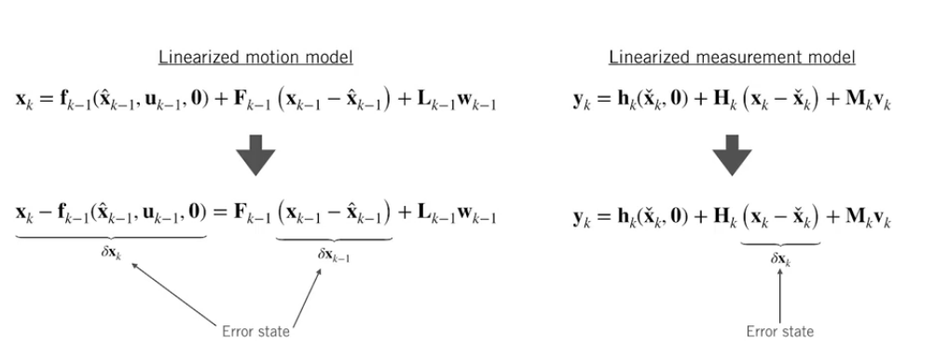
error state where is accumuated error → estimate of error with error state kinematic

1.upgrate nominal state with motion model x(k+1)=f(x,u,0)
2. propagate uncertainty P(k+1)=FPF^{T}+LQL^{T}
3. se misure avaible:
3.1compute kalman gain K=PH^{T}(HPH^{T}+R)⁻¹
3.2 compute error state dx= K(y-h(x,0))
3.3correct nominal state x=x+dx
3.4 correct state covariance P=(1-KH)P

why:
1 perform better than vanilla EKF (+ facile da maneggiare il piccolo errore che il grande stato nominale)
2. easy con contstrain quantities usando un generalized composition operator
https://ieeexplore.ieee.org/document/772597
https://arxiv.org/pdf/1711.02508.pdf

Limitations of the EKF

Linearization error: differebce between state and linearizzation
depends: on how much it change and how more away is located the linearization respect the state point
linearization can cause error:
estimate mean can be very different form the actual state
estimate state covariance can fail to capture the true uncertainty of the state
can diverge → security problem

The Unscented Kalman Filter
Unscented trasform, to pass probability distributions through nonlinear functions. for a similar amount of computation, and without needing to compute any Jacobians.
It's typically much easier to approximate a probability distribution, than it is to approximate an arbitrary nonlinear function.
1. chose sigma point by determinate choise 2. trasform sigma point 3. compute weighted mean and convariance of trasformated trasform

choosing sigma point per dimension N → 2N+1 points (1 for mean the rest simmetrical distribuite from the mean)
1. The first step in determining where the sigma points should be is taking something called the Cholesky decomposition of the covariance matrix associated with the input distribution. TheCholesky decomposition is basically a square root operation that operates on symmetric positive definite matrices such as covariance matrices
2. calculate the sigma point
Once we've decomposed the covariance matrix, we can choose our first sigma point to be the mean of the distribution, and the remainder to be the mean plus or minus some factor times each column of the matrix L that we got from the Cholesky decomposition. The value of N here again is the number of dimensions of the probability distribution. The parameter kappa is a tuning parameter that you are free to set yourself. For Gaussian distributions which is what we'll be working with, setting N plus kappa equal to three is a good choice
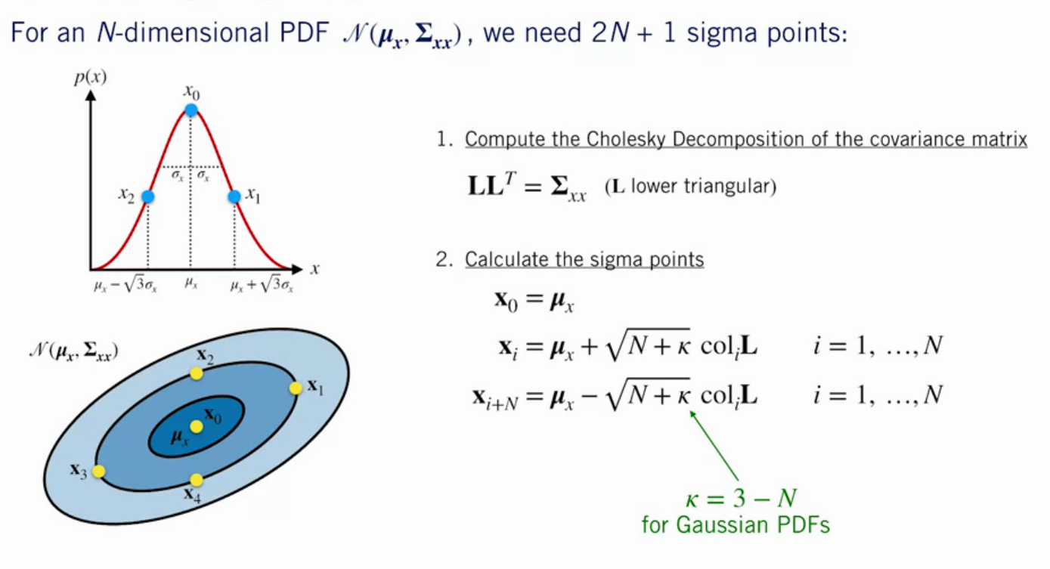

aplicarsi per il sistema nn lineare per ottenere nuovi sigma point y=h(x)
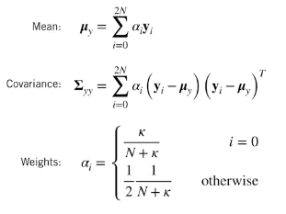
calcolare la media e la covarianza in base al peso che dipende da N e da K scelto

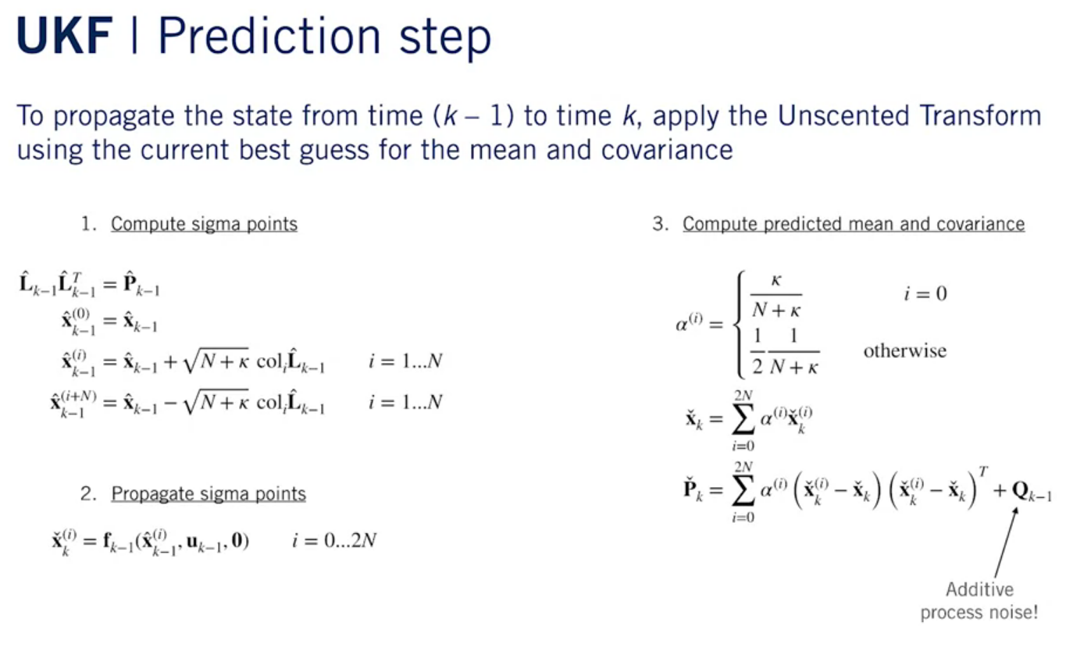
using uscented trasform tio approximatethe PDF directly
prediction:
1. decompose P calcolate sigmapoit
2. propagate sigma point
3. compute predicted mean and covariance

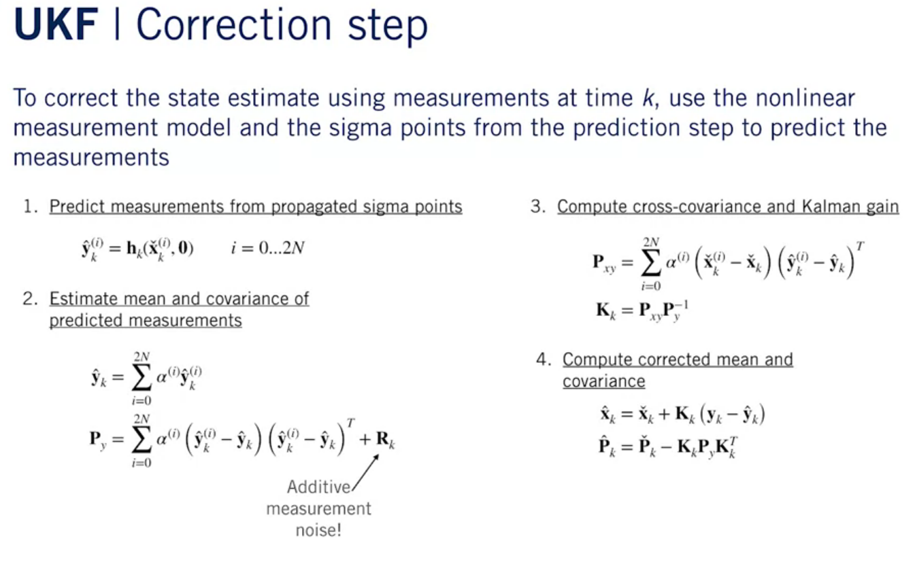
corection:
1.predict measurement from propagated sigma point
2. estimate mean and covariance of predcted measuments
3. compute cross-covariance and kalman gain
4. compute corrected mean and covariacne

https://www.seas.harvard.edu/courses/cs281/papers/unscented.pdf
https://www.cse.sc.edu/~terejanu/files/tutorialUKF.pdf
http://www.cs.unc.edu/~welch/kalman/media/pdf/Julier1997_SPIE_KF.pdf

