Feed Forward Neural Networks
Feesforward neural network = mapping da x to y come y=f(x,theta)
theta= learn parameter /costruiamo un sistema che aprox reale
a N layer FHH f(x,t)=fN(fn-1(….f¹(x)))
input layer/ hidden layer 1 f¹(x) / hidden layer 2 /output layer → feedforward perche dato va da inizio a fine senza feedback

noi vogliamo:
-object classification - object detection – depth estimation – semantic segmentation (label for every pixel)

voglio che theta tale che esempi di x ed f(x*) (training data) = f(x,theta)
hidden layer fa quello che vogliono
h_{n}=g(W^{t}h_{n-1} +b ) (tra parentesi: affine transformation)
g activation function (nn linear function)
W= weight
h input =output di quella prima
b = bias
theta=(W,b)

Rectified linear unit ReLU:default choise of activation function for FNN g(z)=max(0,z)

altre funzioni sono: sigmoid-tanh-maxout unit

http://www.deeplearningbook.org/

Output Layers and Loss Functions
Inference: dato x ottengo y dal modello
training: y e f(x) confronto dentro a loss fuction → optimization e modifica parametri tyheta
output layer e loss fuction have to be choose in modo di ottenere quello che vogliamo
classificazione (voglio una categoria) e regression (voglio un valore: tipo profondità)
class: softmax output layers: to represent the probability distribution over K different classes
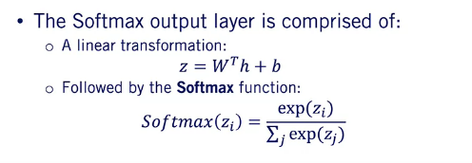
linear trans: gives a output
then using softmax ottengo una probabilita

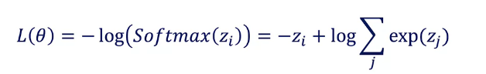
choose a loss function: cross-entropy loss function (derived maximum likelihood)
zi output of the hidden layer corresponding to the true class before being passed through the softmax function (class logit)
When minimizing this loss function, the negative of the class logit z_i encourages the network to output a large value for the probability of the correct class. The second term on the other hand, encourages the output of the affine transformation to be small. The two terms together encourages the network to minimize the difference between the predicted class probabilities and the true class probability.

Note how the loss function heavily penalizes erroneous predictions even when the difference in output is only one. This difference accelerates the learning process and rapidly steers network outputs to the true values during training
regression:
linear output units
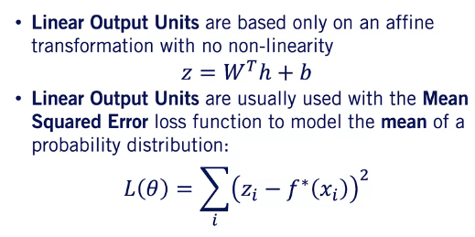

Neural Network Training with Gradient Descent
using an iterative optimization procedure with proper parameter initialization.

Training loss J(theta)=1/N sum su N (L[f(),f*])

Batch gradient descent: iterative first order optimization
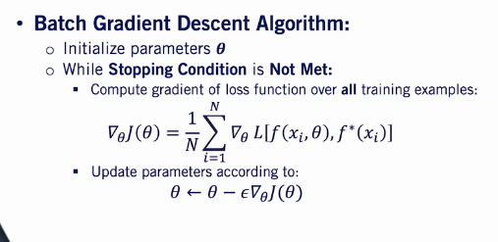
inizializzando
w= random sampling from a standard normal distribution
biases=0
altri heuristics exist

stop:
-n di iterazioni
-chenges in theta value : theta vecchio-theta nuovo<threshold
-changes in J(theta) value < threshold

back propagation : usato per calcolre gradiente theta è peswante per CPU
the laws function as well as its gradient are means over the training dataset. For example, we know that the standard error in a mean estimated from a set of N samples is sigma over the square root of N. Where sigma is the standard deviation of the distribution and N as the number of samples used to estimate the mean. That means that the rate of decrease in error in the gradient estimate is less than linear in the number of samples. This observation is very important, as we now can use a small sub-sample of the training data or a mini batch to compute our gradient estimate
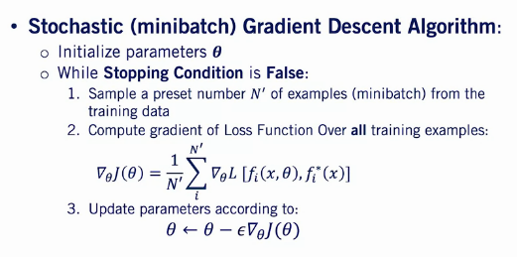
new parameter: size of minibatch:
with gpu 2^n
large batch >256:
-troppo piccolo hardwqare nn utilizzato
- stima migliore gradiente
small batch <64:
-regularizing effect (miglior generalization error with 1)
-fast convergenza

Dataset is shuffled prima di sampling
sgd variation: best is adam

Data Splits and Neural Network Performance Evaluation
Dividere in 3 parti: Training (min loss fuction), validating(usato per scegliere hyperparameters(numero layer)) , testing (mai visto dalla macchina solo per test)

prima 60 20 20 con 10000 dati → now con milion 98 1 1

validating using loss validation J(theta) per ogni set of data

buono se si avvicina al valore minimo ed e stabile
undefitting se vien schifo con valori >1 → train longer, more layer o more parametre, change architecture
overfitting train con 0,2 altri con valori >1 → more taining data, regularization, change architecture

regulation: is any modification made to the learning algorithm with an intention to lower the generalization gap(the difference between a model's performance on training data and its performance on unseen data drawn from the same distribution)but not the training loss

Neural Network Regularization

Parameter norm penalties (Omega)
J(theta)_{reg}=J(t)+alpha* Omega (t)
alpha weight hyperparameter (pesa contributo relativo della norma penalizzante al valore della loss fuction)
Omega(t) misura quanto largo è theta (Lp norm)
no bias

l2-norm parameter penalty ½ W^{T}W=1/2 |W|²₂

dropout
pkeep probabilita di tenere i nodi e tagliando gli altri:
Since we are removing units proportional to the keep probably, P sub keep, we multiply the final weights by P sub keep at the ending of training. This is essential to avoid incorrectly scaling the outputs when we switch to inference for the full network.Dropout can be intuitively explained as forcing the model to learn with missing input and hidden units. Or in other words, with different versions of itself.
Cpu poca ma ottimo metodo / nn limita il modello e metodo

early stopping
validation loss → lowest error validation (fatto sul test) cioè prima di entrare in overfitting

Convolutional Neural Networks
Data con grid-like topology (1d time serie, 2d image, 3s video)
2 tipi layer: convolution layers e pooling layers

fully connected → tutti i nodi sono connessi tra i layer
convolution invece del prodotto dei pesi per le uscite precedenti usa la convoluzione g(W*h+b) → sparce connectivity

We'll assume that we want to apply a convolutional layer to an input image. We will refer to this image as our input volume, as we will see convolutional layers taking output of other layers as their inputs as well. The width of our input volume is its horizontal dimension, the height is its vertical dimension, and the depth is the number of channels. In our case, all three characteristics have a value of three. But why didn't we consider the gray pixels in our height or width computation? The gray pixels are added to the image through a process called padding. The number of pixels added on each side is called the padding size in this case one. Padding is essential for retaining the shape required to perform the convolutions. We perform the convolution operations through a set of kernels or filters. Each Filter is comprised of a set of weights and a single bias. The number of channels of the kernel needs to correspond to the number of channels of the input volume. In this case, we have three weight channels per filter corresponding to red, green, and blue channels of the input image. Usually we have multiple filters per convolutional layer. Let's see how to apply our two filters to get an output volume from our input volume. We start by taking each channel of the filter and perform cross-correlation between that channel and its corresponding channel in the input volume. We then proceed to add the output of the cross-correlation of all channels with the bias of the filter to arrive at the final output value. Notice that we get one output channel per filter. We will get back to this point in a bit. Let's now see how to get the rest of the output volume. After we're done with the first computation, we shift the filter location by a preset number of pixels horizontally. When we reach the end of the input volume width, we shift the filter location by a preset number of pixels vertically. The vertical and horizontal shifts are usually the same value, and we refer to this value as the stride of our convolutional layer
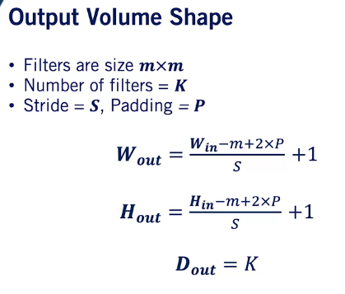

avoid to much beacouse we can lost signal traffic

A pooling layer uses pooling functions to replace the output of the previous layer with a summary statistic of the nearby outputs. Pooling helps make the representations become invariant to small translations of the input. If we translate the input a small amount, the output of the pooling layer will not change. This is important for object recognition for example, as if we shift a car a small amount in an image space, it should still be recognizable as a car

+ conosciuto è il max polling che prende il massimo valore della finesrea
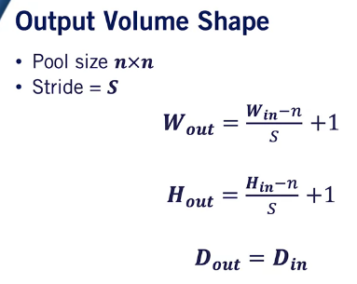

polling layers aiuta nella invarianza della traslazione → cambia solo un valore nell’output

effectiveness of ConvNets.
First, they usually have far fewer parameters in their convolutional layers than a similar network with fully connected layers. This reduces the chance of over-fitting through parameters sharing, and allows ConvNets to operate on larger images. Perhaps more importantly, is translation invariance. By using the same parameters to process every block of the image, ConvNets are capable of detecting an object or classifying a pixel even if it is shifted with a translation on the image plane.

