**COMP 6030 : Software Engineering**

**Coursework – Individual Part**

**Group : 15**

**Student Number : 1920574**

**Subsystem : Cla-Clo Student**

**Task1 - Specification and modelling software functional requirements (20 marks)**

**A-Use Case mode**

**Link:** [**Lucidchart**](https://lucid.app/lucidchart/67af5683-d2e7-4fea-9ab0-0ada37491a65/edit?viewport_loc=-486%2C1890%2C2799%2C1612%2C.Q4MUjXso07N&invitationId=inv_df7c12f5-df52-44f4-9c80-47aafdb487ad)

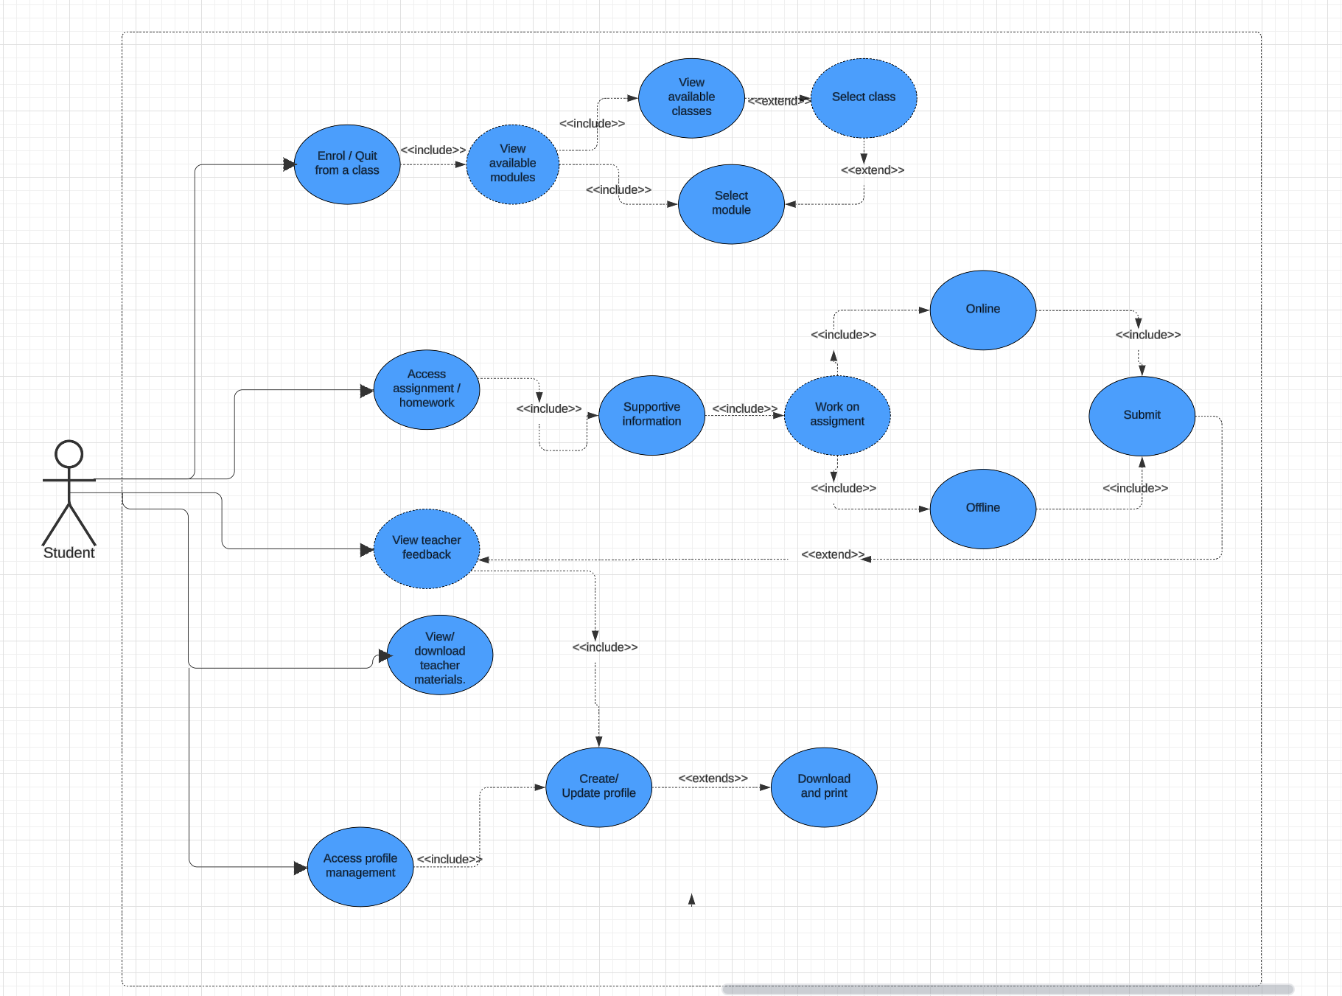

**B-Activity model**

**Link:** [**Lucidchart**](https://lucid.app/lucidchart/67af5683-d2e7-4fea-9ab0-0ada37491a65/edit?viewport_loc=-486%2C1890%2C2799%2C1612%2C.Q4MUjXso07N&invitationId=inv_df7c12f5-df52-44f4-9c80-47aafdb487ad)

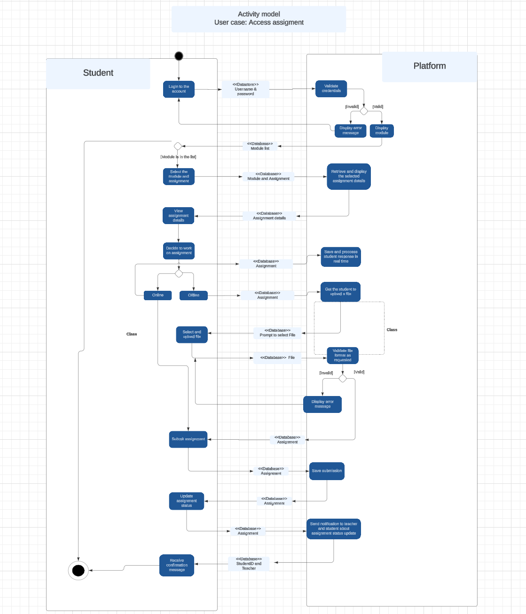

**TASK 2- Architecture of the Student subsystem**

Link: [Lucidchart](https://lucid.app/lucidchart/2077fbd2-e8df-4cf4-8534-7e2e64fa865d/edit?viewport_loc=-3478%2C3721%2C3280%2C1770%2C0_0&invitationId=inv_67beecba-0fac-4ca1-80ff-6ed7fe7bd24e)

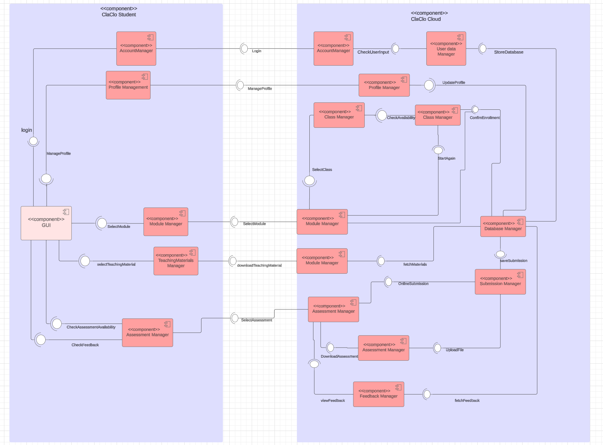

**Specification of components**

| **Component** | AccountManager |
| --- | --- |
| **Description** | This microservice allows the student to login to their account |
| **Type** | microservice |
| **Required interface** | UserDataManager |
| **Provided interface** | CheckUserInput |

| **Component** | ProfileManager |
| --- | --- |
| **Description** | This microservice allows the students to view, update and download their academic profile for printing or sharing |
| **Type** | microservice |
| **Required interface** | databaseManager |
| **Provided interface** | manageProfile, updateProfile |

| **Component** | Module Manager |
| --- | --- |
| **Description** | This microservice allows the student to enroll to a module/class |
| **Type** | microservice |
| **Required interface** | DatabaseManager |
| **Provided interface** | CheckAvailability,ConfirmEnrollment |

| **Component** | Class Manager |
| --- | --- |
| **Description** | This microservice allows the student to enroll into a specific class within a module if many classes are available}, and access all of that class related activities |
| **Type** | microservice |
| **Required interface** | DatabaseManager |
| **Provided interface** | CheckAvailability,ConfirmEnrollment |

| **Component** | Teaching Materials Manager |
| --- | --- |
| **Description** | Allows the student to view or download or view the teaching materials that were uploaded by the teachers. |
| **Type** | microservice |
| **Required interface** | DatabaseManager |
| **Provided interface** | downloadTeachingMaterial, fetchMaterial |

| **Component** | Assessment Manager |
| --- | --- |
| **Description** | Allows the student to view or download the assignments and their feedback after grading |
| **Type** | microservice |
| **Required interface** | SubmissionManager,  Feedback Manager |
| **Provided interface** | CheckAssessmentAvailability,  CheckFeedback,  DownloadAssignment |

| **Component** | Submission Manager |
| --- | --- |
| **Description** | Handles the submissions of the assignments |
| **Type** | microservice |
| **Required interface** | DatabaseManager |
| **Provided interface** | SaveSubmission |

| **Component** | Feedback Manager |
| --- | --- |
| **Description** | Handles the feedback of the submitted assignments |
| **Type** | microservice |
| **Required interface** | SubmissionManager |
| **Provided interface** | fetchFeedback  viewFeedback |

**Specifications of interfaces**

| Name | CheckUserInput | | |
| --- | --- | --- | --- |
| Provider | Account Manager | | |
| Operation name: login | Signature | checkUserInput(userID: String, password: String): Boolean | |
| Function | Checks student credentials and returns true or false if they match with the database saved details | |

| Name | updateProfile | | |
| --- | --- | --- | --- |
| Provider | Profile Manager | | |
| Operation name: updateProfile | Signature | updateProfile(studentID: String, profileData: JSON): Boolean | |
| Function | Allows the student to update their profile based on recent changes related to academic studies | |

| Name | SelectModule | | |
| --- | --- | --- | --- |
| Provider | Module Manager | | |
| Operation name: selectClass | Signature | selectClass(studentID:String, classID:String) | |
| Function | Allows the student to select one of the available classes on that specific module | |
| Operation name:  chooseAssignment | Signature | chooseAssignment(classID:String, assignmentID:String) | |
| Function | Allows the student to select any of the available assignments | |

| Name | SelectAssignment | | |
| --- | --- | --- | --- |
| Provider | Assignment Manager | | |
| Operation name: submitOnlineWork | Signature | submitOnlineWork(studentID:string, assignmentID:string, savedFiles:JSON) | |
| Function | Allows the student to submit their online work straight away | |
| Operation name:  getAssignment | Signature | getAssignment(classID: String): List<Assignment> | |
| Function | Gets all the available assignments for that specific class and displays them as a list for the student | |

| Name | uploadFile | | |
| --- | --- | --- | --- |
| Provider | FileManager | | |
| Operation name: submitOfflineWork | Signature | submitOfflineWork(assignmentID: String, file: File): Boolean | |
| Function | Allows the student to submit their offline work | |
| Operation name:  validateSubmission | Signature | validateSubmission(file: File): Boolean | |
| Function | Checks if the submission format is right | |

| Name | selectTeachingMaterials | | |
| --- | --- | --- | --- |
| Provider | TeachingMaterial Manager | | |
| Operation name:  fetchMaterials | Signature | fetchMaterials(moduleID: String): List<Material> | |
| Function | Allows the student to see the teaching materials | |
| Operation name:  downloadMaterials | Signature | downloadMaterials(materialID: String): File | |
| Function | Allows the student to download the available teaching materials | |

**Task3**

**A-Structural model**

Model for submitting assessments

**Link:** [**Lucidchart**](https://lucid.app/lucidchart/2077fbd2-e8df-4cf4-8534-7e2e64fa865d/edit?viewport_loc=-3011%2C412%2C2205%2C1270%2C0_0&invitationId=inv_67beecba-0fac-4ca1-80ff-6ed7fe7bd24e)

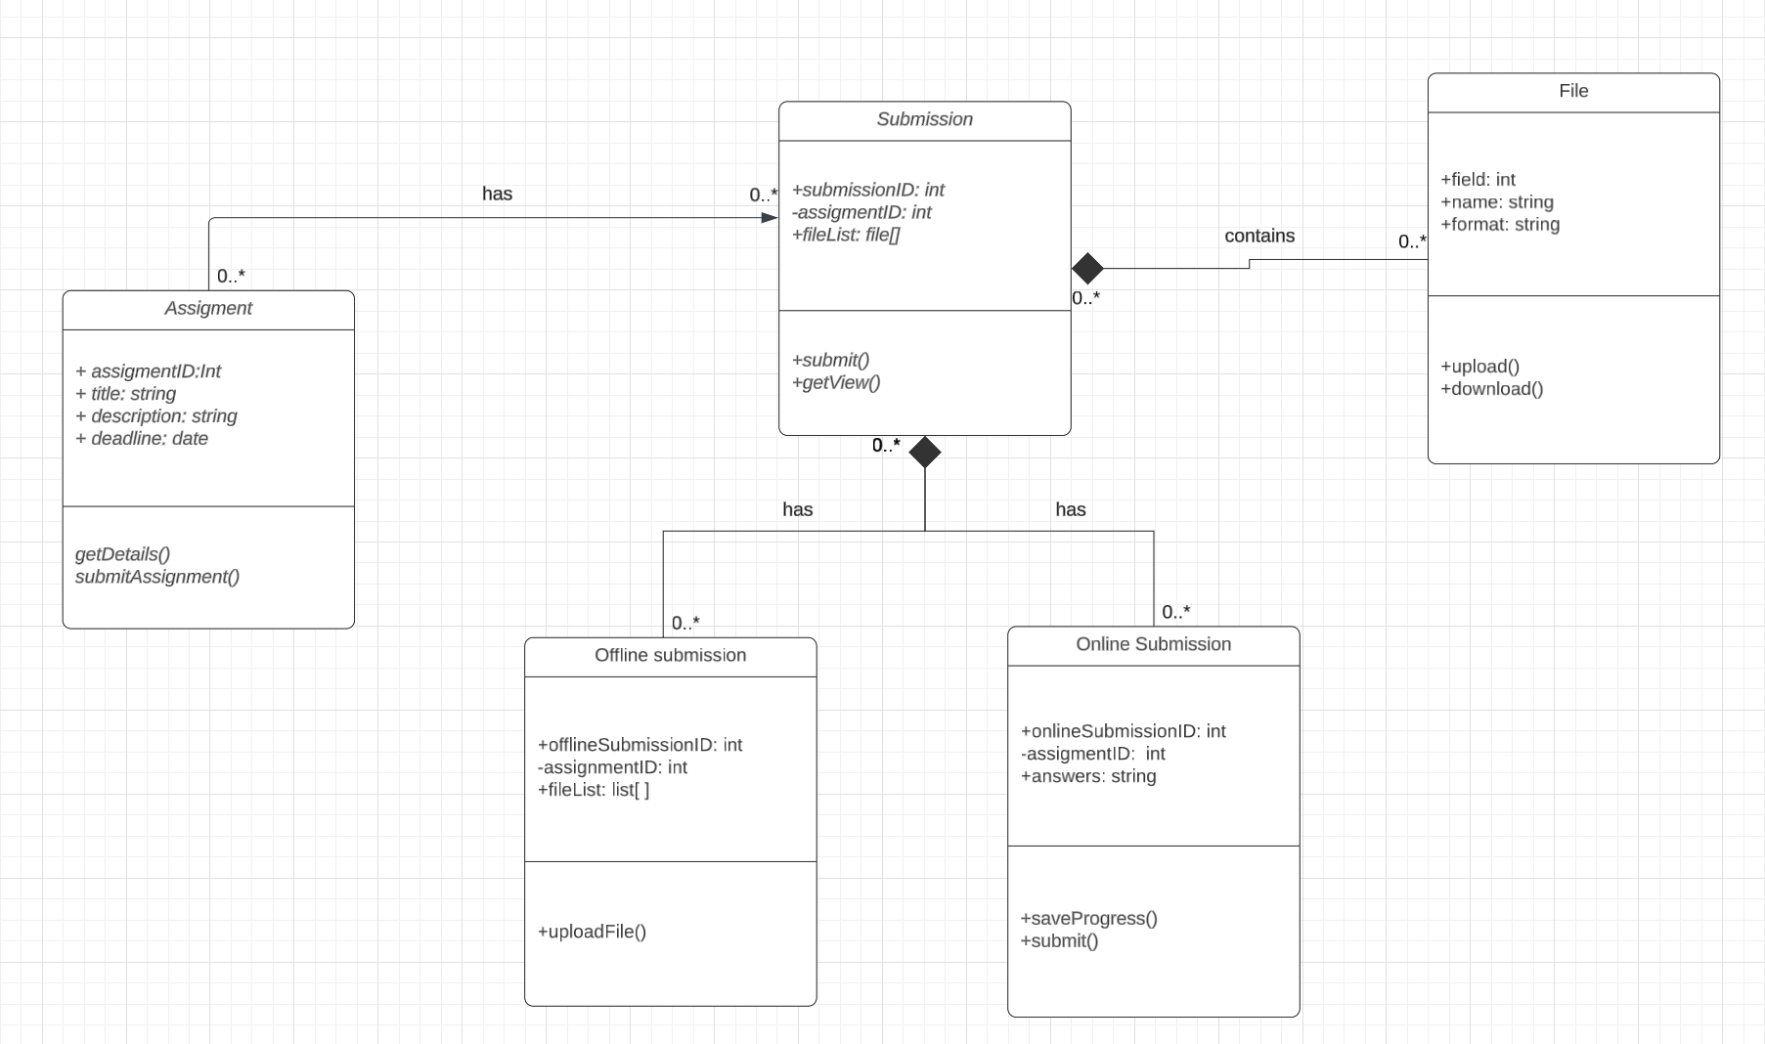

**B-Behaviour model**

**Link:** [**Lucidchart**](https://lucid.app/lucidchart/2077fbd2-e8df-4cf4-8534-7e2e64fa865d/edit?viewport_loc=-4009%2C2063%2C1802%2C1038%2C0_0&invitationId=inv_67beecba-0fac-4ca1-80ff-6ed7fe7bd24e)

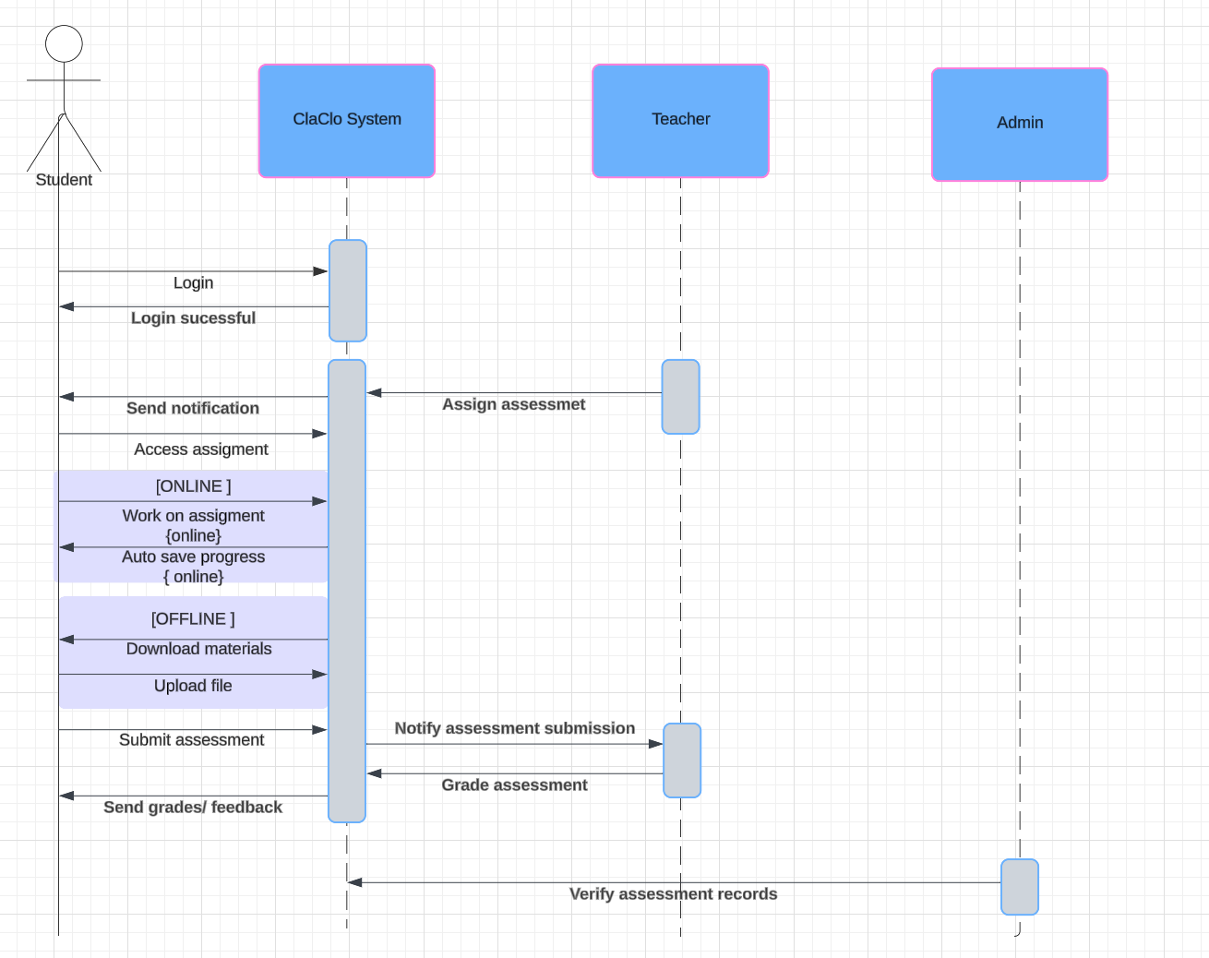

**Task4 - Software Testing**

**A-Unit test plan**

**Class: Student**

| **Test Case** | **Methods and Parameters** | **Expected Output** |
| --- | --- | --- |
| Access assignment (successfully) | accessAssignment(studentID, assignmentID) | Displays assignment with its contents successfully |
| Access assignment (unsuccessfully) | accessAssignment(studentID, assignmentID) | Assignment is not available to this student. Displays message saying “No new assignment assigned” |
| Submit online assignment (valid) | submitAssignment(studentID, assignmentID, Files) | Assignment submitted successfully. |
| Submit online assignment (invalid) | submitAssignment(studentID, assignmentID, Files) | Error message: “Invalid file! Please finish the whole assignment before submission online” |
| Save online work progress | saveProgress(studentID, assignmentID, progressData) | Progress saved successfully |
| Download assignment materials | downloadMaterials(studentID, assignmentID) | Materials downloaded successfully |
| Submit offline assignment (valid) | submitOfflineAssignment(studentID,assignmentID,uploadedFiles) | Successful submission |
| Submit offline assignment (invalid) | submitOfflineAssignment(studentID,assignmentID,uploadedFiles) | Unsuccessful submission, “Please upload files” |

**B- System Test plan**

**Use Case:** Decide to work on assignment  **Scenario:** Choose to work online

**Pre condition:**

* Student already logged in

| **Student** | **System** |
| --- | --- |
| 1.Select module | 2.Redirect to dashboard |
| 3.Select assignment | 4.Display assignment details |
| 5.Choose to work online | 6. Load the online assignment interface |
| 7.Start working on the assignment | 8. Saves progress regularly and display "Saved" messages. |

**Use Case:**  Decide to work on assignment **Scenario:** Choose to work offline

**Pre condition:**

* Student already logged in

| **Student** | **System** |
| --- | --- |
| 1.Select module | 2.Redirect to dashboard |
| 3.Select assignment | 4.Display assignment details |
| 5.Choose to work offline | 6.Encourage student to download all needed materials |
| 7.Downloads materials | 8.Provide downloads links/ files |
| 9.Complete assignment offline | 10.Wait for student to upload assignment later on |

**Use Case:**  Decide to work on assignment **Scenario:** Choose to upload offline work

**Pre condition:**

* Student already logged in

| **Student** | **System** |
| --- | --- |
| 1.Select module | 2.Redirect to dashboard |
| 3.Select assignment | 4.Display assignment details |
| 5.Choose to upload completed offline work | 6.Displays the upload link |
| 7.Downloads materials | 8.Provide downloads links/ files |
| 9.Upload files | 10.Validate file and save submission in the system. |
| 11.Submit assignment | 12.Display “ Assignment submitted successfully” and send notification to teacher |

**Use Case:** Decide to work on assignment

**Scenario:** Choose to work online and start losing connectivity

**Pre condition:**

* Student already logged in

| **Student** | **System** |
| --- | --- |
| 1.Select module | 2.Redirect to dashboard |
| 3.Select assignment | 4.Display assignment details |
| 5.Choose to work online | 6. Load the online assignment interface |
| 7.Start working on the assignment | 8. Saves progress regularly and display "Saved" messages. |
| 9.Starts losing internet connection while working. | 10. Work saved and then displays “Offline Mode activated! Save manually please!” |

**Use Case:** Decide to work on assignment

**Scenario:** Invalid assignment at this time{ overdue assignment)

**Pre condition:**

* Student already logged in

| **Student** | **System** |
| --- | --- |
| 1.Select module | 2.Redirect to dashboard |
| 3.Select assignment | 4.Display assignment details |
| 5.Choose to work on assignment | 6. Error message displayed “ Assignment not available anymore” |