使用说明：

Usage: python pyab.py [options] [http://hostname[:port]/path]

Options are:

-n --requests Number of requests to perform

-c --concurrency Number of multiple requests to make

-t --timelimit Seconds to max. wait for responses

-p --post File containing data to POST

-h --help Print this usage

Default value:

python pyab.py -n 1 -c 1 -t 360000 <http://localhost>

测试apache服务器结果图

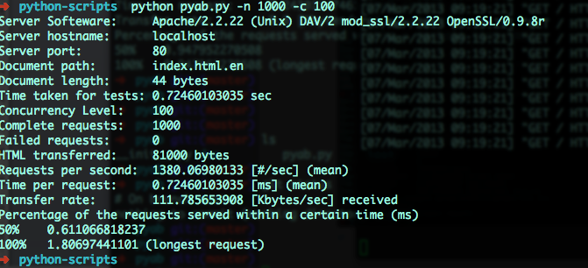

使用程序测试django 开发 服务器的结果图

