import math

def fact(n):

  if type(n) != int:

    return -1

  if n < 0:

    return -1

  if n == 0:

    return 1

  return math.factorial(n)

def test():

  passed=True

  test_cases=[("hello",-1),(0,1),(1,1),(5,120)]

  for i,j in test_cases:

    if(fact(i)!=j):

      print(f"not passed for{i} , for its output to be {j}")

      passed=False

    if passed:

      print("passed successfully")

test()

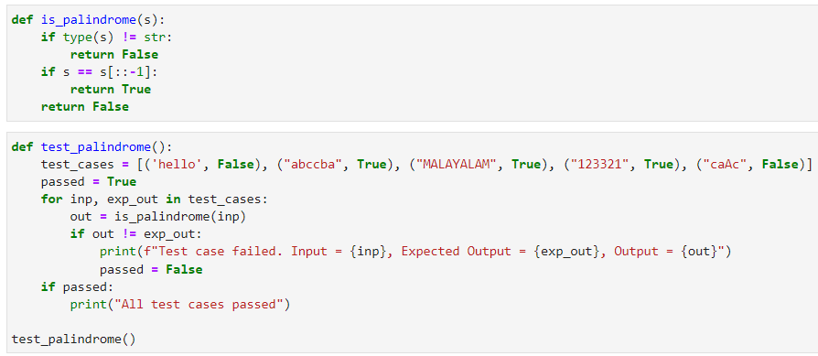

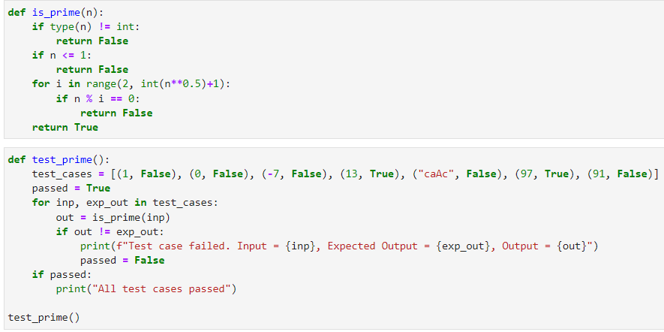

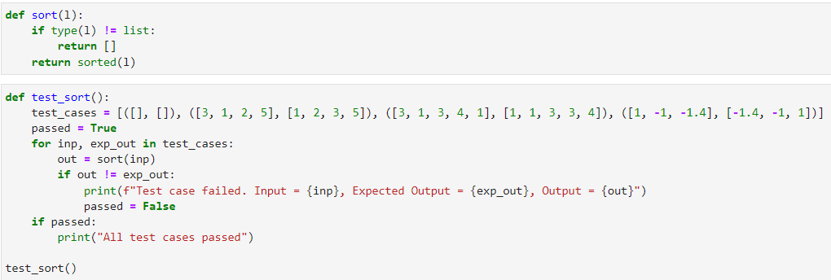

**EX2: CONFIGURING CONTINUOUS INTEGRATION WITH GITHUB ACTIONS**

**SOURCE CODE:**

git config --global user.name “joseph_12”

git config --global user.email “josephfranklin@karunya.edu.in”

mkdir mlops

git clone https://github.com/ joseph_12/Locos.git

cd Locos

echo "MLOPS" > entertainment

git add .

git commit -m "Updated entertainment

git push origin main (main is the name of the branch

**EX3: CREATE A CONTAINER TO RUN ML MODEL**

**SOURCE CODE:**

**DOCKERFILE**

FROM python:3.9

WORKDIR /app

COPY . .

RUN pip install scikit-learn pandas numpy joblib

RUN python train.py

CMD ["python", "inference.py"]

**train.py**

import numpy as np

import pandas as pd

from sklearn.model_selection import train_test_split

from sklearn.linear_model import LogisticRegression

from sklearn.datasets import load_iris

import joblib

import os

df=load_iris()

X=df.data

Y=df.target

xtrain,xtest,ytrain,ytest = train_test_split(X,Y,test_size=0.1)

model=LogisticRegression()

model.fit(xtrain,ytrain)

data_dir="./data"

model_dir="./model"

joblib.dump(model,os.path.join(model_dir,'logisticmodel.joblib'))

print("training completed")

**inference.py**

# Necessary Imports

import joblib

import pandas as pd

# Load the trained model

model = joblib.load("./model/logistic_model.joblib")

# Get user inputs

sepalLength = float(input("Enter sepal Length: "))

sepalWidth = float(input("Enter sepal Width: "))

petalLength = float(input("Enter petal Length: "))

petalWidth = float(input("Enter petal width: "))

# Convert to data point (np.ndarray)

user_input = [[sepalLength, sepalWidth, petalLength, petalWidth]]

# Make predictions on class

predictions = model.predict(user_input)

classes = ["Iris-Setosa", "Iris-Versicolor", "Iris-Virginica"]

print("Predicted class is,", classes[predictions[0]])

print("Inference complete")

**#Terminal code**

**docker build -t my_app .**

**docker run -it my_app**

**OUTPUT:**

Run inference.py

**Ex4: Permutation Feature Importance Explainer**

import pandas as pd

import numpy as np

from sklearn.model_selection import train_test_split

from sklearn.ensemble import RandomForestClassifier

from sklearn.metrics import accuracy_score

from sklearn.inspection import permutation_importance

from sklearn.datasets import load_iris

iris = load_iris()

X =pd.DataFrame(iris.data,columns = iris.feature_names)

Y=iris.target

X_train, X_test, Y_train, Y_test = train_test_split(X, Y, test_size=0.2, random_state=42)

model = RandomForestClassifier(n_estimators=100,random_state=42)

model.fit(X_train,Y_train)

y_pred=model.predict(X_test)

acc=accuracy_score(Y_test,y_pred)

print("Accuracy before permutation",acc)

perm_importance = permutation_importance(model,X_test,Y_test,n_repeats=30,random_state=42)

feature_importance = perm_importance.importances_mean

feature_names = X.columns

for feature_name,importance in zip(feature_names,feature_importance):

    print(f"{feature_name}:{importance:}")

import matplotlib.pyplot as plt

plt.barh(feature_names,feature_importance)

**ex5: SERVING A TRAINED MODEL OVER HTTP**

**SOURCE CODE:**

**DOCKERFILE**

#Dockerfile

FROM python:3.8

WORKDIR /app

RUN pip install scikit-learn joblib flask pandas numpy

COPY . .

RUN python train.py

EXPOSE 5000

CMD ["python","app.py"]

**train.py**

import numpy as np

import pandas as pd

from sklearn.model_selection import train_test_split

from sklearn.linear_model import LogisticRegression

from sklearn.datasets import load_iris

import joblib

import os

df=load_iris()

X=df.data

Y=df.target

xtrain,xtest,ytrain,ytest = train_test_split(X,Y,test_size=0.1)

model=LogisticRegression()

model.fit(xtrain,ytrain)

data_dir="./data"

model_dir="./model"

joblib.dump(model,os.path.join(model_dir,'logisticmodel.joblib'))

print("training completed")

**app.py**

#app.py

from flask import Flask, request, jsonify

import joblib

import numpy as np

app = Flask(_name_)

clf = joblib.load("model.joblib")

@app.route("/predict", methods = ["POST"])

def predict():

data = request.get_json()

new_sample = np.array(data["data"])

prediction = clf.predict(new_sample)

return jsonify({"Expected Price" : prediction[0]})

if _name_ == "_main_":

print("Hello there!")

app.run(host='0.0.0.0', port=7000)

**#cmd command**

docker build –t my app

docker run –p 5000:5000 myapp

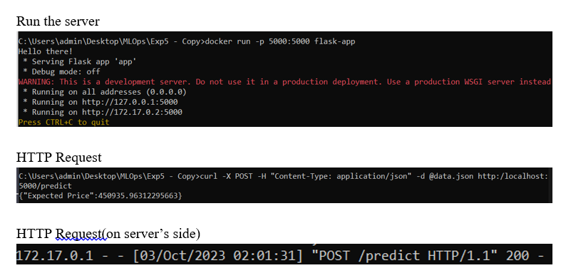

**Ex7: CREATING A MODEL USING AutoML**

**train.py**

from tpot import TPOTClassifier

from sklearn.datasets import load_iris

from sklearn.model_selection import train_test_split

iris = load_iris()

X, y = iris.data, iris.target

X_train, X_test, y_train, y_test = train_test_split(X, y, test_size=0.2, random_state=0)

tpot = TPOTClassifier(

generations=5,

population_size=20,

verbosity=2,

random_state=0,

config_dict='TPOT sparse',

memory='auto',

n_jobs = -1,

cv=5

)

tpot.fit(X_train, y_train)

acc = tpot.score(X_test, y_test)

print(f"Accuracy = {acc:.2f}")

tpot.export('best_model_pipeline.py')

**Dockerfile**

FROM python:3.8

WORKDIR /app

COPY requirements.txt requirements.txt

RUN pip install -r requirements.txt

COPY . .

ENV NAME AutoML_Iris

CMD ["python", "automl_script.py"]

**Ex8: Monitor and Logging**

**train.py**

import mlflow

import mlflow.sklearn

import numpy as np

from sklearn.model_selection import train_test_split

from sklearn.neural_network import MLPRegressor

from sklearn.metrics import mean_squared_error, r2_score

# Generate some sample data

np.random.seed(0)

X = np.random.rand(100, 1)

y = 2 * X[:, 0] + 1 + 0.1 * np.random.randn(100)

# Split the data into training and testing sets

X_train, X_test, y_train, y_test = train_test_split(X, y, test_size=0.2, random_state=42)

# Start an MLflow nested run

with mlflow.start_run(nested=True):

    # Define hyperparameters

    hidden_layer_sizes = (100, 50)  # Two hidden layers with 100 and 50 neurons

    learning_rate_init = 0.001

    max_iter = 500

    # Create and train the MLPRegressor

    model = MLPRegressor(hidden_layer_sizes=hidden_layer_sizes, learning_rate_init=learning_rate_init, max_iter=max_iter)

    mse_list = []  # List to store MSE values at each epoch

    mlflow.log_params({

        "hidden_layer_sizes": hidden_layer_sizes,

        "learning_rate_init": learning_rate_init,

        "max_iter": max_iter

    })

    for epoch in range(max_iter):

        model.partial_fit(X_train, y_train)

        y_pred = model.predict(X_test)

        mse = mean_squared_error(y_test, y_pred)

        mse_list.append(mse)

        # Log metrics at each epoch

        mlflow.log_metric("epoch_mse", mse, step=epoch)

    # Save the final model

    mlflow.sklearn.save_model(model, "MLPRegressor")

# End the nested MLflow run

mlflow.end_run()

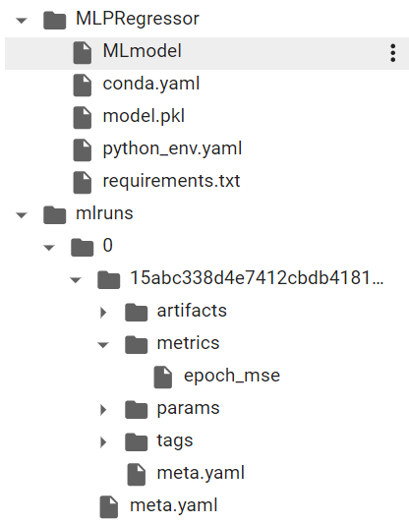

**Ex9: Machine Learning Interoperability**

**Train the Model**

import numpy as np

from sklearn.datasets import load_iris

from sklearn.model_selection import train_test_split

from sklearn.neural_network import MLPClassifier

from sklearn.metrics import accuracy_score

import onnx

from skl2onnx import convert_sklearn

from skl2onnx.common.data_types import FloatTensorType

iris = load_iris()

X, y = iris.data, iris.target

X_train, X_test, y_train, y_test = train_test_split(X, y, test_size=0.2, random_state=42)

model = MLPClassifier(hidden_layer_sizes=(64, 32), max_iter=1000, random_state=42)

model.fit(X_train, y_train)

initial_types = [('input', FloatTensorType([None, X_train.shape[1]]))]

onnx_model = convert_sklearn(model, initial_types=initial_types)

onnx.save_model(onnx_model, 'iris_model.onnx')

**Test ONNX Model**

import onnx

import onnxruntime as ort

import numpy as np

# Create an ONNX Runtime session with the specified providers

providers = ['CPUExecutionProvider']

ort_session = ort.InferenceSession("iris_model.onnx", providers=providers)

input_data = np.array([[5.1, 3.5, 1.4, 0.2],

                       [6.3, 2.8, 5.1, 1.5]], dtype=np.float32)

# Run inference using ONNX Runtime

predictions = ort_session.run(None, {"input": input_data})

print("Predictions:", predictions)

class_labels = ["Iris-Setosa", "Iris-Versicolor", "Iris-Virginica"]

predicted_labels = [class_labels[max(prediction, key=lambda k : prediction[k])] for prediction in predictions[1]]

print("Predicted Class Labels:", predicted_labels)

**exp10: Machine Learning Command Line Workflows**

#!/usr/bin/env python

# coding: utf-8

# In[ ]:

import click

from sklearn.datasets import load_iris

from sklearn.ensemble import RandomForestClassifier

import joblib

from sklearn.model_selection import train_test_split

@click.group()

def cli():

    """Machine Learning CLI Workflow"""

    pass

@click.command()

@click.option('--test_size', default=0.2, help='Test size (default: 0.2)')

@click.option('--n_estimators', default=100, help='Number of trees in classifier (default: 100)')

def train(test_size, n_estimators):

    """Train the Random Forest model on the Iris Dataset"""

    df = load_iris()

    X = df.data

    y = df.target

    X_train, X_test, y_train, y_test = train_test_split(X, y, test_size=test_size, random_state=42)

    model = RandomForestClassifier(n_estimators=n_estimators)

    model.fit(X_train, y_train)

    joblib.dump(model, 'model.joblib')

    print("Model saved as model.joblib")

@click.command()

@click.option('--sl', help='Sepal Length')

@click.option('--sw', help='Sepal Width')

@click.option('--pl', help='Petal Length')

@click.option('--pw', help='Petal Width')

def predict(sl, sw, pl, pw):

    model = joblib.load('model.joblib')

    classes = {0:'Iris Setosa', 1:'Iris Versicolour', 2:'Iris Virginica'}

    print("Prediction:", classes[model.predict([[sl, sw, pl, pw]])[0]])

cli.add_command(train)

cli.add_command(predict)

cli()

**#command**

**Python “path” train –test_size 0.2 –n_estimators 50**

**Python “path” predict –sl 0.2 –sw 0.1 –pl 0.3 –pw 0.2**