FITBUDDY-AI
03 – FitBuddy-AI
Project Design
Student | M. Micheal Sharmila
Degree | B.Sc. Computer Science
College | Government Arts and Science Women’s College, Alangulam
Academic Year | 2025–2028

1. System Architecture
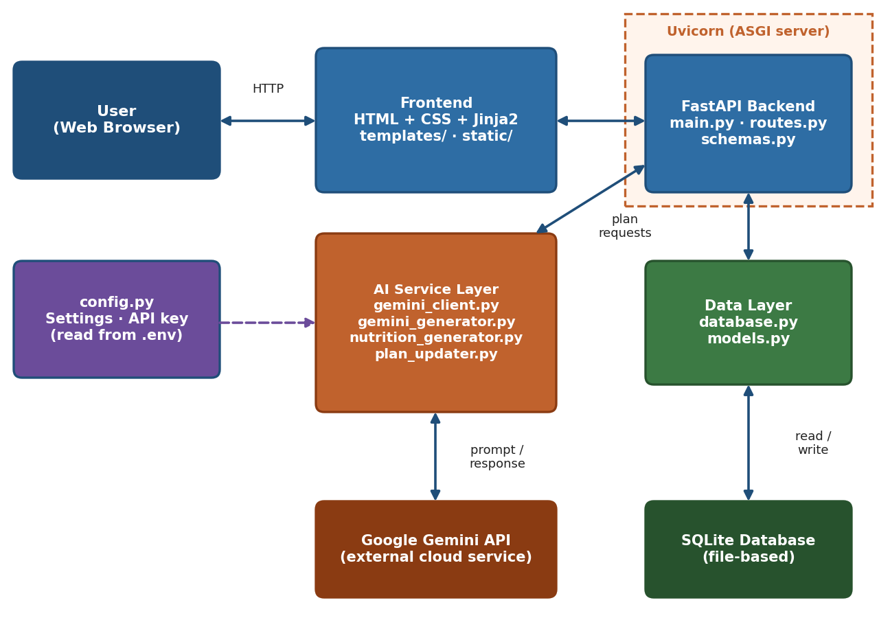
Figure 1: System architecture of FitBuddy-AI
The browser sends user requests to the FastAPI backend. The backend validates input, calls Google Gemini AI to generate the fitness plan, and stores/retrieves data through the database layer. The result is rendered back to the user.

2. Use Case Diagram
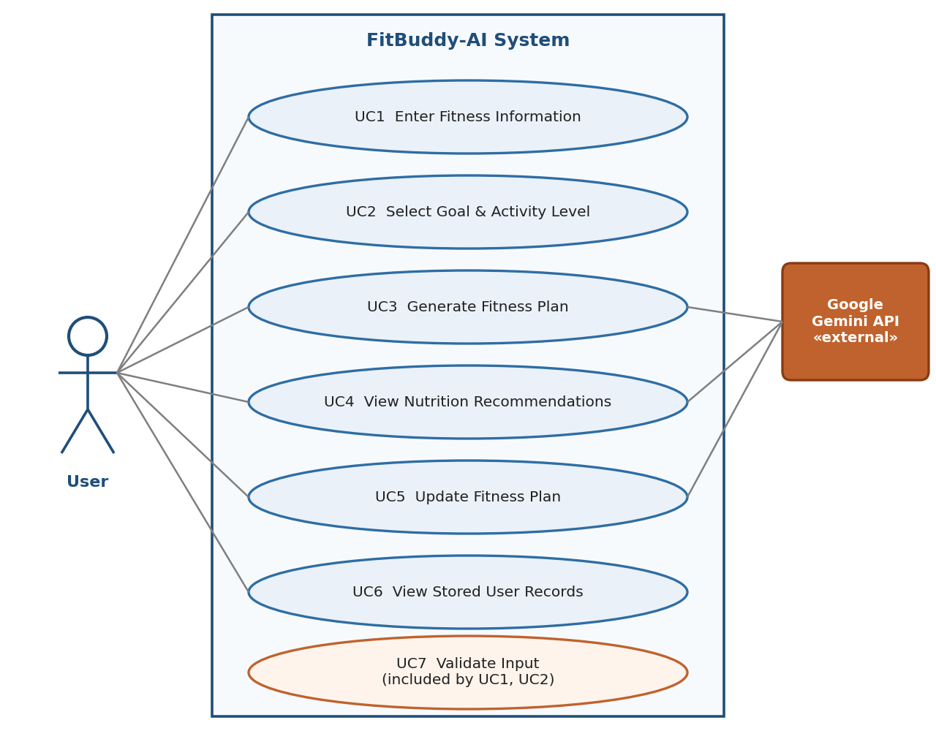
Figure 2: Use case diagram
The main actor is the User, who can enter fitness details, generate a plan, view nutrition recommendations, and update the plan. Google Gemini AI is an external system used during plan generation.

3. Data Flow Diagram
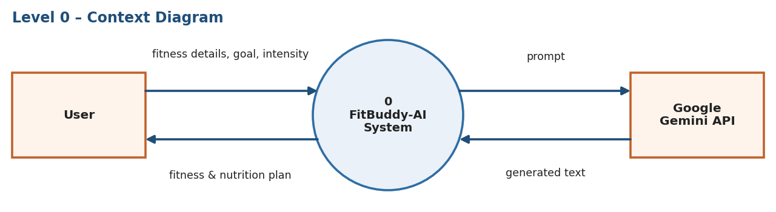
Figure 3: Level 0 data flow diagram (context diagram)
The user provides fitness details and receives a generated plan. Internally, the system exchanges prompts and AI-generated text with Google Gemini.

4. Flowchart
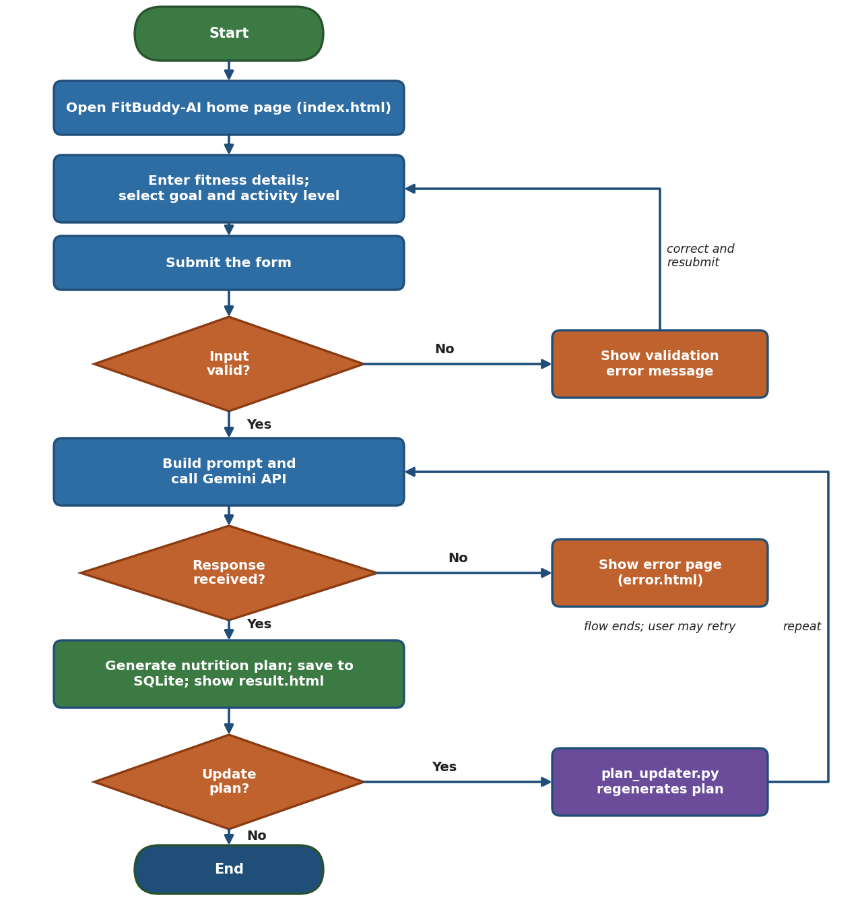
Figure 4: Application flowchart
Invalid input returns the user to the form with an error message. On success, the plan is generated, stored, and displayed; the user may then choose to update it.

5. ER Diagram / Database Design
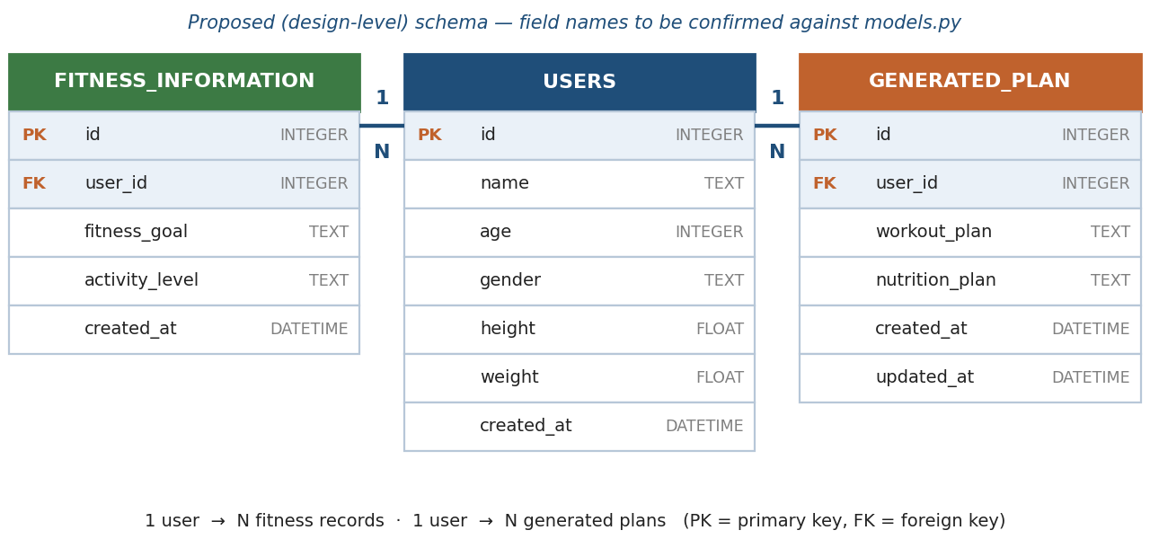
Figure 5: Proposed entity-relationship diagram
Note: these tables and fields are a proposed, design-level schema based on the presence of app/models.py and app/database.py. Exact field names should be confirmed against the actual code.

6. UI Design / Wireframe
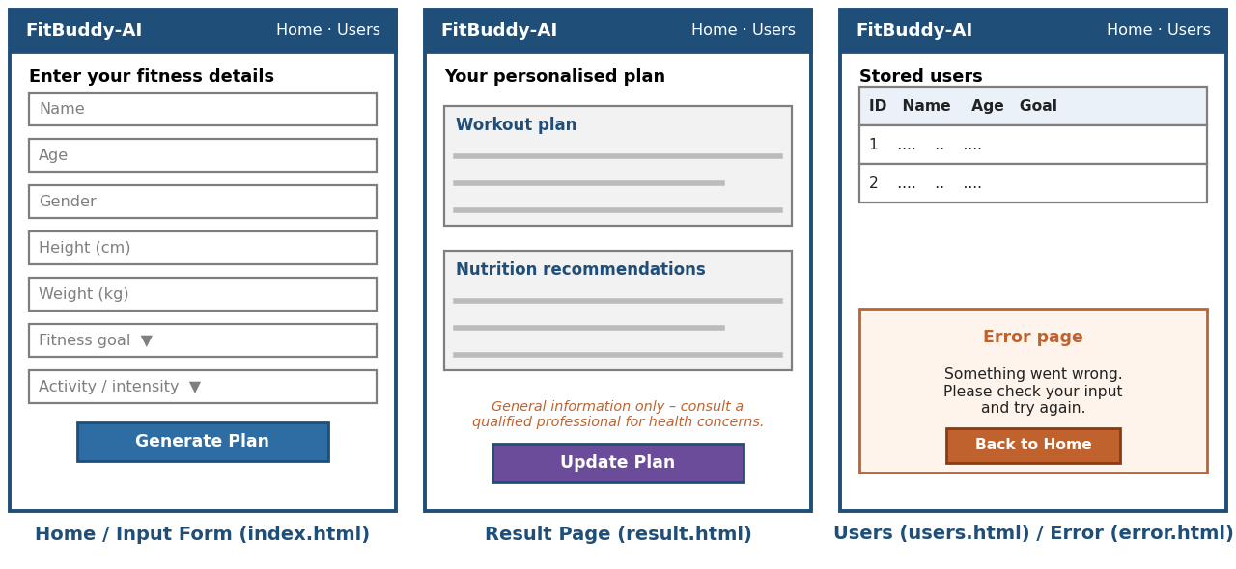
Figure 6: Wireframe of main application pages
The home page collects user details, the result page displays the generated plan and nutrition suggestions, and an error page handles failures.

7. How the Project Files Support the Design
File | Role in the Design
app/main.py | Application entry point; starts the FastAPI app
app/routes.py | Defines the endpoints that connect the UI to backend logic
app/models.py | Defines the data structures used by the database
app/database.py | Handles the database connection and storage operations
app/gemini_client.py | Connects to the Google Gemini AI API
app/gemini_generator.py | Builds the prompt and processes the AI-generated fitness plan
app/nutrition_generator.py | Generates nutrition recommendations
app/plan_updater.py | Handles regenerating/updating an existing plan
templates/ | HTML pages rendered to the user
static/ | CSS and JavaScript files for styling and interactivity

