FITBUDDY-AI
05_Project_Development – FitBuddy-AI
Project Development Phase
Student | M. Micheal Sharmila
Degree | B.Sc. Computer Science
College | Government Arts and Science Women’s College, Alangulam
Academic Year | 2025–2028

1. Development Overview
This document explains how FitBuddy-AI is implemented. The application is developed in Visual Studio Code using Python and FastAPI for the backend, HTML, CSS and Jinja2 templates for the frontend, Google Gemini for AI-based plan generation, SQLite for data storage, and Uvicorn as the server. Git and GitHub are used for version control.
The explanations describe the responsibility of each file according to the project structure. Source code is not reproduced, and no API key or other secret appears in this document. Where a detail depends on the exact code, it is described in general terms and should be confirmed against the repository.
Development Aspect | Approach
Style | Modular: each concern in its own file
Rendering | Server-side using Jinja2 templates
AI | Prompt sent to Google Gemini; text response processed
Storage | SQLite database accessed through database.py and models.py
Version control | Git commits pushed to GitHub

2. Project Architecture and Folder Structure
FitBuddyAI/
│
├── app/
│ ├── __init__.py
│ ├── config.py
│ ├── database.py
│ ├── gemini_client.py
│ ├── gemini_generator.py
│ ├── main.py
│ ├── models.py
│ ├── nutrition_generator.py
│ ├── plan_updater.py
│ ├── routes.py
│ └── schemas.py
├── static/
│ └── style.css
├── templates/
│ ├── base.html error.html index.html
│ └── result.html users.html
├── .env (local only, not committed)
├── .gitignore
├── requirement.txt
└── README.md

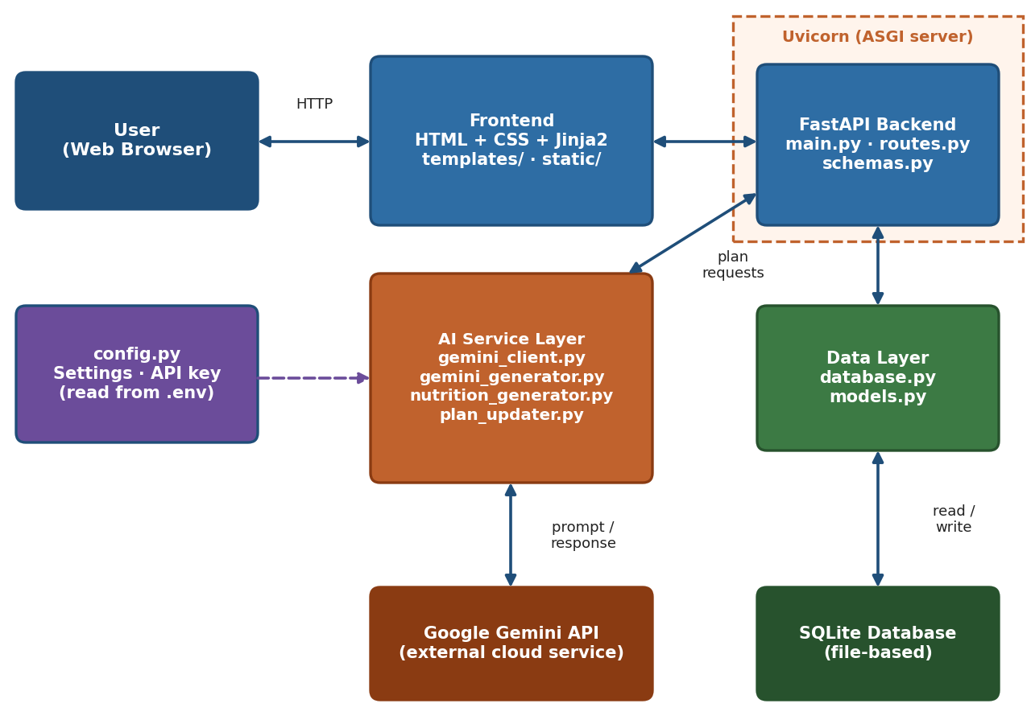
Figure 1: Architecture of the implemented application
The app package holds all backend logic; static and templates hold the presentation layer; .env and .gitignore support secure configuration.

3. Backend Implementation
The backend is a FastAPI application served by Uvicorn. FastAPI provides routing, request handling and data validation through Pydantic-style schemas.
File | Responsibility
app/__init__.py | Marks the app folder as a Python package
app/main.py | Creates the FastAPI application, mounts static files, sets up templates and includes the routes
app/routes.py | Defines endpoints: home page, form submission, result display, plan update and users page
app/schemas.py | Defines the structure and rules of incoming data
app/config.py | Reads settings such as the Gemini API key from the environment

A typical request travels from the browser to routes.py, is validated with the schemas, is processed by the AI and database modules, and is returned as a rendered HTML page. The application is started with Uvicorn pointing at the FastAPI app object in app/main.py.
3.1 Request Handling Sequence
- The browser sends a request to a route defined in routes.py.
- The route validates submitted data using the schemas.
- The route calls the generator modules and the database module.
- The route returns a Jinja2-rendered page, or the error page if a step fails.
3.2 Backend Design Notes
- Routes stay short; AI and database work is delegated to separate modules.
- Configuration is read once from config.py rather than scattered through the code.

4. Google Gemini Integration and Fitness-Plan Generation
File | Responsibility
app/gemini_client.py | Sets up the connection to the Gemini API using the configured key and sends requests
app/gemini_generator.py | Builds a prompt from the user’s details, goal and intensity, requests a fitness plan and processes the response
app/nutrition_generator.py | Produces nutrition recommendations in line with the user’s goal and intensity
4.1 Generation Process
- Validated user data is collected by the route.
- gemini_generator.py forms a prompt describing the user and asking for a workout plan.
- gemini_client.py sends the prompt to Google Gemini.
- The response text is processed and combined with the nutrition recommendations.
- The result is saved to SQLite and passed to result.html.
4.2 Nutrition Recommendation Module and Plan Updating
nutrition_generator.py follows the same pattern as the fitness generator but asks for dietary guidance. app/plan_updater.py lets the user change details or goals and regenerates the plan, saving the new version. Generated content is general information and carries a notice to consult qualified professionals.

5. Database, Models and Data Handling
File | Responsibility
app/database.py | Creates the SQLite connection and session handling and initialises the database
app/models.py | Defines the table models used to store users, fitness details and generated plans
5.1 Data Handled
Data | Purpose
User details | Name, age, gender, height and weight (proposed fields)
Fitness details | Fitness goal and activity level (proposed fields)
Generated plans | Workout plan and nutrition text with timestamps (proposed fields)

Exact table and field names must be confirmed against models.py. SQLite stores everything in a single local file, so no separate database server is needed. Reading stored records supports the users page, and saving a regenerated plan supports plan updating.
5.2 Database Operations
Operation | When It Happens | Module
Create tables | Application start | database.py, models.py
Insert records | After a plan is generated | routes.py, models.py
Read records | Users page or result display | routes.py, models.py
Update record | Plan updating | plan_updater.py

6. Frontend, Templates and User Interaction
File | Responsibility
templates/base.html | Common layout (header, navigation, footer) extended by other pages
templates/index.html | Input form for user details, goal and intensity
templates/result.html | Displays the workout and nutrition plans and the general-information notice
templates/users.html | Lists stored user records
templates/error.html | Shows a friendly error message
static/style.css | Styling for a clean, consistent interface

Jinja2 inserts values from the backend into the HTML pages, so the same layout is reused for every page. The user fills the form, submits it, sees the generated plan and may request an update from the result page. Links in the base layout support navigation between pages.
6.1 User Interaction Flow
- Open the home page and read the form.
- Enter details and select a goal and intensity.
- Submit the form and wait for the plan to be generated.
- Read the workout and nutrition plans on the result page.
- Use the update option or return to the home page.
6.2 Interface Principles
- Simple layout with clear labels.
- Consistent styling through one stylesheet.
- Visible notice that the plan is general information.

7. Validation, Error Handling, Configuration and Git/GitHub
7.1 Input Validation
schemas.py checks that required fields are present, that numbers are numeric and that values are within sensible ranges before any AI call is made.
7.2 Error Handling
Invalid input, Gemini failures and database problems are caught and reported through error.html or a message on the form, so the user sees a clear explanation instead of a crash.
7.3 Security and Environment Configuration
- The Gemini API key is stored only in the local .env file and read through config.py.
- The .env file is listed in .gitignore and must never be committed.
- A template file with placeholder values (for example, GEMINI_API_KEY=your_key_here) can be shared instead.
- No real key, password or secret is included in these documents.
7.4 Git and GitHub Repository
- Git tracks changes; GitHub hosts the remote repository.
- Commits are made after each milestone with descriptive messages.
- README.md explains the project, setup and usage.

8. Implementation Summary and Screenshot Placeholders
Feature | Implemented Through
Input collection | index.html, routes.py, schemas.py
AI plan generation | gemini_client.py, gemini_generator.py
Nutrition recommendations | nutrition_generator.py
Plan updating | plan_updater.py, routes.py
Data storage | database.py, models.py, SQLite
Interface | templates/, static/style.css
Error handling and configuration | error.html, config.py, .env, .gitignore
8.1 Screenshot Placeholders
Placeholder | Status
[Insert Screenshot – Application Home Page] | To be added
[Insert Screenshot – Generated Fitness Plan] | To be added
[Insert Screenshot – Nutrition Recommendation] | To be added
[Insert Screenshot – GitHub Repository] | To be added

No screenshots or test results are invented; real screenshots replace the placeholders after the application is run.

