FITBUDDY-AI
07_Project_Documentation – FitBuddy-AI: AI-Powered Personalized Fitness Plan Generator
Project Documentation Phase
Student | M. Micheal Sharmila
Degree | B.Sc. Computer Science
College | Government Arts and Science Women’s College, Alangulam
Academic Year | 2025–2028

1. Project Title, Abstract and Introduction
1.1 Abstract
FitBuddy-AI is an AI-powered web application that generates personalized fitness and nutrition plans. Users enter basic fitness details and select a goal and activity level; the application sends this information to Google Gemini and displays the generated workout and nutrition recommendations. It is built with Python and FastAPI, HTML, CSS and Jinja2 templates, SQLite and Uvicorn.
1.2 Introduction
Personalized fitness guidance is often costly or hard to obtain. FitBuddy-AI shows how Generative AI can make general fitness and nutrition suggestions accessible through a simple web interface. The project is developed as an individual college project and provides general information only, not medical advice. Users with health conditions should consult qualified professionals.

2. Problem Statement, Objectives and Existing System
2.1 Problem Statement
People who want to begin exercising struggle to find plans matched to their body details and goals, and professional guidance is not affordable or convenient for everyone. Generic plans do not consider the individual, and combining separate workout and diet advice takes time and effort.
2.2 Objectives
- Collect user details, goal and activity level through a web form.
- Generate personalized fitness plans and nutrition recommendations using Google Gemini.
- Allow plans to be updated and store data in SQLite.
- Provide input validation, error handling and a simple interface.
2.3 Existing System
Existing Approach | Limitation
Generic online plans and videos | Not personalized
Personal trainers and dieticians | Costly and not always accessible
Manual self-research | Time-consuming and unreliable
Static printed plans | Cannot be updated easily

3. Proposed System and Technologies Used
3.1 Proposed System
The proposed system collects user information, validates it, sends it to Google Gemini and presents a workout plan with nutrition recommendations on a result page. Plans can be regenerated when the user’s details change, and user and plan data are stored in SQLite. The system is modular, so AI, database and interface parts can be developed, tested and extended separately.
3.2 Technologies Used
Category | Technology | Purpose
AI model | Google Gemini | Generates plan text
Backend | Python, FastAPI | Routes, validation, logic
Frontend | HTML, CSS, Jinja2 | Pages and templates
Database | SQLite | Stores users and plans
Server | Uvicorn | Runs the application
Tools | VS Code, Git, GitHub | Development and version control
3.3 Advantages of the Proposed System
- Recommendations based on the user’s own inputs.
- Workout and nutrition suggestions in one place.
- Quick plan creation and easy updating.
- Simple interface and modular structure that is easy to extend.

4. System Requirements and Project Modules
4.1 System Requirements
Type | Requirement
Hardware | Dual-core processor, 4 GB RAM, about 500 MB storage
Software | Windows/Linux/macOS, Python 3.9+ (assumed), modern browser
Network | Internet access for the Gemini API
4.2 Project Modules
Module | File(s) | Role
User input | index.html, routes.py | Collect details
Validation | schemas.py | Check input
Gemini integration | gemini_client.py, gemini_generator.py | Generate fitness plan
Nutrition | nutrition_generator.py | Diet suggestions
Plan updating | plan_updater.py | Regenerate plan
Database | database.py, models.py | Store data
Interface | templates/, static/ | Pages and style
Configuration | config.py, .env | Settings and key

5. System Design and Database Design
5.1 System Design
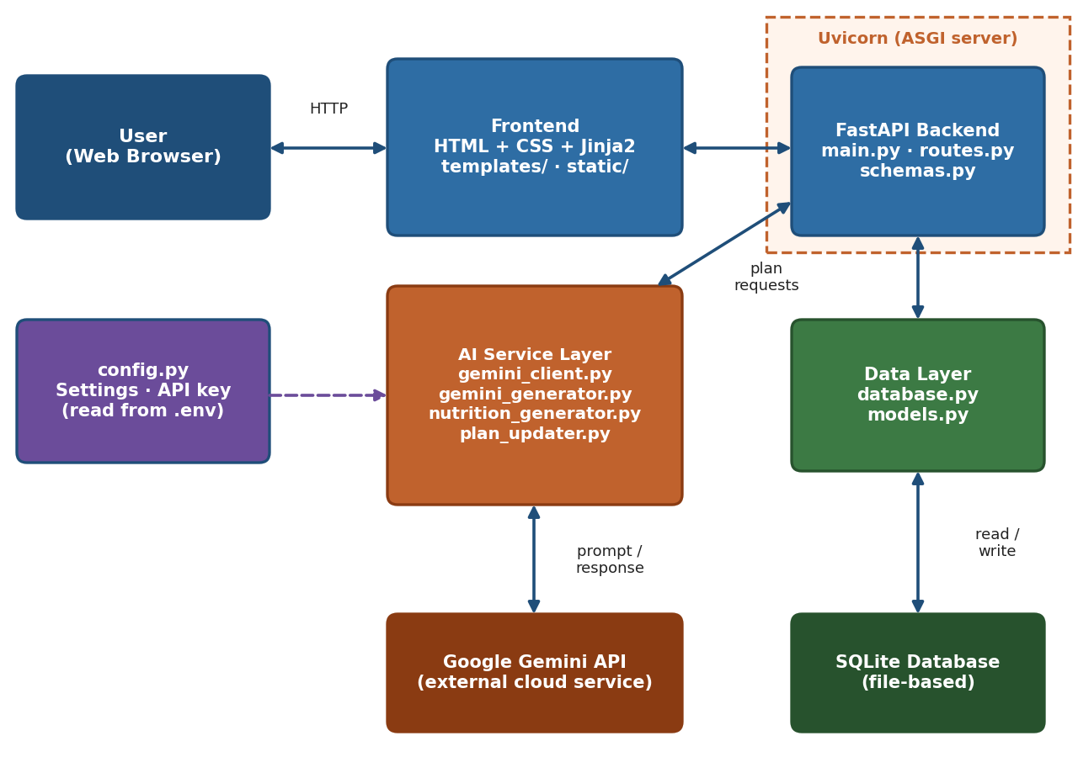
Figure 1: System architecture
The browser communicates with a FastAPI application served by Uvicorn. Routes use the AI service modules to contact Gemini and the data modules to use SQLite.
5.2 Database Design (proposed, design-level)
Table | Key Fields
USERS | id (PK), name, age, gender, height, weight
FITNESS_INFORMATION | id (PK), user_id (FK), fitness_goal, activity_level
GENERATED_PLAN | id (PK), user_id (FK), workout_plan, nutrition_plan
Field names are proposed and must be confirmed against models.py.

6. Implementation and Testing
6.1 Implementation
The backend is implemented with FastAPI; routes handle requests, schemas validate input, Gemini modules generate plans, and database modules store data. Jinja2 templates render pages, and secrets are kept in a local .env file outside Git. Each module is kept in its own file under the app folder.
6.2 Testing
Testing covers functional, validation, Gemini integration, database, error handling and UI cases, defined in the Testing Report (Document 06). Results are recorded only after actual execution; until then, test status is Pending Verification.
Test Area | Planned Cases
Functional | TC_01–TC_08
Validation and errors | TC_09–TC_14
Gemini and database | TC_15–TC_20
UI and integration | TC_21–TC_25
6.3 Error Handling and Security
- Invalid input and AI or database failures are reported through a message or the error page.
- The Gemini API key is stored only in .env, which is excluded from Git.
- Generated content includes a notice that it is general information.

7. Screenshots, Results and Installation / Setup
7.1 Screenshots
- [Insert Screenshot – Application Home Page]
- [Insert Screenshot – Generated Fitness Plan]
- [Insert Screenshot – Nutrition Recommendation]
7.2 Results
The expected result is a working application that produces a workout plan and nutrition recommendations from user input, stores the data and reports errors clearly. No performance figures or user statistics are claimed; final results are described after testing.
7.3 Installation / Setup Instructions
- Install Python and clone the GitHub repository.
- Create and activate a virtual environment.
- Install packages from the requirements file (requirement.txt).
- Copy env.example to .env and add your own Gemini API key (never commit .env).
- Run the app with Uvicorn (for example, uvicorn app.main:app --reload).
- Open the address shown in the terminal in a web browser.
7.4 Environment File
An env.example file containing only placeholder values (for example, GEMINI_API_KEY=your_key_here) is provided as a template. The real .env file stays on the developer’s machine and is never uploaded to GitHub or included in documents.

8. Conclusion, Future Enhancements and References
8.1 Conclusion
FitBuddy-AI demonstrates how Generative AI can be combined with a modular FastAPI web application to provide personalized fitness and nutrition suggestions in a simple interface. The output is general information and should not replace professional advice.
8.2 Future Enhancements
- User authentication and progress tracking.
- Workout history and analytics.
- Exercise video integration and multilingual support.
- Mobile application and wearable device integration.
8.3 References
- FastAPI documentation – https://fastapi.tiangolo.com/
- Google AI for Developers (Gemini API) – https://ai.google.dev/
- Python documentation – https://docs.python.org/3/
- SQLite documentation – https://www.sqlite.org/docs.html
- Jinja2 documentation – https://jinja.palletsprojects.com/
- Uvicorn documentation – https://www.uvicorn.org/
8.4 Limitations
- Depends on the Google Gemini API and an internet connection.
- API usage limits may affect availability.
- Generated recommendations may need professional verification.

