FITBUDDY-AI
08_Project_Demonstration – FitBuddy-AI
Project Demonstration Phase – Demonstration and Evidence Guide
Student | M. Micheal Sharmila
Degree | B.Sc. Computer Science
College | Government Arts and Science Women’s College, Alangulam
Academic Year | 2025–2028

1. Demonstration Introduction and Overview
This document is the final demonstration and evidence guide for FitBuddy-AI. It lists what to show, in what order, and what evidence (screenshots, video, presentation and repository) should be uploaded for each step. It describes only features that belong to the documented project scope and does not claim that any feature exists unless it is actually implemented in the application.
Feature | Status for Demonstration
User information input, goal and intensity selection | Demonstrate
AI-generated fitness plan and nutrition recommendation | Demonstrate
Plan updating | Demonstrate
SQLite storage and users page | Demonstrate (confirm users page works)
Registration / Login / Logout | Not in documented scope

2. Working Application and GitHub Evidence
2.1 Working Application Overview
FitBuddy-AI is a FastAPI web application, served by Uvicorn, that collects user details, sends them to Google Gemini and shows a workout plan with nutrition recommendations. Data is stored in SQLite.
2.2 GitHub Repository Evidence
Evidence Item | What to Upload / Show
Repository page | Screenshot showing the app/, static/, templates/ folders and README
Commit history | Screenshot of commits made during development
Security check | Screenshot or confirmation that .env is not in the repository
Repository link | The GitHub URL in the submission form
2.3 What to Upload for Each Phase
Phase | Document / Evidence to Upload
01 Brainstorming | Ideation document
02 Requirement Analysis | Requirements document
03 Design | Design document with diagrams
04 Planning | Planning document
05 Development | Development document, repository link
06 Testing | Testing report with real results and screenshots
07 Documentation | Project documentation
08 Demonstration | This guide, video and presentation

3. Application Opening and User-Input Demonstration
3.1 Opening the Application
- Activate the virtual environment and start the server with Uvicorn.
- Open the local address in a browser and show the home page.
- Registration/Login and a dashboard are not part of the documented scope; the home page with the input form is the main page.
Before You Start
- Confirm the .env file contains a valid Gemini key (do not show it on screen).
- Check the internet connection.
- Prepare one valid and one invalid set of sample inputs.
3.2 User Fitness Information Input
Step | What to Show | Evidence to Upload
Open home page | Form fields and layout | [Insert Screenshot – Application Home Page]
Enter details | Name, age, gender, height, weight | [Insert Screenshot – Filled Form]
Validation | One invalid entry and the message | [Insert Screenshot – Validation Message]

4. Fitness Goal, Intensity and AI-Plan Demonstration
Step | What to Show | Evidence to Upload
Select goal | Choose a fitness goal from the list | [Insert Screenshot – Goal Selection]
Select intensity | Choose activity/intensity level | [Insert Screenshot – Intensity Selection]
Generate plan | Submit and wait for Gemini | [Insert Screenshot – Generated Fitness Plan]
4.1 Talking Points
- The form data is validated before it is sent to Google Gemini.
- A prompt is built from the goal, intensity and body details.
- The response is processed and shown on the result page.
- The plan is general information, not medical advice.
4.2 What to Verify While Demonstrating
Check | Expected Observation
Goal and intensity | Plan reflects the selected values
Waiting time | Result appears after the Gemini response
Notice | General-information notice is visible

5. Nutrition Recommendation and Plan-Update Demonstration
Step | What to Show | Evidence to Upload
Nutrition | Show nutrition recommendations on the result page | [Insert Screenshot – Nutrition Recommendation]
Update plan | Change goal or intensity and update | [Insert Screenshot – Updated Plan]
5.1 Talking Points
- Nutrition suggestions come from the nutrition generator module.
- Plan updating regenerates and saves the new plan.
- Compare the original and updated plans to show the change.
5.2 If Something Goes Wrong During the Demo
Situation | Suggested Response
Gemini does not respond | Show the error page and explain the error handling
Network unavailable | Use prepared screenshots or the recorded video
Unexpected AI wording | Explain that generated text can vary between runs

6. Database, Backend Explanation and Application Flow
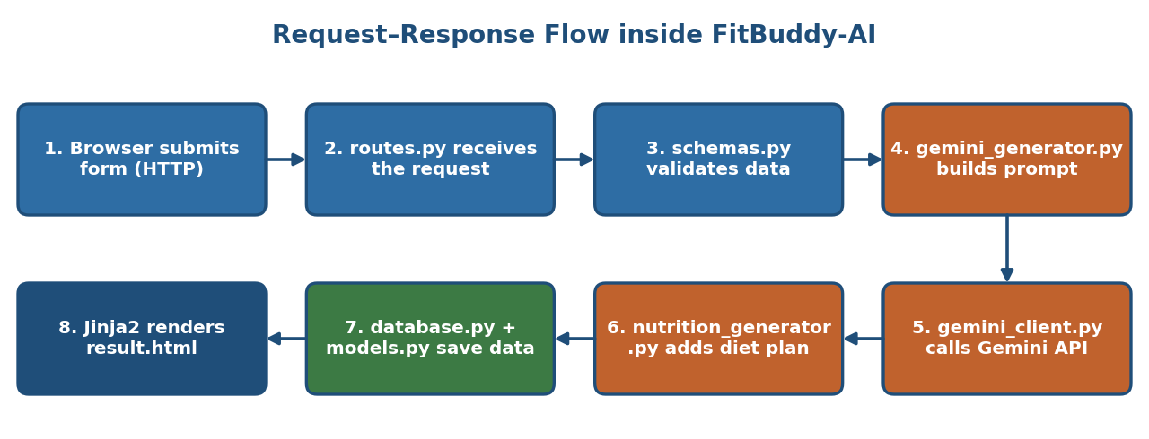
Figure 1: Request–response flow used to explain the backend
6.1 Database Interaction
Show that generated data is stored: open the users page (users.html) if it lists stored records, or show the SQLite database file with a viewer. History/detail views should be shown only if they are implemented.
6.2 Logout
Logout applies only if a login feature exists. It is not part of the documented scope and should not be demonstrated.

7. Screenshot, Demo-Video and PPT Evidence Checklist
Evidence | What to Upload | Ready
Screenshot | Home page | ☐
Screenshot | Filled form and validation message | ☐
Screenshot | Generated fitness plan | ☐
Screenshot | Nutrition recommendation | ☐
Screenshot | Updated plan | ☐
Screenshot | Users page or database view | ☐
Screenshot | GitHub repository page | ☐
Demo video | Recording of the full demonstration sequence | ☐
PPT | Title, problem, solution, architecture, demo screenshots, conclusion | ☐
7.1 Demo Video Checklist
- Show the full sequence from opening the application to the plan update.
- Keep the video short and clear, with readable text on screen.
- Do not show the .env file or API key.
7.2 Presentation Outline
- Title and project overview
- Problem and proposed solution
- Architecture and technologies
- Demonstration screenshots
- Testing, limitations and future work

8. Final Demonstration Sequence and Submission Checklist
8.1 Final Demonstration Sequence
- Open the application.
- (Register/Login – only if implemented; not in documented scope.)
- Show the main page.
- Enter fitness information.
- Select fitness goal and intensity.
- Generate the AI fitness plan.
- Show the nutrition recommendation.
- Show the plan update.
- Explain the database and backend.
- Show the GitHub repository.
- Show screenshots and demo evidence.
- (Logout – only if implemented.)
8.2 Final Submission Checklist
- Eight phase documents (01–08) in order.
- GitHub repository link with no secrets.
- Screenshots, demo video and presentation.
- Genuine test results replacing the pending statuses.

