FITBUDDY-AI
05 – FitBuddy-AI
Project Development
Student | M. Micheal Sharmila
Degree | B.Sc. Computer Science
College | Government Arts and Science Women’s College, Alangulam
Academic Year | 2025–2028

1. Development Environment
Item | Details
Language | Python
Framework | FastAPI
AI Engine | Google Gemini AI
Frontend | HTML, CSS, JavaScript
Editor | Visual Studio Code
Version Control | Git and GitHub

2. Project Folder Structure
app/
main.py
config.py
database.py
gemini_client.py
gemini_generator.py
models.py
routes.py
nutrition_generator.py
plan_updater.py
templates/
static/
.env
requirements.txt

3. Backend Development
app/main.py initialises the FastAPI application and includes the routes defined in app/routes.py. Routes receive form submissions, pass validated data to the AI modules, and return the rendered result page.

4. Frontend Development
The frontend uses HTML pages in templates/, styled with CSS and enhanced with JavaScript from static/. Pages include the input form and the result page showing the generated plan.

5. Google Gemini AI Integration
app/gemini_client.py sets up the connection to the Google Gemini API using the key from configuration. app/gemini_generator.py builds a prompt from the user's fitness details and processes the AI response into a fitness plan.
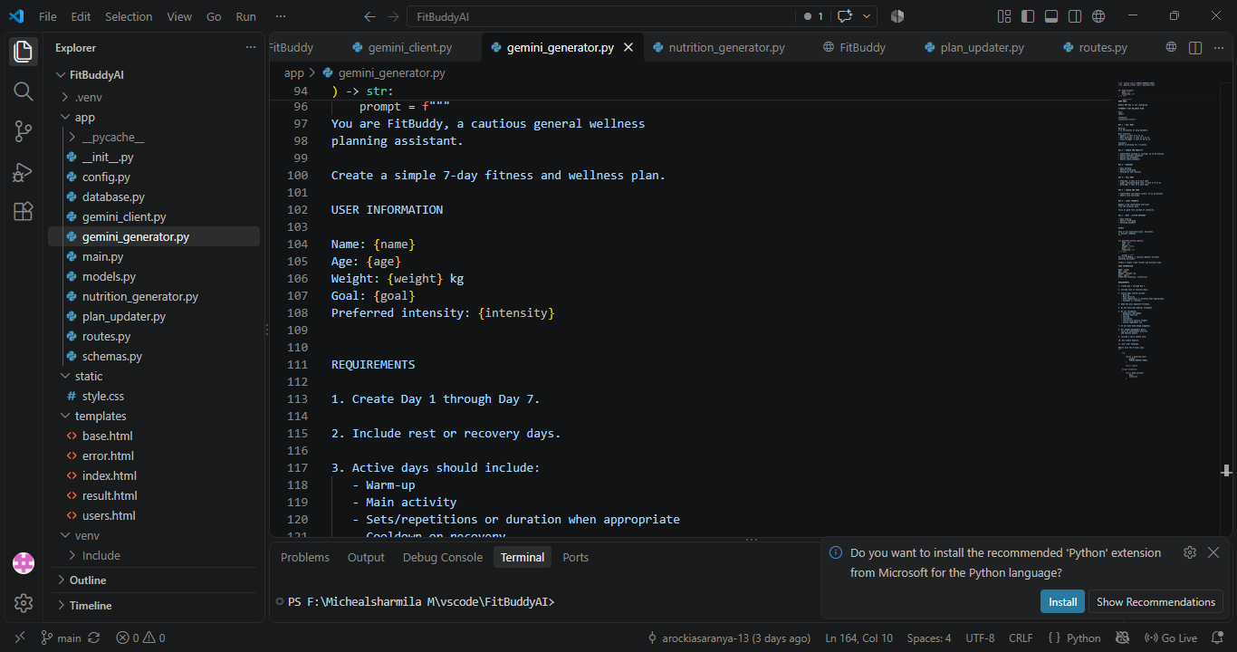
Figure 1: gemini_generator.py – prompt built from user details

6. Database Integration
app/models.py defines the data structures, and app/database.py manages the database connection and read/write operations, storing user details and generated plans.
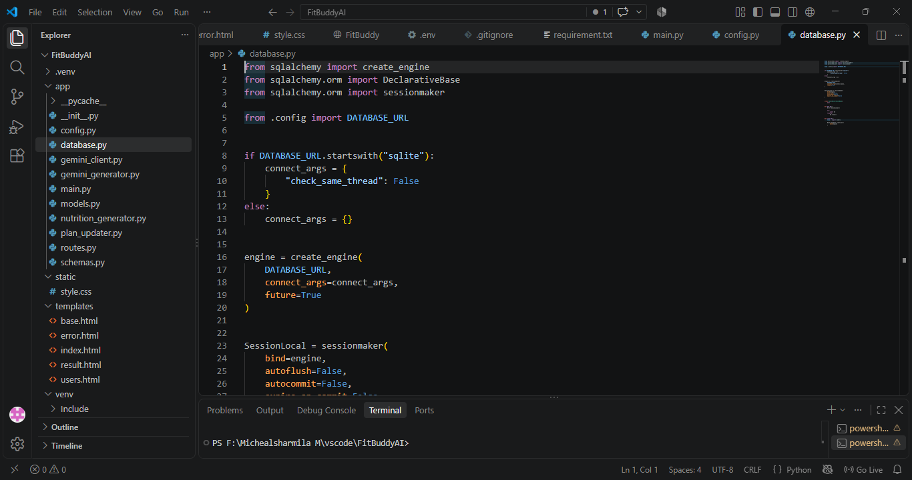
Figure 2: database.py – SQLAlchemy engine and session setup

7. Fitness Plan Generation
User input is validated, sent to Gemini through gemini_generator.py, and the returned text is formatted and displayed to the user as the fitness plan.

8. Nutrition Generation
app/nutrition_generator.py produces nutrition recommendations to accompany the fitness plan, based on the same user input. When the Gemini API key is not configured, this module falls back to a demo-mode nutrition tip so the page still works during local testing.

9. Plan Update / Feedback
app/plan_updater.py allows the user's plan to be regenerated when their details or goals change, using the same Gemini integration.

10. Environment Configuration
Sensitive values such as the Gemini API key are stored in a local .env file and loaded through app/config.py. The .env file is not committed to version control and its contents are not reproduced in this document.

11. Application Execution
- Install dependencies: pip install -r requirements.txt
- Create a .env file with the required configuration values (see env.example if provided).
- Run the application using a command such as: uvicorn app.main:app --reload
- Open the local address shown in the terminal in a web browser.
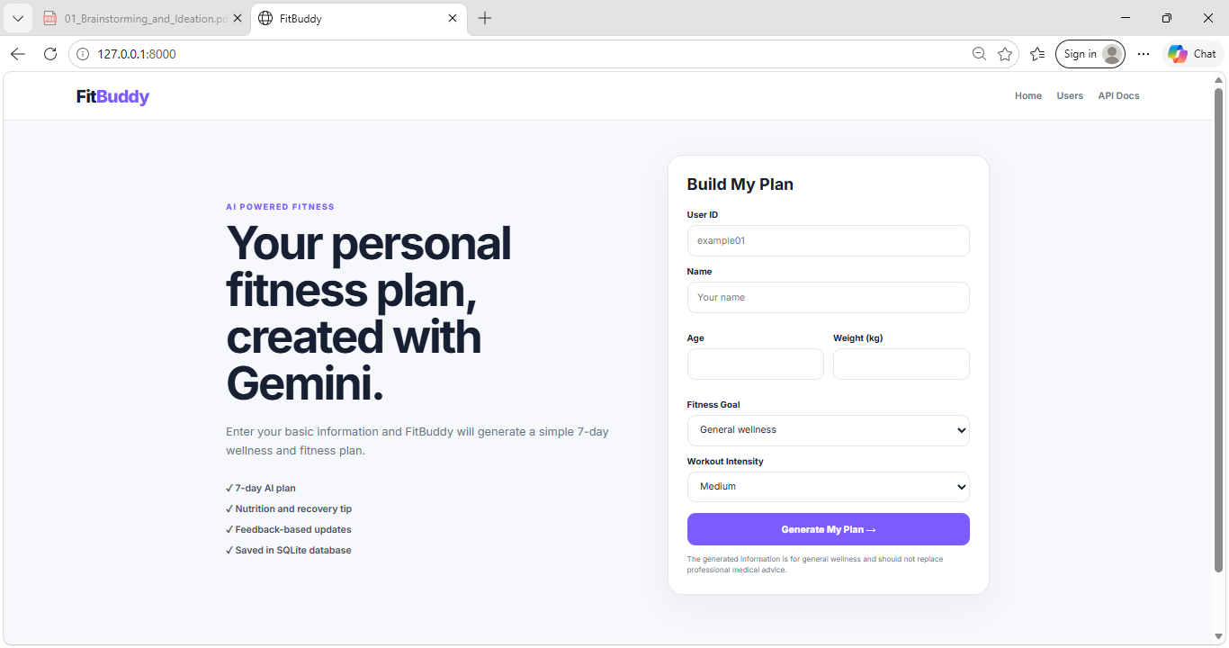
Figure 3: FitBuddy-AI home page running locally at 127.0.0.1:8000

