FITBUDDY-AI
06 – FitBuddy-AI
Testing Report
Student | M. Micheal Sharmila
Degree | B.Sc. Computer Science
College | Government Arts and Science Women’s College, Alangulam
Academic Year | 2025–2028

1. Testing Introduction
This report defines the tests planned for FitBuddy-AI. Some tests below have now been executed with real screenshots as evidence; these are marked Pass. Tests not yet executed remain marked Pending Verification. No result is claimed without evidence.
Important note: at the time of this testing round, the Gemini API key was not configured, so the application used its built-in fallback (demo mode) plan instead of a live Gemini-generated plan. This confirms the fallback/error-handling logic works correctly, but it does not yet confirm real Gemini AI generation. That should be tested again once a valid API key is added, and this report updated.

2. Testing Objectives
- Verify that the application starts and the input form works correctly.
- Verify that valid and invalid input are handled as expected.
- Verify that a fitness plan is generated using Google Gemini AI.
- Verify that nutrition recommendations and plan updates work, if implemented.
- Verify that database operations complete without error.

3. Test Environment
Item | Details
Operating System | [Add OS used for testing]
Browser | [Add browser used for testing]
Python Version | [Confirm Python version]
Server | Local development server (Uvicorn)

4. Test Case Table
Test Case ID | Test Scenario | Input/Action | Expected Result | Actual Result | Status
TC_01 | Application startup | Start server; open 127.0.0.1:8000 | Home page loads without error | Home page loaded correctly with form | Pass
TC_02 | Valid input submission | Name, Age 19, Weight 50kg, Goal: Improve flexibility | Input accepted; processing begins | Form submitted; redirected to /generate-workout | Pass
TC_03 | Invalid input validation | Submit empty or invalid fields (e.g. negative age) | Validation error is shown | To be recorded | Pending Verification
TC_04 | Fitness plan generation | Submit valid data | AI-generated fitness plan is displayed | Fallback demo 7-day plan displayed (Gemini key not configured) | Pass (Fallback Mode)
TC_05 | Nutrition recommendation | Submit valid data | Nutrition suggestion displayed | Nutrition/Recovery Tip section displayed on result page | Pass
TC_06 | Plan update / feedback | Enter feedback (“make six days”) and submit | Updated plan displayed | Updated fallback plan displayed with feedback text shown back | Pass (Fallback Mode)
TC_07 | Database operation | Generate a plan | User and plan data saved successfully | To be recorded | Pending Verification
TC_08 | Gemini unavailable handling | Gemini key not configured (observed, not simulated) | App shows a message and does not crash | App displayed fallback plan gracefully; no crash | Pass

Status legend: Pass = verified with real evidence; Pass (Fallback Mode) = feature verified working, but using the built-in fallback plan rather than a live Gemini response; Pending Verification = not yet tested.

5. Bug Tracking
Bug | Cause | Solution | Retesting
[Add Bug Description] | [Add Cause] | [Add Solution] | [Add Retest Result]
[Add Bug Description] | [Add Cause] | [Add Solution] | [Add Retest Result]

6. Screenshot Evidence
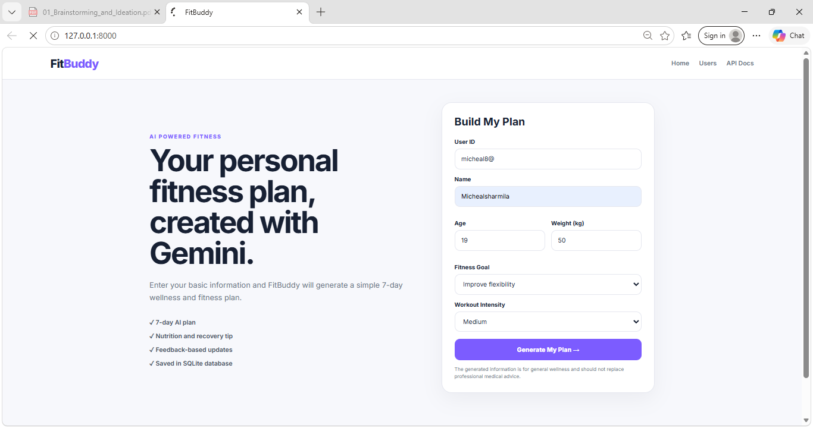
Figure 1: TC_02 – Home page with valid fitness details entered
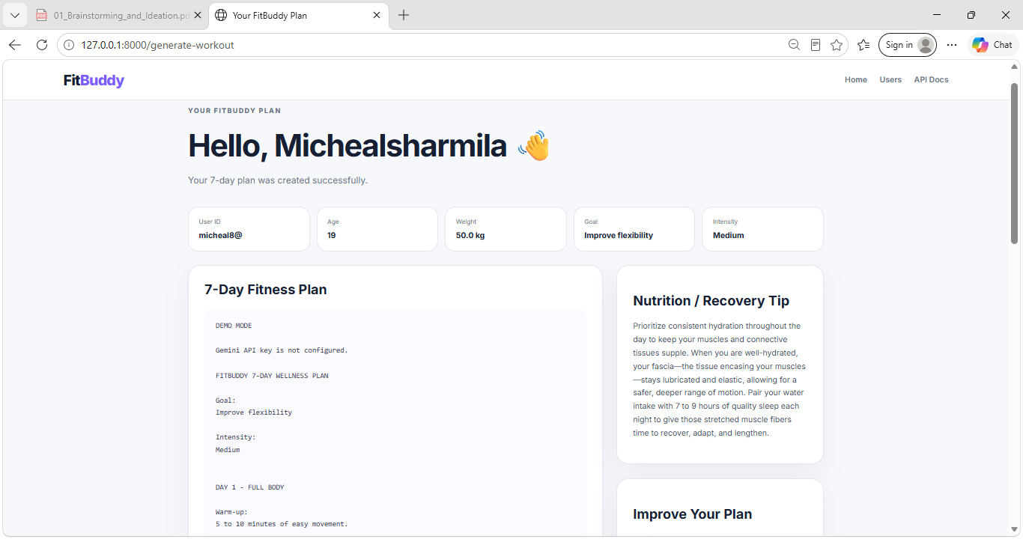
Figure 2: TC_04 / TC_05 – Generated plan and nutrition tip (fallback mode)
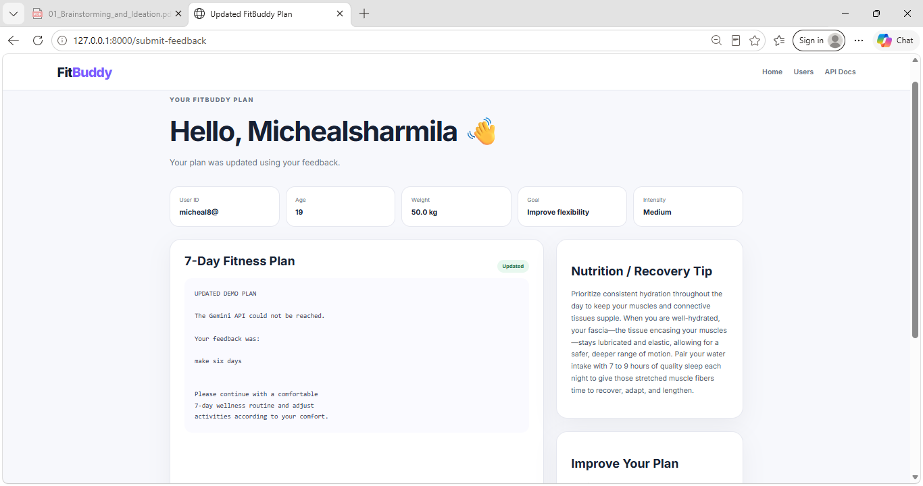
Figure 3: TC_06 – Plan updated using user feedback (fallback mode)

