FITBUDDY-AI
08 – FitBuddy-AI
Project Demonstration
Student | M. Micheal Sharmila
Degree | B.Sc. Computer Science
College | Government Arts and Science Women’s College, Alangulam
Academic Year | 2025–2028

1. Demonstration Overview
This document guides the final demonstration of FitBuddy-AI, showing the working application, its AI-generated fitness plans, and the supporting backend and database.

2. Working Application
FitBuddy-AI runs as a FastAPI web application. The user opens it in a browser, submits fitness details, and receives a fitness plan with a nutrition tip. In the current demonstration, the Gemini API key was not configured, so the plan shown is produced by the application's fallback (demo mode) logic; this will show a live Gemini-generated plan once a valid API key is added.

3. GitHub Repository
Source code repository: [Insert GitHub Link]

4. Demo Video
Recorded demonstration video: [Insert Demo Video Link]

5. Major Screenshots
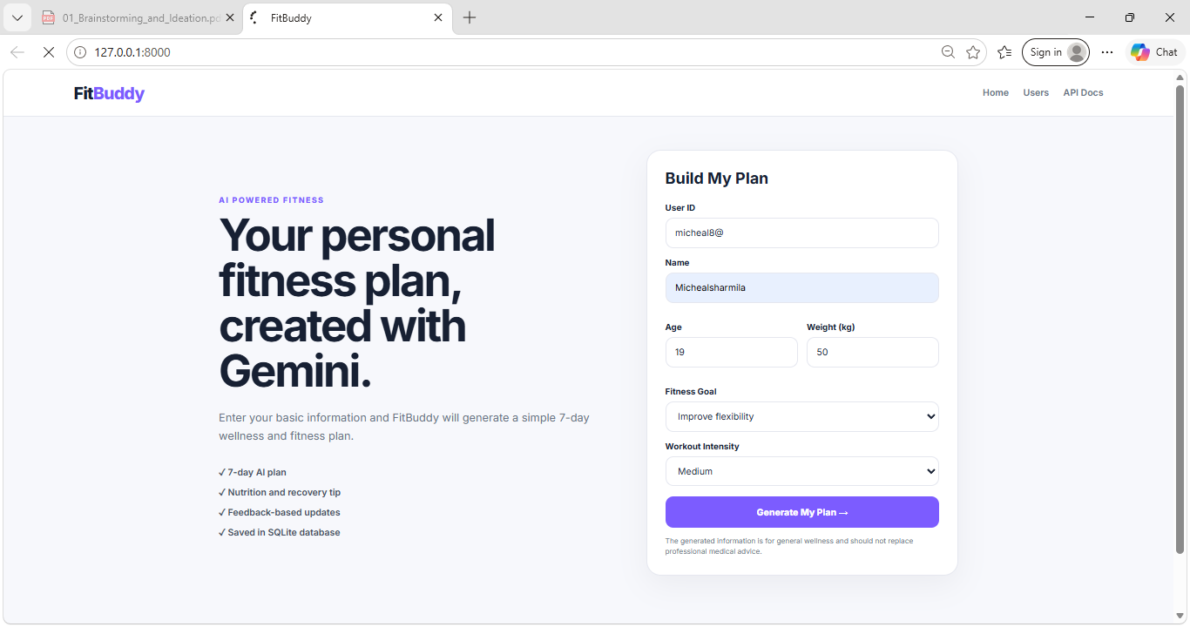
Figure 1: Home page with user fitness details entered
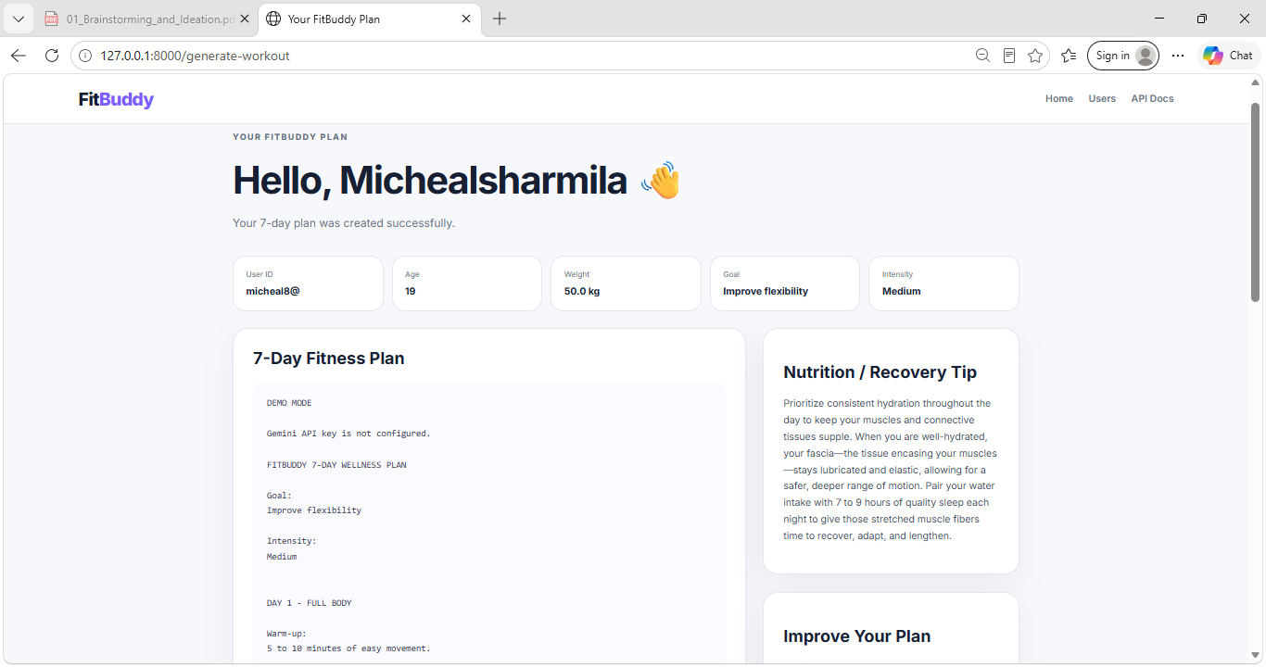
Figure 2: Generated fitness plan and nutrition tip
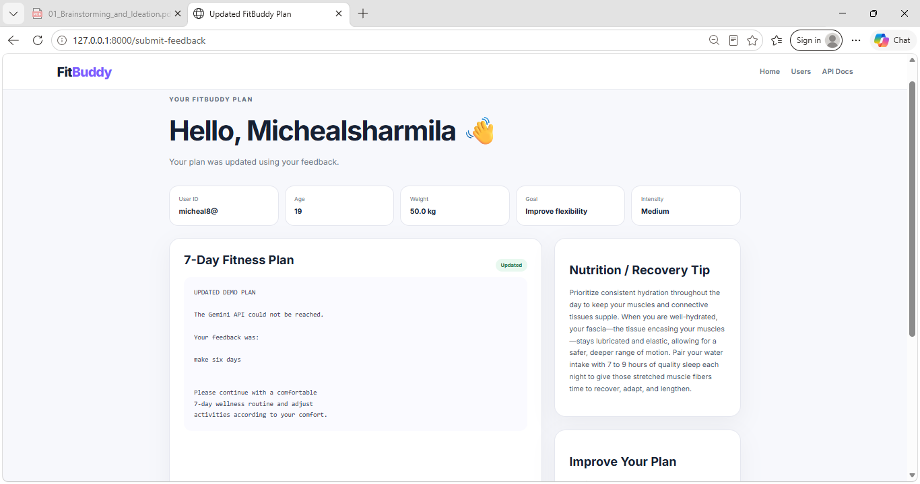
Figure 3: Plan updated using user feedback (“make six days”)

6. Demonstration Sequence
- Open the application.
- Enter user details / login (if implemented).
- Show the main dashboard.
- Enter fitness requirements.
- Generate the AI fitness plan.
- Show the generated plan.
- Show the nutrition recommendation (if implemented).
- Show the plan update / feedback option (if implemented).
- Explain the backend and database.
- Logout (if implemented).

7. Features Demonstrated
Feature | Status
User detail input | Demonstrated (Figure 1)
Fitness plan generation | Demonstrated – fallback mode (Figure 2); live Gemini output pending API key
Nutrition recommendation | Demonstrated (Figure 2)
Plan update / feedback | Demonstrated – fallback mode (Figure 3)
Login / dashboard | Not implemented in current scope

8. Backend / Database Explanation
During the demonstration, the FastAPI backend (app/main.py, app/routes.py) and the database layer (app/models.py, app/database.py) are briefly explained, showing how user input flows to Google Gemini AI (app/gemini_client.py, app/gemini_generator.py) and how the result is stored and displayed.

9. Final Result
The demonstration confirms that FitBuddy-AI accepts user fitness details, generates a fitness plan with a nutrition tip, and supports updating the plan using feedback, end-to-end. The core objective is met at the application-flow level; live Gemini AI generation should be re-verified once a valid API key is configured.

