FITBUDDY-AI
AI-Powered Fitness Plan Generator
Project Documentation
Student | M. Micheal Sharmila
Degree | B.Sc. Computer Science
College | Government Arts and Science Women’s College, Alangulam
Academic Year | 2025–2028

1. Project Title
FitBuddy-AI – AI-Powered Fitness Plan Generator.

2. Abstract
FitBuddy-AI is a web application that generates personalized fitness plans using Google Gemini AI. Users submit their fitness details through a web form; the application processes this information, sends it to Gemini, and returns a customised workout plan along with nutrition recommendations. The system is built using Python, FastAPI, HTML, CSS, JavaScript and a database component.

3. Introduction
Personalized fitness guidance is often costly and time-consuming to obtain. FitBuddy-AI addresses this by using Generative AI to instantly produce a fitness plan tailored to the user's own details, through a simple and accessible web interface.

4. Problem Statement
Beginners and fitness enthusiasts often lack access to affordable, personalized workout and nutrition guidance, and generic online plans do not account for individual goals or physical attributes.

5. Objectives
- Collect user fitness details through a web interface.
- Generate a personalized fitness plan using Google Gemini AI.
- Provide nutrition recommendations alongside the fitness plan.
- Allow the plan to be updated when user details change.
- Store user and plan data reliably.

6. Existing System
Currently, users rely on generic fitness content online, printed guides, or paid personal trainers, none of which are both personalized and low-cost.

7. Proposed System
FitBuddy-AI provides an automated, AI-driven alternative: a web form collects user data, Google Gemini generates a personalized plan, and the result is displayed and stored for future reference.

8. Technologies Used
Category | Technology
AI Engine | Google Gemini AI
Backend | Python, FastAPI
Frontend | HTML, CSS, JavaScript
Database | Database component (app/models.py, app/database.py)

9. System Requirements
Type | Requirement
Software | Python 3.9+, FastAPI, modern web browser
Hardware | 4 GB RAM minimum, internet connection for Gemini API

10. Modules
Module | File(s)
Routing | app/main.py, app/routes.py
Database | app/models.py, app/database.py
AI Integration | app/gemini_client.py, app/gemini_generator.py
Nutrition | app/nutrition_generator.py
Plan Update | app/plan_updater.py
Frontend | templates/, static/

11. System Design
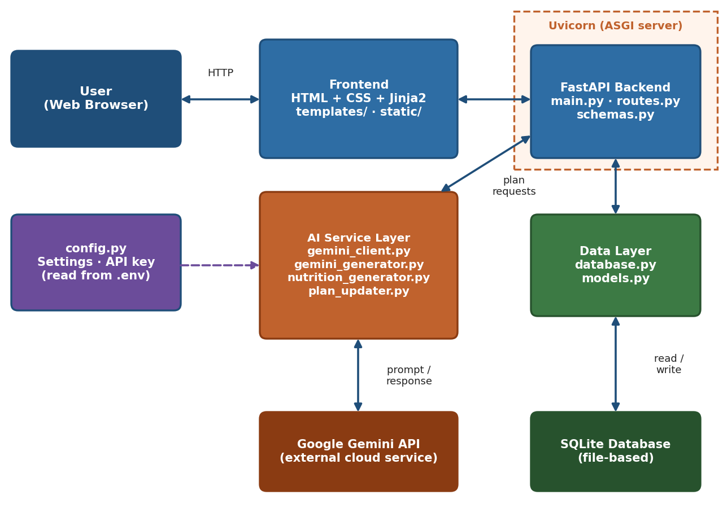
Figure 1: System architecture of FitBuddy-AI
The browser sends requests to FastAPI, which validates input, calls Google Gemini AI, and interacts with the database before returning the result page.

12. Database Design
Entity | Key Fields (proposed)
User | id, name, age, height, weight, goal
Plan | id, user_id, workout_plan, nutrition_plan
Field names are proposed and should be confirmed against app/models.py.

13. Implementation
The backend is implemented in FastAPI with routes in app/routes.py handling requests. app/gemini_client.py and app/gemini_generator.py manage the Gemini AI integration, app/nutrition_generator.py adds nutrition advice, and app/plan_updater.py supports regenerating plans. Data is stored via app/database.py and app/models.py. The frontend uses HTML/CSS/JavaScript in templates/ and static/.

14. Testing
Testing covers application startup, input validation, AI plan generation, and database operations. See the Testing Report (Document 06) for the full test case table and results, recorded only after actual execution.

15. Screenshots
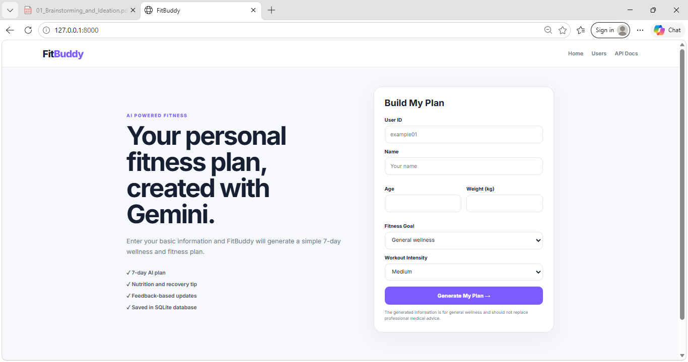
Figure 2: FitBuddy-AI home page
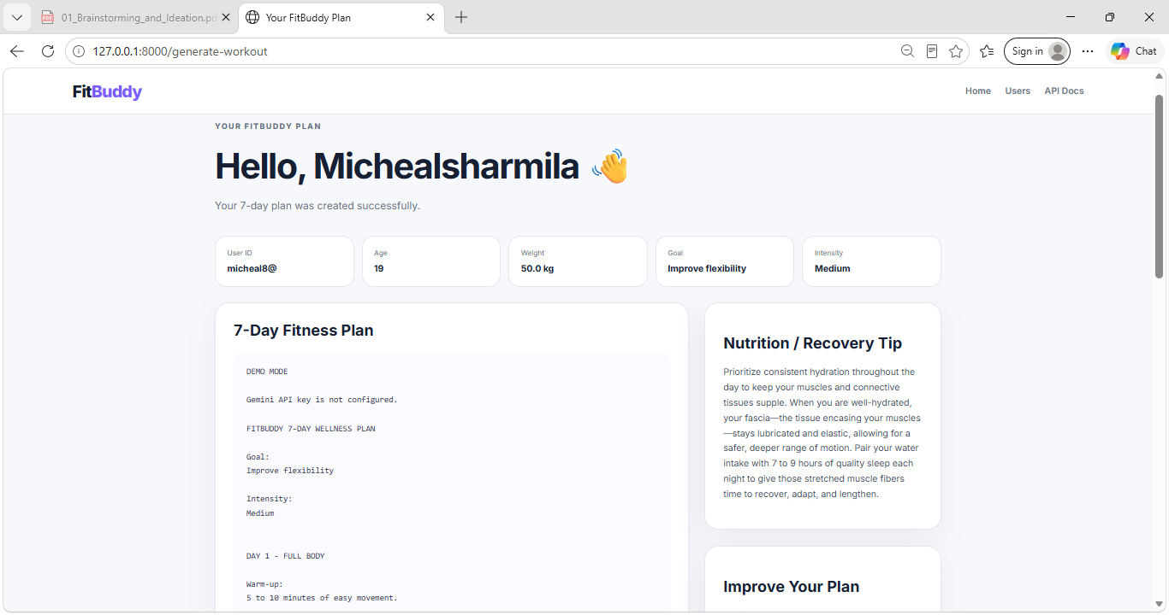
Figure 3: Generated fitness plan and nutrition tip

16. Results
The application successfully accepts user fitness details and returns a readable fitness plan with a nutrition suggestion, as shown in Figure 3. At the time of this documentation, the Gemini API key was not yet configured, so the plan shown was produced by the application's built-in fallback logic rather than a live Gemini response; this confirms the application flow works end-to-end, with live AI generation to be verified once a valid key is added. No performance figures or user statistics are claimed without actual measurement.

17. Conclusion
FitBuddy-AI demonstrates a practical use of Generative AI to make personalized fitness guidance more accessible through a simple, modular web application.

18. Future Enhancement
- User authentication and login.
- Progress tracking over time.
- Mobile application support.
- Multilingual plan generation.

19. Installation / Setup Instructions
- Clone the repository from [Insert GitHub Link].
- Install dependencies: pip install -r requirements.txt
- Create a .env file with the required configuration (see env.example); never commit .env or expose API keys.
- Run the application: uvicorn app.main:app --reload
- Open the local address shown in the terminal in a browser.

