SPEAKER & MEDIA KIT · 2026
Micheal Sheehy
Global payments, financial crime, AI governance and executive leadership
Compliance leader. Global operator. Original thinker.
Prepared for event organizers, journalists, podcast hosts and communications teams

AT A GLANCE

A practical voice on complex risk
Micheal Sheehy is a global payments and compliance executive with more than 20 years of experience building financial-crime, regulatory and operating capabilities across international markets. His work connects compliance, technology, customer experience and strategy—especially where static governance is being overtaken by faster-moving risk.
Compliance should move as fast as the risk it manages.

Prompt | Working response / evidence
Best for | Keynotes, fireside chats, panels, podcasts, board and executive sessions, media commentary.
Core themes | Adaptive compliance; global payments; AI and model governance; financial crime; sanctions; KYC; leadership.
Style | Direct, evidence-led and practical—with enough humor to keep the governance slide from becoming a medical emergency.
Location | New York / global engagements.
Contact | micheal@michealsheehy.com · +1 (818) 397-8890 · michealsheehy.com

Short bio
Micheal Sheehy is a global payments and compliance executive who writes and speaks about financial crime, artificial intelligence, model governance and the operating models required to scale safely. A Chief Compliance Officer with more than 20 years in financial services, he is the author of the Adaptive Compliance series and a frequent contributor to industry conversations on the future of risk.

Long bio
Micheal Sheehy is a global payments and compliance executive with more than 20 years of experience across financial services and cross-border payments. He has led distributed organizations and transformations spanning financial crime, sanctions, customer lifecycle, transaction monitoring and model governance. His work asks how compliance can become an adaptive operating system that helps global businesses grow safely. Micheal is the author of the eight-volume Adaptive Compliance series.

KEYNOTE TOPICS

Signature sessions

Compliance Should Move as Fast as the Risk It Manages
Why periodic review and static governance are failing—and how continuous evidence, model oversight and human accountability create an adaptive system.
Audience leaves with: a five-stage maturity model, practical governance questions and a clearer distinction between automation and adaptability.

While Compliance Debates AI Governance, Criminals Are Already in Production
How agents, deepfakes and synthetic identities are changing the production model of financial crime—and what defensive operating models must do differently.
Audience leaves with: an adversarial AI frame, authenticity controls and a roadmap for integrating fraud, cyber, KYC and financial-crime intelligence.

The Message Is the Control
How payment transparency, structured data and emerging regulatory expectations are moving financial-crime decisions upstream.
Audience leaves with: a payment-data quality stack, practical readiness questions and a grounded view of virtual-account complexity.

Global Compliance Without the Global Bottleneck
How to combine one global standard with local expertise, follow-the-sun execution and decision-making closer to customers.
Audience leaves with: decision-right principles, a capability placement model and a way to diagnose concentration risk.

Your New Platform Is Not a Transformation
A candid account of why buying technology is the easy part—and why data, process, governance, adoption and ownership determine the outcome.
Audience leaves with: a transformation scorecard, coexistence controls and questions to ask before signing the next contract.

SESSION DESIGN

Formats that work
Prompt | Working response / evidence
20–30 minute keynote | A sharp argument, memorable framework and practical close. Best for leadership and industry conferences.
45–60 minute keynote | A deeper evidence-led narrative with case examples and audience reflection.
Fireside chat | Conversational exploration of current developments, leadership decisions and lessons learned.
Executive or board session | A private, interactive discussion centered on strategic questions, operating choices and oversight.
Panel or moderator role | Clear synthesis, constructive provocation and enough discipline to keep six panelists from answering one question for 40 minutes.
Podcast / media interview | Concise, quotable commentary that connects current events to durable operating implications.

Sample moderator introduction
Micheal Sheehy is a global payments and compliance executive with more than 20 years of experience building financial-crime and regulatory capabilities across international markets. He is the author of the Adaptive Compliance series and writes about AI, payments, model governance and the leadership choices required to scale safely. Please welcome Micheal Sheehy.

Suggested interview questions
- What has the compliance industry optimized that matters less than it thinks?
- How should boards distinguish a genuine AI control from an impressive demonstration?
- What changes when criminals use agents and synthetic identities at scale?
- Why is payment-message quality becoming a financial-crime control?

SELECTED APPEARANCES

Media and industry conversations
Prompt | Working response / evidence
Nasdaq TradeTalks | How financial institutions are using AI and machine learning to combat fraud.
PYMNTS | Payments, financial crime and the role of compliance in responsible growth.
Integrity Innovators | Leadership, integrity and building a modern culture of compliance.
FinTech Futures | Regulatory change, global payments and emerging financial-crime risk.
Finextra | North Korean financial crime and the evolving role of payment platforms.
Money20/20 and industry events | Panels and interviews on payments, compliance transformation and AI.

Editorial platforms
Micheal’s writing at michealsheehy.com includes the eight-volume Adaptive Compliance series, essays on North Korean IT-worker networks, global KYC, stablecoins, payment transparency, de-risking, AI-enabled financial crime and personal leadership.
For current links, video and article references, visit michealsheehy.com/media.html.

APPROVED IMAGES

Headshots
High-resolution files are available on request. The images below are suitable for speaker pages, event listings and editorial use.
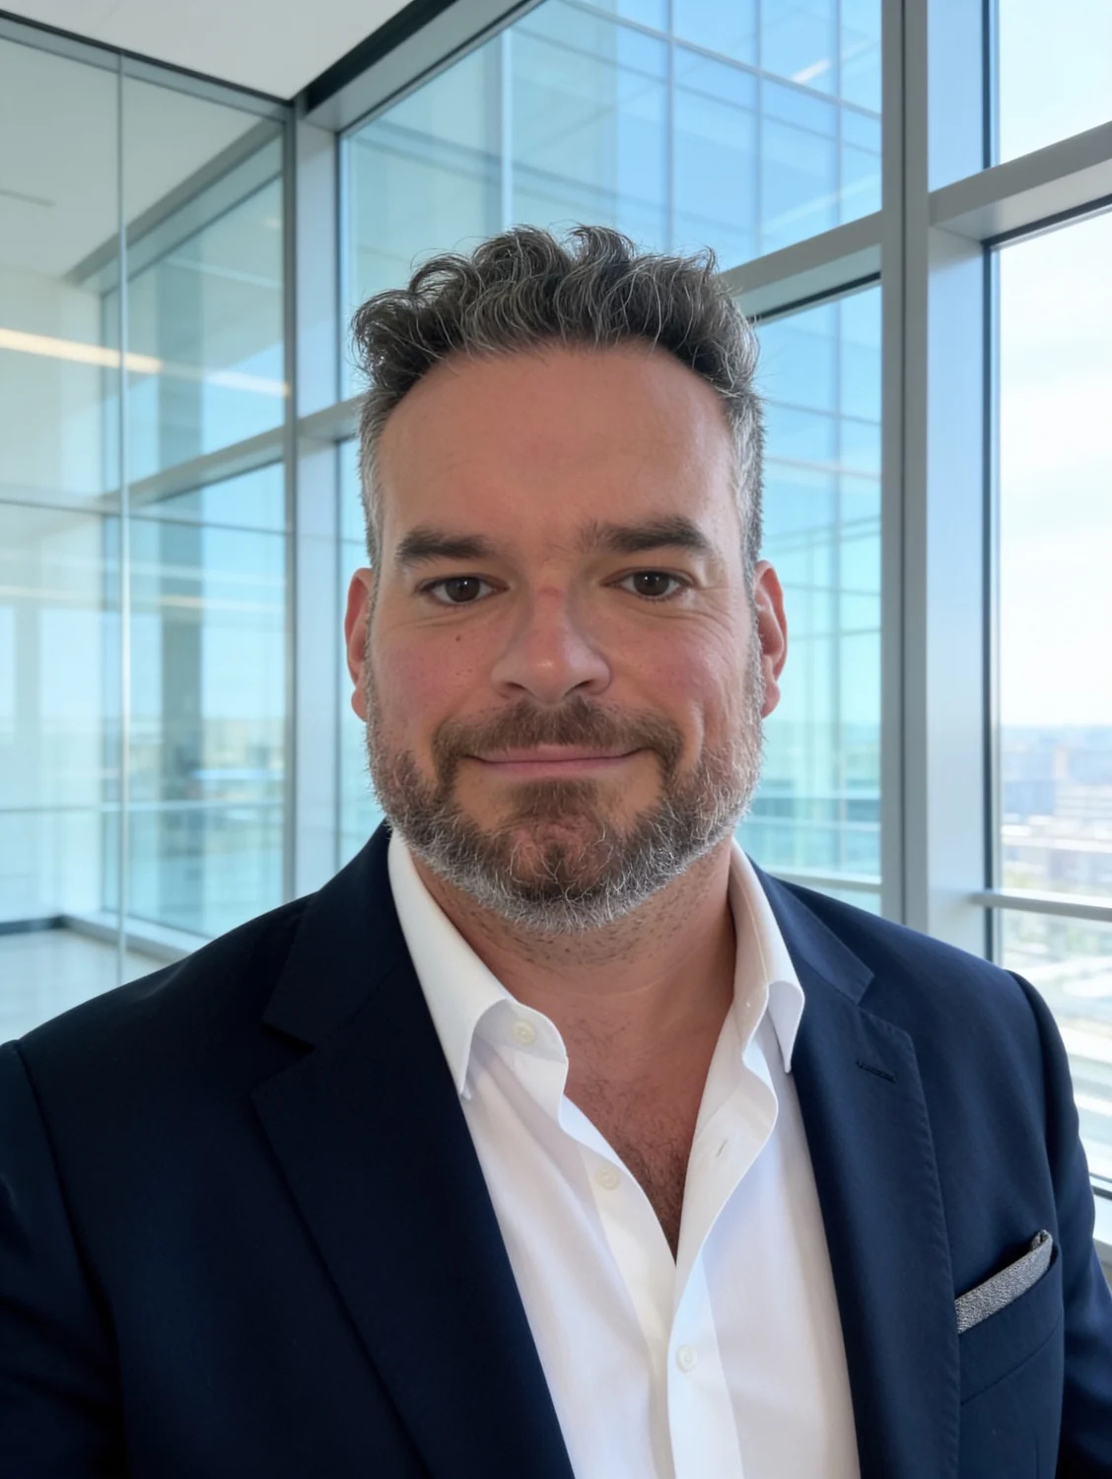  Executive close-up | 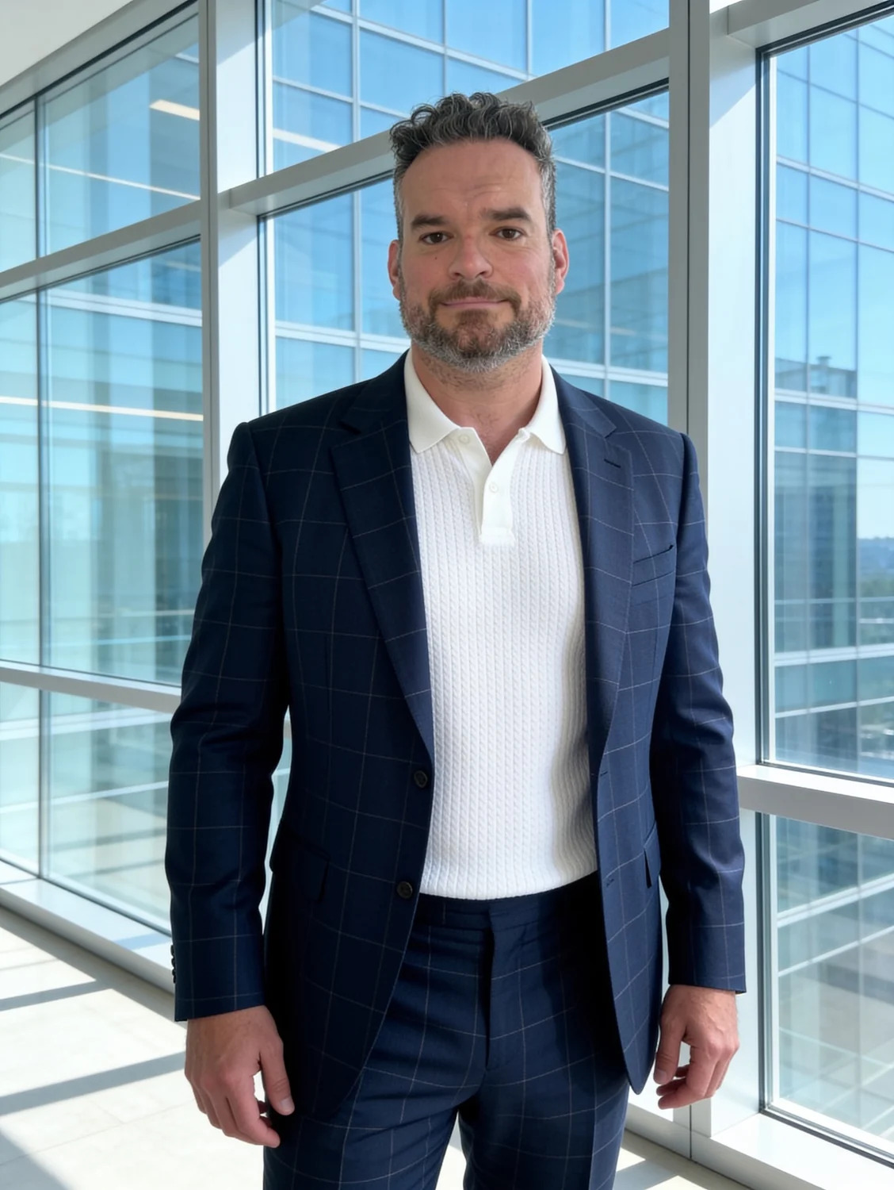  Formal portrait |   Editorial portrait

Image and biography use
- Credit: Courtesy of Micheal Sheehy.
- Do not materially alter the images beyond normal cropping and color correction.
- Use the short bio for agendas and the long bio for event pages, media notes and formal introductions.
- Confirm current title and event-specific language before publication.

CONTACT

Bring the conversation to your audience
For keynotes, panels, fireside chats, podcasts, board discussions, media commentary and selected advisory conversations:
micheal@michealsheehy.com · +1 (818) 397-8890 · www.michealsheehy.com

- LinkedIn: linkedin.com/in/micheal-s-88479045
- Speaking: michealsheehy.com/speaking.html
- Media: michealsheehy.com/media.html
- Adaptive Compliance: michealsheehy.com/adaptive-compliance.html
Please include the event or publication, audience, proposed format, timing and any deadline. All participation is subject to availability and appropriate approvals.

