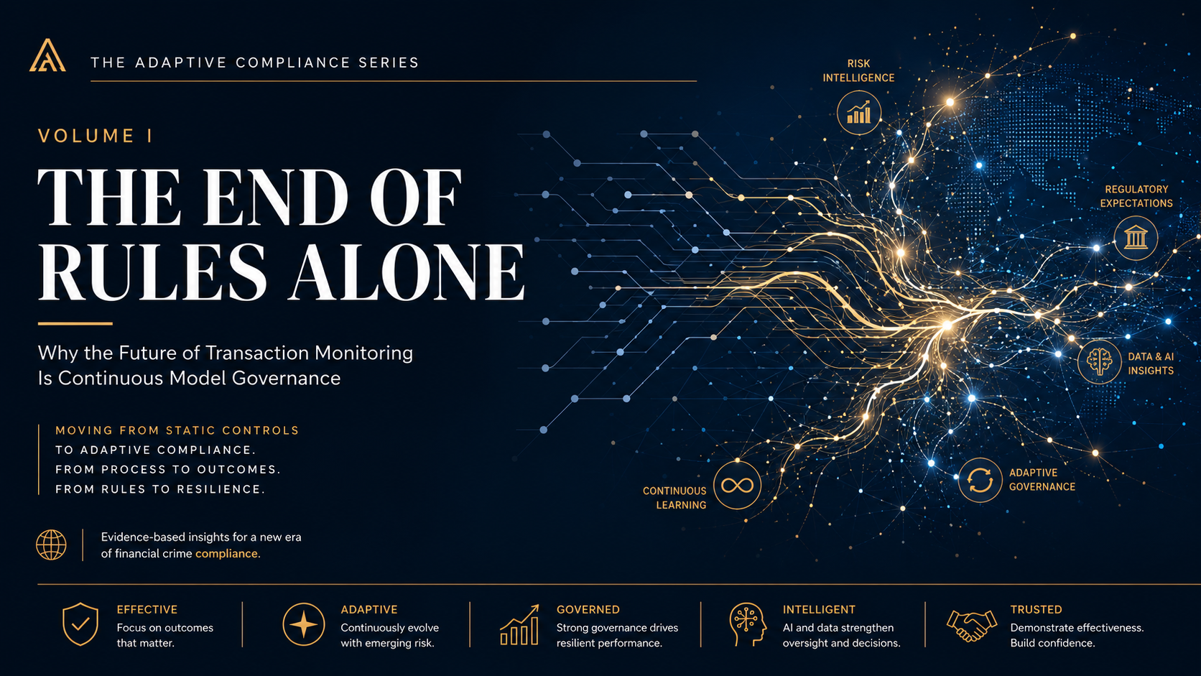
THE ADAPTIVE COMPLIANCE SERIES
VOLUME I
THE END OF RULES ALONE
Rethinking Financial Crime Compliance for an Adaptive World
Micheal Sheehy
Expanded Implementation Edition · July 2026

Copyright and Publication Note
© 2026 Micheal Sheehy. All rights reserved. This expanded implementation edition is prepared as an implementation-focused publisher's edition for executive education, workshops and thought-leadership publication. It is not legal advice and should not be relied upon as a statement of any institution's confidential controls, policies or procedures.
For speaking, advisory and publishing enquiries: michealsheehy@gmail.com

Case-study note
The operational case studies in this edition are anonymized composites developed from professional experience and common industry patterns. They are designed to illustrate implementation choices without disclosing confidential customer information, proprietary thresholds or institution-specific control logic.

Contents
Chapter 1 · The Industry Solved the Wrong Problem
Chapter 2 · The Evidence Has Been There All Along
Chapter 3 · Every Model Begins Drifting on Day One
Chapter 4 · The Adaptive Compliance Maturity Model
Chapter 5 · AI Won't Replace Compliance. It Will Replace Static Governance
Chapter 6 · Designing an Adaptive Compliance Organization
Chapter 7 · Measuring What Matters
Chapter 8 · Adaptive Compliance as a Strategic Capability
Toolkit · Practical Questions for Leaders
References and Further Reading
About the Author

Foreword
The Adaptive Compliance Series begins from a simple observation: financial crime evolves continuously, while many governance models still operate periodically. The challenge facing compliance leaders is no longer only to build better controls, but to build organisations capable of recognising when those controls need to change.
This volume is intended for compliance leaders, CEOs, boards, regulators, product executives and technologists who are thinking about the future of financial crime control in a world shaped by AI, digital payments, geopolitical volatility and rapidly changing customer behaviour.
The argument is intentionally practical. Rules, models, monitoring systems and investigative teams remain essential. The problem is not that the industry built them. The problem is that too many programmes still treat them as fixed assets rather than living capabilities that must be continuously governed, tested and improved.

Introduction
Financial crime compliance has spent decades becoming more sophisticated. Institutions have invested in technology, expanded specialist teams and strengthened governance. Yet the environment surrounding those controls now changes faster than the periodic processes designed to oversee them.
The central argument of this book is simple: rules, models and controls remain essential, but they are no longer sufficient on their own. The defining capability of modern compliance is the ability to recognise change, challenge assumptions and adapt governance continuously.
The eight chapters that follow move from diagnosis to design. They examine why efficiency became the wrong north star, what enforcement actions reveal, why models inevitably drift, how maturity should be assessed, how AI changes governance, how organisations should be designed, what they should measure and why adaptive compliance ultimately becomes a strategic capability.
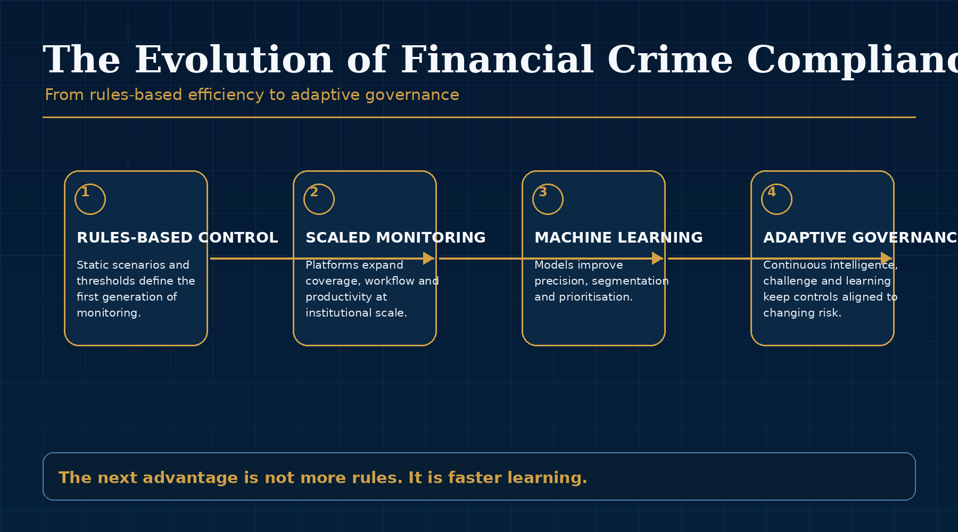
Series overview: the eight-part argument for adaptive compliance.

CHAPTER 1

HOW TO USE THE IMPLEMENTATION EDITION

This edition preserves the core argument of each chapter and adds the operating detail required to put the idea into practice. Each implementation playbook is structured around five questions: What capability is required? What evidence shows the current state? What sequence should the organization follow? Who decides? How will leaders know the change worked?
The tables are designed to be copied into workshops and governance papers. The 30/60/90-day plans are intentionally practical: they assume an organization can begin with one product, model, region or control rather than waiting for a multi-year transformation program.
The governing principle
Do not copy every template mechanically. Use the frameworks to make assumptions explicit, assign decisions and create evidence that the institution is learning faster than risk changes.

The Industry Solved the Wrong Problem
Efficiency became the industry's dominant objective. Adaptability must become the next one.

Opening illustration for Chapter 1: The Industry Solved the Wrong Problem.
EXECUTIVE INSIGHT
For more than two decades, financial crime compliance has pursued a remarkably consistent objective: reduce false positives, process alerts faster and lower the operational cost of control. Those goals were understandable, and they delivered meaningful improvements. Yet they also encouraged the industry to confuse efficiency with effectiveness. A quieter monitoring programme is not necessarily a safer one. The central question is no longer whether controls operate efficiently, but whether they continue to reflect the risks that exist today.


Figure 1.1: The Industry Solved the Wrong Problem - key framework.

The Wrong North Star
For more than two decades, the financial crime industry has organised much of its transformation agenda around operational efficiency. The language has become familiar: lower false positives, higher investigator productivity, faster case resolution and reduced cost per alert. These measures appear in vendor demonstrations, board reporting packs and annual strategic plans because they are concrete, measurable and easy to explain. They also respond to a real pressure. As digital payments and cross-border commerce expanded, compliance functions had to process more activity without allowing operational cost to grow without limit.
The difficulty is that a metric can become so dominant that it begins to distort the objective it was originally intended to support. False-positive reduction matters only if the programme continues to identify the right risk. Faster investigations matter only if investigators are looking at the activity that best represents the institution's exposure. Lower cost matters only if the institution has not quietly reduced its sensitivity to the forms of financial crime that are emerging around it.
A highly efficient monitoring programme can still become less effective. It may produce fewer alerts, meet service-level targets and show steady productivity while the assumptions behind its detection logic become progressively outdated. The dashboard can remain green at precisely the moment governance should be asking whether the programme still understands the risk environment it is supposed to protect.

Technology Advanced. Governance Often Did Not.
The industry's technological progress has been significant. Rules engines have become more configurable. Machine-learning models have improved segmentation and prioritisation. Cloud infrastructure allows institutions to process vast datasets. Screening tools incorporate richer lists and better matching. Workflow platforms have improved case management and auditability. These advances have delivered real benefits, and no serious argument for adaptive compliance should understate them.
Yet regulatory findings and industry experience continue to point to the same underlying problem: the technology may improve while the operating model around it remains largely periodic. Scenarios are reviewed after scheduled intervals. Thresholds are adjusted after evidence becomes compelling. Risk assessments catch up to business change rather than anticipating it. Product launches alter customer behaviour before monitoring assumptions are reassessed. Data quality problems remain tolerated because ownership is fragmented. Governance identifies deterioration only after internal audit, a backlog or an external examiner forces the issue.
The issue is therefore not that rules, models or platforms are unimportant. They remain essential. The issue is that technology is a tool for expressing an institution's understanding of risk, and that understanding has a shorter half-life than it once did. If governance does not continuously test whether assumptions remain valid, even sophisticated controls can become outdated with impressive efficiency.

Efficiency Is Not Effectiveness
Efficiency asks whether the organisation is doing the work with less effort. Effectiveness asks whether the work is producing the intended outcome. In financial crime compliance, the intended outcome is not simply fewer alerts or faster closure. It is the ability to detect, prevent, escalate and explain financial crime risk as that risk changes.
The distinction sounds obvious, but it has significant implications. A scenario that generates fewer alerts may have been successfully tuned, or it may have become less sensitive. A model that performs well against historical validation data may still be poorly aligned to a new product or customer segment. A risk rating methodology may produce consistent outputs while failing to reflect how a market has changed. In each case, the institution can point to operational evidence that the process is working, while the more important question remains unresolved: is the control still describing reality?
This is why the industry's next stage cannot be defined by efficiency alone. The next stage requires governance capable of asking whether controls remain true to the environment. It requires a willingness to treat every model, rule and methodology as a hypothesis that must be continuously tested against changing facts.

The Real Problem Is Adaptation
Financial crime is adaptive. Criminal networks experiment, learn and move rapidly across products, jurisdictions and payment rails. Fraud typologies can spread internationally in days. State-sponsored actors exploit legitimate digital platforms. Sanctions exposure can change overnight. Customers adopt new products, establish new counterparties and behave in ways that historical baselines could not anticipate.
The industry's defining challenge is therefore not simply building better controls. It is building governance capable of recognising when controls no longer describe the world. That is an organisational capability, not merely a technical one. It depends on information moving between teams, assumptions being challenged, performance being continuously interpreted and leadership treating change as a normal condition rather than an exceptional event.
The next era of compliance begins with a different question. Instead of asking only how to make controls more efficient, organisations must ask how they know those controls still reflect today's risks. That question changes the role of governance. It turns monitoring from a static system into a continuously tested hypothesis about how risk appears in the institution.
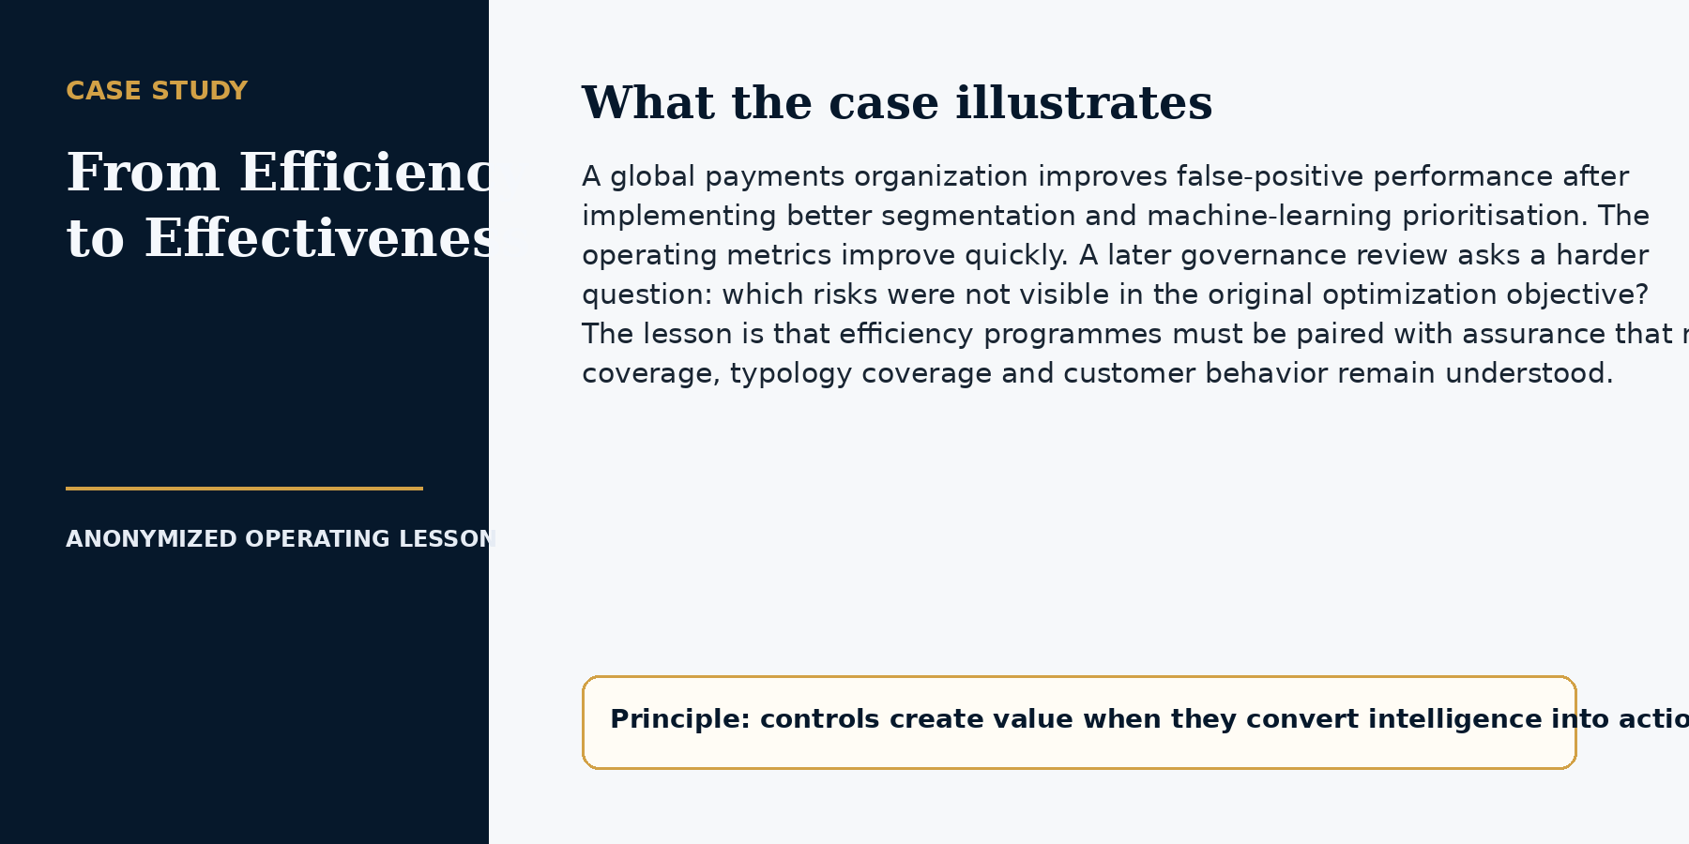

CHAPTER 1 IMPLEMENTATION PLAYBOOK

From Principle to Practice
The strategic argument becomes operational only when an institution changes the unit of management. The unit cannot be the alert alone. It must be the control hypothesis: the risk the control is intended to detect, the population to which it applies, the evidence that it works, and the conditions that would make it obsolete.
A practical effectiveness program does not begin by tuning thresholds. It begins by building a reliable inventory and asking whether every control still has a defensible purpose. The institution then separates operational burden from risk coverage so that it can reduce noise without treating alert reduction as evidence of success.
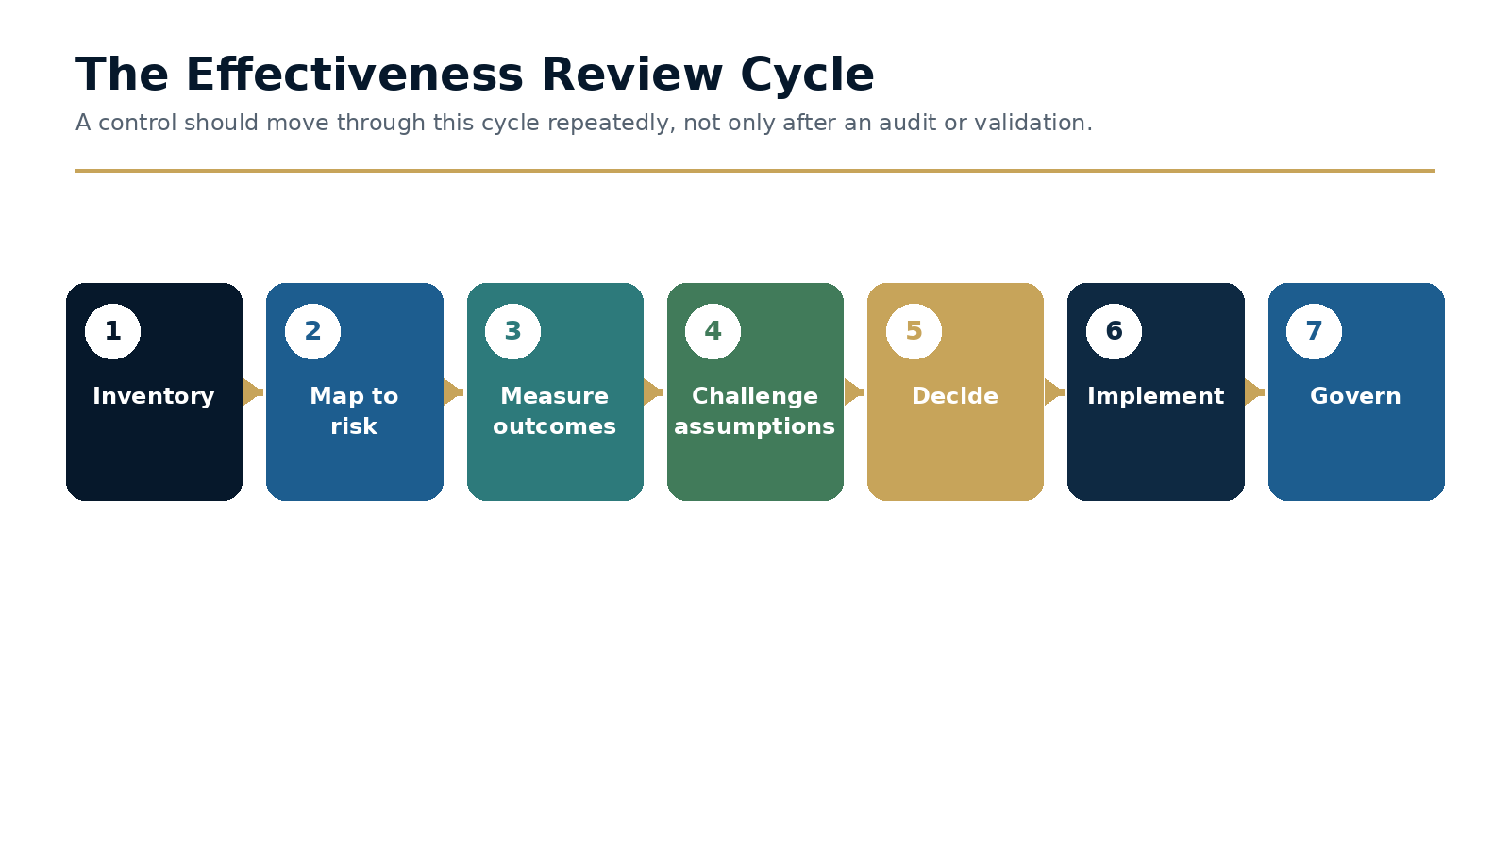
Figure 1.2 · The Effectiveness Review Cycle

Step 1: Build a control inventory that can be challenged
At minimum, the inventory should identify the control owner, risk typology, customer and product scope, data inputs, logic or model version, operational output, known limitations, dependencies and the most recent evidence of effectiveness. This is more demanding than a technical catalogue. It connects the control to a specific risk statement and makes assumptions visible.
The inventory should be maintained as a governed record rather than a one-time transformation deliverable. Product changes, data changes, emerging typologies and enforcement themes should trigger review. A control that cannot be linked to a current risk should not continue indefinitely simply because it has always existed.

Step 2: Measure coverage before optimizing workload
Coverage assessment asks whether material typologies, customer segments, products and payment corridors are addressed by an appropriate combination of preventive and detective controls. It should distinguish between nominal coverage - a scenario is said to address a risk - and evidenced coverage, where test results, investigations, intelligence and outcomes demonstrate that the control can identify the behavior in the relevant population.
This assessment should be performed before major alert-reduction targets are set. Otherwise, the organization may remove the very signals needed to understand where coverage is weak.

Step 3: Decide whether to tune, retire, replace or redesign
Tuning is appropriate when the control objective remains valid and noise can be reduced without materially weakening sensitivity. Retirement is appropriate when the risk is covered more effectively elsewhere or the scenario no longer addresses a relevant exposure. Replacement is appropriate when the current technology or data cannot support the control objective. Redesign is required when the risk itself has changed or when the control was built around an assumption that no longer holds.
Each decision should be recorded with the evidence considered, the expected effect on risk coverage and customer impact, the approver, and the monitoring period after implementation. This converts tuning from a technical exercise into a governed risk decision.

Working Template
Field | Purpose | Minimum evidence
Risk typology and objective | Defines what the control is intended to identify or prevent. | Current risk assessment, typology library and regulatory rationale.
Population and product scope | Shows where the control applies and where it does not. | Customer segments, entities, corridors, products and exclusions.
Data and dependencies | Makes upstream fragility visible. | Fields, lineage, latency, quality rules and known gaps.
Logic / model version | Creates traceability to the deployed control. | Rule, features, threshold, code version and approval record.
Outcome evidence | Demonstrates whether the control produces useful risk information. | Investigations, filings, confirmed events, quality testing and back-testing.
Known limitations | Prevents false confidence. | Documented blind spots, assumptions and compensating controls.

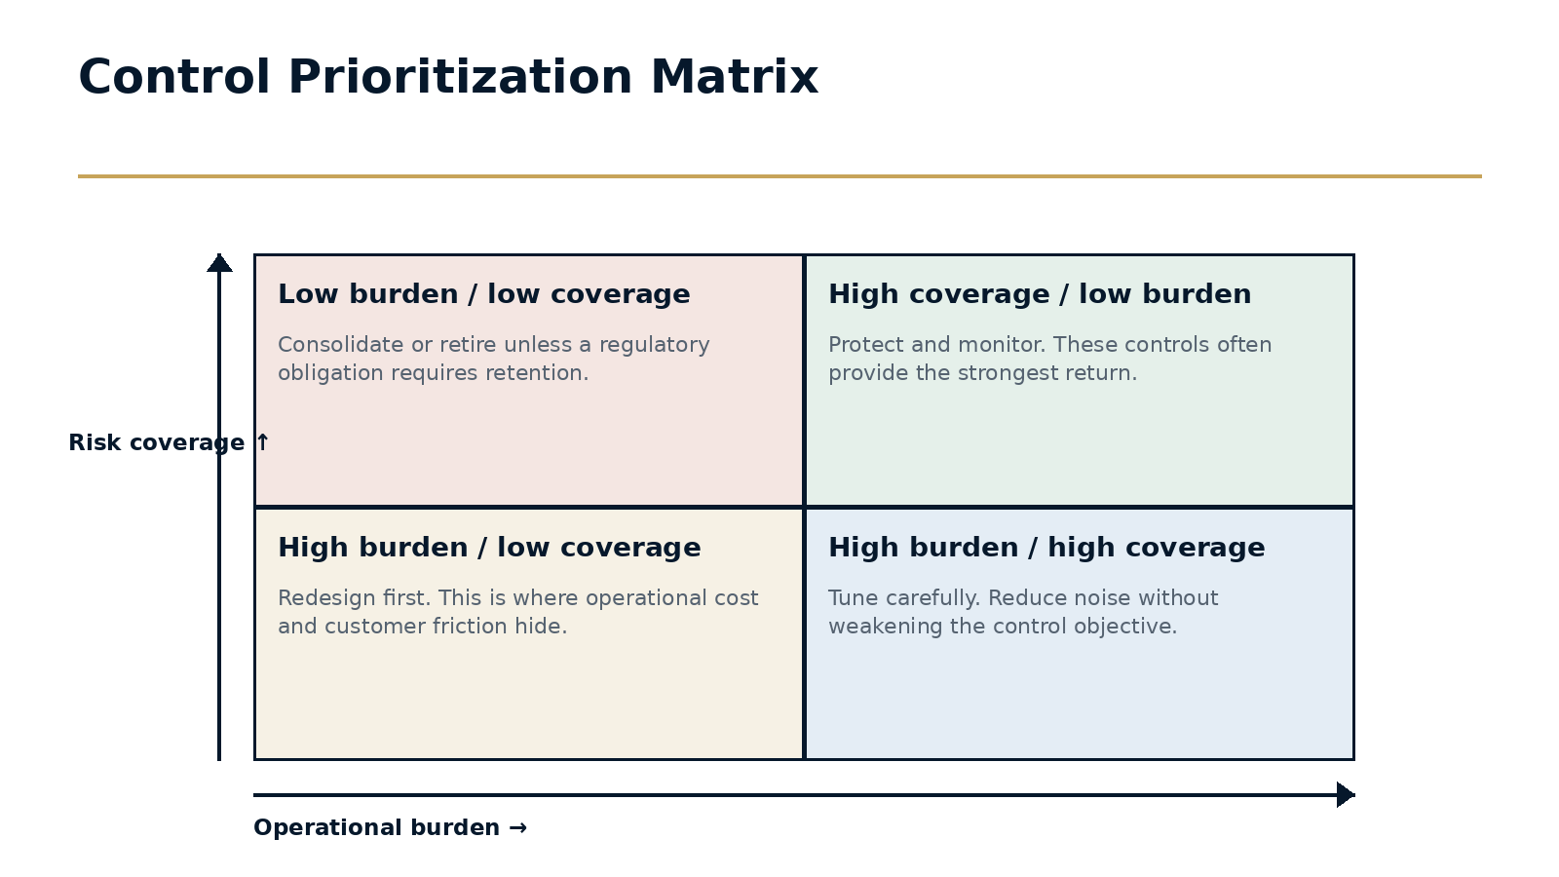
Figure 1.3 · Control Prioritization Matrix

Decision Framework
Condition | Primary action | Governance question
High coverage / high noise | Tune | Can burden be reduced while preserving demonstrated detection capability?
Low coverage / high noise | Redesign or replace | Why is the institution paying for activity that does not address material risk?
Low coverage / low noise | Retire or consolidate | Is the control retained only because it is familiar?
High coverage / manageable burden | Protect and monitor | What changes in the environment would threaten performance?

Executive Case Study
Transaction-monitoring modernization
A global payments business had invested heavily in alert reduction. Productivity improved, but executives still could not explain whether the program covered the most important typologies across customer segments and corridors. High-volume scenarios received the most attention because their operational cost was visible; low-volume coverage gaps received less attention because they did not create backlogs.

Implementation
The organization built a control inventory and mapped every scenario and model to a current typology library. Outcomes were segmented by product, geography and customer type. A cross-functional review then placed each control in a coverage-versus-burden matrix and assigned one of four decisions: tune, retire, replace or redesign.

Governance
Changes were approved through a monthly effectiveness forum with Compliance accountable, Data and Technology responsible for implementation, Operations consulted on workflow impact, and independent testing responsible for post-change verification. Each material change had a defined monitoring window and rollback criteria.

Outcome and lesson
The most important result was not a single percentage reduction. It was a better decision system. The organization could show where burden was reduced, where coverage was strengthened and why each change was defensible. The lesson is that modernization succeeds when the objective is explicit: improve detection effectiveness and customer outcomes together.

Common Failure Modes
- Starting with a false-positive target before establishing coverage.
- Allowing technology teams to tune controls without a documented risk decision.
- Treating true-positive counts as a complete measure of effectiveness.
- Keeping legacy scenarios because ownership for retirement is unclear.
- Failing to monitor the effect of a change after deployment.

A Practical 30 / 60 / 90-Day Plan
Period | Actions and evidence
First 30 days | Create the scenario and model inventory; map material typologies; identify the five highest-burden controls; agree the effectiveness forum and decision record.
Days 31-60 | Complete segmented outcome analysis; assess coverage gaps; select two tuning candidates and one redesign candidate; define post-change measures and rollback criteria.
Days 61-90 | Implement the first changes; perform independent outcome testing; update the board dashboard to show coverage, burden and change decisions; set the next quarterly review cycle.

Implementation checkpoint
At the end of the first ninety days, leadership should be able to point to at least one changed decision, one implemented control or governance improvement, and evidence that the result was tested. Activity alone is not proof of adaptation.

Executive Reflection
The industry did not fail by pursuing efficiency. It failed only when efficiency became the destination. The future belongs to organisations that can improve efficiency without losing sight of effectiveness - and that can adapt before yesterday's assumptions become tomorrow's failures.

Questions for Leaders
• What assumptions underpin the metrics your organization celebrates most?
• If false positives declined significantly, what evidence would prove that risk coverage did not decline with them?
• Which controls are most dependent on assumptions made more than twelve months ago?
• Where does your governance model test whether the environment has changed, not merely whether the control performed?

CHAPTER 2

The Evidence Has Been There All Along
Enforcement actions are not isolated failures. Collectively, they are a map of where governance repeatedly falls behind change.
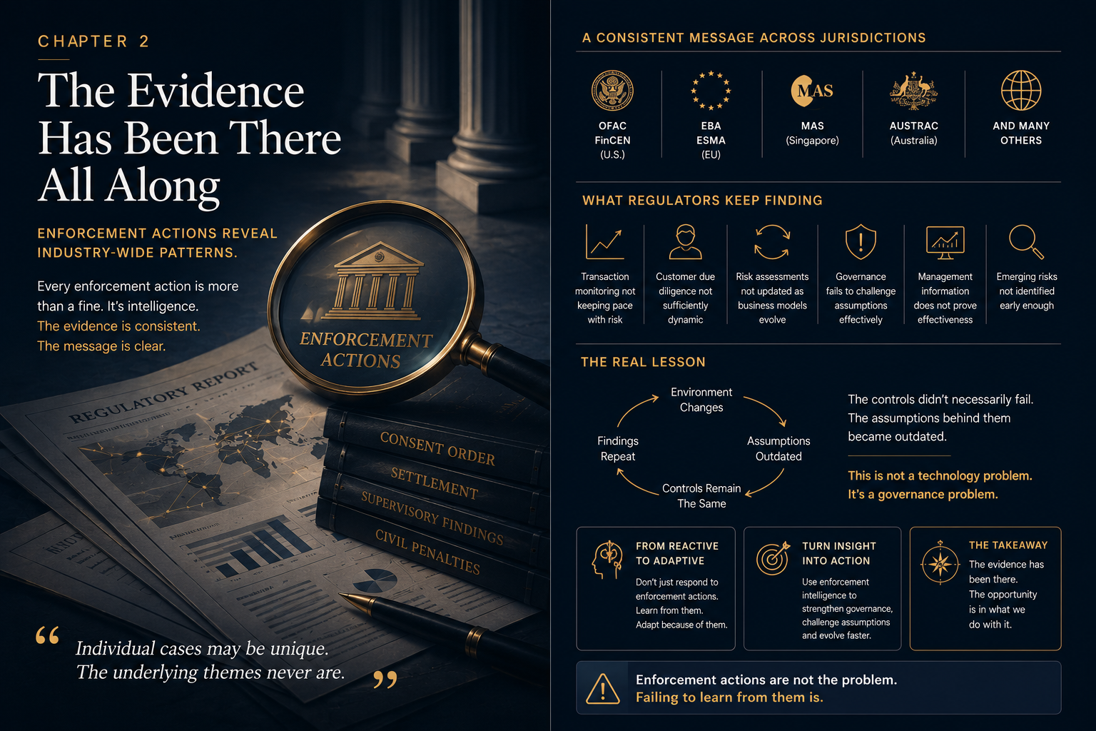
Opening illustration for Chapter 2: The Evidence Has Been There All Along.
EXECUTIVE INSIGHT
Regulatory enforcement actions are often studied as individual events: a particular institution, a specific control failure, a remediation programme and a financial penalty. Viewed collectively, however, they reveal something more valuable. Across jurisdictions and business models, regulators repeatedly identify the same underlying weaknesses: outdated assumptions, fragmented ownership, delayed escalation and governance that reacts after risk has already changed.

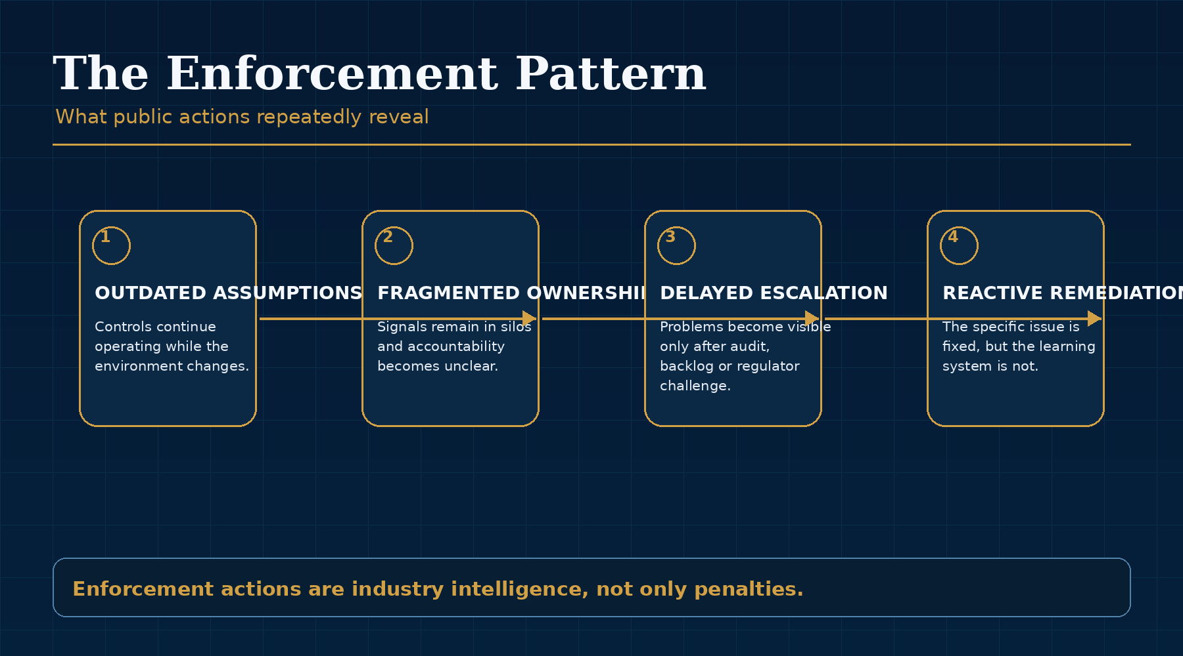
Figure 2.1: The Evidence Has Been There All Along - key framework.

Enforcement as Industry Intelligence
Consent orders, examination findings and public enforcement notices are among the richest sources of industry intelligence available to compliance leaders. They reveal not only what regulators considered deficient, but how supervisory expectations are evolving. Yet many organisations consume these actions defensively. They ask whether the same issue exists in their own programme, complete a gap assessment and implement a tactical enhancement. That is necessary, but it is not sufficient.
An enforcement action should be read as more than a story about another institution. It should be treated as a data point in a broader pattern. The names, products and jurisdictions vary, but the recurring themes are strikingly consistent. Regulators do not simply object to isolated procedural mistakes. They regularly identify governance systems that failed to recognise that the environment had changed around the controls.
This is why enforcement actions are particularly useful for adaptive compliance. They show where real institutions lost alignment between controls, assumptions and reality. They also show how long a weakness can persist when governance is periodic, fragmented or overly focused on operational metrics.

The Recurring Pattern
Across major public actions, the pattern is rarely that a financial institution had no controls at all. More often, controls existed but were not governed with sufficient curiosity. Transaction monitoring scenarios remained unchanged despite shifts in customer behaviour. Customer risk methodologies failed to reflect new markets, new products or new channels. Data limitations were known but tolerated. Backlogs signalled operational strain, but not necessarily the deeper issue of control effectiveness. Governance committees received extensive information without a clear view of whether underlying assumptions remained valid.
The TD Bank resolution in 2024 drew particular attention to sustained weaknesses in transaction monitoring governance and coverage. The broader lesson for the industry was not only about one institution. It was that monitoring programmes can continue to operate while material categories of activity, scenario logic or assumptions remain insufficiently challenged over time. Similar lessons can be drawn from public actions involving institutions in Europe and Australia, where regulators repeatedly pointed to delayed remediation, inadequate monitoring, poor customer understanding or failure to escalate known problems quickly enough.
The facts differ, but the governance lesson is consistent: controls rarely fail in isolation. The more important failure is the absence of a mechanism capable of recognising that the design no longer matches the risk.

Regulatory Expectations Are Moving Toward Outcomes
This pattern aligns with the direction of global standard setters. FATF's methodology explicitly assesses both technical compliance and effectiveness. The Wolfsberg Group has similarly argued that true financial crime risk management is not only about complying with laws and regulations, but about delivering useful outcomes, supporting government priorities and establishing reasonable, risk-based controls. The direction of travel is clear: institutions must demonstrate that controls work in practice, not merely that controls exist in policy.
That shift matters because it changes the burden on governance. A programme cannot simply point to the existence of a model, a validation report or a committee structure. It must be able to explain why a control exists, what assumptions support it, how those assumptions are monitored, what changed during the period and how governance responded. Evidence of effectiveness becomes dynamic rather than static.
This does not mean regulators expect perfection. Financial crime is too complex and too adversarial for that. What regulators increasingly expect is evidence that institutions understand their risks, test their controls and learn from new information before weaknesses become systemic.

From Remediation to Learning
Traditional remediation asks how to fix the finding. Adaptive remediation asks what the weakness reveals about the organisation's broader ability to learn. If a regulator identifies an outdated scenario, the answer should not end with updating that scenario. The more important question is why change was not detected earlier, which signals were missed, whether similar assumptions exist elsewhere and how governance should be redesigned to identify the next change before an external party does.
This changes the value of enforcement analysis. The goal is not merely to avoid being the next institution named in a public action. The goal is to use the public record as a collective learning system. Enforcement actions show where the industry has struggled to convert information into timely governance. Adaptive organisations use those lessons to strengthen their own capacity to identify change early.
The evidence has been there all along. The question is whether the industry has been reading it as a checklist or as a map.
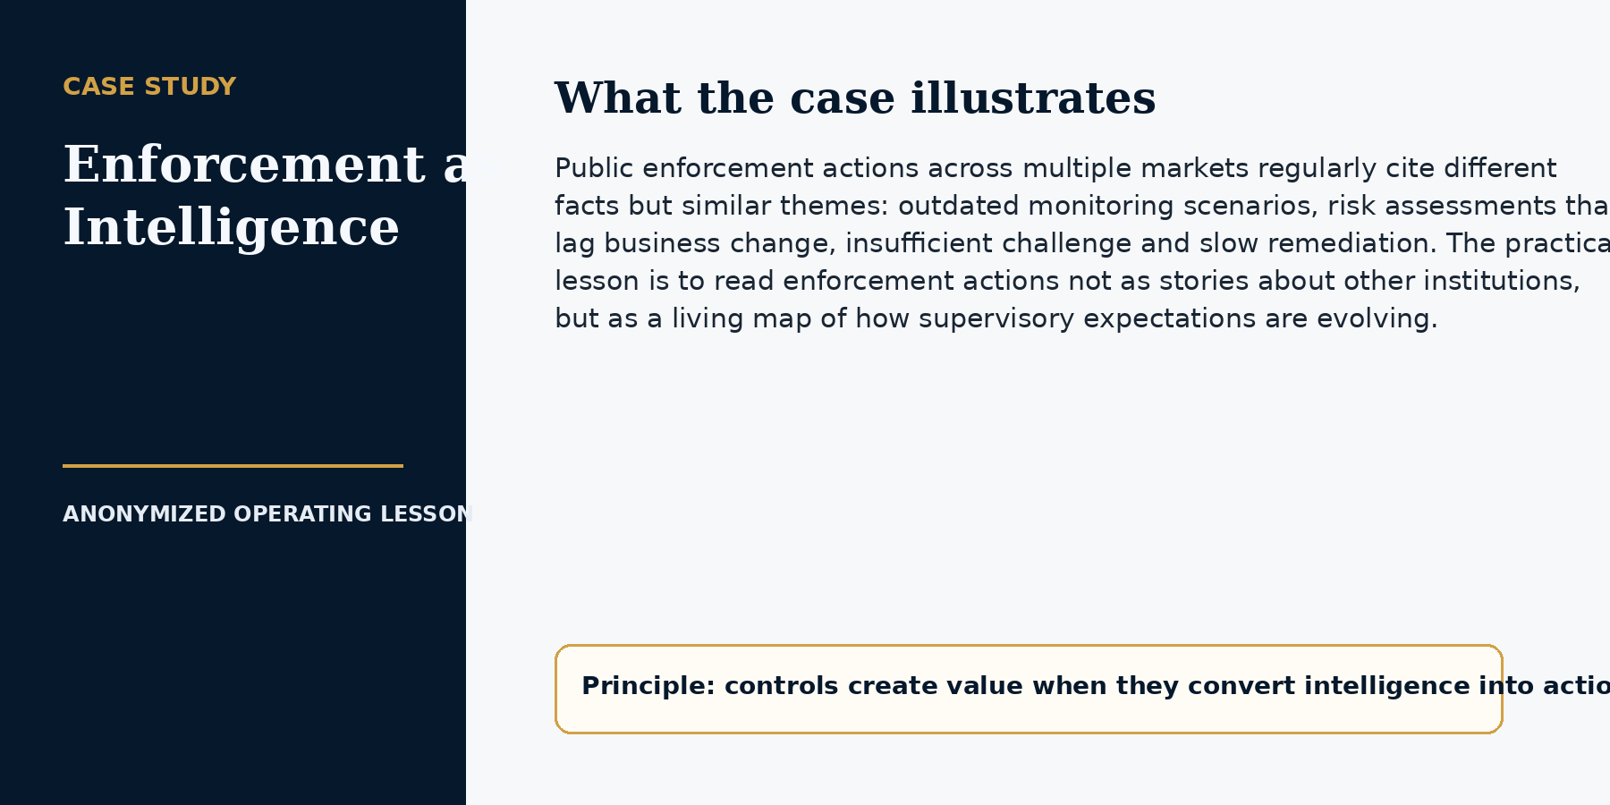

CHAPTER 2 IMPLEMENTATION PLAYBOOK

From Principle to Practice
Adaptive compliance requires a disciplined way to learn from the public record. Enforcement actions, supervisory speeches, advisories and thematic reviews should not be consumed as news. They should enter a repeatable regulatory intelligence process that converts external events into internal decisions.
The objective is not to remediate every headline. It is to identify recurring failure patterns, assess their relevance to the institution, map them to controls and produce evidence that the resulting action was completed and sustained.
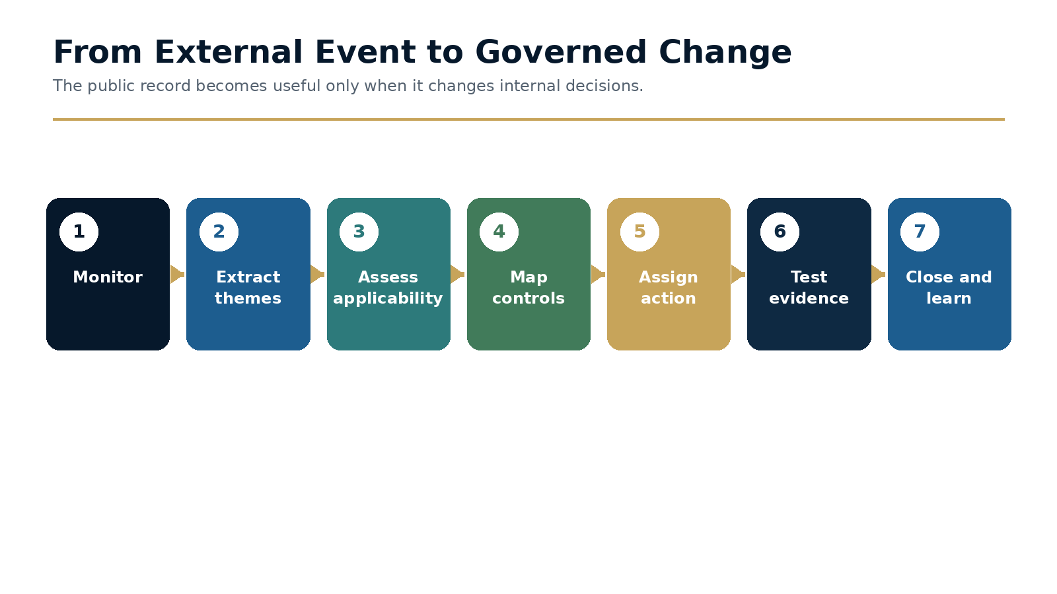
Figure 2.2 · From External Event to Governed Change

Step 1: Create a regulatory intelligence intake
The intake log should record the source, date, jurisdiction, business model, products involved, finding themes, root causes, customer or market relevance and the initial owner. A small central team can curate the information, but interpretation should involve legal, regulatory, product, operations and data specialists.
The value of the log emerges over time. When findings are coded consistently, the organization can see recurring themes such as weak data lineage, ineffective escalation, outdated risk assessments or delayed remediation rather than treating each action as unique.

Step 2: Separate applicability from severity
A severe enforcement action may have limited direct relevance to the institution; a modest action may expose a control weakness that is highly applicable. The assessment should therefore score both dimensions. It should also consider indirect applicability: the institution may not offer the same product, but may rely on the same data architecture, governance model or third party.
The conclusion should be recorded, approved and revisited if the theme recurs. A decision that no action is required is still a governance decision and should be supported by evidence.

Step 3: Close the loop with sustainable evidence
Remediation should not close when a policy is updated or a project milestone is marked complete. Closure evidence should show that the control was implemented, users were trained, data and systems changed where necessary, the control operates as intended and the underlying root cause is unlikely to recur.
Independent testing is particularly important where the lesson relates to governance weakness. The same management team that designed the response should not be the only source of assurance that the problem is solved.

Working Template
Root-cause category | Typical symptom | Appropriate response
Design gap | The control never addressed the relevant risk. | Redesign the framework or introduce a new control.
Execution gap | The control is sound but inconsistently performed. | Clarify procedure, capacity, training and quality assurance.
Data gap | Required information is missing, late or unreliable. | Fix lineage, validation, ownership and compensating controls.
Governance gap | Warning signals existed but did not trigger action. | Change thresholds, escalation rights, forum cadence or accountability.
Change-management gap | Business or regulatory change was not translated into controls. | Create formal impact assessment and implementation tracking.
Sustainability gap | Remediation was completed but not embedded. | Test outcomes, repeat performance and ownership after closure.

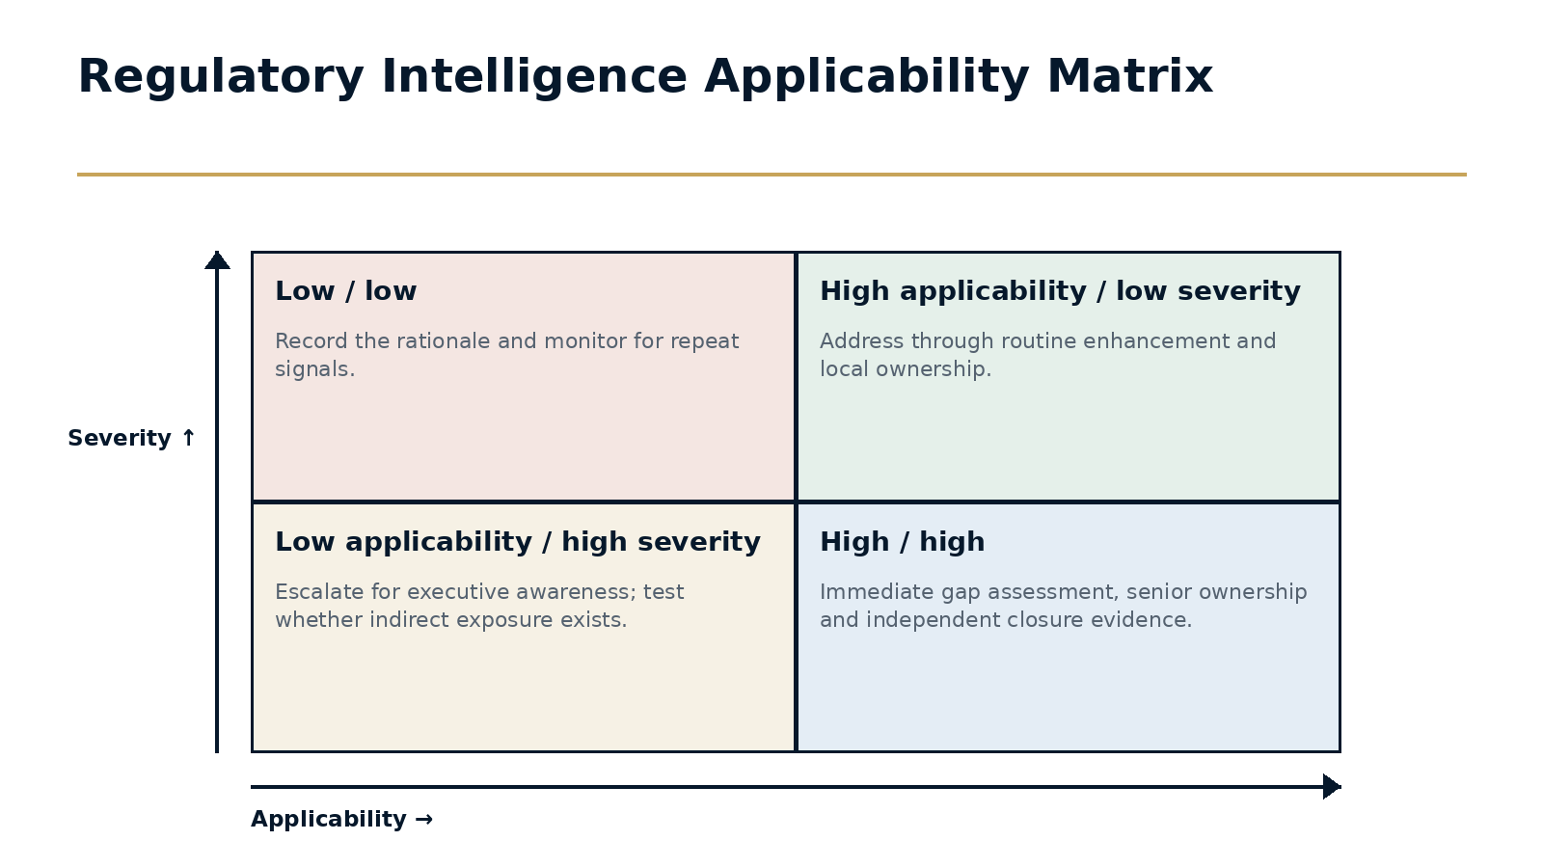
Figure 2.3 · Regulatory Intelligence Applicability Matrix

Decision Framework
Assessment question | Evidence to review | Output
Is the business model comparable? | Products, customers, channels and geography. | Direct, indirect or low applicability.
Could the same root cause exist here? | Data architecture, ownership, governance and third parties. | Control-map and gap hypothesis.
What is the potential consequence? | Regulatory, customer, financial and systemic impact. | Severity rating and escalation level.
What would prove the issue is absent or controlled? | Testing, metrics, documentation and expert challenge. | Evidence plan and accountable owner.

Executive Case Study
Turning enforcement into internal governance
A public enforcement action described static transaction-monitoring scenarios, weak escalation and delayed remediation. The institution reviewing the action did not have the same products or jurisdictional exposure, and an initial legal assessment concluded that the facts were not directly comparable.

Implementation
Instead of ending the review, the regulatory intelligence team coded the underlying themes. It identified three questions with broader relevance: whether scenario coverage changed with product growth, whether committee thresholds forced timely escalation, and whether remediation closure required evidence of sustained performance.

Governance
Those themes were mapped to the institution's own monitoring governance. The review found no equivalent misconduct, but it identified an escalation threshold that relied too heavily on backlog size and did not capture deteriorating model performance. The threshold was revised, a model-health indicator was added and the closure standard for material issues was strengthened.

Outcome and lesson
The case illustrates the purpose of regulatory intelligence. The institution did not copy another firm's remediation plan. It translated the root cause into its own operating context and used the public record to challenge assumptions before an examiner did.

Common Failure Modes
- Reviewing only the penalty and headline facts.
- Launching broad remediation without testing applicability.
- Using different root-cause language in every assessment.
- Closing actions on documentation rather than demonstrated operation.
- Failing to track repeated themes across regulators and markets.

A Practical 30 / 60 / 90-Day Plan
Period | Actions and evidence
First 30 days | Create the intake log and taxonomy; identify accountable owners; review the last twelve months of relevant public actions; select three recurring themes.
Days 31-60 | Complete applicability assessments; map high-priority themes to controls; define evidence standards; establish a monthly regulatory intelligence forum.
Days 61-90 | Implement the first control enhancements; independently test one closure; add recurrence and action-aging measures to executive reporting; publish lessons learned to product and regional teams.

Implementation checkpoint
At the end of the first ninety days, leadership should be able to point to at least one changed decision, one implemented control or governance improvement, and evidence that the result was tested. Activity alone is not proof of adaptation.

Executive Reflection
Regulators have repeatedly shown that the greatest weaknesses do not arise because institutions lack controls. They arise because controls, assumptions and governance fail to evolve together. Enforcement actions should therefore be read not simply as warnings, but as a collective blueprint for building organisations that adapt before external intervention becomes necessary.

Questions for Leaders
• When your organization reviews enforcement actions, does it identify only control gaps or also governance failure patterns?
• Which public regulatory findings have changed your internal assumptions in the last year?
• How would your board know whether remediation improved learning rather than simply closed an issue?
• What evidence proves your monitoring programme remains effective in practice rather than present in policy?

CHAPTER 3

Every Model Begins Drifting on Day One
Drift is not an exception. It is the natural consequence of operating in a changing world.

Opening illustration for Chapter 3: Every Model Begins Drifting on Day One.
EXECUTIVE INSIGHT
Every model is built from assumptions about data, behaviour and risk. Those assumptions begin ageing the moment the model enters production. Customer populations change, products evolve, economic conditions shift and criminal methodologies adapt. The question is not whether drift will occur. It is whether the organisation will recognise and govern it before performance materially deteriorates.

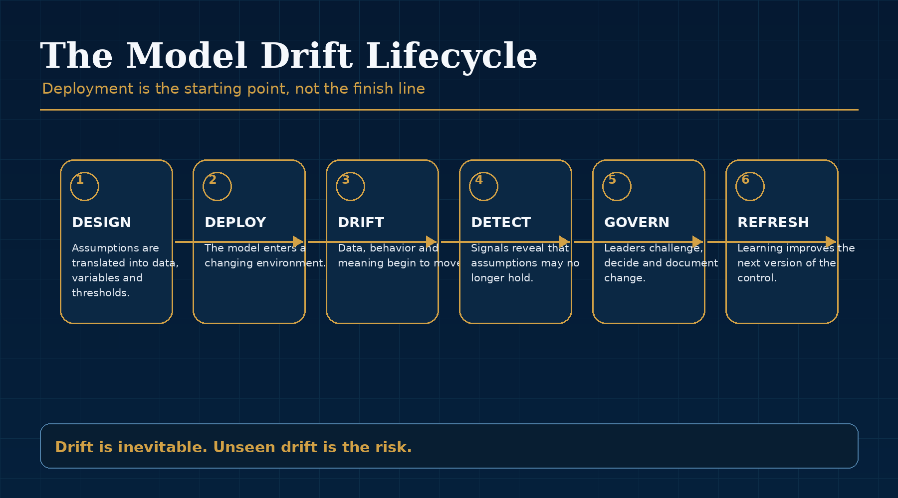
Figure 3.1: Every Model Begins Drifting on Day One - key framework.

Models Are Structured Assumptions
Models often appear objective because they produce scores, classifications and thresholds. Yet every output reflects choices: which data was included, which period was considered representative, how outcomes were labelled, how exceptions were treated and what trade-offs were accepted between sensitivity and precision. A model is therefore not a permanent truth. It is a structured view of the world at a particular moment.
That view may be highly accurate when the model is developed. It may be validated carefully, approved through governance and monitored against accepted performance measures. None of that prevents the environment from changing after deployment. The customer base evolves. Products are modified. Payment corridors shift. Criminal methodologies adapt. Data quality improves or deteriorates. Investigator decisions introduce new feedback. The model continues to operate, but the world it describes begins to move.
This is why deployment should never be treated as the finish line. It is the beginning of the model's governance life.

Data Drift and Concept Drift
Data drift occurs when the characteristics of inputs change. Customers may use products differently, transaction values may shift, new corridors may become significant or a once-small customer segment may become material. The model sees different data from the data on which it was trained or calibrated.
Concept drift is deeper. It occurs when the relationship between behaviour and risk changes. A pattern that once indicated suspicious activity may become common and legitimate as products evolve. Conversely, a new criminal typology may not resemble the historical examples on which the model learned. The model may continue to perform against historical definitions while becoming less effective against current risk.
Both forms of drift matter, but concept drift is particularly important in financial crime because the problem is adversarial. Criminals are not passive variables. They respond to detection, learn from controls and deliberately search for patterns that existing models do not recognise.

Why Periodic Validation Is No Longer Enough
Periodic validation remains essential. It provides independent challenge, documentation and assurance that a model was developed and implemented appropriately. However, it provides a point-in-time assessment. In fast-moving environments, a model can deteriorate substantially between scheduled reviews. Annual validation can confirm that a model was reasonable at the time of testing while offering limited assurance about the months that follow.
The issue is not whether validation is valuable. It is whether validation alone is sufficient. If a product launch materially changes customer behaviour in March, a validation scheduled for December may arrive too late. If geopolitical developments alter sanctions or payment corridors overnight, a quarterly committee cycle may not be fast enough. If investigators begin observing new typologies, those insights must influence governance before they become a theme in next year's review.
The pace of governance must match the pace of change. When it does not, drift becomes invisible until performance, audit or regulation exposes it.

Govern the Environment, Not Only the Model
Continuous model governance expands attention beyond statistical performance. It monitors changes in customers, products, markets, typologies, data quality, investigator outcomes and external intelligence. These signals provide context for understanding why performance changes and whether intervention is required.
This broader view is important because a model can appear statistically stable while the underlying risk environment becomes less familiar. Performance metrics may not immediately show the effect of a newly emerging typology if that typology is not yet labelled or visible in historical outcomes. A governance process that waits for performance to decline may therefore lag behind the risk it is supposed to manage.
Adaptive governance treats drift as information. It asks what the drift reveals about the institution, its customers and the threat environment. The objective is not to eliminate change. The objective is to make change visible, interpretable and governable.
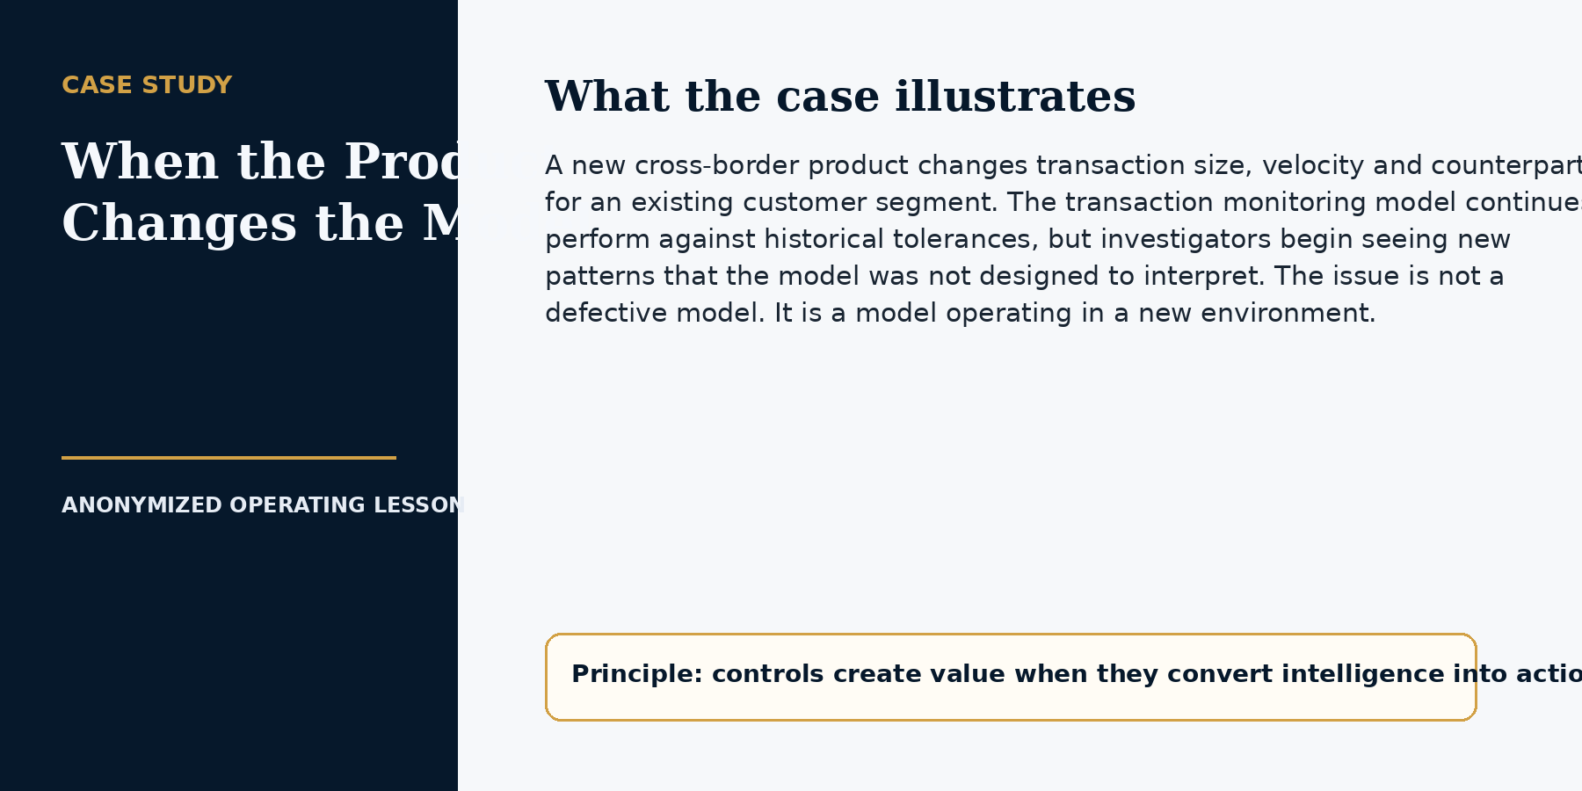

CHAPTER 3 IMPLEMENTATION PLAYBOOK

From Principle to Practice
The practical implication of drift is that deployment must be treated as the beginning of governance, not the end of development. A model owner needs a defined set of indicators, a cadence for interpretation, thresholds for escalation and authority to change or retire the model when its assumptions no longer hold.
The aim is not to create one universal threshold. Models differ in purpose, risk and data. The aim is to create a disciplined process for determining which changes matter and what decision they should trigger.
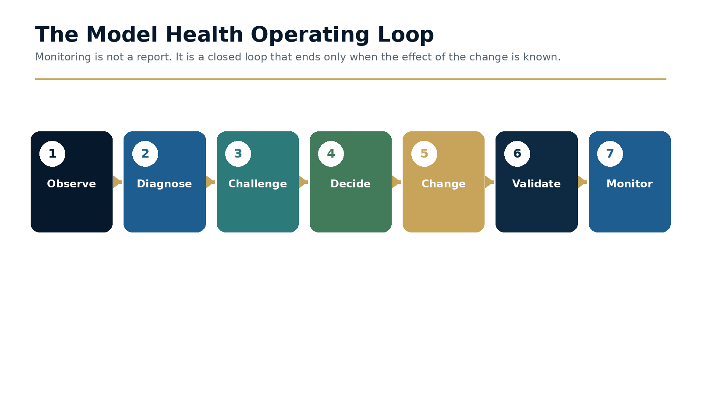
Figure 3.2 · The Model Health Operating Loop

Define the forms of drift you are prepared to detect
Data drift occurs when the distribution, completeness or quality of inputs changes. Population drift occurs when the customers, products, corridors or transaction patterns using the model differ from the original population. Concept drift occurs when the relationship between behavior and risk changes. Performance drift occurs when outcomes deteriorate, even if the reason is not yet known. Operational drift occurs when queues, overrides, investigation practice or downstream capacity alter how model outputs are used.
A monitoring plan should cover each category. Otherwise, the organization may observe stable model scores while the inputs, customers or investigation process have changed materially.

Design thresholds as decision triggers
A threshold is useful only when the required response is defined. Warning thresholds may trigger diagnostic analysis. Escalation thresholds may require a formal performance review, temporary compensating control, approval of continued use or restriction of the model. Material thresholds may require suspension, rollback or independent validation.
Thresholds should be calibrated to the model's risk and consequence. They should combine quantitative indicators with expert judgment and contextual events such as a product launch, sanctions change or major shift in customer behavior.

Govern model change according to consequence
Not every adjustment requires the same approval. A change taxonomy should distinguish routine maintenance, threshold tuning, feature or data changes, methodology changes and emergency interventions. Each class should define documentation, testing, approval, validation and post-implementation monitoring.
Emergency change must be possible when risk is material, but urgency should not remove traceability. The decision, evidence, temporary controls and required retrospective review should be recorded.

Working Template
Monitoring domain | Examples | Decision supported
Data quality | Missing fields, latency, distribution shift, lineage breaks. | Investigate upstream change or apply compensating control.
Population | Customer mix, geography, product use, value bands, corridor migration. | Re-segment, recalibrate or reassess applicability.
Performance | Detection yield, precision proxies, case outcomes, overrides. | Tune, retrain, redesign or validate.
Operations | Queue age, analyst behavior, quality scores, disposition changes. | Adjust capacity, procedure, training or workflow.
External context | Typologies, sanctions, product releases, economic events. | Challenge features and coverage before metrics deteriorate.

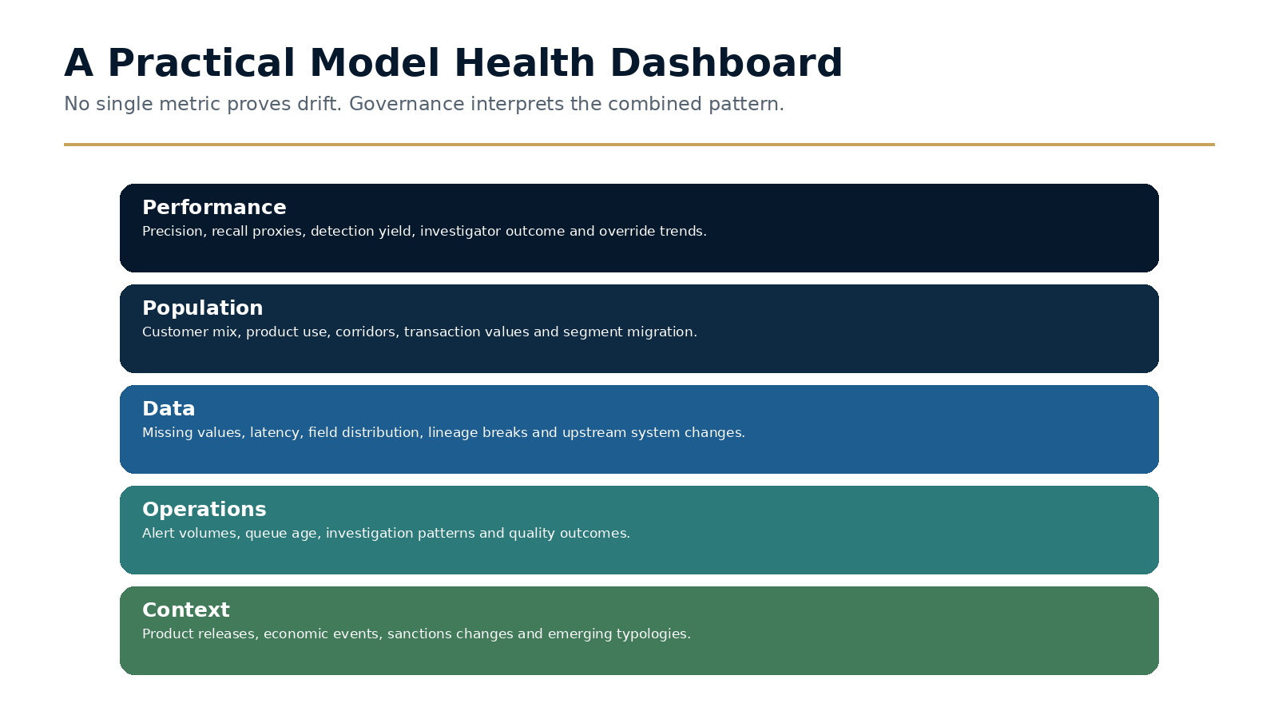
Figure 3.3 · A Practical Model Health Dashboard

Decision Framework
Change class | Examples | Minimum governance
Routine maintenance | Bug fix, non-material display or workflow correction. | Owner approval, testing and release record.
Tuning | Threshold or parameter adjustment within approved methodology. | Outcome analysis, Compliance approval and monitored deployment.
Material model change | Features, data source, segmentation or methodology. | Formal change paper, testing, validation and committee approval.
Emergency intervention | Temporary restriction, rollback or compensating rule. | Senior approval, documented rationale, time limit and retrospective review.
Retirement | Model no longer effective or required. | Coverage assessment, replacement or residual-risk approval.

Executive Case Study
A model that remained green while the business changed
A transaction-monitoring model remained within its historical performance tolerances. Alert rates and investigator outcomes were stable, and the periodic validation had not identified a material weakness. During the same period, the business launched a new product and attracted a different customer population.

Implementation
The model-health review added population and product indicators rather than relying on aggregate alert performance. It revealed that the new customers were underrepresented in the original development data and that a growing payment corridor produced behavior outside the model's historical range.

Governance
The organization introduced segment-level monitoring, temporary rules for the new corridor and a formal change assessment. A revised model was tested against both historical outcomes and targeted cases from the new product. Governance approved a staged deployment with explicit post-launch thresholds.

Outcome and lesson
The lesson is that model performance can look stable when the population has changed underneath it. Model risk management must monitor the environment the model describes, not only the outputs the model produces.

Common Failure Modes
- Monitoring only aggregate performance and missing segment deterioration.
- Using thresholds without defined actions or accountable owners.
- Treating annual validation as a substitute for ongoing monitoring.
- Allowing emergency changes to remain indefinitely.
- Ignoring operational drift in analyst decisions and downstream capacity.

A Practical 30 / 60 / 90-Day Plan
Period | Actions and evidence
First 30 days | Inventory models and decision owners; classify risk and consequence; define the minimum monitoring domains; identify critical data and population indicators.
Days 31-60 | Set warning and escalation triggers; establish the model-health forum; define change classes and emergency authority; pilot the dashboard on one high-risk model.
Days 61-90 | Complete the first diagnostic review; implement one controlled change; independently test monitoring data; report model health and open decisions to senior governance.

Implementation checkpoint
At the end of the first ninety days, leadership should be able to point to at least one changed decision, one implemented control or governance improvement, and evidence that the result was tested. Activity alone is not proof of adaptation.

Executive Reflection
A model does not become unreliable because it drifts. It becomes dangerous when drift remains unnoticed or unexplained. The strongest institutions will be those that treat every model as a living capability, continuously observed, challenged and improved as the world around it changes.

Questions for Leaders
• Which model assumptions are explicitly monitored after deployment?
• How quickly would your organization detect a change in customer behaviour that invalidates a threshold?
• What evidence from investigators, fraud teams or product teams is incorporated into model governance?
• Does validation answer whether the model was built correctly, or whether it remains the right model for today?

CHAPTER 4

The Adaptive Compliance Maturity Model
Compliance maturity is best measured by how effectively an organisation learns and adapts.
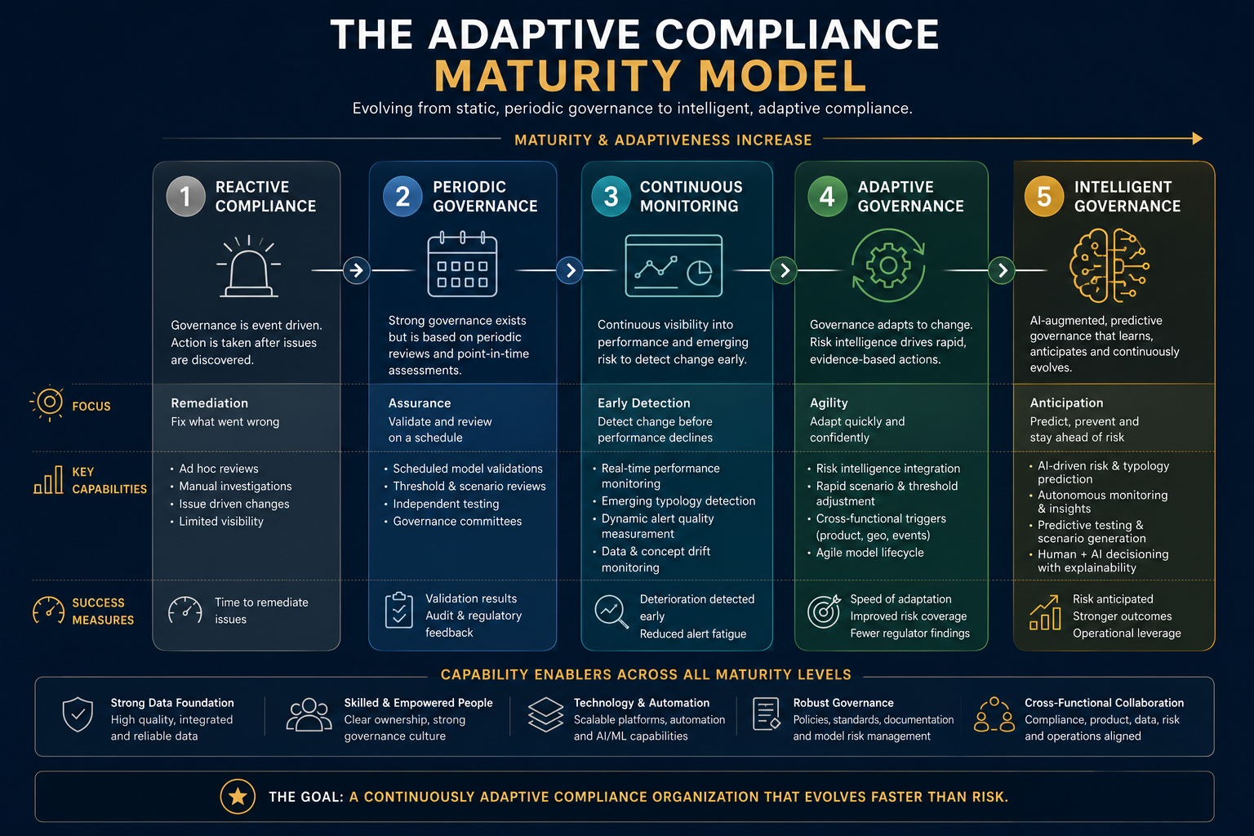
Opening illustration for Chapter 4: The Adaptive Compliance Maturity Model.
EXECUTIVE INSIGHT
Compliance maturity has traditionally been associated with scale, documentation and technological sophistication. Adaptive compliance requires a different lens. The most mature institutions are not simply those with the largest teams or most advanced platforms. They are the organisations that convert new information into better decisions faster than risk evolves.

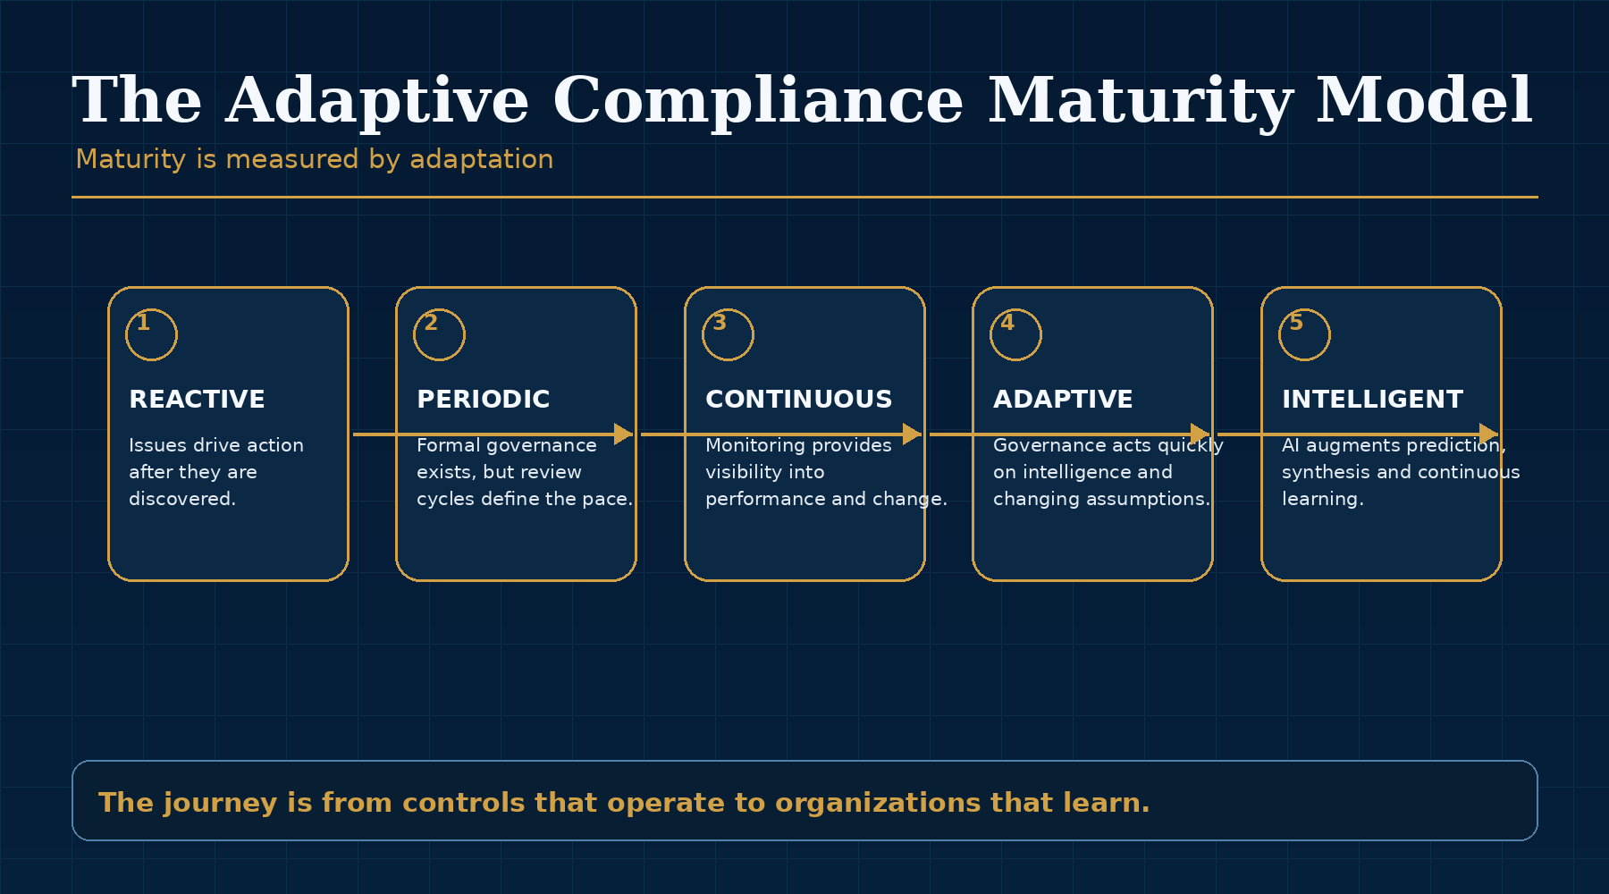
Figure 4.1: The Adaptive Compliance Maturity Model - key framework.

Rethinking Maturity
Traditional maturity models often describe a journey from manual processes to automation. That journey matters, but it is incomplete. An institution can automate a static process without becoming more adaptive. It can implement machine learning without connecting the outputs to stronger governance. It can maintain extensive documentation without proving that its controls respond to changing risk.
An adaptive maturity model asks a different question: how effectively does the organisation convert new information into better decisions? Viewed through this lens, maturity becomes less about the sophistication of technology and more about the strength of organisational learning.
The model described below is not intended to rank institutions for its own sake. It is intended to help leaders identify where governance is strong, where it remains periodic and what capabilities are required to move toward continuous adaptation.

Five Stages of Adaptive Maturity
The first stage is Reactive Compliance. Organisations respond to regulatory findings, operational incidents or external events after they have already occurred. Governance is largely retrospective, and improvements are typically driven by remediation. Many institutions have operated at this stage during periods of rapid growth, acquisition or regulatory change.
The second stage is Periodic Governance. Controls become more structured, validation processes are formalised and regular governance forums are established. This is a meaningful improvement. However, the pace of oversight remains defined by predetermined review cycles.
The third stage is Continuous Monitoring. Operational intelligence becomes more dynamic. Model performance, customer behaviour, emerging typologies and external intelligence are monitored more consistently, giving governance a current view of changing risk. The fourth stage is Adaptive Governance. Organisations do not merely observe change; they act on it systematically through evidence-based decision-making, clear ownership and rapid control adjustment. The fifth stage is Intelligent Governance, where AI augments awareness and synthesis while human leaders retain accountability for judgment and decisions.

Maturity Is Measured by Adaptation
The most important implication of the model is that maturity should not be understood as a destination. Financial crime continues to evolve. Technology continues to evolve. Regulation continues to evolve. Consequently, organisational maturity must evolve as well.
The most advanced compliance functions will not be those that possess the largest technology budgets or the most sophisticated models. They will be those capable of continuously reassessing their understanding of risk and adjusting governance accordingly. Adaptation itself becomes the measure of maturity.
This is also why no maturity level can be sustained through technology alone. Technology supports the journey, but leadership, culture, governance, data quality and decision rights determine whether the organisation actually becomes more adaptive.

Using the Model
The maturity model should be used as a practical diagnostic. Where does information move slowly? Where does governance rely too heavily on calendar cycles? Which controls depend on assumptions that are not being continuously tested? Where does intelligence remain trapped in functional teams? Which decisions require repeated escalation because decision rights are unclear?
These questions make the model useful for boards, executive teams and compliance leaders. It allows the organisation to discuss maturity in terms of capability rather than technology spend. It also provides a roadmap for investment: not simply more tools, but better information flows, clearer ownership, stronger model governance, more usable data and a culture that rewards challenge.
The objective is not to become fully autonomous. It is to become more capable of recognising change early, interpreting it intelligently and adapting with confidence.
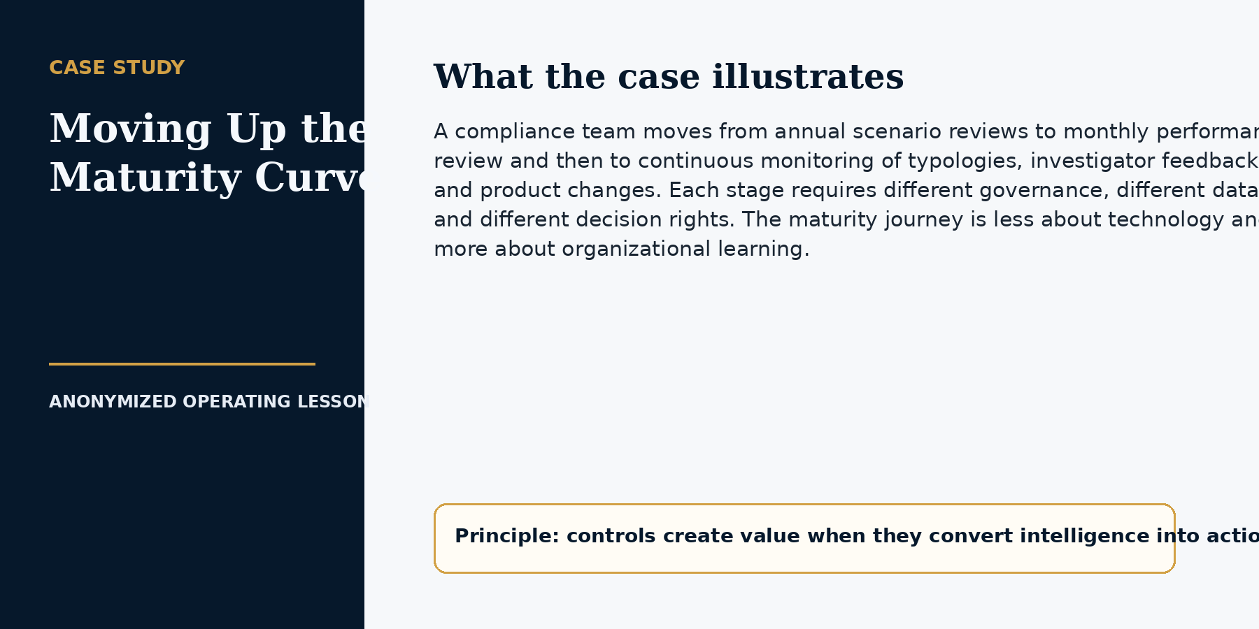

CHAPTER 4 IMPLEMENTATION PLAYBOOK

From Principle to Practice
A maturity model becomes useful only when it can distinguish aspiration from demonstrated capability. The assessment should therefore be evidence-based, scored by dimension and tied to a realistic target state. The objective is not to reach the highest level everywhere. It is to invest in the capabilities that matter most for the institution's risk, products and strategy.
The assessment is most effective when it is completed jointly by Compliance, Operations, Product, Technology, Data, regional leaders and independent assurance. Different views reveal where policy appears mature but execution or information flow remains weak.
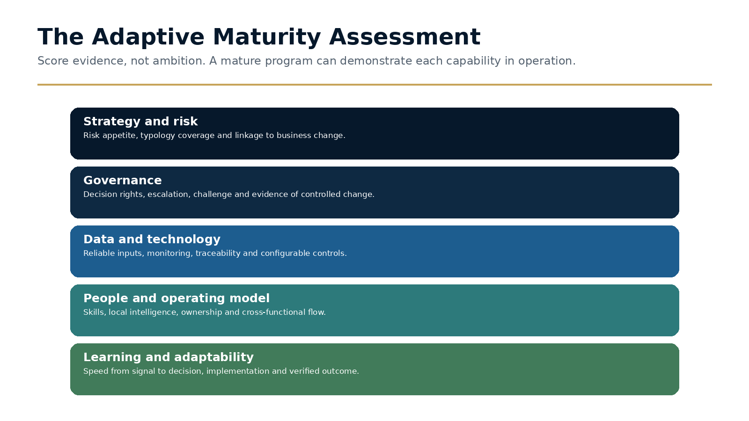
Figure 4.2 · The Adaptive Maturity Assessment

Assess five dimensions separately
Strategy and risk examines whether the program is linked to current business activity and material typologies. Governance examines decision rights, challenge, escalation and evidence of controlled change. Data and technology examine reliability, traceability and configurability. People and operating model examine ownership, skills and the flow between global and local teams. Learning and adaptability examine the speed with which signals become decisions and verified control changes.
A single overall score can hide important imbalances. An organization may have advanced technology but reactive governance, or strong policy and weak local intelligence. The heat map matters more than the average.

Score evidence, not documentation volume
Each score should be supported by observed evidence: meeting records showing decisions, dashboards that triggered action, completed change records, quality testing, examples of cross-market learning and proof that remediation remained effective. Policies are relevant, but they do not by themselves demonstrate maturity.
Assessors should record both the current score and the confidence in that score. Low-confidence ratings identify where additional testing or data is needed before investment decisions are made.

Select a target state and sequence investment
Not every capability needs to move to the highest level at once. The target should reflect risk severity, regulatory expectation, customer impact, strategic importance and implementation dependency. A model-health capability may need to mature before advanced AI is deployed. Local evidence pathways may need to be governed before a global customer platform can scale.
The roadmap should identify a small number of capabilities that can be improved within twelve months, with named outcomes and evidence. A broad maturity ambition without sequencing usually produces fragmented projects rather than an operating capability.

Working Template
Dimension | Level 1 evidence | Level 3 evidence | Level 5 evidence
Strategy and risk | Control response is incident-driven. | Risk and typology coverage reviewed on a defined cadence. | Risk intelligence shapes products and market decisions continuously.
Governance | Escalation depends on individuals. | Decision rights and thresholds are documented and used. | Governance anticipates change and tests assumptions proactively.
Data and technology | Manual reconciliation and limited lineage. | Reliable dashboards and controlled configuration. | Integrated intelligence, real-time monitoring and traceable automation.
People and operating model | Knowledge concentrated in individuals. | Clear global, regional and specialist ownership. | Networked expertise with rapid cross-market learning.
Learning and adaptability | Lessons remain in reports. | Issues and typologies produce controlled changes. | The organization measures and improves signal-to-action speed.

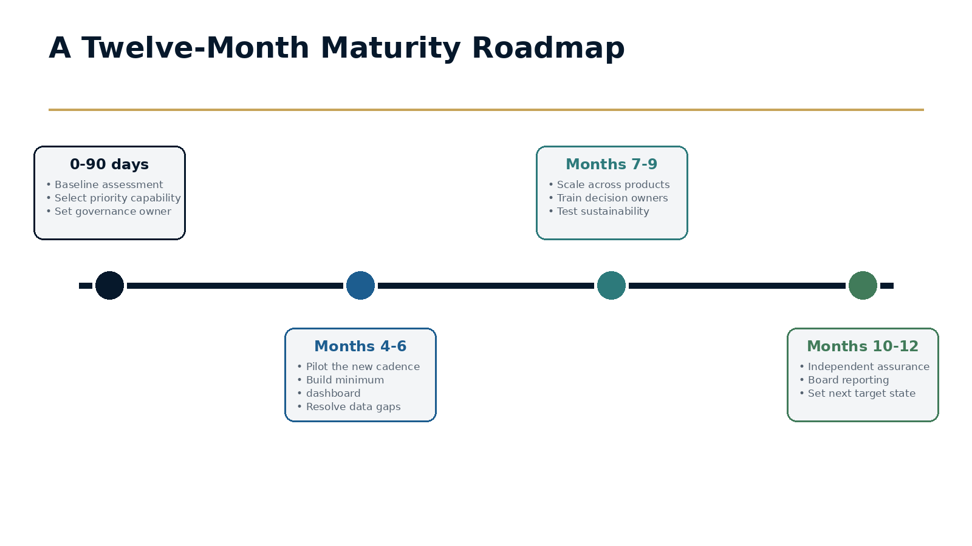
Figure 4.3 · A Twelve-Month Maturity Roadmap

Decision Framework
Prioritization factor | Question | Evidence
Risk severity | Which weakness could create the greatest customer or regulatory harm? | Risk assessment, incidents, findings and typology exposure.
Strategic dependency | Which capability is required for planned products or markets? | Roadmap, licences, partnerships and technology plans.
Customer impact | Where does weak design create avoidable friction or exclusion? | Abandonment, complaints, review and appeal data.
Implementation dependency | What foundation must exist before other work can succeed? | Data, ownership, system and governance prerequisites.
Feasibility | What can produce credible evidence within twelve months? | Resources, leadership sponsorship and change capacity.

Executive Case Study
Using maturity assessment to stop funding disconnected projects
A compliance function had several modernization initiatives: a new monitoring platform, an AI investigation pilot, updated KYC workflows and a global operating-model redesign. Each project had a business case, but there was no shared view of the capability the projects were intended to create.

Implementation
A cross-functional maturity assessment scored five dimensions and required evidence for each rating. The heat map showed that technology investment was moving faster than governance, data ownership and local implementation. The organization was at risk of deploying advanced tools into a program that could not monitor or challenge them effectively.

Governance
The roadmap was resequenced. Data ownership, change governance and model-health monitoring became the first six-month priorities. The AI pilot continued on a limited use case with stronger human review. The customer platform focused first on approved local evidence pathways and version control.

Outcome and lesson
The assessment did not reduce ambition. It made the ambition executable. The lesson is that maturity models create value when they help leaders decide what not to do yet.

Common Failure Modes
- Scoring maturity through self-assessment without evidence.
- Using a single average score that hides weak dimensions.
- Treating Level 5 as the correct target for every capability.
- Launching too many improvement projects at once.
- Failing to retest maturity after implementation.

A Practical 30 / 60 / 90-Day Plan
Period | Actions and evidence
First 30 days | Confirm dimensions and scoring evidence; select assessors; complete interviews and document review; identify low-confidence areas.
Days 31-60 | Validate scores through workshops; produce the heat map; select the target state for each dimension; identify dependencies and priority gaps.
Days 61-90 | Approve a twelve-month roadmap; define outcome evidence and owners; launch two priority capabilities; establish quarterly maturity review and independent challenge.

Implementation checkpoint
At the end of the first ninety days, leadership should be able to point to at least one changed decision, one implemented control or governance improvement, and evidence that the result was tested. Activity alone is not proof of adaptation.

Executive Reflection
The maturity journey is not a race toward autonomous compliance. It is a progression toward better organisational learning. The destination is an institution capable of recognising change early, interpreting it intelligently and adapting controls with confidence before risk overtakes governance.

Questions for Leaders
• At which maturity level does your organization operate today, and does that differ by function?
• Where does governance remain calendar-driven even though the risk changes continuously?
• Which signals would need to be connected to move from monitoring to adaptation?
• What cultural behaviours would have to change before intelligent governance could be trusted?

CHAPTER 5

AI Won't Replace Compliance. It Will Replace Static Governance
AI's greatest contribution is not automation. It is making continuous governance possible.
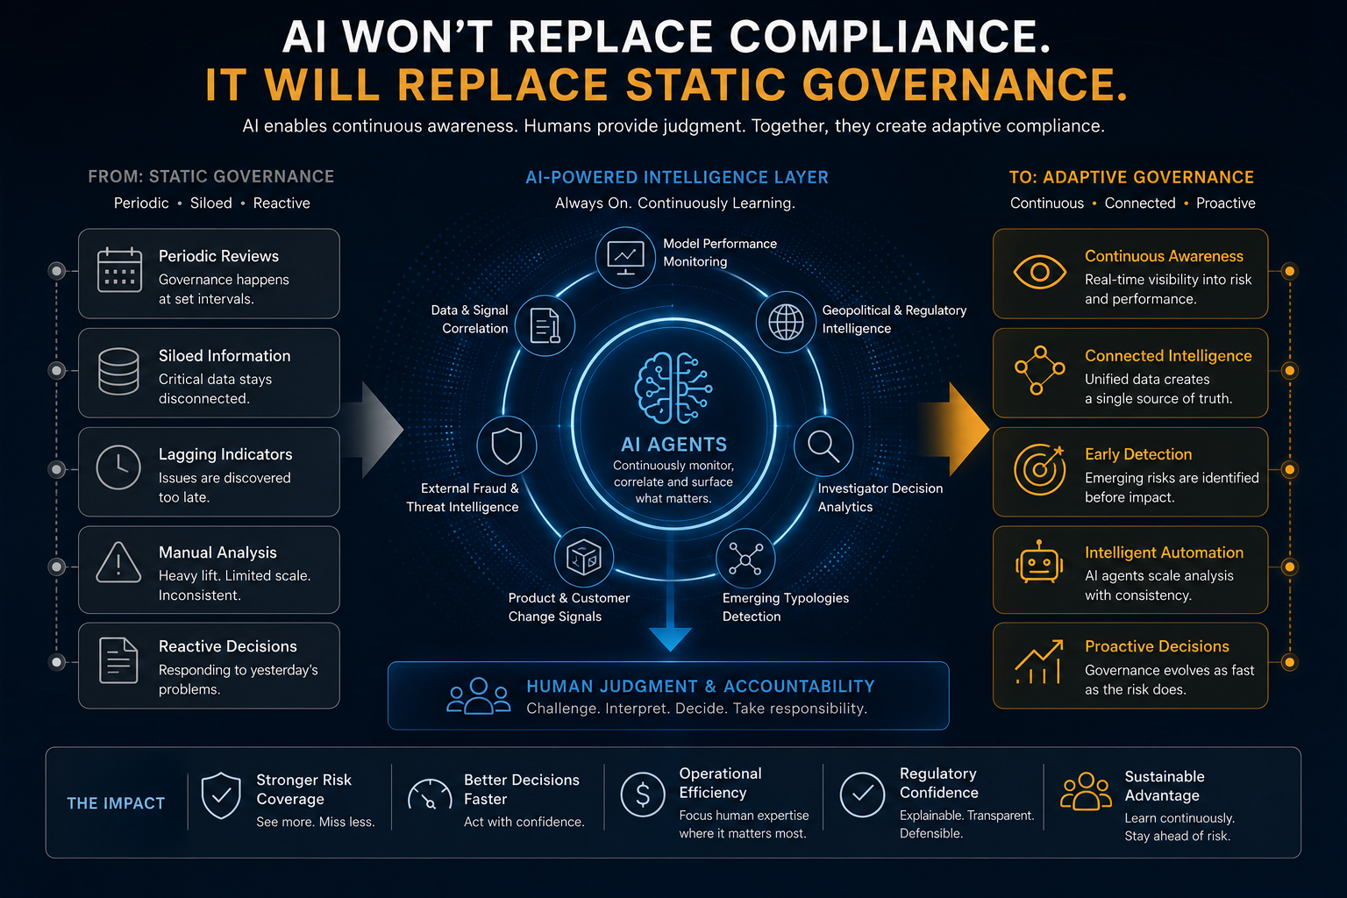
Opening illustration for Chapter 5: AI Won't Replace Compliance. It Will Replace Static Governance.
EXECUTIVE INSIGHT
Artificial intelligence is often described as the next revolution in financial crime compliance. The discussion usually focuses on faster investigations, lower costs and improved productivity. These outcomes are valuable, but they overlook AI's most significant contribution: the ability to observe changes in risk continuously rather than periodically. The transformation is not AI itself. It is the transition from static governance to adaptive governance.

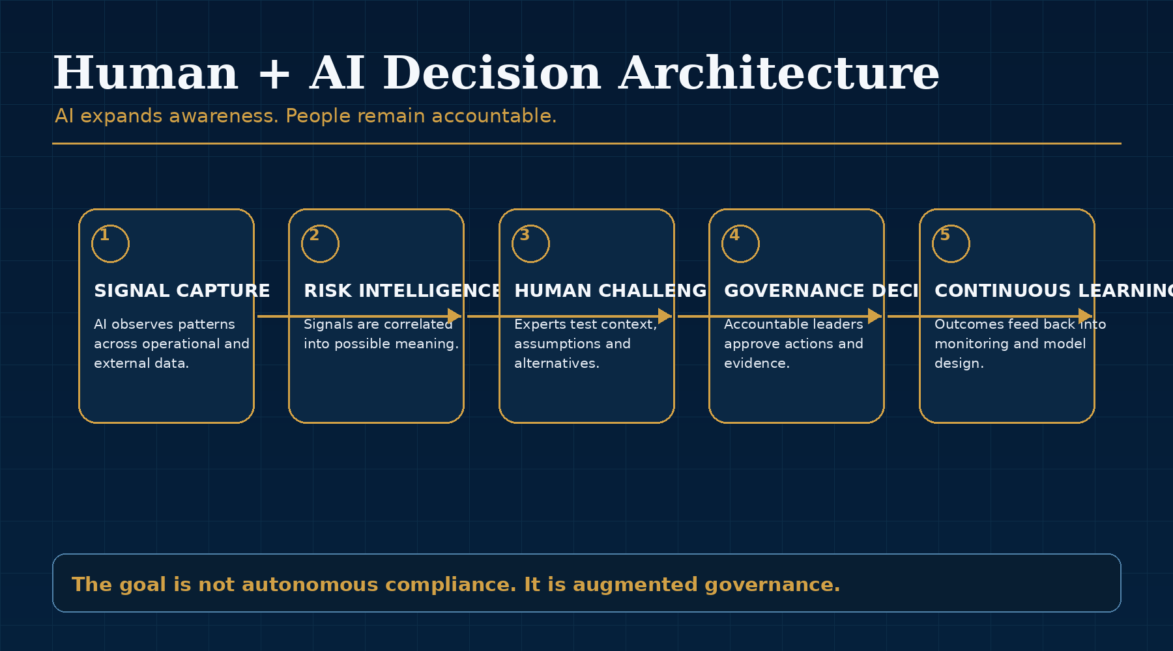
Figure 5.1: AI Won't Replace Compliance. It Will Replace Static Governance - key framework.

The Information Paradox
Financial institutions possess extraordinary volumes of information: transactions, investigator decisions, customer behaviour, fraud intelligence, sanctions alerts, regulatory updates and model statistics. The difficulty is not obtaining information. It is connecting that information quickly enough that governance reflects a complete and current understanding of risk.
In many institutions, each function analyses its own data and reports through its own governance rhythm. Fraud sees one pattern. Sanctions sees another. Product teams understand how customers adopt new services. Investigators notice emerging behaviours. Data science monitors model performance. Legal and regulatory affairs follow supervisory expectations. The challenge is that the most important risks often sit at the intersection of those perspectives.
AI is valuable because it can help connect weak signals across systems, functions and time horizons. It can surface relationships that humans may not have time to identify manually, not because humans lack expertise, but because the scale and fragmentation of the information environment have outgrown periodic review.

From Automation to Organisational Awareness
Drafting narratives, summarising guidance and reducing false positives are useful applications, but they improve the existing operating model incrementally. The deeper opportunity is the ability to identify relationships that would otherwise remain invisible. A gradual change in payment behaviour may correspond with a new fraud trend. An emerging typology may resemble dismissed cases from another market. A regulatory statement in one jurisdiction may have implications for global product design.
Human organisations struggle to recognise these connections consistently because they emerge across multiple systems and because the relevant information is often owned by different teams. AI does not eliminate complexity. It allows organisations to see complexity more clearly.
This is why AI should be framed as an intelligence layer rather than an automation layer. Automation performs tasks. Intelligence changes what governance is able to know.

The Emergence of Continuous Governance
Governance has traditionally operated through monthly committees, annual validations and periodic risk assessments. This cadence reflected the effort required to gather and analyse information. AI changes that assumption. Models can continuously monitor behaviour, performance, investigator decisions and emerging typologies, allowing governance to respond while change is occurring rather than after it has become established.
This does not mean every decision should be made in real time. Financial crime compliance remains accountable, documented and risk-based. But it does mean that the evidence informing decisions can be continuously refreshed. Governance forums can spend less time assembling information and more time interpreting what changed, what it means and what should happen next.
The future governance committee will not be defined by a larger report pack. It will be defined by better questions, richer evidence and earlier visibility into changing assumptions.

Intelligence Requires Judgment
Financial crime compliance remains an exercise in judgment. Determining whether behaviour represents innovation or suspicious activity, balancing regulatory expectations and setting risk appetite require human context and accountability. AI expands awareness; human leaders interpret; governance challenges; boards remain accountable.
This is why the most credible future is not autonomous compliance. Autonomous decision-making may have narrow applications, but the central challenge is not simply deciding faster. It is deciding with better context, clearer evidence and stronger accountability. The more powerful analytical tools become, the more important governance becomes.
Technology does not replace responsibility. It expands awareness. The future belongs not to organisations that automate the fastest, but to those that learn the fastest.
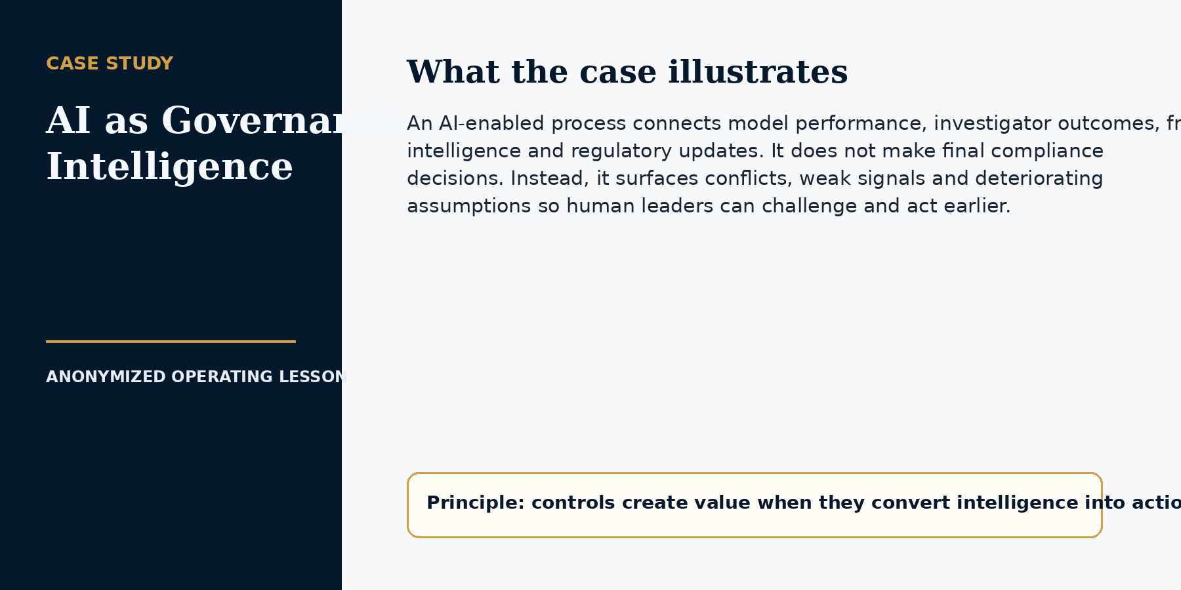

CHAPTER 5 IMPLEMENTATION PLAYBOOK

From Principle to Practice
The practical question is not whether an organization uses AI. It is what authority the AI has, what evidence supports that authority and how the organization knows when the capability is wrong. Governance should scale with autonomy, consequence, data sensitivity and the difficulty of reversing the outcome.
A low-risk assistant that summarizes a case requires different controls from a system that recommends account restriction or executes a regulatory action. Treating all AI as one category either creates unnecessary bureaucracy or leaves consequential use cases under-governed.
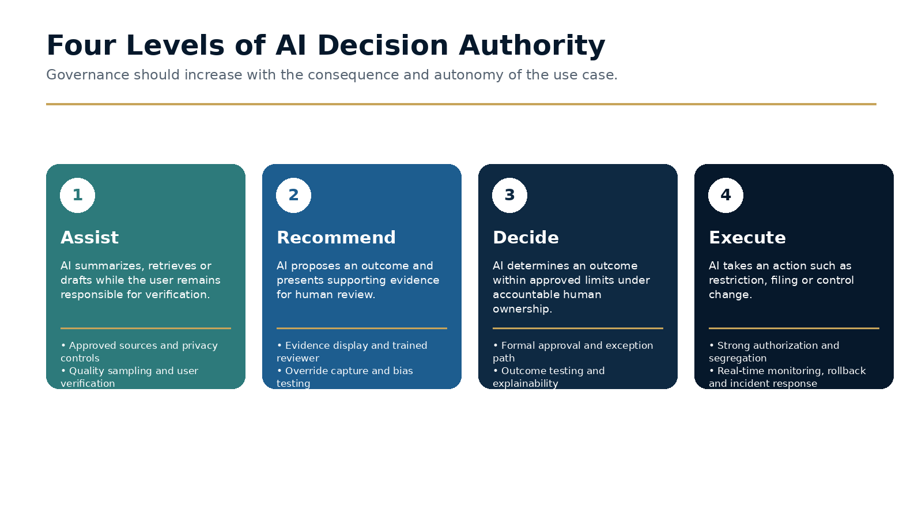
Figure 5.2 · Four Levels of AI Decision Authority

Classify the use case by authority and consequence
At the assist level, AI retrieves, summarizes or drafts while a user remains responsible for verification. At the recommend level, AI proposes an outcome and presents supporting evidence for human review. At the decide level, AI determines an outcome within defined limits, with accountable human ownership and exception rights. At the execute level, AI takes an action such as restricting activity, routing a filing or changing a control.
The classification should also consider customer impact, regulatory consequence, explainability, reversibility, volume, data sensitivity and whether errors could concentrate across a population.

Design human oversight as a control, not a slogan
Human-in-the-loop is meaningful only when the reviewer has time, information, competence and authority to disagree. The workflow should specify which evidence the reviewer sees, how disagreement is recorded, when secondary review is required and how override patterns are monitored.
If users accept recommendations automatically because of volume or interface design, the process is functionally automated even if a human clicks the final button. Governance should test actual behavior, not only the documented workflow.

Monitor quality, change and incidents continuously
Pre-deployment testing should cover accuracy, bias, hallucination, prompt manipulation, confidentiality, edge cases and failure under incomplete data. Post-deployment monitoring should include sampling, override rates, outcome differences, data drift, user behavior and customer impact.
The organization also needs an AI incident process. Material errors, data exposure, unexpected autonomy or systematic bias should trigger containment, escalation, customer remediation where appropriate, root-cause analysis and a decision to change, restrict or retire the use case.

Working Template
Authority level | Typical compliance use | Minimum control expectation
Assist | Summarization, information retrieval, draft narratives. | User verification, approved sources, confidentiality controls and quality sampling.
Recommend | Risk prioritization, suggested disposition, proposed escalation. | Evidence display, trained reviewer, override capture, bias testing and monitored acceptance.
Decide | Automated decision within approved policy limits. | Formal approval, explainability, exception path, outcome testing and accountable owner.
Execute | Restriction, filing action, control change or customer communication. | Strongest authorization, segregation, real-time monitoring, rollback and incident response.

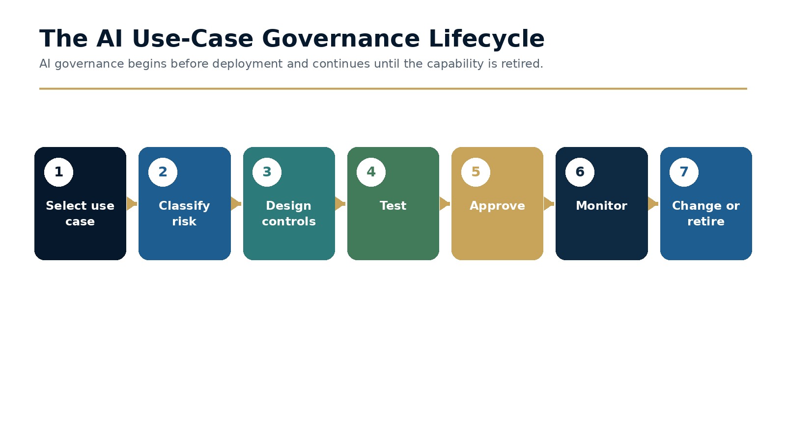
Figure 5.3 · The AI Use-Case Governance Lifecycle

Decision Framework
Model-card field | What must be documented | Why it matters
Purpose and prohibited use | Intended decision, users, customers and boundaries. | Prevents capability expansion without review.
Data and sources | Training or retrieval sources, sensitive data and retention. | Supports privacy, quality and traceability.
Performance and limitations | Tests, known errors, populations and uncertainty. | Allows reviewers to understand when not to rely on output.
Human oversight | Reviewer role, evidence, override and escalation. | Turns accountability into a workflow.
Monitoring and change | Metrics, thresholds, owner, version and retirement criteria. | Ensures the capability remains governed after launch.

Executive Case Study
AI-assisted investigation without automated judgment
An investigations team piloted an AI capability to summarize transaction history, retrieve relevant policy and draft a case narrative. The objective was to reduce time spent assembling information, not to automate the decision to close or escalate a case.

Implementation
The use case was classified as Assist. Approved data sources were defined, customer information was protected, and the output displayed source links so investigators could verify every material statement. Quality assurance compared AI-assisted and non-assisted cases, while override and correction data were captured as learning signals.

Governance
The pilot revealed that speed improved only when the interface made verification easy. Early versions produced polished narratives that encouraged over-reliance. The design was changed so unsupported statements were highlighted and the investigator had to confirm critical facts before the narrative could be finalized.

Outcome and lesson
The lesson is that governance and product design are inseparable. AI can improve judgment when it directs attention and preserves evidence. It weakens judgment when fluency is mistaken for accuracy.

Common Failure Modes
- Calling a process human-reviewed when users cannot meaningfully challenge it.
- Approving a model but not the workflow and downstream action.
- Allowing use cases to expand beyond the documented purpose.
- Monitoring only average accuracy and missing concentrated harm.
- Failing to define rollback, suspension and incident authority.

A Practical 30 / 60 / 90-Day Plan
Period | Actions and evidence
First 30 days | Inventory AI use cases; classify authority and consequence; pause undocumented high-impact uses; define the model-card and incident standard.
Days 31-60 | Select one bounded pilot; design human oversight and quality sampling; test privacy, hallucination, bias and edge cases; approve monitoring thresholds.
Days 61-90 | Launch with controlled users; review overrides and errors weekly; complete an independent assessment; decide whether to scale, change or retire the use case.

Implementation checkpoint
At the end of the first ninety days, leadership should be able to point to at least one changed decision, one implemented control or governance improvement, and evidence that the result was tested. Activity alone is not proof of adaptation.

Executive Reflection
Artificial intelligence is not the destination. Adaptive governance is. The institutions that succeed will use AI to see change earlier, challenge assumptions more intelligently and support human judgment with richer evidence than periodic governance has ever allowed.

Questions for Leaders
• Where is AI currently used to automate work rather than improve governance?
• What signals would your AI layer need to connect to make governance more continuous?
• Which decisions should remain explicitly human, even if AI informs them?
• How would your board assess whether AI improves accountability rather than obscures it?

CHAPTER 6

Designing an Adaptive Compliance Organization
The operating model must be intentionally designed to recognise change, connect intelligence and learn.
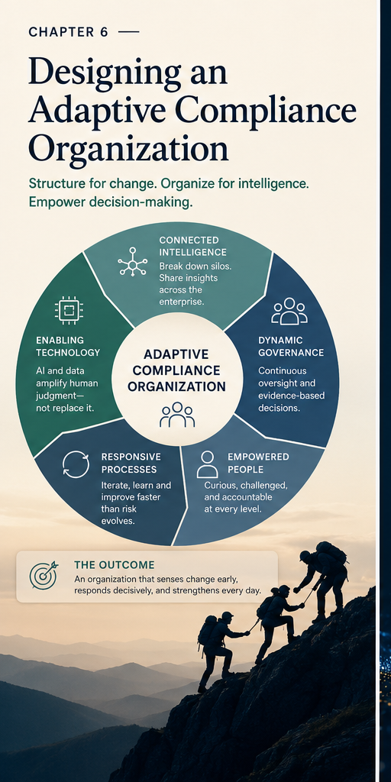
Opening illustration for Chapter 6: Designing an Adaptive Compliance Organization.
EXECUTIVE INSIGHT
Every compliance organisation is designed to produce the outcomes it consistently delivers. When institutions struggle to adapt, the explanation is rarely a lack of expertise or investment. More often, the operating model was designed for an era in which risk evolved more slowly and periodic governance was sufficient. Adaptive compliance requires organisations intentionally designed to learn.

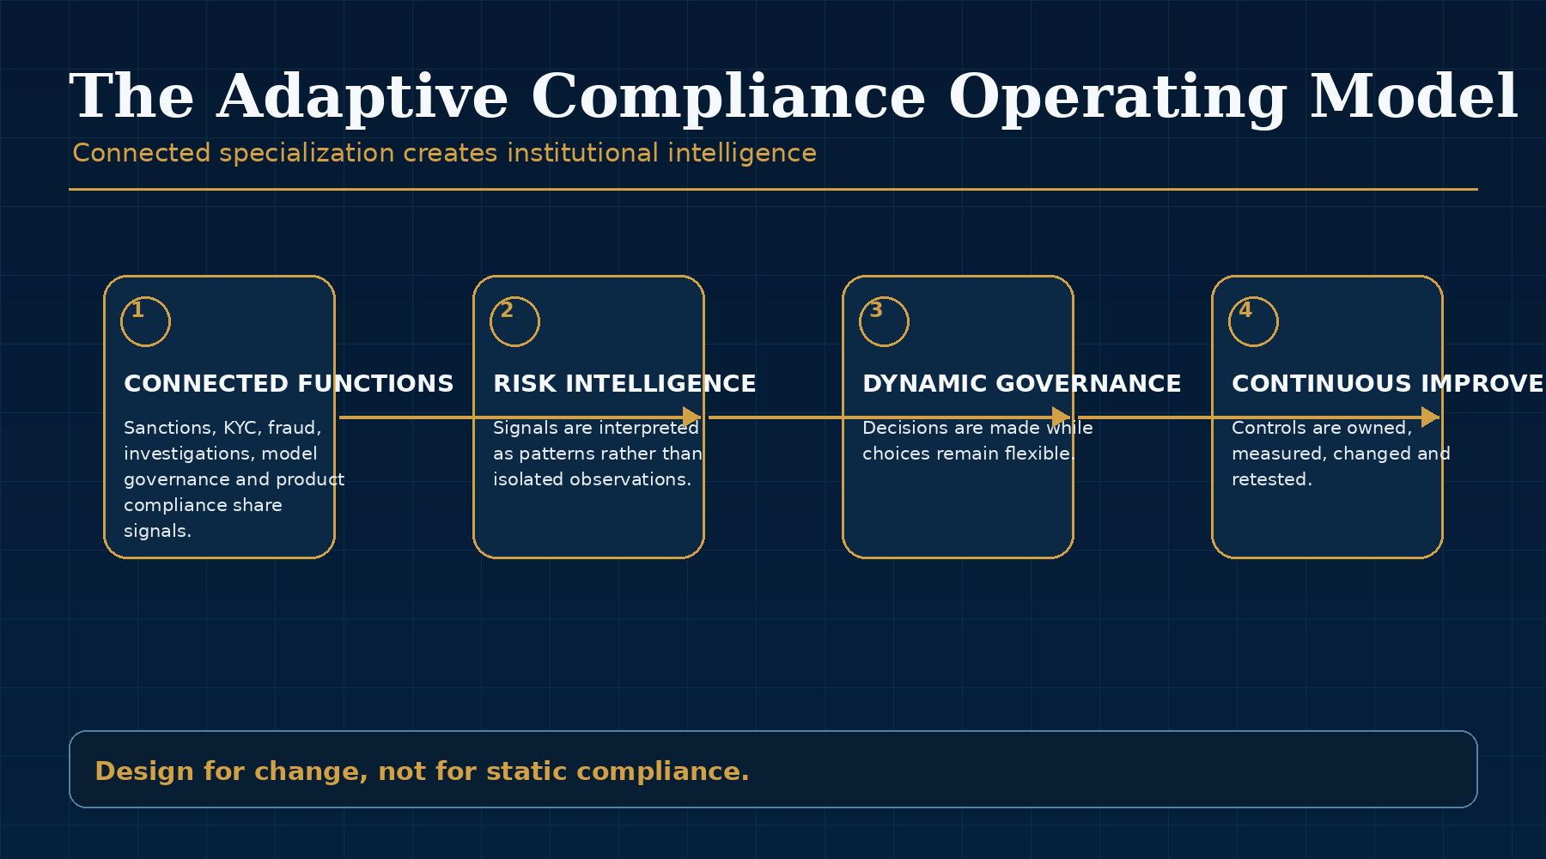
Figure 6.1: Designing an Adaptive Compliance Organization - key framework.

Expertise Is Not the Same as Integration
Modern compliance functions contain deep expertise across investigations, sanctions, fraud, KYC, data science, product compliance and model validation. This specialization is necessary. Financial crime is too complex for generalists alone, and regulated institutions require teams that understand the detail of specific obligations and threats.
The challenge is that financial crime does not recognise those boundaries. A product decision may change transaction behaviour. A fraud pattern may create sanctions exposure. A market expansion may invalidate customer risk assumptions. A cyber event may become a financial crime event. The organisation may possess all the necessary expertise and still fail to connect it quickly enough.
The objective is not less specialisation. It is connected specialisation. Adaptive organisations treat every specialist function as part of a shared intelligence system rather than as an isolated control owner.

Information Is the Most Important Control
Organisations rarely fail because important information does not exist. They fail because it arrives too late, remains within silos or is never connected to other observations. An investigator notices an unusual pattern. A fraud analyst identifies a new technique. A regulator publishes updated expectations. A product team observes changing customer behaviour. Individually, these may appear modest. Together, they may indicate that a long-standing assumption is beginning to fail.
Adaptive organisations therefore design for the movement of intelligence, not only the execution of controls. They ask how information moves from investigation to model governance, from fraud to sanctions, from product to KYC, from legal to operations and from customer support to account security.
In this sense, information flow becomes a control. Slow information flow is a control weakness, even when each individual team performs well.

Governance Moves Closer to the Business
When compliance becomes involved only after products, partnerships or expansion plans are largely complete, friction is inevitable. Business teams experience delay and compliance inherits risks it had little opportunity to shape. The result is often repeated redesign, exception handling and difficult late-stage escalation.
Adaptive organisations involve governance early. The conversation moves from approval to responsible design. Compliance becomes part of product architecture, market-entry planning and customer-experience design. This does not weaken risk management. It strengthens it by ensuring that risk is understood while strategic choices remain flexible.
This shift is particularly important in payments, where product design determines how customers move money, what evidence can be collected, which counterparties are visible and how controls can be embedded. A compliance requirement added after launch is often more expensive, less elegant and less effective than one designed into the product from the beginning.

New Capabilities
Three capabilities become particularly important. Continuous model governance evaluates whether assumptions remain valid after deployment. Enterprise risk intelligence connects signals from investigations, fraud, products, regulation and external events. Compliance product management treats controls as living products with owners, roadmaps, feedback and continuous improvement.
These capabilities do not replace traditional compliance disciplines. They connect them. They also change how compliance is managed. Controls have product owners. Monitoring logic has performance objectives. Customer journeys are designed with regulatory evidence in mind. Changes are tested, measured and improved rather than implemented once and revisited periodically.
The result is a compliance function that behaves less like a static control inventory and more like a learning organisation.

Culture Is the Operating System
Culture determines whether investigators challenge assumptions, data scientists raise concerns, product teams involve compliance early and committees reward curiosity. Technology accelerates adaptation. Culture determines whether adaptation occurs.
Leaders who recognise uncertainty design organisations capable of learning. Questions become more valuable than assumptions, evidence more valuable than hierarchy and collaboration more valuable than functional ownership. Leadership creates the conditions in which information flows and challenge is constructive.
Adaptive compliance is therefore not simply an operating model. It is a leadership philosophy. It requires the organisation to value learning more than defensive certainty.
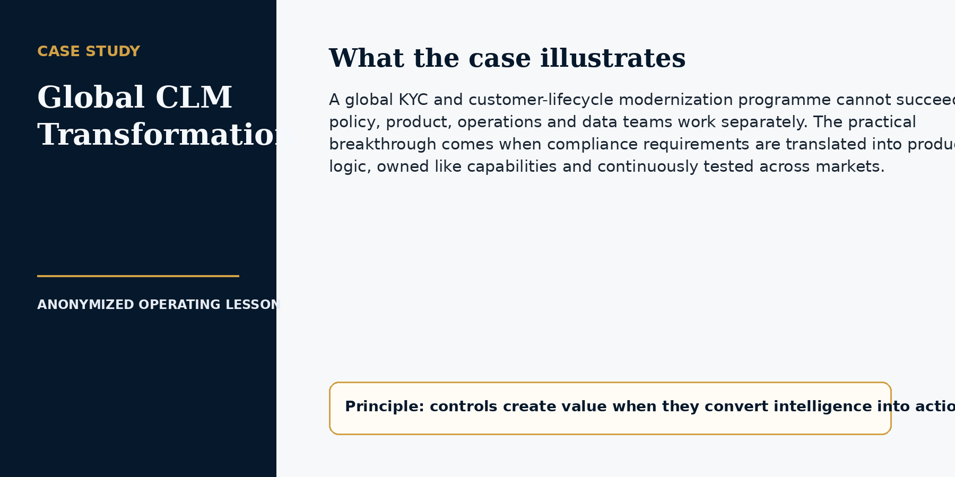

CHAPTER 6 IMPLEMENTATION PLAYBOOK

From Principle to Practice
Adaptive compliance is an organizational design problem. Information must move from operations and local markets to specialist teams, product leaders and governance quickly enough to change decisions. A structure can have clear reporting lines and still fail if signals travel slowly or accountability becomes fragmented.
The design should therefore start with decisions and information flows: which decisions must be made, who has authority, what intelligence they need, and how the outcome returns to the teams that execute and learn from the control.
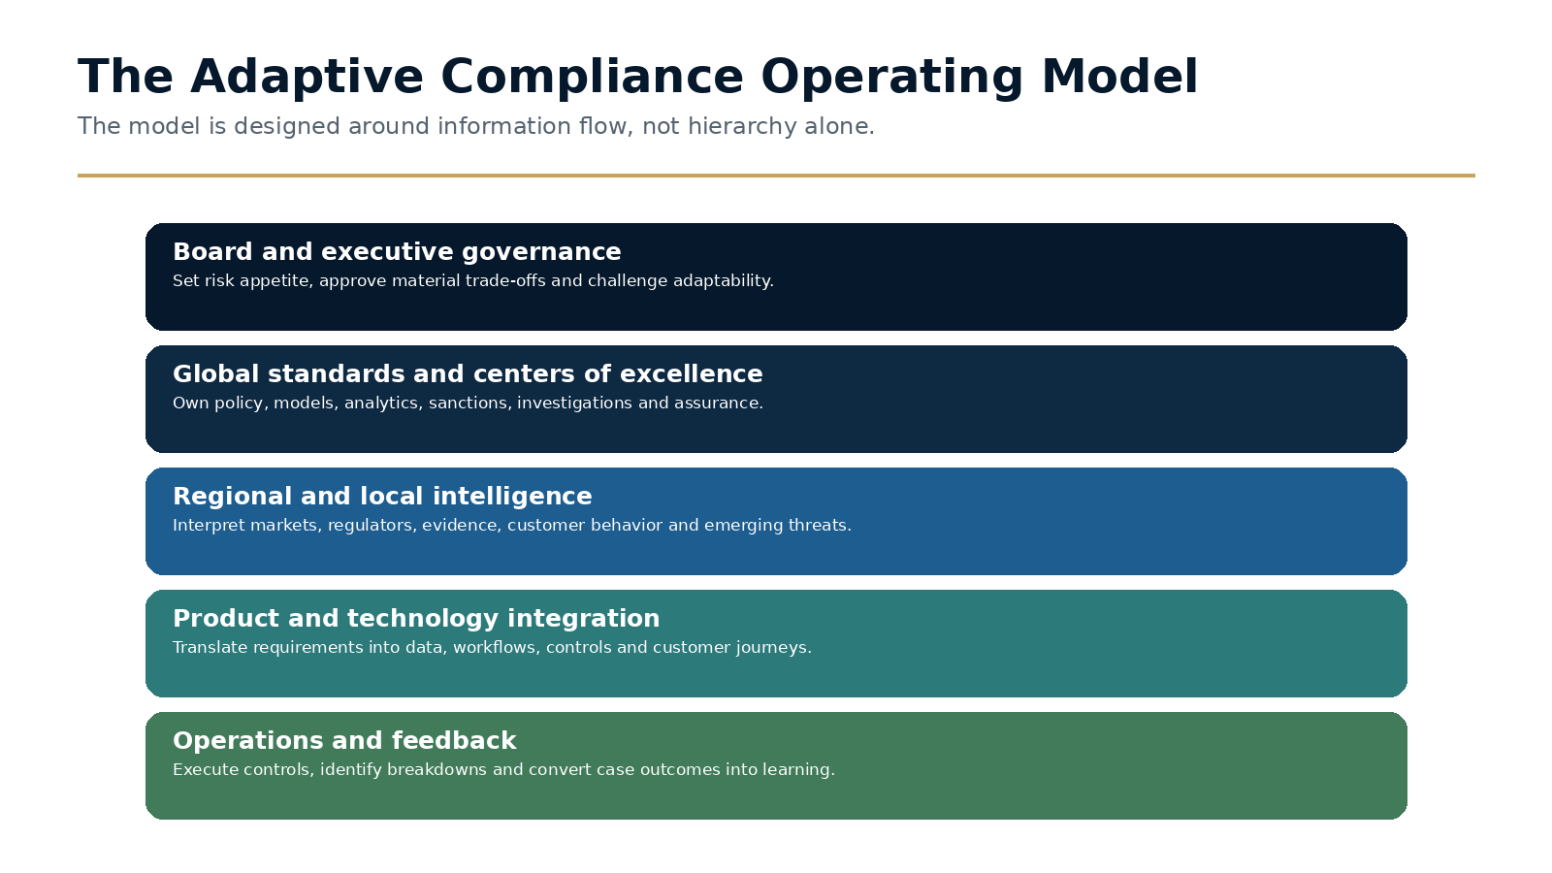
Figure 6.2 · The Adaptive Compliance Operating Model

Separate global standards from local intelligence
Global teams should own minimum standards, risk frameworks, core methodologies, specialist expertise and enterprise governance. Regional and local teams should interpret regulatory expectations, market practices, evidence, customer behavior and emerging risks. Neither layer is sufficient alone.
Centralization without local intelligence creates inappropriate controls and slow escalation. Localization without global governance creates inconsistency and hidden risk. The operating model must make translation between the two an explicit responsibility.

Build centers of excellence around reusable capability
Centers of excellence are most valuable when they provide methods, data, tools and expert challenge that regions and products can reuse. Model governance, sanctions, investigations, regulatory intelligence, KYC policy, analytics and quality assurance are common examples.
A center should not become a queue through which every local decision must pass. It should define decision boundaries, provide standards and intervene when risk or consequence exceeds local authority.

Create a governance cadence that matches decision speed
Operational incidents may require daily decisions. Emerging typologies and product risks may require weekly review. Model health, metrics and regulatory intelligence may require monthly forums. Risk appetite and strategic capability should receive quarterly executive and board challenge.
The cadence should not produce overlapping committees. Each forum needs a defined purpose, decision rights, inputs, outputs and escalation path. Information should move upward because a decision is required, not simply because a report is due.

Working Template
Decision / activity | Global role | Regional / local role | Product / technology role
Policy and minimum standard | Accountable for enterprise requirement. | Interprets local law and market evidence. | Implements configurable workflow and data.
Emerging typology | Aggregates intelligence and coordinates response. | Identifies local signal and validates relevance. | Builds or changes product and detection controls.
Model change | Owns methodology and governance standard. | Provides population and operational context. | Implements, tests and monitors release.
Customer exception | Defines boundaries and material escalation. | Decides within delegated authority. | Provides evidence, restrictions and workflow.
Regulatory engagement | Coordinates enterprise position. | Owns local relationship and commitments. | Supplies implementation evidence and delivery plan.

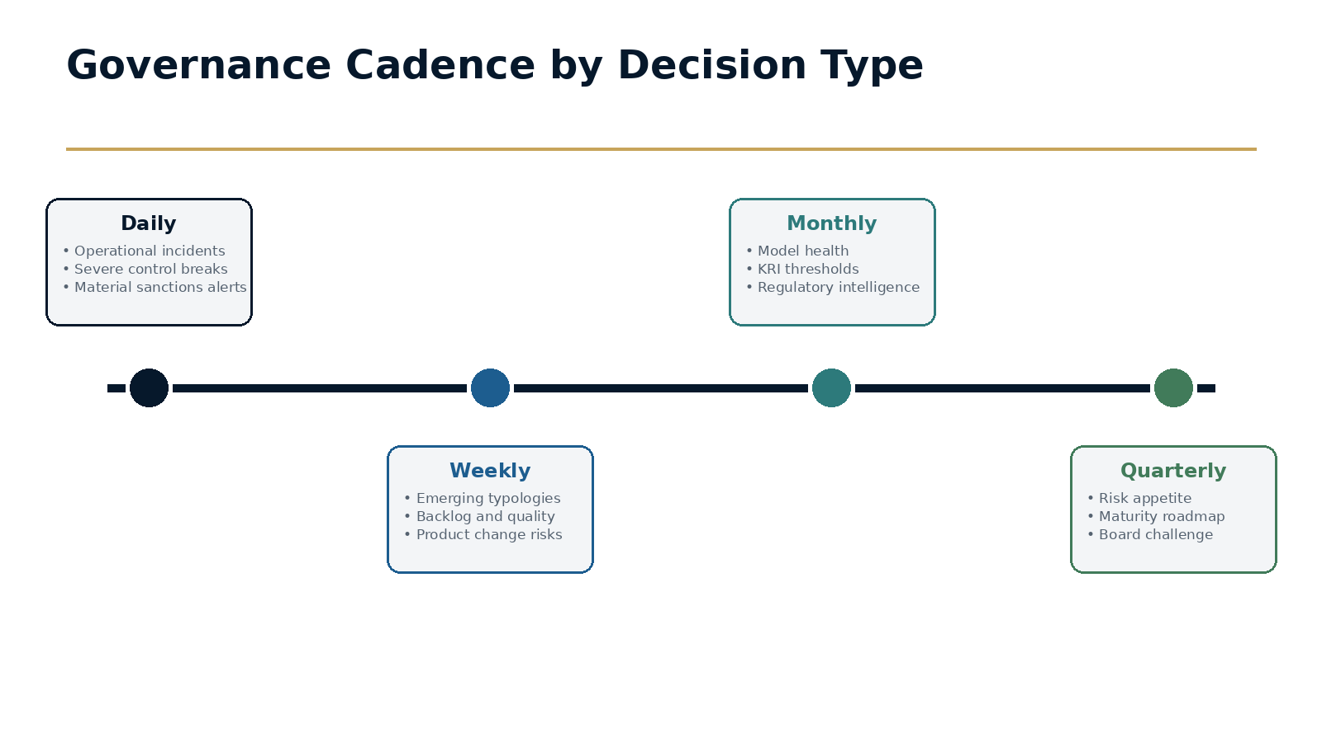
Figure 6.3 · Governance Cadence by Decision Type

Decision Framework
Forum | Cadence | Core decisions
Operational risk huddle | Daily / as needed | Incidents, severe control breaks, sanctions and customer harm.
Emerging risk forum | Weekly | Typologies, product changes, cross-market signals and temporary controls.
Control and model forum | Monthly | Performance, drift, tuning, issues, regulatory intelligence and change approval.
Executive compliance committee | Monthly / quarterly | Risk appetite, investment, material exceptions and remediation.
Board risk / compliance committee | Quarterly | Capability, trust, material exposure, strategic change and accountability.

Executive Case Study
Scaling a global compliance organization without creating a global bottleneck
A payments company expanded across regions and built specialist teams for sanctions, investigations, KYC, model governance, analytics and regulatory engagement. Growth created 24-hour demand and a wider range of local requirements. The initial response was to centralize decisions so that standards remained consistent.

Implementation
Centralization improved control but created delays and reduced local ownership. The organization redesigned the model around delegated decisions. Global centers defined standards, methods and escalation thresholds. Regional leaders owned local implementation and regulatory context. Product and technology teams were assigned explicit responsibility for translating requirements into systems.

Governance
Governance forums were simplified and aligned to decision speed. A weekly emerging-risk forum connected local signals to specialists and product teams. A monthly control forum approved material changes. Regional hubs provided continuous coverage and became sources of intelligence rather than processing locations.

Outcome and lesson
The lesson is that scale comes from clear boundaries and reusable capability, not from routing every decision to headquarters. The organization becomes adaptive when intelligence can move globally without removing accountability locally.

Common Failure Modes
- Centralizing every decision in the name of consistency.
- Treating regional hubs primarily as lower-cost operations.
- Creating centers of excellence with no service model or decision boundary.
- Using RACI charts that do not match actual authority.
- Maintaining committees that receive information but cannot decide.

A Practical 30 / 60 / 90-Day Plan
Period | Actions and evidence
First 30 days | Map the twenty most important compliance decisions; identify current owners and bottlenecks; inventory forums; document global and local responsibilities.
Days 31-60 | Define delegated authority and escalation thresholds; redesign two critical decision flows; establish the emerging-risk and control forums; clarify center-of-excellence services.
Days 61-90 | Pilot the model in one region or product; measure decision time and rework; train owners; update governance charters; report operating-model outcomes to the executive committee.

Implementation checkpoint
At the end of the first ninety days, leadership should be able to point to at least one changed decision, one implemented control or governance improvement, and evidence that the result was tested. Activity alone is not proof of adaptation.

Executive Reflection
Organisations do not become adaptive because they purchase better technology. They become adaptive because they are designed to recognise change before it becomes failure. Technology enables that capability. Governance coordinates it. Leadership reinforces it. Culture sustains it.

Questions for Leaders
• Where does critical risk intelligence currently get trapped in your organization?
• Which compliance requirements are designed into products early, and which are attached later?
• What new capability would most improve your ability to learn: model governance, risk intelligence or compliance product management?
• Does your culture reward people for challenging assumptions before a control fails?

CHAPTER 7

Measuring What Matters
If organisations are expected to adapt, their dashboards must measure learning as well as efficiency.
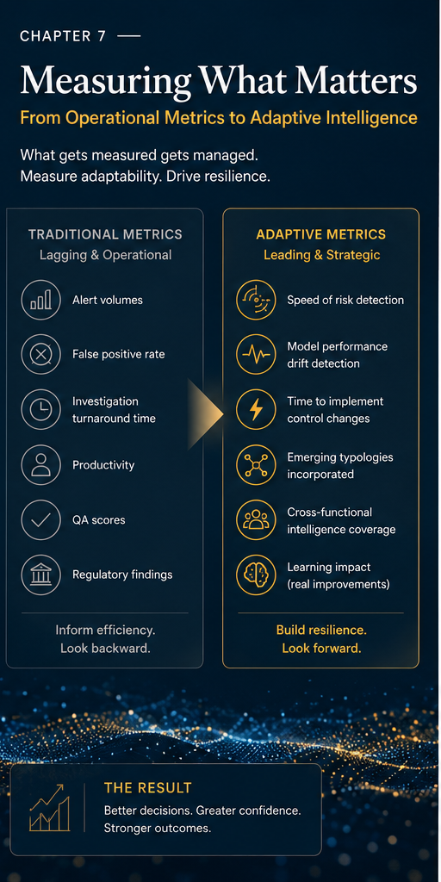
Opening illustration for Chapter 7: Measuring What Matters.
EXECUTIVE INSIGHT
Every organisation is shaped by the metrics it values. Financial crime compliance has traditionally measured false positives, alert volumes, productivity, turnaround time and quality. These indicators reveal whether a programme operates efficiently. They say far less about whether it adapts effectively.

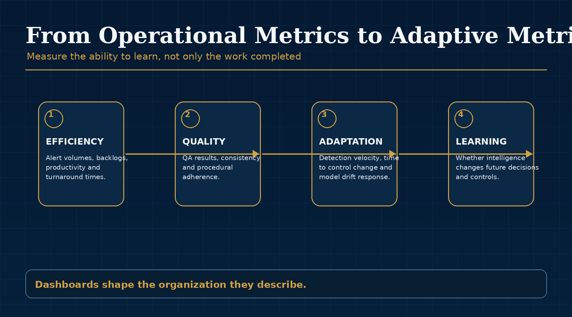
Figure 7.1: Measuring What Matters - key framework.

Performance and Resilience
A monitoring programme may process alerts faster while becoming less capable of detecting emerging typologies. KYC may meet service levels while the risk methodology no longer reflects the customer base. Model performance may remain within historical tolerances while behaviour diverges from original assumptions. Operational performance and resilience are not interchangeable.
This distinction matters because dashboards shape behaviour. If leaders primarily reward alert closure, the organisation becomes better at closing alerts. If they reward false-positive reduction, the organisation becomes better at reducing false positives. If they reward learning, the organisation begins to ask what information changed future decisions.
The metrics of adaptive compliance must therefore describe not only how much work was completed, but how effectively the organisation recognised and responded to change.

Why Traditional Dashboards Fall Short
Traditional reporting evolved when products, payment ecosystems and customer behaviour changed more gradually. Today's environment is defined by rapid product adoption, AI-enabled crime, geopolitical disruption and continuously shifting customer expectations. Dashboards can appear reassuring precisely when governance should be asking harder questions.
Backlogs, findings and false-positive rates are largely lagging indicators. They describe what has already happened. They may signal strain, but they rarely identify whether an emerging typology is forming, whether model assumptions are ageing or whether a product change has altered expected customer behaviour.
This does not mean traditional metrics should be abandoned. It means they must be balanced with indicators that measure the organisation's capacity to identify and respond to change.

Measuring Organisational Learning
Learning occurs when information changes future decisions. Investigations should improve monitoring. Fraud events should strengthen controls. Examinations should improve governance. Product launches should refine risk assessments. Knowledge stored in reports has limited value; knowledge embedded in future decisions creates resilience.
Adaptive metrics therefore ask questions such as: how quickly was a new typology identified? How long did it take to translate that typology into a monitoring change? How often are model assumptions challenged? Which risk signals originate outside compliance? How frequently do lessons learned in one market improve controls in another?
These questions are more difficult to measure than alert volumes. They are also more valuable because they describe the capability that determines whether the organisation can keep pace with risk.

The Dashboard of the Future
Future dashboards will retain operational measures but add a view of adaptability. Governance will ask which assumptions changed, where intelligence originated, how quickly the organisation responded and which decisions strengthened long-term resilience.
A mature adaptive dashboard might include detection velocity, time from governance decision to implemented control change, rate of recurring exceptions, drift indicators, typology coverage, intelligence-sharing measures, and evidence that remediation produced sustainable learning. These measures do not replace productivity and quality. They complete the picture.
Ultimately, the purpose of governance is not to produce dashboards. It is to create confidence. Confidence that management understands how risk is changing, that controls remain aligned with the business and that uncertainty is recognised rather than ignored.
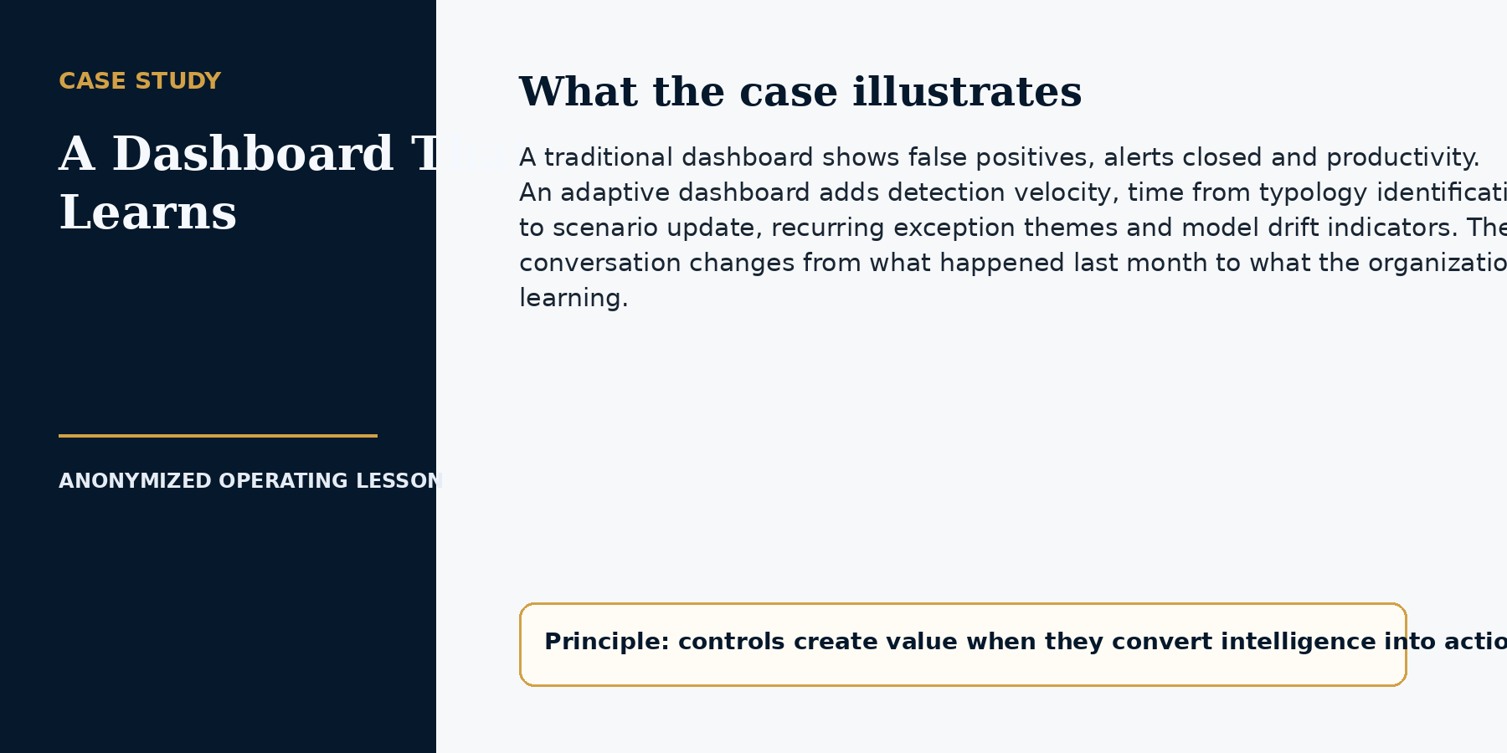

CHAPTER 7 IMPLEMENTATION PLAYBOOK

From Principle to Practice
The implementation challenge is to move from reporting activity to creating decision intelligence. Every metric should have a precise definition, trusted source, accountable owner, threshold and named decision. If leadership cannot describe what action a metric should trigger, it should not occupy space on the executive dashboard.
Adaptive dashboards retain operational measures, but they balance them with effectiveness, adaptability, customer impact, control health and trust. The aim is not more data. It is a smaller set of measures that change behavior.
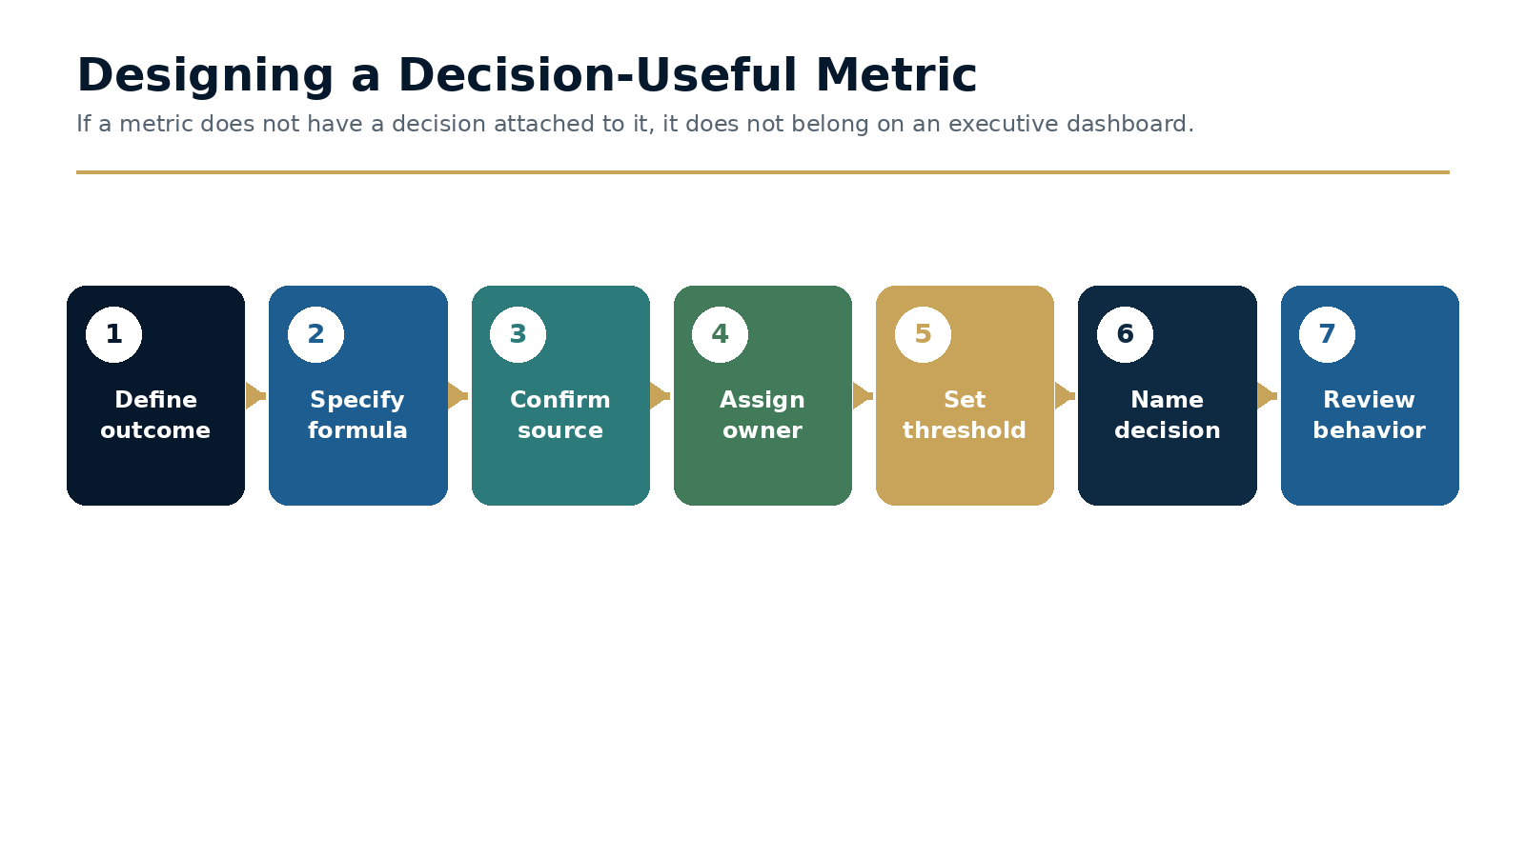
Figure 7.2 · Designing a Decision-Useful Metric

Start with the outcome and decision
Metric design should begin with the question leadership needs to answer. For example: are material typologies covered, is the model deteriorating, are legitimate customers experiencing avoidable friction, or is regulatory change being implemented fast enough? The formula is designed only after the decision is clear.
This approach prevents reporting teams from promoting measures simply because the data is easy to obtain. Easy-to-count activity often dominates dashboards even when it provides little insight.

Balance leading and lagging indicators
Lagging indicators such as findings, backlogs and confirmed events remain important. Leading indicators identify conditions that may create future failure: rising data-quality exceptions, model population shifts, repeat overrides, delayed product impact assessments, recurring customer appeals or an aging control-change backlog.
A leading indicator should not be presented as certainty. It is a signal that triggers inquiry. Governance should record the question asked, the analysis performed and the decision reached.

Test the behavior the metric creates
Every metric creates incentives. A turnaround-time target can encourage superficial closure. A false-positive target can reduce sensitivity. A remediation-completion rate can reward documentary closure. Metric governance should therefore consider unintended behavior and use balancing measures.
Definitions should be version-controlled. Formula changes, source changes and threshold changes should be approved and explained so that trends remain interpretable.

Working Template
Metric design field | Question | Example
Outcome | What capability or risk are we trying to understand? | Whether new typologies become effective controls quickly.
Definition and formula | What exactly is measured and at what level? | Median days from validated signal to deployed control.
Data source | Is the source reliable, timely and traceable? | Typology log, governance decision and release record.
Owner | Who explains the result and drives action? | Head of financial crime intelligence.
Threshold and decision | What happens when the result changes? | Escalate if median exceeds approved tolerance.
Balancing measure | What harmful behavior could the metric create? | Quality and customer-impact check after accelerated change.

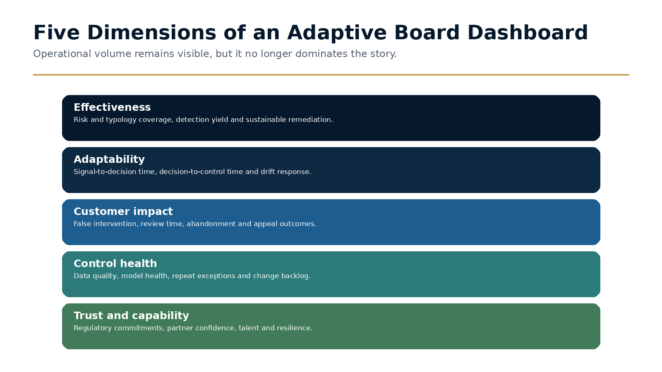
Figure 7.3 · Five Dimensions of an Adaptive Board Dashboard

Decision Framework
Traditional measure | Useful insight | Adaptive counterpart
Alert volume | Workload and capacity. | Risk coverage by typology and segment.
False-positive rate | Operational noise. | Detection yield balanced with customer impact.
Case turnaround | Process speed. | Time from signal to risk decision and control change.
Issue closure rate | Delivery progress. | Sustainable closure and recurrence rate.
Training completion | Participation. | Demonstrated decision quality and error reduction.
Model validation status | Point-in-time assurance. | Continuous model health and drift response.

Executive Case Study
Modernizing the board compliance dashboard
A board pack showed alert volumes, backlog, investigator productivity, training completion and issue status. The measures were accurate and consistently green, but board members could not determine whether controls covered emerging risks or whether the organization was adapting fast enough.

Implementation
The dashboard was redesigned around five dimensions: effectiveness, adaptability, customer impact, control health and trust. Existing operational metrics remained in an appendix. Each executive metric was assigned a definition, owner, threshold and decision. The pack also included a short record of assumptions challenged and material control changes approved during the quarter.

Governance
The first reports generated harder conversations. A stable backlog no longer offset a rising change backlog. Improved case speed was considered alongside quality and customer appeals. A model that remained within tolerance was challenged because its population had shifted.

Outcome and lesson
The lesson is that a dashboard should not reassure leadership that activity is under control. It should help leadership decide where confidence is justified and where inquiry is required.

Common Failure Modes
- Adding adaptive metrics without retiring low-value reporting.
- Using formulas that vary by region or month.
- Setting thresholds with no named decision or owner.
- Treating leading indicators as proof rather than prompts for inquiry.
- Ignoring the incentives and gaming created by targets.

A Practical 30 / 60 / 90-Day Plan
Period | Actions and evidence
First 30 days | Inventory executive metrics; document definitions, sources and owners; identify measures with no decision trigger; select five outcomes for the adaptive dashboard.
Days 31-60 | Design formulas and thresholds; add balancing measures; validate data quality; pilot the dashboard with the executive compliance committee.
Days 61-90 | Retire redundant metrics; present the new dashboard to the board; record decisions triggered; review unintended behavior and adjust thresholds after the first cycle.

Implementation checkpoint
At the end of the first ninety days, leadership should be able to point to at least one changed decision, one implemented control or governance improvement, and evidence that the result was tested. Activity alone is not proof of adaptation.

Executive Reflection
Organisations rarely improve what they fail to measure. The next stage of compliance requires measuring not only how efficiently the organisation performs, but how effectively it learns. The future belongs to institutions that recognise change first and adapt with confidence.

Questions for Leaders
• Which metrics receive the most executive attention today, and what behaviours do they create?
• What would prove that your organization learned from an investigation, audit or regulatory review?
• How quickly do new typologies move from observation to control design?
• What leading indicators would warn your board that assumptions are changing?

CHAPTER 8

Adaptive Compliance as a Strategic Capability
Adaptive compliance enables confident growth, stronger trust and better decisions under uncertainty.
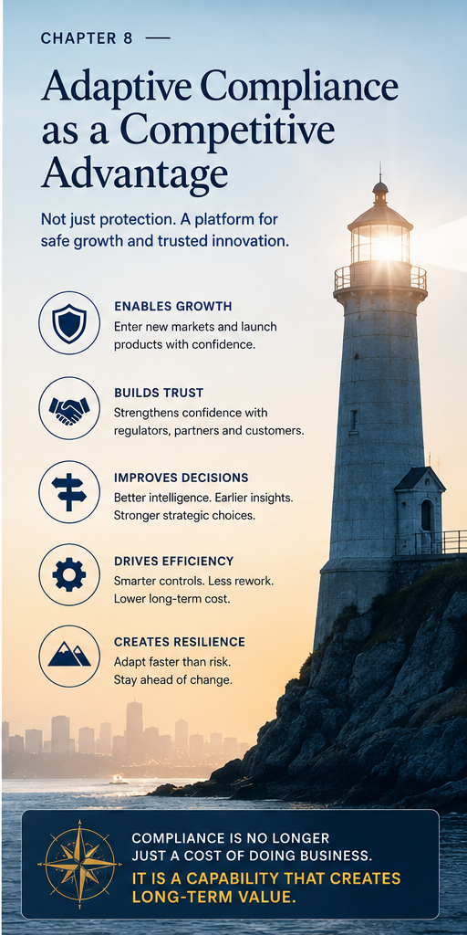
Opening illustration for Chapter 8: Adaptive Compliance as a Strategic Capability.
EXECUTIVE INSIGHT
Financial crime compliance has traditionally been viewed as a control function: satisfy obligations, protect the institution and avoid enforcement. As financial services become more digital, global and interconnected, the ability to understand risk quickly becomes inseparable from the ability to make commercial decisions confidently. Adaptive compliance becomes a strategic capability.

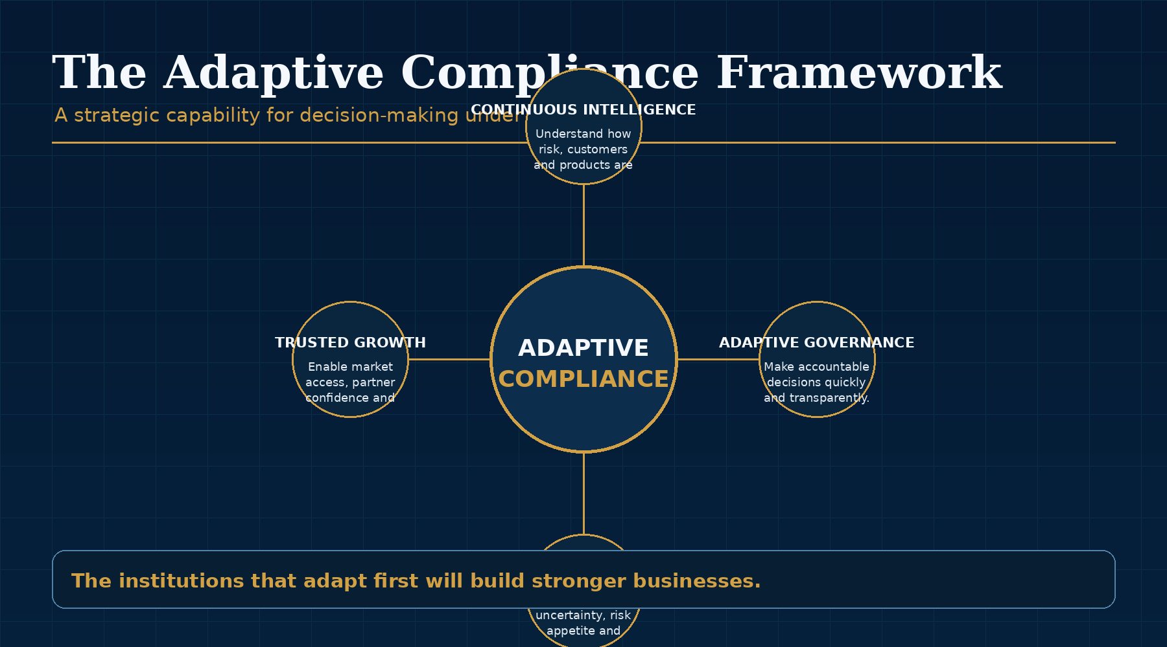
Figure 8.1: Adaptive Compliance as a Strategic Capability - key framework.

Growth Creates Complexity
Every leadership team eventually confronts the same challenge. Growth creates complexity. A company enters new markets, launches new products, acquires another business or adopts a new technology. Each decision creates opportunity, but each also introduces uncertainty. New customer behaviours emerge. Regulatory obligations expand. Criminal methodologies evolve. Existing assumptions become less reliable.
The executive question is not whether uncertainty exists. It is whether the organisation understands it well enough to act. The organisations that move fastest are no longer those that ignore risk. They are those that understand it earliest.
This is why adaptive compliance matters beyond the compliance function. It helps the institution decide where it can grow, how it should design products, which partnerships are viable and what controls are needed to operate with confidence.

From Gatekeeper to Strategic Partner
When compliance joins after strategic decisions are largely complete, business teams experience delay and compliance inherits risks it had little opportunity to shape. Adaptive organisations involve governance early. The conversation moves from approval to responsible design, making risk management part of innovation rather than an obstacle to it.
This does not mean compliance becomes less independent or less rigorous. It means compliance becomes more useful. Early risk intelligence allows product and business teams to design around constraints before they become expensive. It reduces late-stage conflict and creates clearer decision-making.
The strongest compliance functions therefore help the business move faster by reducing uncertainty earlier.

Trust Is an Economic Asset
Customers, partners, regulators, investors and employees all depend on trust. Adaptive compliance strengthens trust not by promising perfection, but by demonstrating awareness: the ability to identify emerging risks, challenge assumptions and respond transparently.
Trust has economic consequences. Banks decide whether to support payment flows. Partners decide whether to integrate. Regulators decide how much confidence to place in the institution. Customers decide whether the platform is safe enough to rely on. Investors assess whether growth is sustainable. In each case, compliance capability influences commercial possibility.
This is one reason compliance should not be viewed solely through its cost. Strong compliance can reduce friction, improve partner confidence, enable market access and support resilient growth.

Competitive Advantage
Technology is increasingly accessible. Two institutions may buy the same monitoring platform and data, yet achieve different outcomes. Technology does not make decisions; organisations do. Advantage lies in the ability to integrate intelligence, challenge assumptions and adapt governance faster than peers.
This is a harder advantage to replicate than software. It depends on leadership, culture, operating model, data quality and the speed of learning. It is built through repeated decisions that strengthen institutional judgment over time.
The future Chief Compliance Officer will not simply oversee controls. Increasingly, they will help executive teams understand the implications of change before change becomes disruption.

Beyond Compliance
The principles extend to cybersecurity, privacy, operational resilience, AI governance and third-party risk. Wherever uncertainty intersects with accountability, controls must be reassessed as circumstances evolve. Adaptive governance becomes an enterprise capability.
Financial crime has always been adaptive. Compliance has often been procedural. The next generation of institutions will close that gap. They will use technology to improve human judgment, measure adaptability alongside efficiency and design organisations that learn faster than risk evolves.
The greatest risk is not that change will occur. It is believing yesterday's assumptions are still enough for tomorrow's decisions.
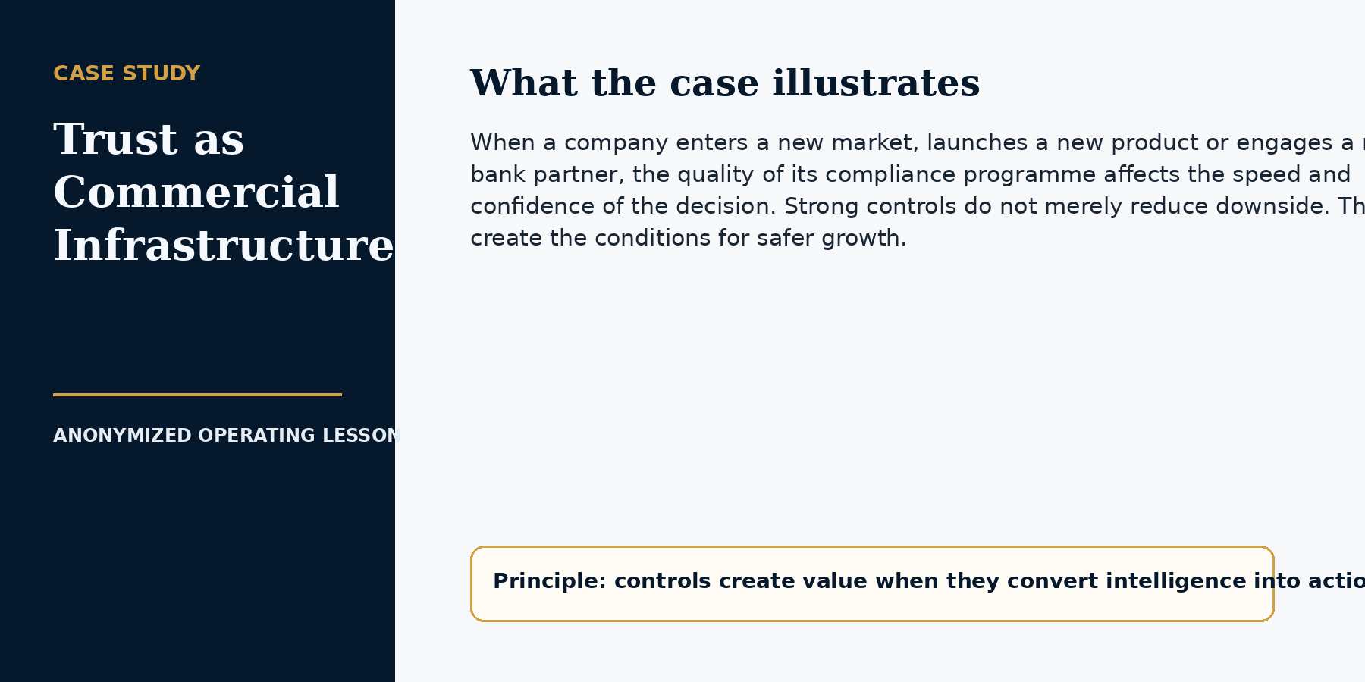

CHAPTER 8 IMPLEMENTATION PLAYBOOK

From Principle to Practice
The final step is to embed adaptive compliance into the way the institution chooses products, markets, partnerships and investments. Compliance creates strategic value when it reduces the time and uncertainty between an opportunity and a responsible decision.
This requires more than early consultation. Risk appetite must be translated into product logic, reusable decision frameworks and stage gates. The organization should be able to explain what evidence is required, who decides, which conditions permit launch and how the control environment will be monitored as the business scales.
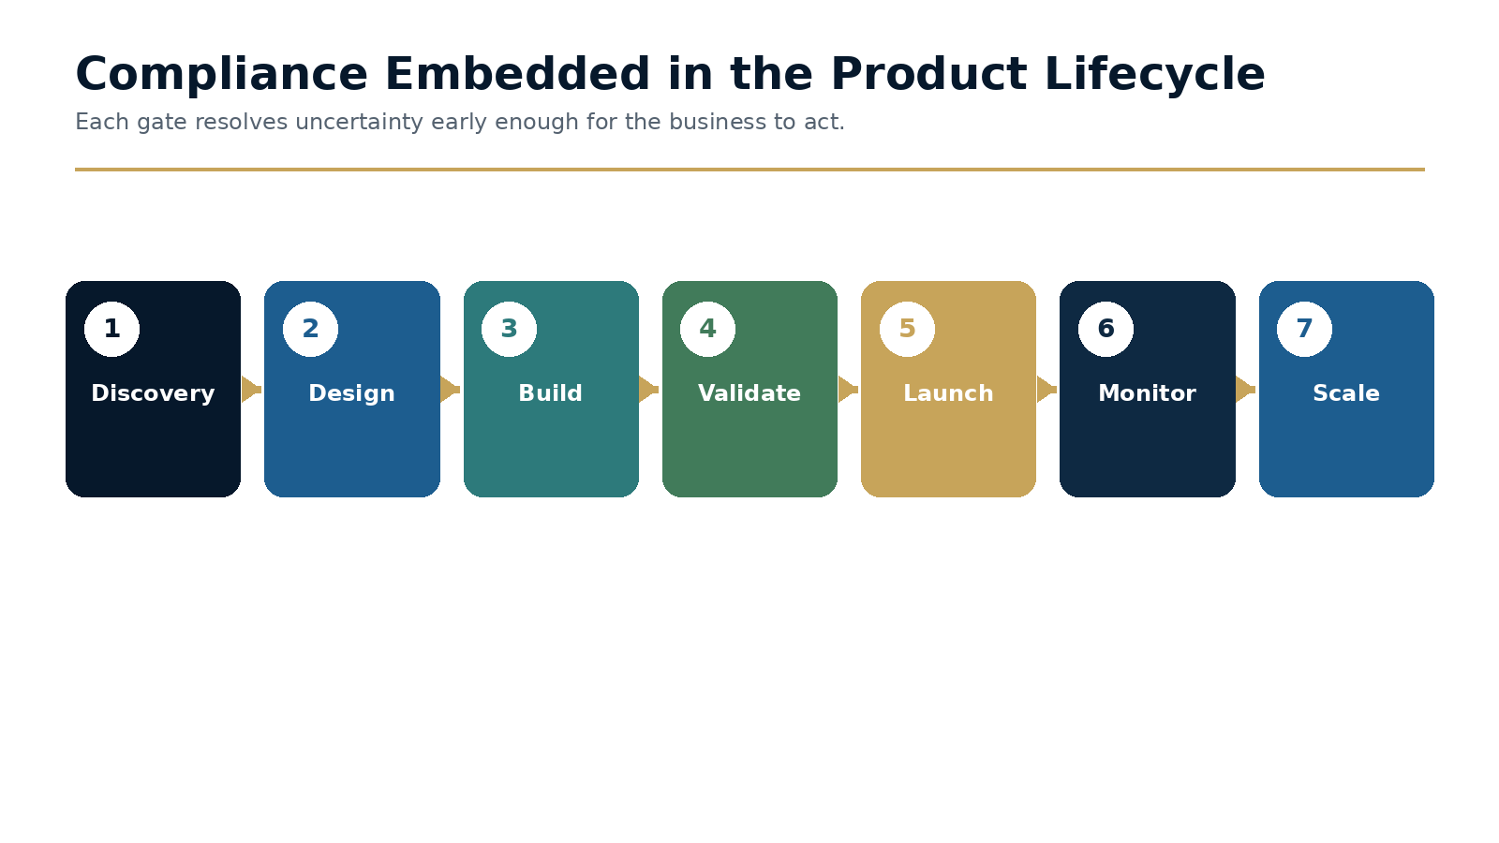
Figure 8.2 · Compliance Embedded in the Product Lifecycle

Embed compliance in product and market discovery
Discovery should produce a regulatory and risk hypothesis before resources are committed. The institution identifies the activity, jurisdictions, entities, customer types, funds flow, data, partners and material risk assumptions. This is not a full approval. It is an early view of feasibility and uncertainty.
The output should guide design. If a product requires local licensing, enhanced identity evidence, transaction restrictions or a specialist partner, those requirements can be incorporated before commercial promises and technical architecture harden.

Translate risk appetite into decision rules
Risk appetite statements are often too abstract to guide product teams. They should be translated into approved customer categories, prohibited activities, corridor or jurisdiction rules, limits, evidence standards, escalation thresholds and conditions for exceptions.
Product logic should implement the repeatable parts of these decisions. Material exceptions remain human governance decisions, but they should be informed by consistent data and recorded rationale.

Measure what compliance creates
Strategic compliance reporting should show proposal-to-risk-decision time, late-stage redesign, markets or products enabled through reusable controls, partner due-diligence time, customer friction, change implementation speed and the institution's ability to remain open during disruption.
These measures do not turn Compliance into a sales function. They demonstrate whether the program creates the certainty, trust and resilience required for responsible growth.

Working Template
Product stage | Compliance question | Required output
Discovery | What activities, entities, markets and customers are in scope? | Regulatory and risk hypothesis; key unknowns.
Design | What must be true for the product to operate responsibly? | Control requirements, evidence, restrictions and ownership.
Build | Have requirements become data, workflow and product logic? | Traceable implementation and test plan.
Validate | Does the product meet legal, risk and control conditions? | Readiness decision, residual risk and launch conditions.
Launch | Who monitors early behavior and exceptions? | Enhanced monitoring, governance cadence and rollback criteria.
Scale | Do controls remain effective as volume, markets and customers change? | Performance evidence and approved expansion decision.

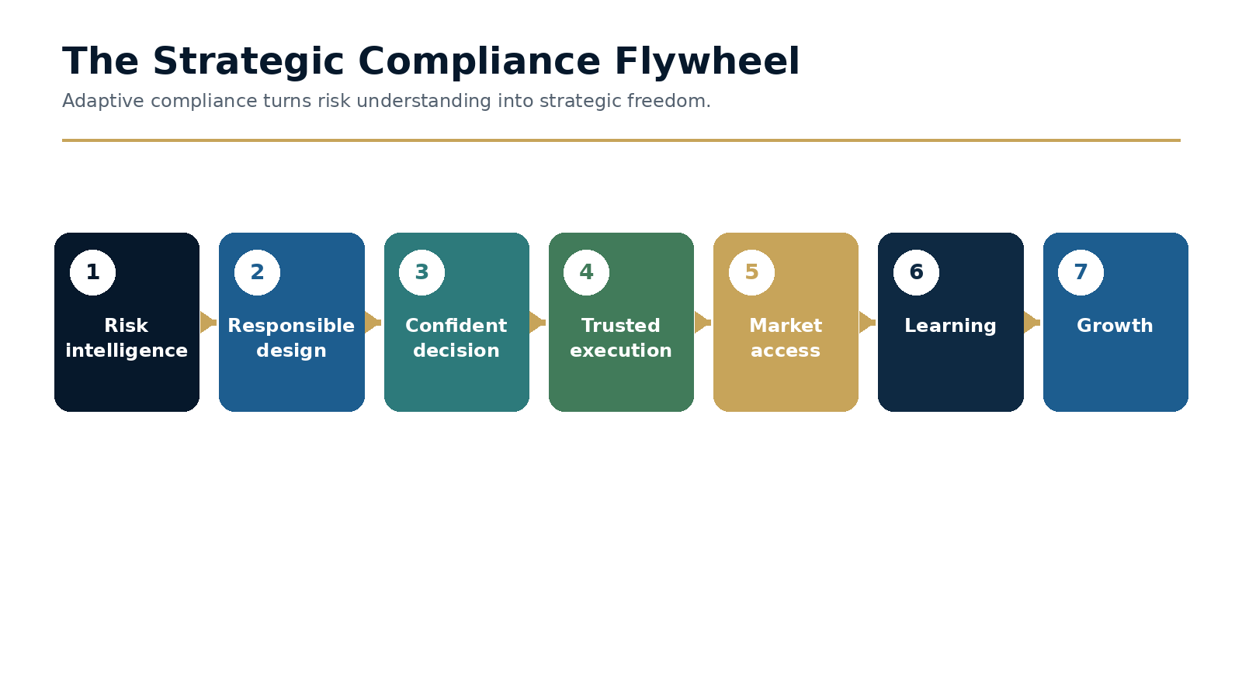
Figure 8.3 · The Strategic Compliance Flywheel

Decision Framework
Decision dimension | Evidence | Possible outcome
Legal feasibility | Licence, entity, jurisdiction and regulatory analysis. | Proceed, restructure, limit or stop.
Risk appetite | Customer, product, geography, funds flow and threat assessment. | Within appetite, conditional, exception or prohibited.
Control readiness | Data, systems, people, monitoring and governance. | Ready, staged pilot, remediation before launch or delay.
Commercial value | Customer need, revenue, strategic fit and partner support. | Prioritize, sequence, test or deprioritize.
Trust impact | Regulator, bank, partner and customer confidence. | Engage early, add assurance or revise design.

Executive Case Study
Compliance as growth infrastructure in a global payments business
A payments company sought to add products, expand corridors and deepen enterprise partnerships. Compliance was frequently engaged near the end of the approval process, after launch expectations and technical decisions had been set. The resulting escalations were experienced as compliance delay.

Implementation
The organization introduced product compliance gates from discovery through scale. Risk appetite was translated into customer and product rules, while common requirements such as identity, sanctions, monitoring and record evidence were designed as reusable platform capabilities. Material uncertainties were recorded early and assigned to accountable owners.

Governance
The new model did not approve every opportunity. It made decisions earlier. Some proposals were redesigned before significant investment; others moved faster because requirements and evidence were clear. Banking and enterprise partners received more consistent due-diligence responses because the control architecture and governance record were reusable.

Outcome and lesson
The lesson is that compliance becomes a competitive advantage when it creates strategic freedom: the ability to pursue attractive opportunities with confidence and decline unsupported risk before it consumes time, capital and trust.

Common Failure Modes
- Inviting Compliance to meetings without giving it decision authority or data.
- Using broad risk appetite language that product teams cannot implement.
- Treating every product as unique and rebuilding common controls.
- Measuring only prevention and cost, not certainty and access.
- Assuming early compliance involvement means automatic approval.

A Practical 30 / 60 / 90-Day Plan
Period | Actions and evidence
First 30 days | Map the product and market approval lifecycle; identify the most common late escalations; define discovery questions and accountable decision owners.
Days 31-60 | Introduce stage gates on two active initiatives; translate one risk-appetite area into product rules; identify reusable controls and evidence.
Days 61-90 | Complete launch-readiness decisions; measure proposal-to-decision time and redesign; establish executive reporting on growth enablement, trust and adaptability.
Months 4-12 | Scale the model across products and regions; integrate the Compliance Atlas for local requirements; connect board reporting to strategic planning and investment.

Implementation checkpoint
At the end of the first ninety days, leadership should be able to point to at least one changed decision, one implemented control or governance improvement, and evidence that the result was tested. Activity alone is not proof of adaptation.

Executive Reflection
Adaptive compliance is not the destination. It is the discipline of ensuring that an institution's understanding of risk evolves at the same pace as the world itself. The institutions that adapt first will not simply manage financial crime more effectively. They will build stronger, more resilient businesses because of it.

Questions for Leaders
• Where does compliance currently create confidence for commercial decisions?
• Which growth opportunities would move faster if compliance were involved earlier?
• How does your organization measure trust as an economic asset?
• What compliance capability would be hardest for competitors to replicate?

Toolkit

Practical Questions for Leaders
The following toolkit translates the core argument of the book into practical board, executive and governance conversations. It is not a compliance checklist. It is a set of prompts for diagnosing whether an organisation is becoming more adaptive over time.
Concept | Leadership Question
Adaptive Capacity | How quickly does governance recognise material changes in risk, customer behaviour, products or external conditions?
Control Drift | Which controls depend on assumptions that are not being monitored continuously?
Intelligence Flow | Where does risk intelligence get trapped before it reaches accountable decision-makers?
Governance Velocity | How long does it take to move from a new typology or regulatory development to an implemented control change?
Learning Impact | Which investigations, audit findings or product launches changed future controls?
Strategic Confidence | Where does compliance enable faster, better-supported commercial decisions?

REUSABLE IMPLEMENTATION TOOLKIT

Use these templates to run working sessions, document decisions and connect the eight chapter playbooks into one transformation program. The toolkit is deliberately concise. It should be adapted to the institution's governance, legal obligations and risk profile.

1. Universal Decision Record
Field | Required content
Decision required | The specific question governance must resolve.
Options considered | At least the credible alternatives, including no change.
Evidence reviewed | Data, analysis, legal interpretation, testing and expert challenge.
Risk and customer impact | Expected benefits, limitations, residual risk and customer consequences.
Owner and approver | Person accountable for recommendation and authority approving the decision.
Conditions and monitoring | Implementation conditions, thresholds, review date and rollback criteria.

2. Governance Forum Charter
Charter element | Definition
Purpose | The decisions the forum exists to make - not the reports it receives.
Scope | Products, entities, models, risks and changes within authority.
Decision rights | What can be approved, rejected, deferred or escalated.
Inputs | Required dashboards, papers, evidence and pre-read deadlines.
Membership | Accountable chair, voting members, specialists and independent challenge.
Outputs | Decision record, actions, owners, due dates and escalation.
Effectiveness review | Annual assessment of decisions, timeliness and recurring deferrals.

3. Twelve-Month Integrated Roadmap
Quarter | Primary outcomes
Q1 - Baseline | Inventories, maturity assessment, decision rights, priority risks and minimum dashboards.
Q2 - Pilot | One monitoring review, one model-health dashboard, one AI use case and one product gate.
Q3 - Scale | Extend across priority products and regions; embed regulatory intelligence and delegated authority.
Q4 - Assure | Independent testing, board reporting, lessons learned and target state for the following year.

4. Executive Transformation Scorecard
Dimension | Evidence of progress
Effectiveness | Material risks mapped to controls; changes improve coverage and outcomes.
Adaptability | Reduced signal-to-decision and decision-to-control time.
Governance | Clear decisions, owners, thresholds and sustainable closure evidence.
Customer impact | Reduced unnecessary intervention and improved resolution experience.
Technology and AI | Use cases classified, monitored and changed under accountable human authority.
Organization | Global standards, local intelligence and reusable specialist capability.
Strategic value | Earlier product decisions, stronger partner confidence and resilient market access.

How the pieces connect
Chapter 1 establishes effectiveness. Chapter 2 creates external learning. Chapter 3 governs models continuously. Chapter 4 sequences maturity. Chapter 5 governs AI. Chapter 6 designs the organization. Chapter 7 measures decisions. Chapter 8 connects the capability to strategy. The transformation succeeds when these components operate as one system rather than eight separate initiatives.

References and Further Reading
FATF. Methodology for Assessing Technical Compliance with the FATF Recommendations and the Effectiveness of AML/CFT/CPF Systems. https://www.fatf-gafi.org/en/publications/Mutualevaluations/Fatf-methodology.html
FATF. FATF Recommendations and risk-based approach guidance. https://www.fatf-gafi.org/en/topics/fatf-recommendations.html
FATF. An effective system to combat money laundering and terrorist financing. https://www.fatf-gafi.org/en/publications/Fatfgeneral/Effectiveness.html
Wolfsberg Group. Effectiveness resources and definition of effective AML/CTF programme. https://wolfsberg-group.org/resources/effectiveness
Wolfsberg Group. Statement on Effective Monitoring for Suspicious Activity. https://wolfsberg-group.org/news/the-wolfsberg-group-statement-on-effective-monitoring-for-suspicious-activity
Wolfsberg Group. Risk-Based Approach resources. https://wolfsberg-group.org/resources/rba
U.S. Department of Justice. TD Bank AML resolution and related public materials. https://www.justice.gov/
U.S. Department of Justice. North Korean remote IT worker enforcement actions and related public materials. https://www.justice.gov/opa/pr/justice-department-announces-coordinated-nationwide-actions-combat-north-korean-remote

About the Author
Micheal Sheehy is a global compliance executive focused on the intersection of payments, financial crime risk, technology and organisational design. His work has centred on building scalable compliance programmes, modernising customer and transaction controls and helping international businesses grow confidently across complex regulatory environments.
The Adaptive Compliance Series explores how financial crime compliance must evolve from static controls and periodic governance toward continuous intelligence, adaptive governance and accountable use of AI.
For speaking, advisory and publishing enquiries: michealsheehy@gmail.com

