Michel MAIER - Resume
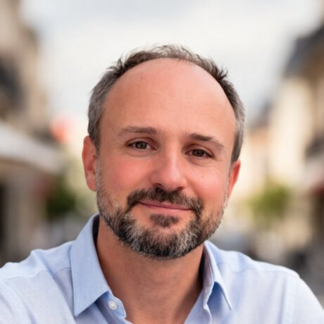

Michel MAIER
michel@solean-it.com
(+33) 6.13.56.19.40
https://php-freelance.com/
Strasbourg, FR

Senior Fullstack Developer
Backend, Cloud & AI
TypeScript · PHP/Symfony · AWS serverless
19 years of experience

Profile
For nineteen years I have been designing and taking over back-ends and cloud platforms, between serverless on AWS in TypeScript and the modernisation of PHP/Symfony monoliths step by step rather than through a rewrite.
I work on systems that are already in production. I learn them, I make them safe to change with tests, then I split them up or scale them without interrupting your business. I also embed AI in them, to speed up your teams and improve your users' experience.
Working remotely from Strasbourg.

Skills
- TypeScript & Node.js : TypeScript, Node.js, NestJS, React, GraphQL / Apollo / AppSync, Electron, Jest
- AWS & Serverless : Lambda, Step Functions, DynamoDB, S3 & CloudFront, AppSync, SQS / SNS / EventBridge, ECS & containers, Terraform, CI/CD & Docker
- Applied AI : LLMs in production, Claude Code, Claude Agent SDK, MCP, Ollama, Multi-provider abstraction
- PHP & Symfony : Symfony 2 to 6, Legacy modernisation, Domain extraction, PHP version upgrades, API Platform, PhpUnit
- Architecture & craft : Hexagonal Architecture, Clean Architecture, DDD & bounded contexts, Strangler fig, TDD, Refactoring under tests

Professional Experience
Jan 2026 - Sep 2026

Fullstack TypeScript Developer – Cloud & AI
GoTombola
Ansacq, FR
A SaaS platform for raffles and fundraising, serving small charities as well as high-visibility campaigns: the UNICEF 10 KM solidarity raffle, or the one run by the Paris Saint-Germain endowment fund. Working as a pair with the CTO, who has trusted me since 2015, we delivered in nine months the product's turning point: moving away from configuration-driven site generation towards AI-assisted generation in HTML, without touching the API contract.
- Context: TypeScript, Node.js, React, Electron, Jest, GraphQL / AppSync, AWS (Lambda, Step Functions, DynamoDB, S3, CloudFront, CodeArtifact), Terraform, Docker, Claude Agent SDK, MCP, Ollama
Dec 2024 - Nov 2025

Fullstack TypeScript Developer
Sanofi Accelerator
Paris, FR
Sanofi's Accelerator builds internal AI-driven document generation tools. Embedded in a feature team as a fullstack developer, I evolved the existing tool, which served two distinct document use cases, then prepared its transformation into a generic platform configurable without dedicated development, an effort that started as my assignment was ending. The second part of my work focused on backend refactoring and the dismantling of the NestJS monolith deployed in an ECS container, whose code is being extracted into serverless microservices.
- Context: Node.js, TypeScript, React, NestJS, GraphQL, Docker, ECS, Lambda, Step Functions, DynamoDB, Terraform, LLMs
Dec 2022 - Oct 2024

Back-end Developer – PHP / Symfony
IAD
Paris, FR
IAD is the leading network of self-employed estate agents in France, with close to 14,000 advisors domestically and more than 17,000 worldwide. As part of the overhaul of its tools and its expansion into the UK and the US, the company embarked on the modernisation of its platforms. I worked two years on that programme, in hexagonal architecture and with a DDD approach, on a modular monolith.
- Context: Docker, PHP 7.2 / 8, Symfony 3.4 to 6, Postgres, PhpUnit, API Platform, AWS, hexagonal architecture, DDD
Sep 2021 - Sep 2022

Back-end Developer – PHP / Symfony
Leboncoin (Adevinta)
Paris, FR
After the acquisition of the L'Argus group, Leboncoin's Import feature team forked an application for the multi-posting of automotive classified ads, written elsewhere, with no test safety net and only patchy documentation. The stake was to bring multi-posting in-house and stop paying their incumbent provider for it. My assignment was to make that application usable: understand it, secure it with tests, run it inside the group's ecosystem and publish to Leboncoin.fr. A textbook case of taking over legacy code, and the kind of assignment I have specialised in since.
- Context: Docker, PHP 7.2 / 8, Symfony 3.4 / 5, MariaDB, MongoDB, Kubernetes, PhpUnit, AWS, hexagonal architecture
May 2021 - Jul 2021

DevOps / Technical Coaching
Agence DPS (Syneido)
Lille, FR
Oct 2020 - Apr 2021

Back-end Developer – PHP / JS / Terraform
Lunii · Maars · GoTombola
Strasbourg, FR
Jul 2018 - Dec 2019

Back-end Developer – PHP / Symfony
DgBirds (Air France)
Tremblay en France, FR
Oct 2015 - Jun 2018

Developer – PHP / Symfony
ItiQiti
Paris, FR
Dec 2011 - May 2015

Designer / Developer – PHP / Symfony
Amadeus IT (Gestour)
Schiltigheim, FR
Dec 2008 - Dec 2011

Developer – PHP / TYPO3
Cora Informatique (Carrefour)
Metz, FR

References
David Huby : Head of Engineering, IAD
Thomas Haddad : Head of Engineering, leboncoin
Sébastien Veigneau : Air France Captain, co-founder of DgBirds
Olivier Hoareau : CTO of GoTombola, former CTO of ItiQiti

Education
2007

Master's degree (Level 1 RNCP)
Paris Graduate School of Computer Science (ESI – SUPINFO)
2002

University Technology Diploma (DUT)
IUT de Mulhouse

Languages
- French: Native language
- English: Professional working proficiency

