Prince (artiste)
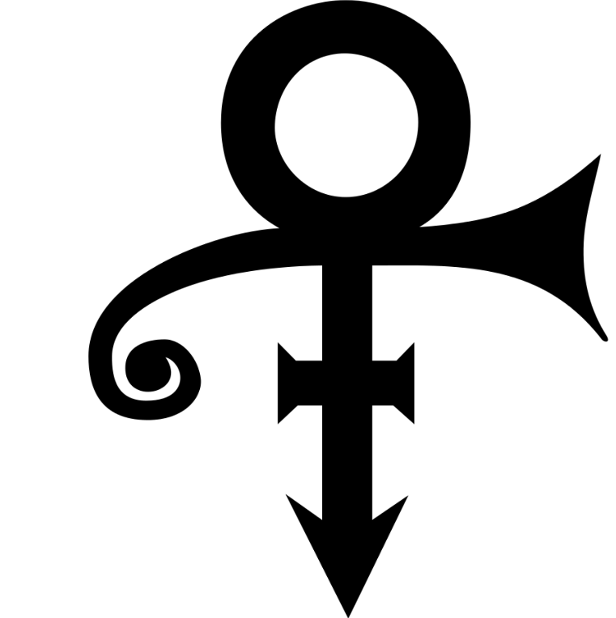
Logo Apple – Caractère F0 (240) dans MacRoman
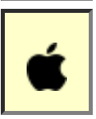

Autre exemples
East Asian Ideographs (see also gaiji), mathematical symbols, special ligatures,...

Cf. https://www.w3.org/International/articles/missing-char-glyph/index.en

