**Objective:**

To facilitate a better understanding, managers have provided ratings for each employee which will help the HR department to finalize the employee performance mapping. As a DBA, you should find the maximum salary of the employees and ensure that all jobs are meeting the organization's profile standard. You also need to calculate bonuses to find extra cost for expenses. This will raise the overall performance of the organization by ensuring that all required employees receive training.

**The task to be performed:**

1. Create a database named employee, then import **data_science_team.csv** **proj_table.csv** and **emp_record_table.csv** into the **employee**database from the given resources. (LESSON 2)

1. Create an ER diagram for the given **employee**database. (LESSON 3)

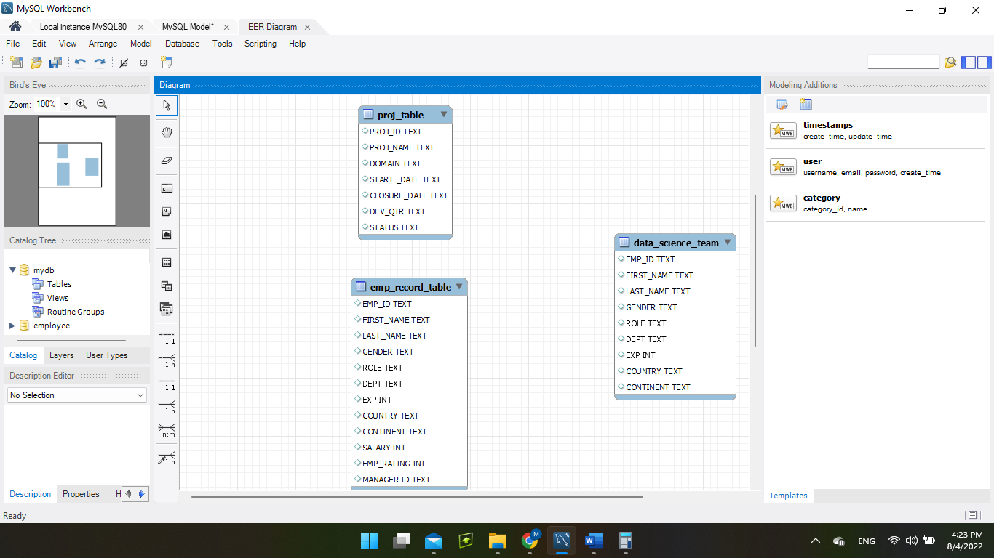

1. Write a query to fetch EMP_ID, FIRST_NAME, LAST_NAME, GENDER, and DEPARTMENT from the employee record table, and make a list of employees and details of their department. (LESSON 5-6)

  SELECT EMP_ID, FIRST_NAME, LAST_NAME, GENDER, DEPT FROM emp_record_table;

1. Write a query to fetch EMP_ID, FIRST_NAME, LAST_NAME, GENDER, DEPARTMENT, and EMP_RATING if the EMP_RATING is:  (LESSON 5-6)

* less than two
* greater than four
* between two and four

 SELECT EMP_ID, FIRST_NAME, LAST_NAME, GENDER, DEPT, EMP_RATING FROM emp_record_table WHERE EMP_RATING<2;

 SELECT EMP_ID, FIRST_NAME, LAST_NAME, GENDER, DEPT, EMP_RATING FROM emp_record_table WHERE EMP_RATING>4;

SELECT EMP_ID, FIRST_NAME, LAST_NAME, GENDER, DEPT, EMP_RATING FROM emp_record_table WHERE EMP_RATING BETWEEN 2 AND 4;

1. Write a query to concatenate the FIRST_NAME and the LAST_NAME of employees in the Finance department from the employee table and then give the resultant column alias as NAME. (LESSON 5-6)

SELECT FIRST_NAME, LAST_NAME,CONCAT(FIRST_NAME, LAST_NAME) AS full_name FROM emp_record_table WHERE DEPT=”FINANCE”;

1. Write a query to list only those employees who have someone reporting to them. Also, show the number of reporters (including the President). (LESSON 5-6)

7. Write a query to list down all the employees from the healthcare and finance departments using union. Take data from the employee record table. (LESSON 5-6)

SELECT * FROM emp_record_table WHERE DEPT = "HEALTHCARE"

UNION

SELECT * FROM emp_record_table WHERE DEPT = "FINANCE";

1. Write a query to list down employee details such as EMP_ID, FIRST_NAME, LAST_NAME, ROLE, DEPARTMENT, and EMP_RATING grouped by dept. Also include the respective employee rating along with the max emp rating for the department. (LESSON 5-6)

SELECT EMP_ID, FIRST_NAME, LAST_NAME, ROLE, DEPT, EMP_RATING, max(emp_rating) as max_dept_rating FROM emp_record_table GROUP BY DEPT;

1. Write a query to calculate the minimum and the maximum salary of the employees in each role. Take data from the employee record table. (LESSON 5-6)

SELECT EMP_ID, FIRST_NAME, LAST_NAME, MIN(SALARY), ROLE FROM emp_record_table GROUP BY ROLE

UNION

1. Write a query to assign ranks to each employee based on their experience. Take data from the employee record table. (LESSON 5-6)

SELECT EMP_ID, FIRST_NAME, LAST_NAME, RANK () OVER (PARTITION BY EXP ORDER BY LAST_NAME ASC) exp_rank FROM emp_record_table;

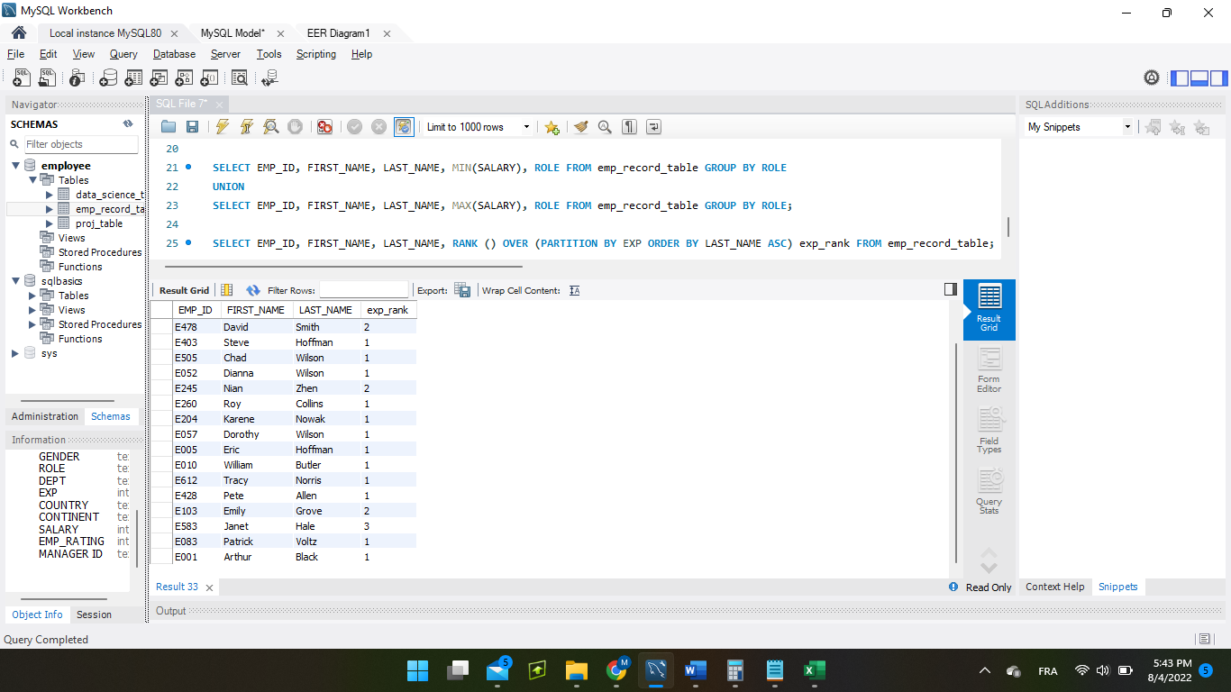

1. Write a query to create a view that displays employees in various countries whose salary is more than six thousand. Take data from the employee record table. (LESSON 5-6)

CREATE VIEW employee_view AS SELECT EMP_ID, FIRST_NAME, LAST_NAME, ROLE, COUNTRY FROM emp_record_table WHERE SALARY>6000;

1. Write a nested query to find employees with experience of more than ten years. Take data from the employee record table. (LESSON 8)

SELECT * FROM emp_record_table WHERE EXP>10;

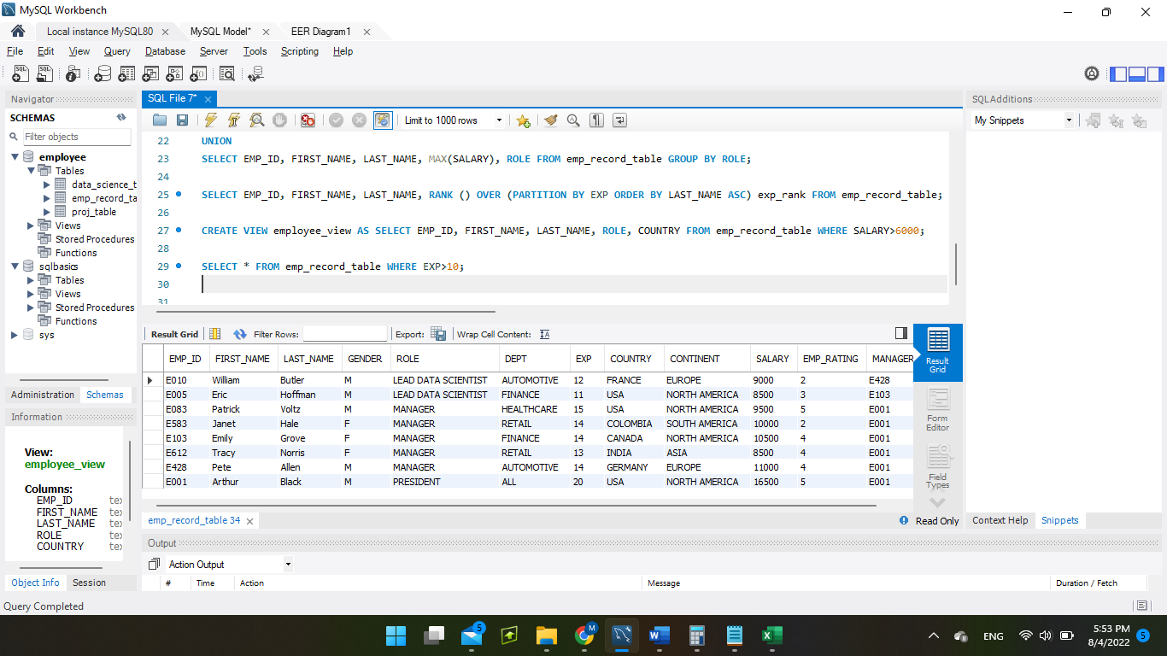

1. Write a query to create a stored procedure to retrieve the details of the employees whose experience is more than three years. Take data from the employee record table. (LESSON 5-6)

SELECT * from emp_record_table;

delimiter &&

CREATE PROCEDURE morethan3yrsexp()

BEGIN

SELECT EMP_ID, FIRST_NAME, LAST_NAME, EXP

FROM emp_record_table where EXP>3;

END &&

delimiter ;;

call morethan3yrsexp();

1. Write a query using stored functions in the project table to check whether the job profile assigned to each employee in the data science team matches the organization’s set standard. (LESSON 5-6)

DELIMITER //

CREATE FUNCTION correct_standard (EXP int)

RETURNS VARCHAR(80)

BEGIN

DECLARE correct_standard VARCHAR(80);

IF EXP<=2 THEN SET correct_standard='JUNIOR DATA SCIENTIST';

ELSEIF EXP BETWEEN 2 AND 5 THEN SET correct_standard='ASSOCIATE DATA SCIENTIST';

ELSEIF EXP BETWEEN 5 AND 10 THEN SET correct_standard='SENIOR DATA SCIENTIST';

ELSEIF EXP BETWEEN 10 AND 12 THEN SET correct_standard='LEAD DATA SCIENTIST';

ELSE SET correct_standard='MANAGER';

END IF;

RETURN correct_standard;

END; //

DELIMITER ;

**WASN’T ABLE TO RUN THIS PART OF THE CODE**

The standard being:

For an employee with experience less than or equal to 2 years assign 'JUNIOR DATA SCIENTIST',

For an employee with the experience of 2 to 5 years assign 'ASSOCIATE DATA SCIENTIST',

For an employee with the experience of 5 to 10 years assign 'SENIOR DATA SCIENTIST',

For an employee with the experience of 10 to 12 years assign 'LEAD DATA SCIENTIST',

For an employee with the experience of 12 to 16 years assign 'MANAGER'.

1. Create an index to improve the cost and performance of the query to find the employee whose FIRST_NAME is ‘Eric’ in the employee table after checking the execution plan. (LESSON 12)

CREATE INDEX indx ON emp_record_table (FIRST_NAME);

EXPLAIN SELECT EMP_ID, FIRST_NAME, LAST_NAME FROM emp_record_table WHERE FIRST_NAME=”Eric”;

**I GOT ERROR CODE 1170 HERE, KEY LENGTH SPECIFICATION???**

1. Write a query to calculate the bonus for all the employees, based on their ratings and salaries (Use the formula: 5% of salary * employee rating). (LESSON 5-6)

SELECT * , 0.05*salary*emp_rating as bonus FROM emp_record_table;

1. Write a query to calculate the average salary distribution based on the continent and country. Take data from the employee record table. (LESSON 5-6)

SELECT COUNTRY, AVG(SALARY) AS AVG_SALARY FROM emp_record_table GROUP BY COUNTRY WITH ROLLUP;

