# Client Logs Meeting Notes 8/16/2018

After viewing a prototype of the Client Logs entry screen, a review of the fields was discussed, resulting in breaking out more revenue categories and prepopulating the current revenue values.

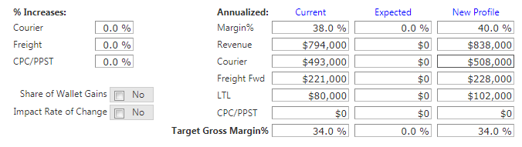

## The Revenue Categories will be changed to:

* Courier
* Freight Fwd
* LTL
* PPST
* CPC
* Other

### Other changes:

* The *Other* category will have a space for where a small description can be entered.
* When *Share of Wallet Gains* is checked, another column will be added between *Current* and *Expected*.
* When *Impact Rate of Change* is checked, another column will be added between *Current* and *Expected*.
* The *Share of Wallet* and *Rate of Change* checkboxes will be hidden for new contracts.
* For Contract Renewals, the *Expected* column will be hidden.
* The *Revenue Total* will be calculated as the sum of all the other revenue categories.
* The Percent Increase categories will match the Revenue Categories listed above.
* Tom’s Margin numbers will be used to populate the *Current* Columns.
* The percent increase values will be applied to the *Current* numbers to calculate the *Expected* Column.
* The *New Profile* values will be calculated as the sum of *Current* and *Expected* (and Share of Wallet and Rate of Change when applicable).
* All calculated values can be overridden by pricing.
* The First Ship Date will be displayed on the form, using the values maintained for Sales Incentive purposes, which originate from the win tracker.
* Accessorials may be added to the bottom of the form, after further investigation with Eric.
* The Notes entry box will have an option to keep the note private. Notes that are private will not be included in the printed or exported to PDF version.