Insights from Fitbit Data: Leveraging Smart Device Trends for Bellabeat’s Growth
Michele McCluskey
December 2025

Insights from Fitbit Data: Leveraging Smart Device Trends for Bellabeat’s Growth
Introduction
Bellabeat is a manufacturer of health focused smart devices designed specifically for women. Cofounder and Chief Creative Officer Urška Sršen is particularly interested in exploring how smart device data can inform Bellabeat’s marketing strategy. This report analyzes smart device usage and trends to uncover insights that may reveal growth opportunities and guide evidence based marketing decisions. The analysis seeks to answer questions relevant to Bellabeat’s business strategy: How does consistent engagement with tracking features influence the users' activity levels? And how could these insights guide Bellabeat in developing marketing campaigns and improving their products to encourage sustained interaction with their wellness devices?
The Data
The dataset for this analysis was obtained from Kaggle and includes Fitbit data from 35 consenting users collected between March and May 2016. The data tracks several variables such as heart rate, weight, sleep quality, daily steps, and other activity points. However, there are limitations in the dataset that may affect reliability: the dataset is dated, covers only a brief three month period, and lacks demographic context such as gender, age, or location.
Analysis was conducted in R. The original dataset contained 28 tables derived from two separate files. Because many tables were duplicated across months, equivalent tables were combined using the bind_rows() function to extend the date range, while distinct() was used to remove overlapping April entries. Columns with missing or insufficient data, such as logged_activities_distance and the underpopulated fat column in the weight records, were removed. Data cleaning also standardized column names, corrected data types, and eliminated NAs or impossible values. After cleaning and processing, 18 consolidated tables were ready for analysis.
Analysis and Findings
This analysis examined how users' engagement with various Fitbit logging features was associated with key activity indicators such as daily steps and hourly calories. A usage table was created to count the number of users utilizing each service (Figure 1).
Figure 1
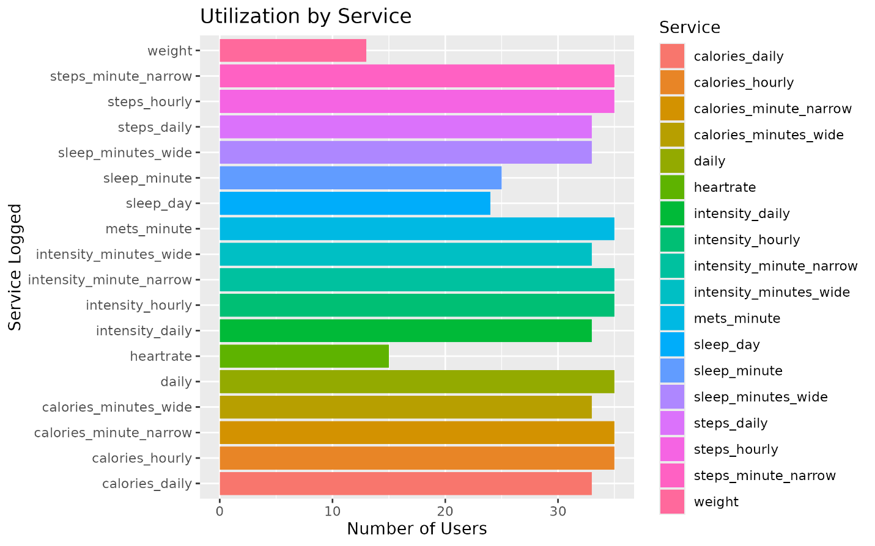
Results revealed significant variation in usage rates for logging weight, sleep, and heart rate. To evaluate how usage patterns influenced activity, logging behavior was compared with average daily step counts (Figures 2–4) and hourly calorie expenditure (Figures 5–7).
Figure 2
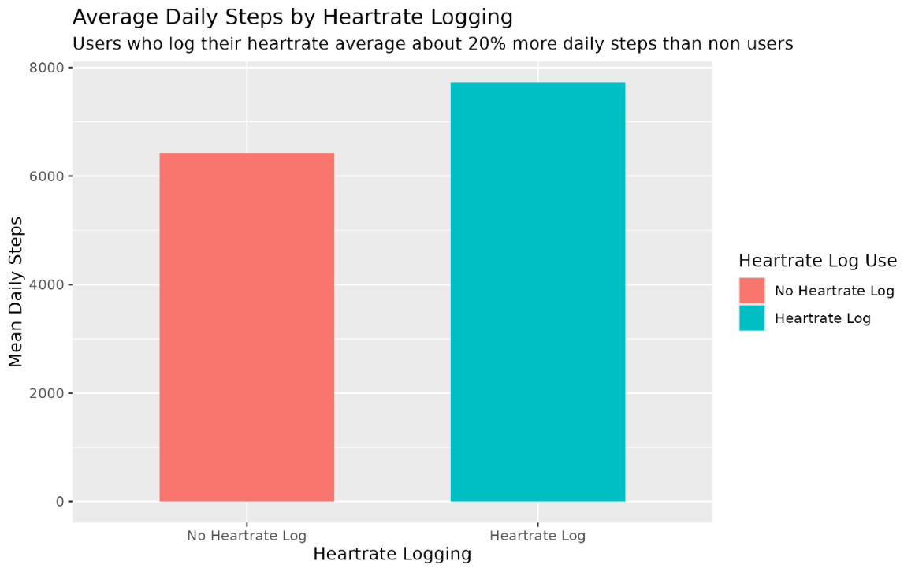
Figure 3
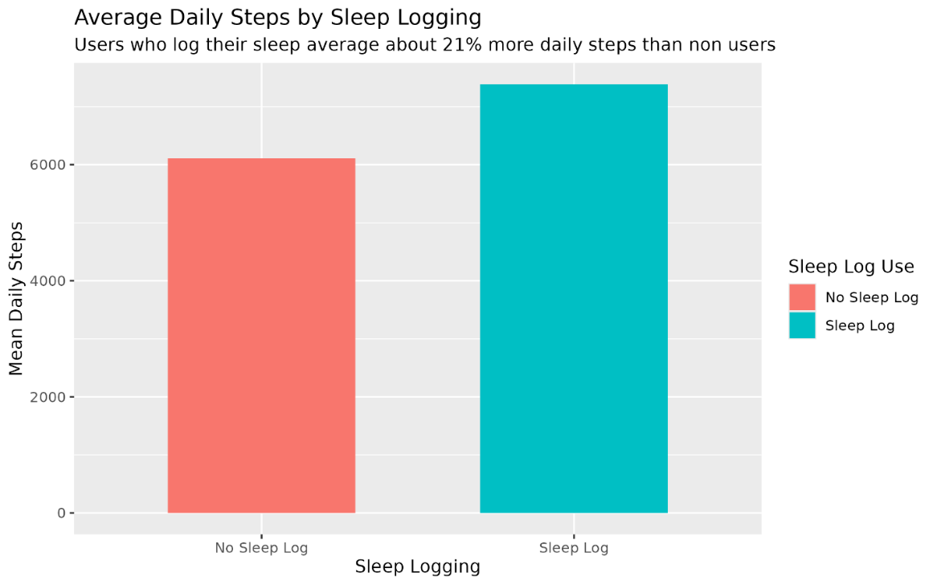
Figure 4
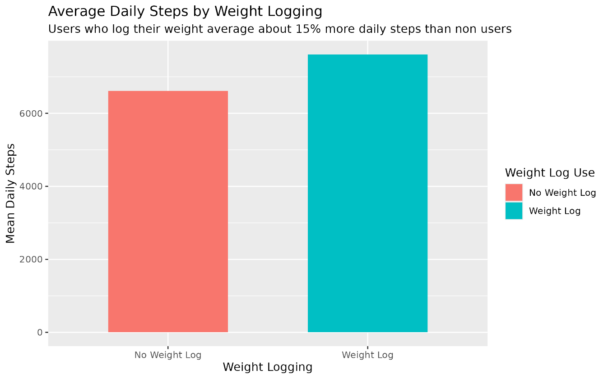
Figure 5
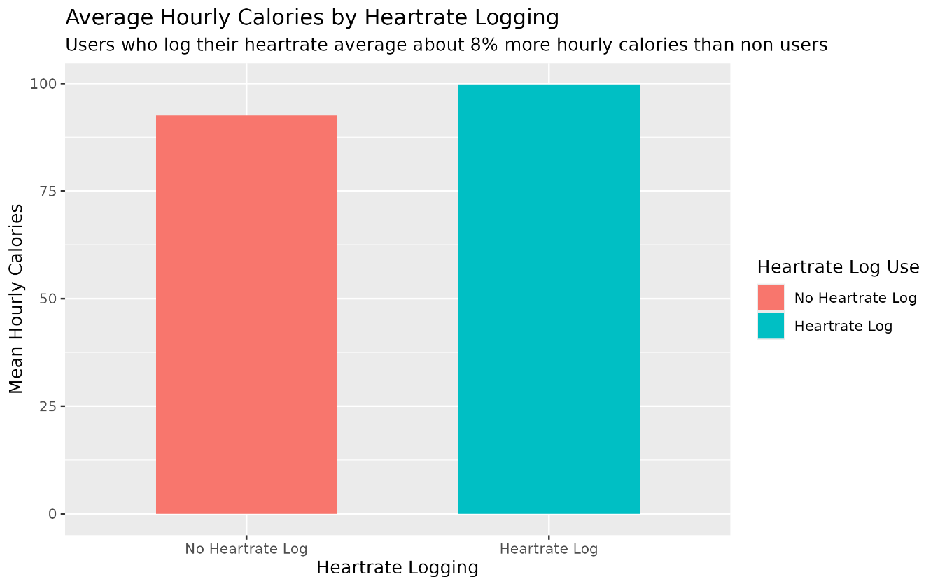
Figure 6
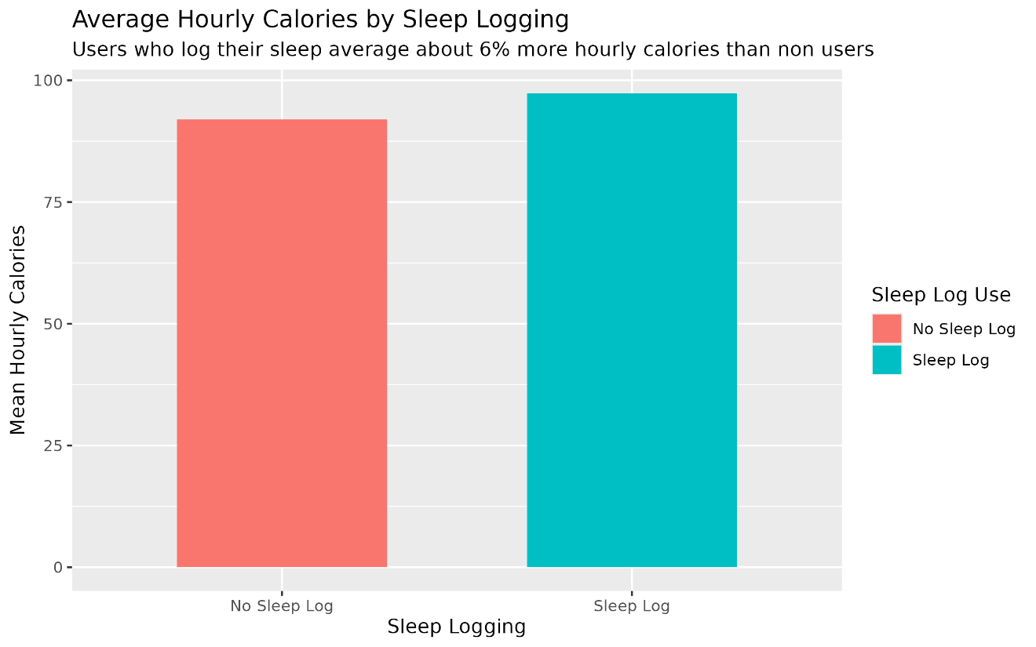
Figure 7
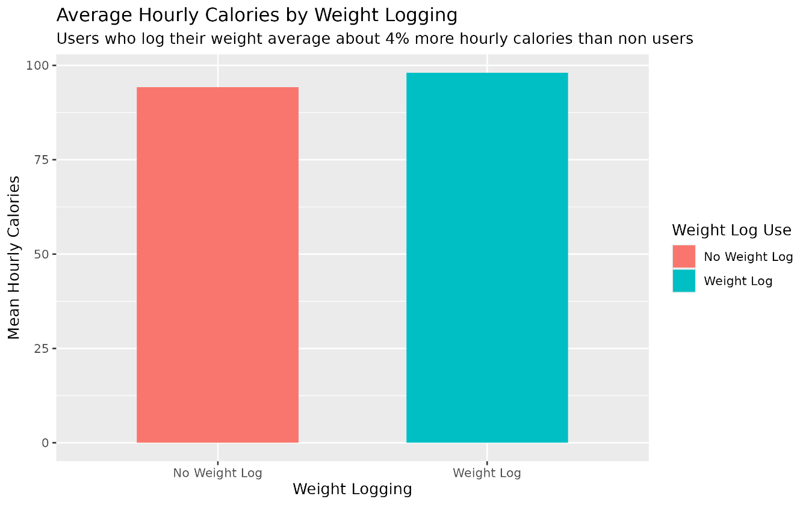
The analysis revealed that users who used multiple different logging features on the platform demonstrated a positive relationship with their average daily step count. Users who used the logging features daily recorded 15–20% more daily steps according to their usage data. There were also increases in average hourly calories, but those increases were more modest, ranging from 4–7%. This analysis suggests that greater use of tracking features is associated with greater physical activity and potentially higher attainment of fitness goals.
Conclusions and Recommendations
Although the findings provide valuable insights, the dataset's limitations are a cause for caution. Data from 2016 may not reflect current behaviors, especially with post pandemic lifestyle changes. Attitudes towards fitness and the increase in remote work may have altered the activity habits of users. Given that Bellabeat develops and markets products for women, data with gender demographics would be vital for assessing trends and patterns within the target demographic. Future datasets should include updated, more diverse data collected over longer timeframes to account for differences in behavior due to seasonal changes. The study shows that users who spend more time using tracking features achieve better outcomes in their physical activities. Bellabeat should use this knowledge to develop marketing strategies that highlight the benefits of regularly tracking users' activities. Bellabeat should add motivational elements, such as weekly badges, milestone rewards, and streak acknowledgments, to encourage user engagement in the long term. Automated reminders to help users track their activities more frequently and show them how regular monitoring leads to better health outcomes would be particularly useful if reminders were targeted to users who don't engage as often or have a decrease in engagement.
In conclusion, although data limitations constrain this exploratory analysis, it provides a strong foundation for strategic decision making. The evidence supports the notion that increased engagement with smart device features can lead to better health outcomes, a message that Bellabeat can leverage both to enhance product design and to craft marketing campaigns rooted in the empowerment and well being of women.

References
Coursera | Online courses & credentials from top educators. Join for free | CourseRA. (n.d.). Coursera. https://www.coursera.org/learn/google-data-analytics-capstone/supplement/ZsmDD/case-study-2-how-can-a-wellness-company-play-it-smart
Bellabeat. (2024, April 3). Bellabeat – Bellabeat. https://bellabeat.com/
FitBit Fitness Tracker Data (By Möbius). (n.d.). Kaggle.com. https://www.kaggle.com/datasets/arashnic/fitbit
Spinu, V., Grolemund, G., & Wickham, H. (n.d.). Date and Times with Lubridate Cheatsheet. https://lubridate.tidyverse.org/
Create elegant data visualisations using the grammar of graphics. (n.d.). https://ggplot2.tidyverse.org/
Perplexity AI. (2025, December 11). Help debugging R data cleaning script with dplyr [Generative AI chat]. https://www.perplexity.ai
Appendix
Figures 8 and 9 display the average number of steps and calories for each day of the week. Since the data showed no significant variation, it was excluded from further analysis.
Figure 8
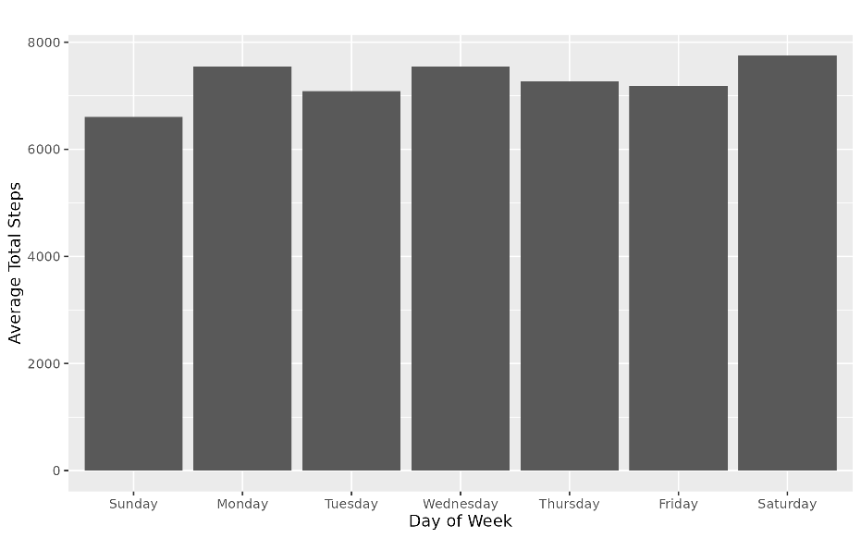
Figure 9
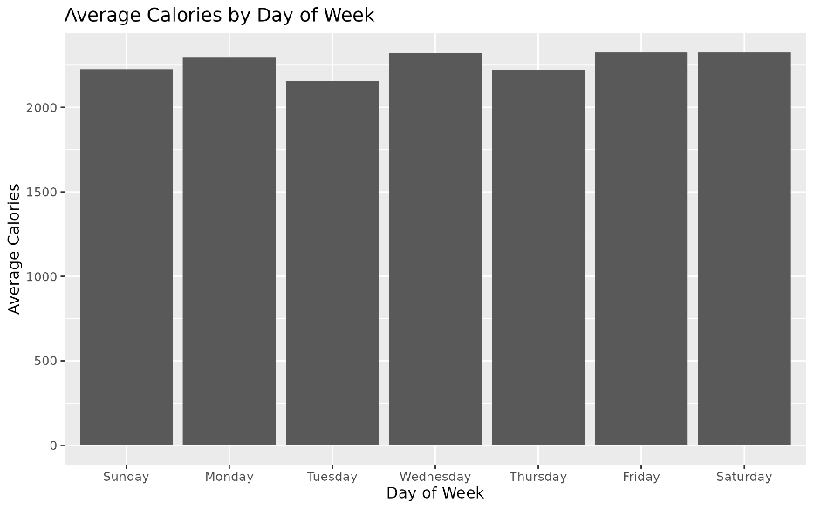

Figures 10 and 11 illustrated a positive relationship between user activity levels and the number of services utilized; however, a simple column chart conveyed this correlation more clearly.
Figure 10
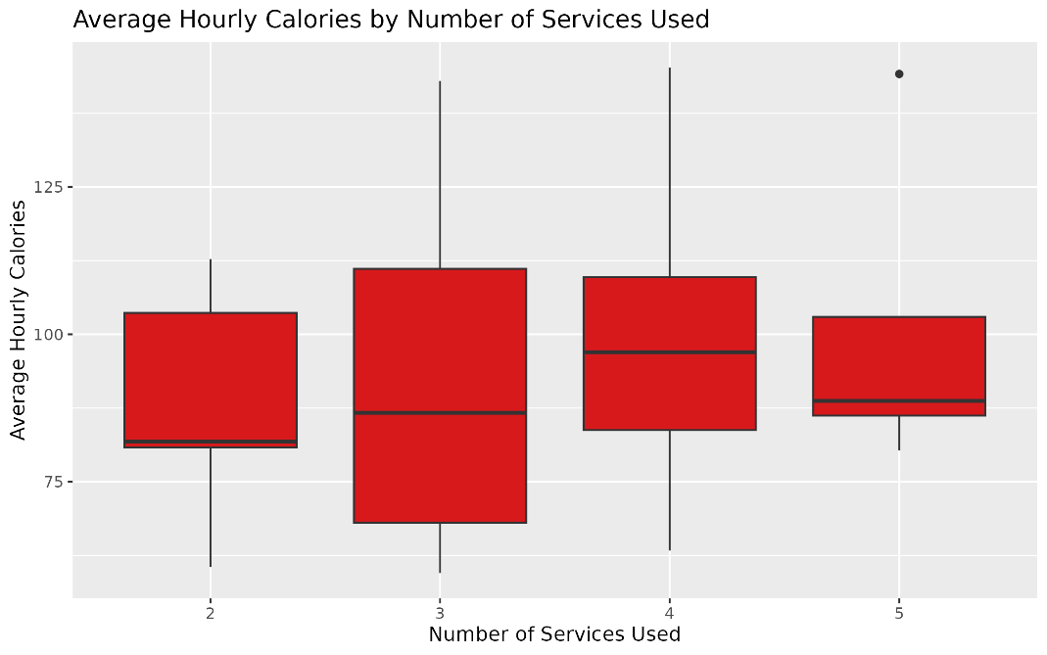
Figure 11
