Evaluating Warehouse Closure Feasibility Through Inventory Optimization at Mint Classics
Michele McCluskey
January 2026
Introduction
Mint Classics is a company that sells collectible model car products. The organization needs to determine whether it can close one of its four warehouses without negatively affecting customer satisfaction. This analysis investigates inventory patterns and performance measures that the company can use to unify processes, rearrange stock, and reduce inventory while maintaining service quality.

The Data
The analysis used nine related CSV tables from a Coursera case study that contained information about warehouses, products, orders, and order details. These tables were imported into MySQL Workbench for inspection, data quality checks, and analysis, and the final visualizations were created in Tableau. The data covers the period from January 6, 2003, to May 31, 2005, with the warehouse, products, orders, and orderdetails tables serving as the primary sources for this project.

Methodology
The first step involved validating record counts and data types in each table to confirm that the data was complete and usable. Each table was checked for duplicate entries and missing values, and data types were standardized where needed so that prices, quantities, and dates could be calculated accurately. Aggregate queries were then used to combine the products, orderdetails, orders, and warehouse tables in order to compute product-level and warehouse-level revenue, profit, inventory value, inventory turnover, and sell-through metrics, which were then visualized in Tableau.

Analysis and Findings
The analysis shows that the Classic Cars product line generates the highest total profits but also includes 7 of the 20 least profitable products in the catalog. This category holds the largest amount of inventory, while lower profit products tend to have smaller stock levels, suggesting that stock levels generally correspond to profitability with notable exceptions in Classic Cars where some low performers are overstocked (see Figures 1–4).

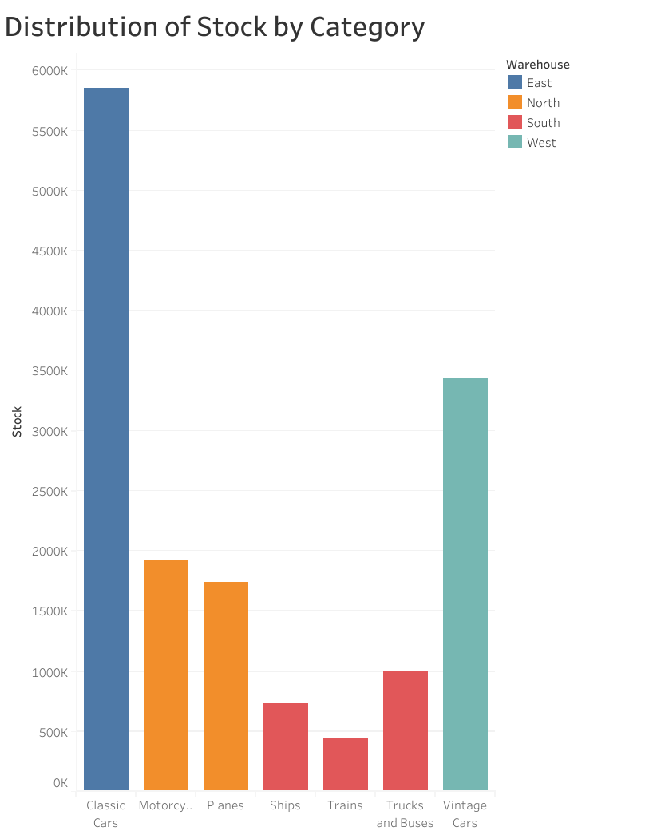
Figure 1
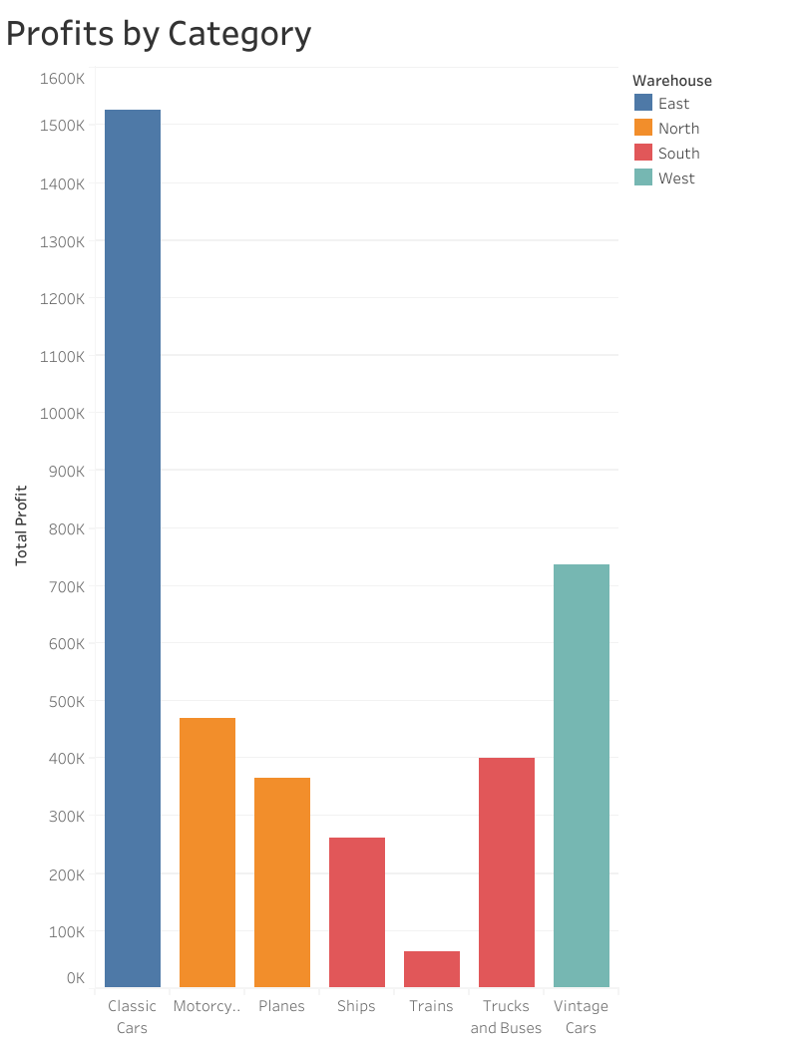
Figure 2
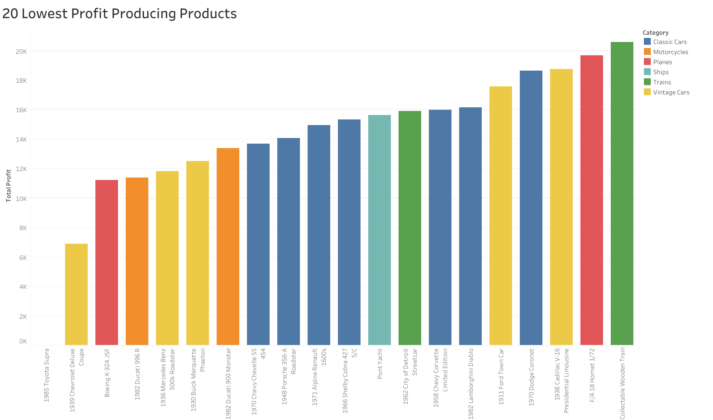Figure 3 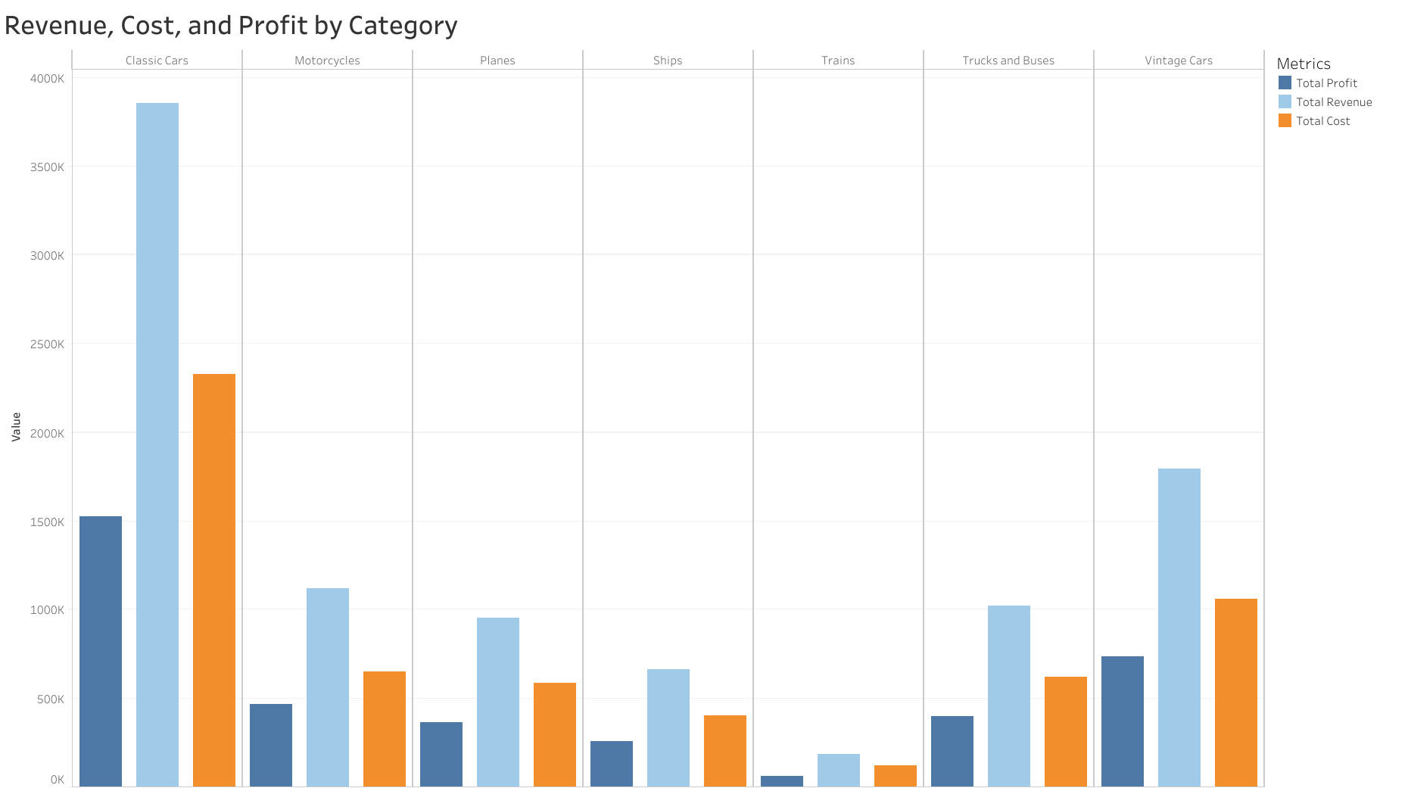
Figure 4

Across all product categories, inventory levels relative to sales performance exhibit excessive surpluses. The data shows that products maintain excessive inventory levels beyond their actual market demand which results in working capital being locked in products that do not sell well. Sell through percentages and inventory turnover rates reveal that many products carry more inventory than their demand justifies, meaning a significant amount of working capital is tied up in slow moving items. The Classic Cars and Vintage Cars categories generate the highest profits, but their unsold inventory requires considerable capital, making them strong candidates for optimizing stock levels without jeopardizing customer availability (see Figures 5–8).​

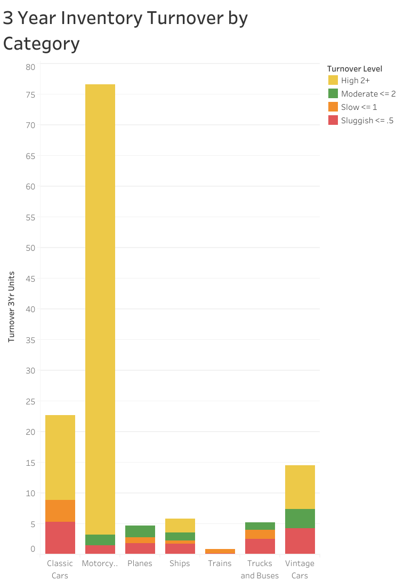
Figure 5

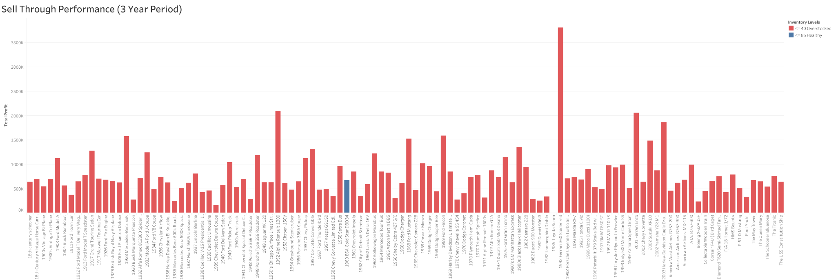
Figure 6

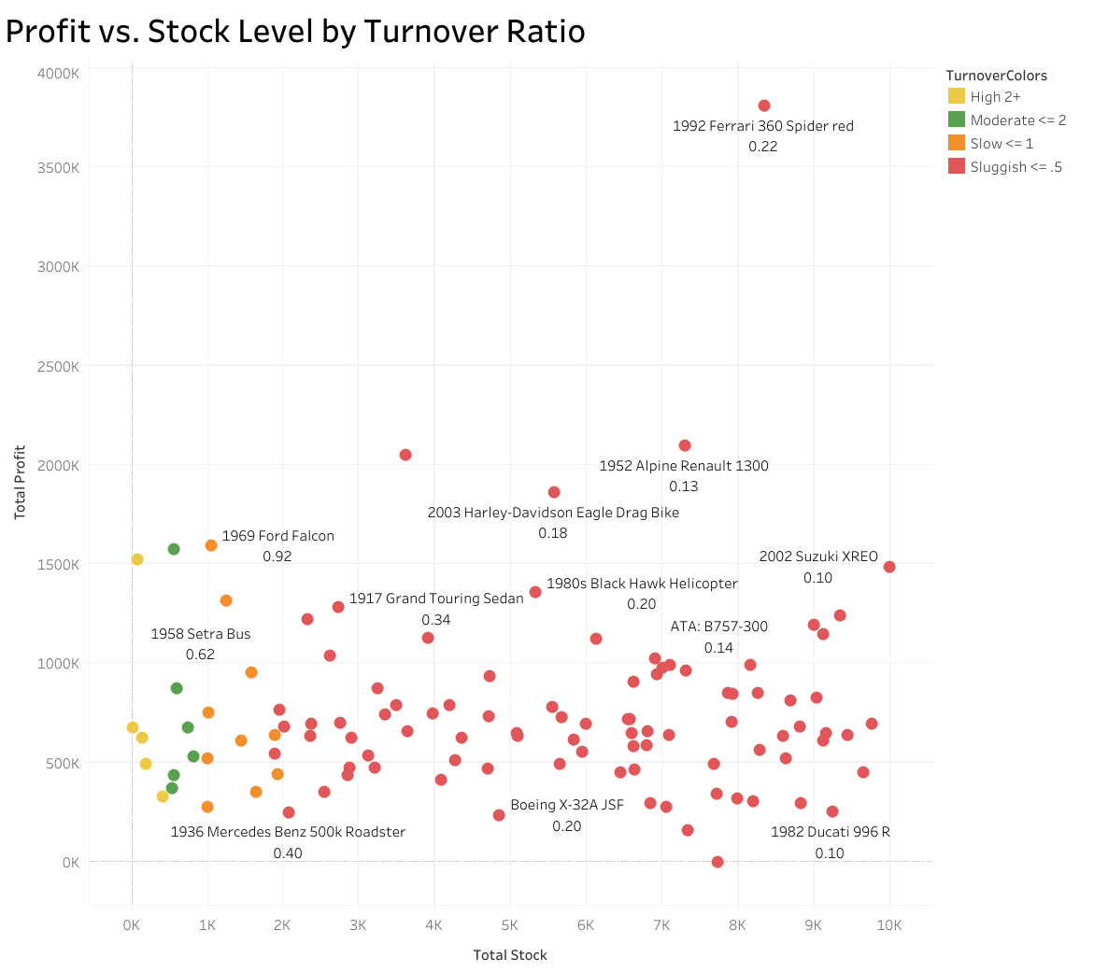
Figure 7

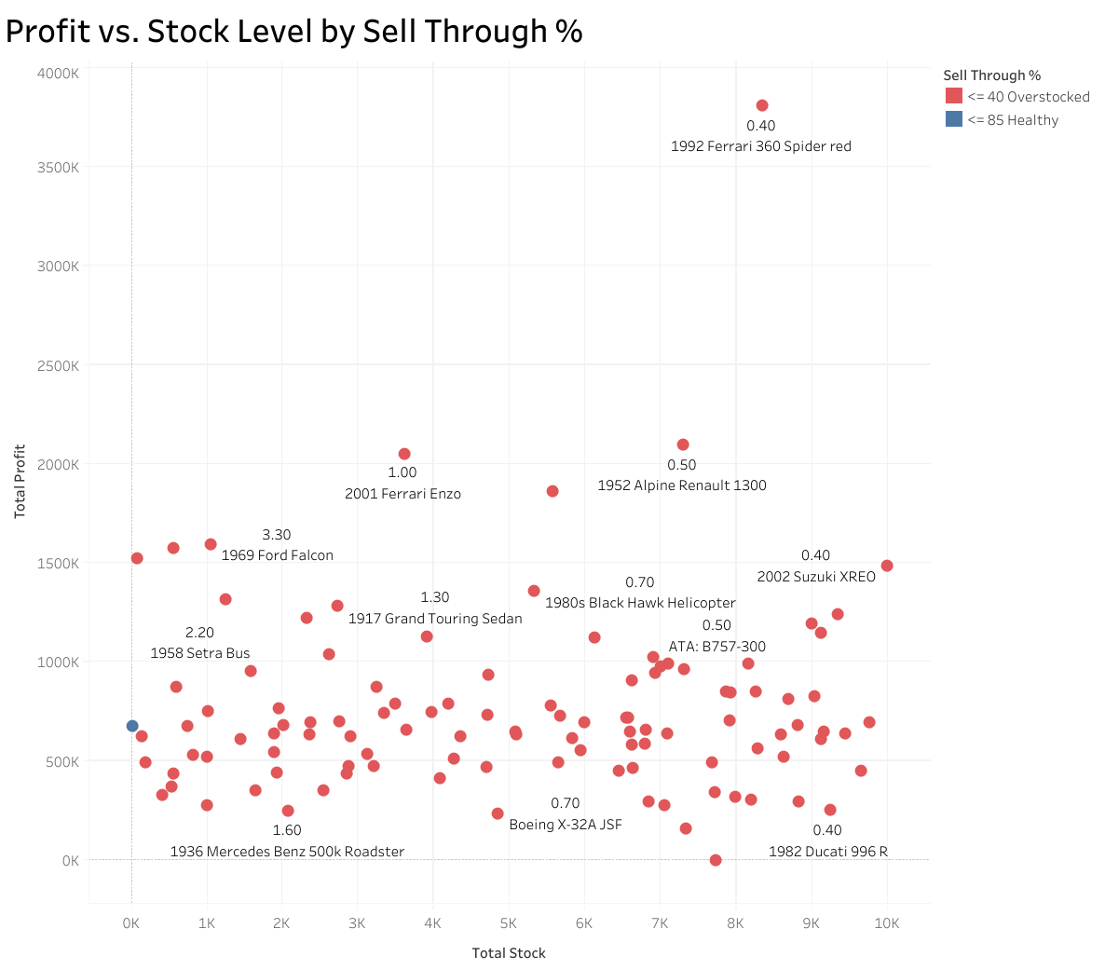
Figure 8

Conclusions and Recommendations
Surplus stock could be reduced without harming the companys ability to fulfill demand as inventory levels at Mint Classics exceed what is necessary to maintain customer service. Discontinuing the least successful products would free warehouse capacity, reduce inventory holding costs, and improve overall financial performance. In particular, the Classic Cars product line remains the most profitable, but removing the seven worst performing Classic Cars models would reduce excess inventory in that category while concentrating resources on higher performing items.​
The analysis also indicates that closing one warehouse is feasible if inventory is strategically consolidated. Vintage Cars inventory currently stored in the West warehouse can be reallocated to the remaining three warehouses according to their available storage capacity, allowing Mint Classics to reduce fixed warehouse costs without harming product availability or service quality (see Figures 9 and 10).​

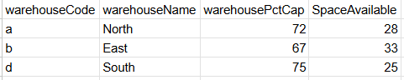
Figure 9

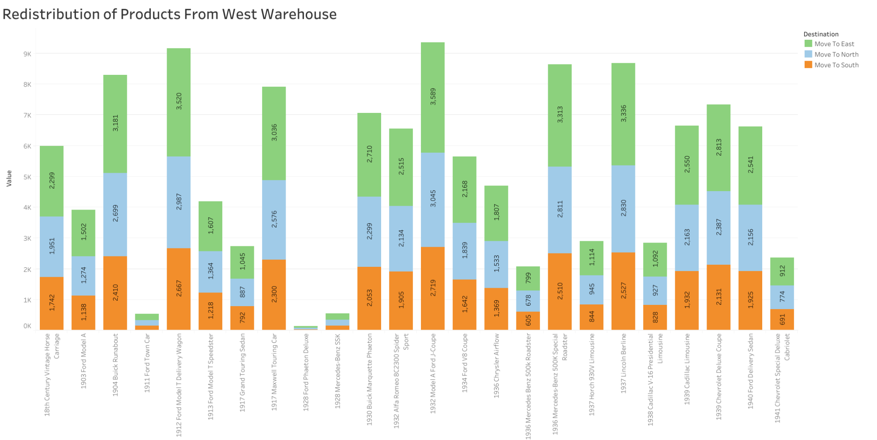
Figure 10

References
27 Inventory Management Terms You must know - Fishbowl. (n.d.). 27 Inventory Management Terms and Definitions You Must Know. https://www.fishbowlinventory.com/blog/27-inventory-management-terms-and-definitions-you-must-know
Boomer, B. (2025, September 26). What is a good inventory turnover ratio? Sortly. https://www.sortly.com/blog/what-is-a-good-inventory-turnover-ratio/#:~:text=An%20inventory%20turnover%20ratio%20between,business%20out%20of%20the%20red.
Funds, O. (2025, September 21). Inventory Turnover Benchmarks by Industry 2025. Onramp Funds. https://www.onrampfunds.com/resources/inventory-turnover-benchmarks-by-industry-2025#:~:text=Definition%20and%20Calculation,Factors%20That%20Affect%20Industry%20Benchmarks
LearnSQL.com Team. (2023, September 5). MySQL Cheat Sheet. LearnSQL.com. https://learnsql.com/blog/mysql-cheat-sheet/
Spiotta, J. (2025, August 14). Understanding Sell-Through rate. SPS Commerce. https://www.spscommerce.com/blog/sell-through-rate/

